Mayfield Messenger
27th January 2023

Ready, Respectful, Resilience, Responsible, Resourceful, Reflective
Dear parents and carers,
A message from Mr Howard
"If you want trust, you trust; if you want respect, you respect; if you want conflict, do neither." (Mark Finnis)

During the INSET Day on Monday 23rd January, all of the staff across the school attended training in Relational Practice (a whole school approach and a key priority in our School Improvement Plan). It focussed on how to put behaviour right when it goes wrong in a more positive, less punitive way, and, more importantly, on how to get it right and keep it right in the first place. Furthermore, the lead trainer championed an approach that is collaborative, empowering and positive – and ultimately aimed to improve motivation, engagement and independent learning for all pupils.

The training challenged us to reflect honestly on our own behaviours and language when we are working in school and with our young people. The feedback from staff has been positive and is another positive platform where we all believe in the approach to achieve our goal of improving the behaviour culture of the school so that we support our young people to succeed. The work in relational practice will continue to be implemented and embedded in the day-to-day school practice whether that be in the office, classroom, outside or in the corridors. I will keep you updated with the next phase of the approach to improving the culture of our school.

I wish you all a great weekend!
Year 9 Teenage Booster Vaccination When: Thursday 9th February 2023
If you are a parent / carer of a Year 9 student, please find attached information regarding the above vaccination. To sign up click the link below for the registration, or follow the link on the attached document.

E-Consent link

https://links.inhealthcare.co.uk/solent-portsmouth- tdm
OFSTED report
You will have seen the letter and the Ofsted report which I sent out yesterday about the outcome of the inspection on the 15th and 16th November 2022.
Disappointingly, in this recent inspection (November 2022), the school has received a judgement of 'inadequate' for its Overall Effectiveness. It is obviously very disappointing for all members of the school community.
I would like to personally thank you for the overwhelming positive support in the journey that we are on and the support in the actions already being taken.

Year 8 Parent’s Evening Reminder

The parental booking system for the Year 8 Parent’s Evening on Thursday 9th February is now open. Parents can book their appointments via SchoolCloud - Mayfield School.

This is a face-to-face parents’ evening from 4 till 7pm and all teachers will be based in the Main Hall.
Community Event Reminder

We look forward to welcoming you to our next event on:
Tuesday 7th February 5pm-6pm
Refreshments will be available.

A Christmas Carol
We have been lucky enough to book an afternoon performance with the 'Quantum Theatre Company' who will be coming to Mayfield on the afternoon of the
30th to perform 'A Christmas Carol.'

This will involve the whole of year 10 and 11 pupils and the performance will be in the Main Hall - this performance is Free to pupils.

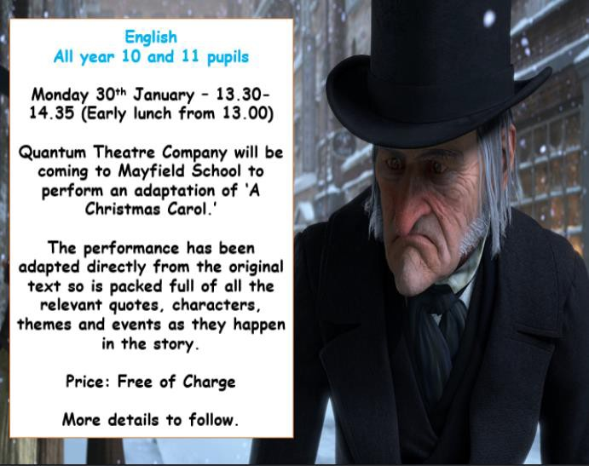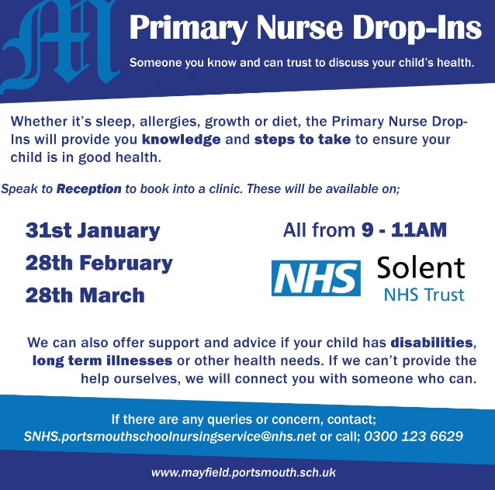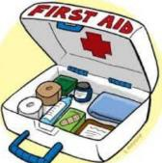This week’s successes outside of Mayfield are;
Apply for free school meals
It is not too late for parents to apply for free school meals and be eligible for these vouchers.

Parents and carers can apply through this link on the PCC website
School meals - Portsmouth City Council or complete a paper form that is available at Reception.
Primary school nurse clinic
Families can sign up via the main reception. You do not need to explain the reason; you just need to put your name down. The next school nurse clinic is;
31st January 2023 All from 9-11am
Medication for primary
If your child/ren require medication during the school day, please could parents and carers bring this into school reception as a consent form must be completed before handing medication over. Children should not be bringing this in by themselves. Thank you for
your support with this.
Share your child’s success outside of Mayfield
If your child/ren have achieved something over the weekend or during the week, please share a picture and a brief description of the success.
This could appear in the next Mayfield Messenger. Please send these to general@mayfield.portsmouth.sch.uk
Unfortunately, we will not be able to share all of these. However, we will use them to contribute to a beyond Mayfield display.
We look forward to seeing you all again on Monday
Alice in Year 4 was inspired by seeing an item about Mermaid Purses on Winterwatch. She went to the beach and built up her own collection on Monday’s Inset Day.

27th January 2023

Dear all parents and carers Update on day of strike
Mayfield Road Portsmouth Hampshire PO2 0RH

Tel : 02392 693432
Fax: 02392 665298

www.mayfield.portsmouth.sch.uk

- Partially closed and open to Year 11 pupils, pupils with a current Education, Health and Care Plan and during lunch time only - pupils eligible for Free School Meals

Following on from the message sent to you all on Monday 23rd January you will already be aware that members of the National Education Union (NEU) have voted to take industrial action on a range of days over the next few months. The action is not against the school but is part of national industrial action organised by the union. The strike dates currently announced are:

  - Wednesday 1 February 2023,
  - Thursday 2 March 2023,
  - Wednesday 15 March 2023
  - Thursday 16 March 2023

Although I have been liaising with union representatives, members of the unions are not required to let employers know ahead of time whether they intend to strike.

Based on the current information, we will be partially closed. The school will only be open for pupils in Year 11 and those pupils who currently have an Education Health and Care Plan (EHCP). The school will also be open during lunchtime for pupils eligible for Free School Meals.

The decision to partially close has not been taken lightly and unfortunately covering the classes has not been an option. I do realise that this will cause difficulties for parents and carers. Our first concern when making such decisions is always the safety of the children and young people and the school.

If we have a higher number of staff taking action on the day it could lead to full closure of the school and notification to Year 11 and pupils with an EHCP may be very late. The lunchtime opening to pupils eligible for Free School Meals will continue.

Due to this uncertainty, it would be advisable to have plans in place to ensure that your child/ren are able to be cared for in the event of a full school closure.

Work for children not in school
Due to partial closure, we aim to have work available on our school website. Please see the below links to access this learning.

Primary work can be found here:
Home Working - Primary | Mayfield School

Senior work can be found here:
Home Working | Mayfield School Homepage>Learning and Curriculum>Home Learning
Teachers taking strike action are not required to set cover work and so the work may be general work rather than lesson specific.

Free School Meals

Primary
- For primary pupils who are eligible for free school meals, we will be providing a hot meal during the lunchtime. This will be from 12pm – 12:45pm. We will be sending out a form for parents and carers of primary aged pupils eligible for Free school meals to sign up to this offer.

The children will need to arrive at the main reception area to be registered at 12pm and then collected at 12:45pm from outside the main school hall.

Seniors
- Senior pupils eligible for free school meals are able to arrive between 1pm-1:15pm at Kensington gate entrance where they will be registered and taken through to the canteen to collect and enjoy their lunch. They will leave once they have finished their lunch.
Thank you for your patience and support. Yours sincerely
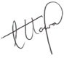
Mr Howard Headteacher

Believe. Achieve. Succeed
Headteacher, Mr. Ashley Howard

