Mayfield School Autumn Term 2022 Careers and Enterprise Newsletter
We have had a very successful term for Careers and Enterprise activity at Mayfield School. There have been many opportunities for our secondary pupils to interact with employers from the real world. We are always striving to develop our pupils’ employability skills and other vital skills for the workplace such as responsibility, independence, communication, teamwork, and resilience.
Here are some activities that have taken place this term:
- Tutor focus week for Career Aspirations – All pupils
- House Assembly delivered by University of Portsmouth – All pupils
- University Of Oxford for Year 10
- Careers and Apprenticeship Show at Fratton Park for Year 10 and 11
- Careers and Your Future Networking event for Year 10 and 11
- Southampton Boat show trip – Future Leaders Society
- UNLOC Accelerate programme – Future Leaders Society
- ASK Apprenticeship Team Awareness Talk for Year 11
- Post 16 providers in for Year 11 Assembly talks about their provisions
- Creative Careers Workshop for Year 8 and 9 pupils
- University of Portsmouth for Connect Physics for Year 8 pupils
- Author Visits for Year 7 pupils
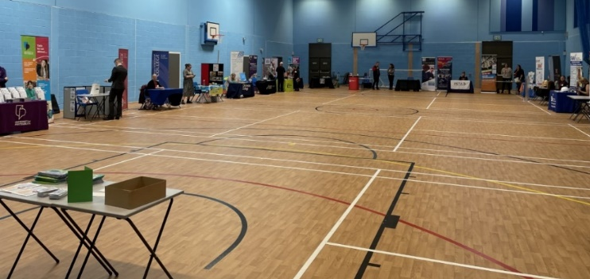
- 1-2-1 Careers Meetings for Year 11 pupils
- UNLOC Enterprise Workshop for Year 10 Business pupils
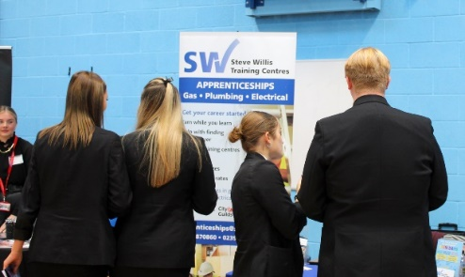
Evaluations for some of these events can be seen on the careers page of the school website please follow the link to explore the range of resources available on our page: Careers & Enterprise | Mayfield School

Resources for Parents and Pupils:
There is an informative website called Amazing Apprenticeships with lots of resources for parents about apprenticeships, traineeships and T levels. There is a monthly parents pack which can be downloaded.
Here is the link for the monthly pack: Resources for parents and guardians (apprenticeships.gov.uk)
If your pupil is in Year 11 and thinking about applying for an Apprenticeship a great place to start is: Find an apprenticeship - GOV.UK (www.gov.uk)
Another great recourse to explore future aspirations is Careerpilot : Plan your future work & study

Alumni Project
We have also invited past pupils to let us know “Where are you know” and it is great to hear that of the 2020 cohort we have had replies from over 50% are now attending University to extend their qualifications and learning journey. It is great to heard from past pupils please do make contact to let us know what you are up to! Email denfordr@mayfield.portsmouth.sch.uk

Moving to the Spring Term
We have lots to look forward to in the spring term. The focus being for Year 10 having a CPR unit on careers. They will get to develop a CV and have an interview ready session then followed by a 1-2-1 Mock Interview in March.
We have a trip open to 30 Year 9 pupils in January to Portsmouth Guildhall looking at future careers called “Get Inspired”. Pupils are to see Mrs Denford in 218 for a letter.
There will be another tutor focus week in January and many more interactions with business and employers over the Spring term.
Feedback
We welcome any feedback about the provision to the careers lead on the following email denfordr@mayfield.portsmouth.sch.uk. We will also be completing pupil voice groups to improve and tailor the provision towards the pupils and include their feedback in developing the careers provision.

Enterprise @ Mayfield
It's been a great term for Mayfield's Enterprise students!
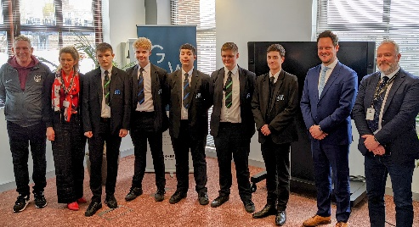
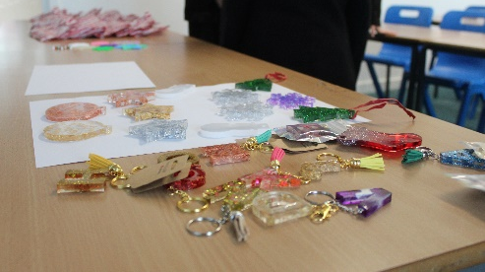
Our year 10's won 1st and 2nd place in the annual Made In Portsmouth sustainability competition and finished selling all their Chilly's water bottles at the Christmas Fayre, which raised over £600 for Water Aid.
Congratulations to our students that took part in this year's enterprising Fiver and Tenner Challenge. The teams achieved over £500 in sales and have hugely helped the school, with all sales going to Friends of Mayfield. This was a great event causing lots of excitement in our community and the students showed how amazing they are!

A huge thank you to the year 11 yearbook committee for their help in the design for this year's book and to Kurt Geiger this term for agreeing to sponsor our yearbook, helping to significantly reduce the price for our students. Watch this space for your chance to purchase your year 11 leavers book next term.

Finally, our year 10 business students were joined by the newly formed 'Enterprise Ambassadors' to go to The Guildhall for a great day of pitching, inspirational speakers and soft-skill development. The winning team included one of our year 8 Enterprise Ambassadors, yet again our brilliant students showed how great they are!

If you think you would like to get involved with any careers or enterprise activities or have any feedback please email denfordr@mayfield.portsmouth.sch.uk with your details and they will be in touch!

Mrs Denford Mr Batchelor
Careers Lead Enterprise Lead

