**GCSE English Language**

**Paper 1: Question 5**

How I feel about my creative writing skills in general (circle):

     

My effort relating to written tasks in remote learning… (circle – and be honest!):

     

|  |  |
| --- | --- |
| Strengths: | Weaknesses: |
| Opportunities: | TARGET: |

|  |  |  |  |
| --- | --- | --- | --- |
| Skill | Red | Amber | Green |
| I can *plan* my writing effectively |  |  |  |
| I can structure an interesting narrative |  |  |  |
| I can write in paragraphs using *TiPToP* |  |  |  |
| I can vary my sentence lengths and structures |  |  |  |
| I can vary my sentence starts |  |  |  |
| I can use a range of discourse markers and linking phrases |  |  |  |
| I understand the difference between *figurative* and *rhetorical* language |  |  |  |
| I can use the features of SPAMROD |  |  |  |
| I can vary my *vocabulary* |  |  |  |
| I can create a *tone* using my language choices |  |  |  |
| I can use the correct tense consistently |  |  |  |
| I can use a clear narrative voice/point of view |  |  |  |
| I can use basic punctuation effectively |  |  |  |
| I can use a wide range of punctuation effectively |  |  |  |
| I can proof-read my word for errors |  |  |  |

**Synonym challenge: extend your vocabulary and be a better writer.**

|  |  |  |  |  |
| --- | --- | --- | --- | --- |
| Strong | Tired | Bright | Hit (physical) | Tiny |
|  |  |  |  |  |
|  |  |  |  |  |
|  |  |  |  |  |
|  |  |  |  |  |
|  |  |  |  |  |
|  |  |  |  |  |
|  |  |  |  |  |

**Mark scheme: aiming high**

**AO5: Content and Organisation**

*Communicate clearly, effectively and imaginatively, selecting and adapting tone, style and register for different forms, purposes and audiences. Organise information and ideas, using structural and grammatical features to support coherence and cohesion of texts.*

|  |  |  |  |
| --- | --- | --- | --- |
| **Mark/Level** |  | **Skill Descriptor** | **Target** |
| Level 4  19-24 marks  **Compelling,**  **Convincing**  **Communication** | Upper Level 4  22-24 marks | **Content**   * Communication is convincing and compelling |  |
| * Tone, style and register are assuredly matched to purpose and audience |  |
| * Extensive and ambitious vocabulary with sustained crafting of linguistic devices |  |
| **Organisation**   * Varied and inventive use of structural features |  |
| * Writing is compelling, incorporating a range of convincing and complex ideas |  |
| * Fluently linked paragraphs with seamlessly integrated discourse markers |  |
| Lower Level 4  19-21 marks | **Content**   * Communication is convincing |  |
| * Tone, style and register are convincingly matched to purpose and audience |  |
| * Extensive vocabulary with conscious crafting of linguistic devices |  |
| **Organisation**   * Varied and effective structural features |  |
| * Writing is highly engaging with a range of developed complex ideas |  |
| * Consistently coherent use of paragraphs with integrated discourse markers |  |

**AO6: Technical Accuracy**

*Students must use a range of vocabulary and sentence structures for clarity, purpose and effect, with accurate spelling and punctuation.*

|  |  |  |
| --- | --- | --- |
| **Level/Mark** | **Skill Descriptor** | **Target** |
| Level 4  13-16 marks | * Sentence demarcation is consistently secure and consistently accurate |  |
| * Wide range of punctuation is used with a high level of accuracy |  |
| * Uses a full range of appropriate sentence forms for effect |  |
| * Uses Standard English consistently and appropriately with secure control of complex grammatical structures |  |
| * High level of accuracy in spelling, including ambitious vocabulary |  |
| * Extensive and ambitious use of vocabulary |  |

My AO5 target is:

My AO6 target is:

**Lesson 2: Planning (AO5) Use this session to recap approaches to planning. Students have a go at their own planning in one of the chosen ways below.**

You **must** plan your writing to ensure that it has *cohesion*. Use the *Power of 3, story mountain, hour glass* or *key words* methods to ensure that you have sufficient detail to sustain your response.

05:

Your school or college is asking students to contribute some creative writing for its website.

**Either**

Describe a fight as suggested by this picture:



**Or**

Write a story beginning, *What started with some rough and tumble soon descended into anarchy.*

(24 marks for content and organisation

16 marks for technical accuracy)

**[40 marks]**

Planning: Choose **one of these** planning methods and plan your response.

Description: Try the hourglass plan…

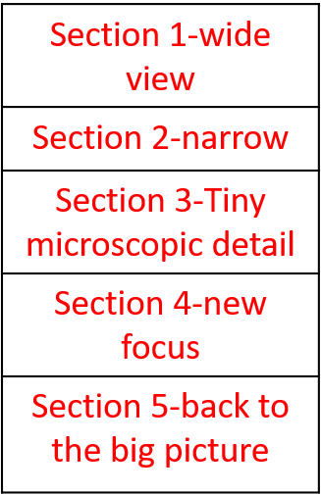

|  |
| --- |
|  |
|  |
|  |
|  |
|  |

Description only: Write around the image plan…

What is

beyond the

picture?

What is

behind or in

front?

What might

be hidden?

Label with 

Ideas/words (adjectives/nouns)

Description or narrative: Try planning to the power of three…

Idea 2

Idea 1

Idea 3

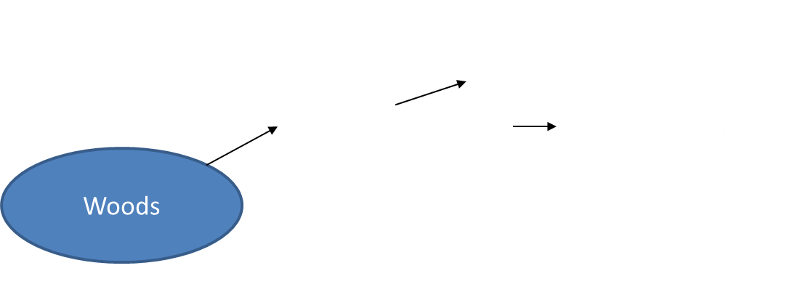

For example…

Narrative: Try the story mountain plan…



**Lesson 3-Fractured writing. Using the planning write for 10 minutes/stop/reflect/continue-three times.**



My AO5 target is:

My AO6 target is:

Choose one of the questions that you have planned.

10 minutes writing!

|  |  |
| --- | --- |
| S  P  A  M  R  O  D  S  C  S  1  ;  :  ( )  -  …  !  “ ”  Ti  P  To  P |  |

Now, using a different colour, reflect on what you have written.

Consider:

* What features of SPAMROD have you used?
* How many varieties of sentences (SCS1) have you used?
* What punctuation have you used?
* How have you varied your vocabulary?

|  |  |  |  |
| --- | --- | --- | --- |
| Yes |  | No |  |

Have you hit your target?

What will you do next?

10 more minutes writing!

|  |  |
| --- | --- |
|  |  |

Now, using a different colour, reflect on what you have written.

Consider:

* What features of SPAMROD have you used?
* How many varieties of sentences (SCS1) have you used?
* What punctuation have you used?
* How have you varied your vocabulary?

|  |  |  |  |
| --- | --- | --- | --- |
| Yes |  | No |  |

Have you hit your target?

What will you do next?

A final 10 minutes writing!

|  |  |
| --- | --- |
|  |  |

Now, using a different colour, reflect on what you have written.

Consider:

* What features of SPAMROD have you used?
* How many varieties of sentences (SCS1) have you used?
* What punctuation have you used?
* How have you varied your vocabulary?

|  |  |  |  |
| --- | --- | --- | --- |
| Yes |  | No |  |

Have you hit your target?

Do you think you are at the top of the mark scheme?

**Lesson 4: reflection/self assessment/peer assessment- students use this opportunity to read peer examples and review their successes/target areas.**

**Use the mark schemes below AO5/AO6:**

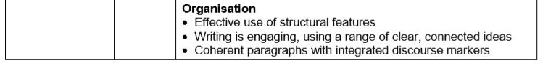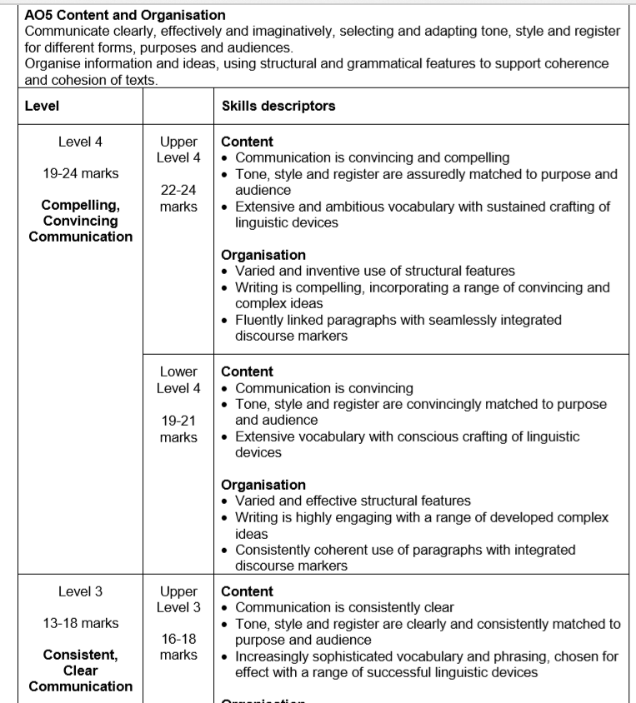

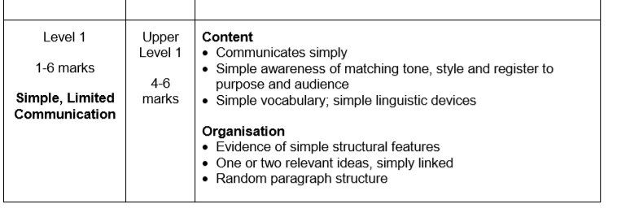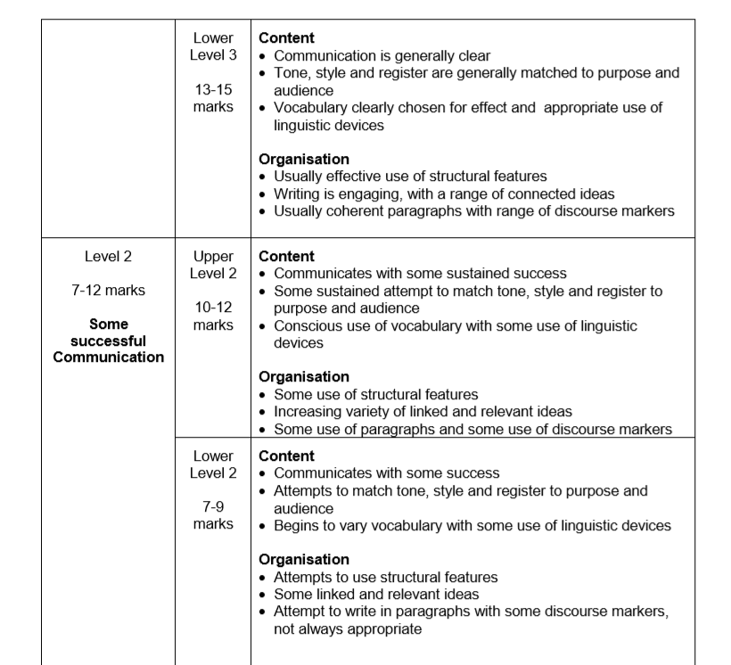

I have self-assessed and would give myself _____/24 marks for AO5 (Content and Organisation)

My target is __________________________________________________________________________________________________________________________________________

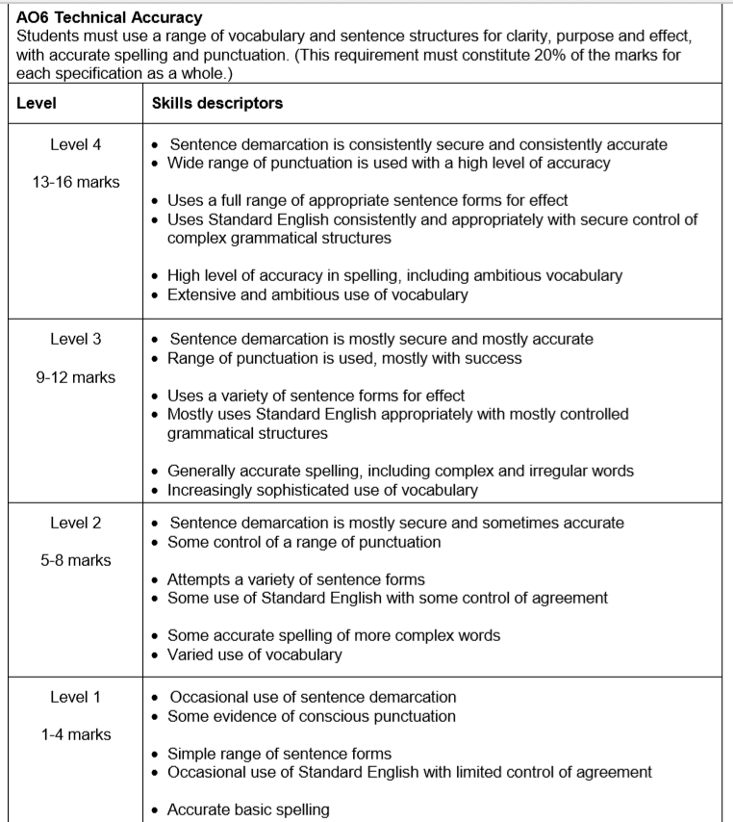

I have self-assessed and would give myself _____/16 marks for AO6 (Technical Accuracy-SPaG)

My target is __________________________________________________________________________________________________________________________________________