Analysing data
Setting the scene
Scientists design experiments to answer a question. Once they have the data, they must analyse it so they can explain if there is a relationship. In this activity you will find out how to analyse data from experiments.
Aims
In this activity you will be working scientifically to:
- plot graphs
- use graphs to describe a relationship
- describe stages in stating a relationship between variables.
Task
Plot a graph for each table of data using the grids provided.
- A scatter graph or line graph are best when variables are continuous (can have any value).
- Choose the scale so the numbers go up in equal steps.
- The independent variable is in the first column and goes on the x-axis (horizontal axis).
- Plan ahead so the numbers you plot fit on the graph’s axes.
- Don’t forget labels and units for both axes.
- Plot the points on the graph.
- Draw a straight line that goes as close to all the points as possible.
Table 1
Volume of water (cm³) | Height of water in measuring cylinder (cm)
20 | 2
40 | 4
60 | 6
80 | 8
100 | 10
Graph 1
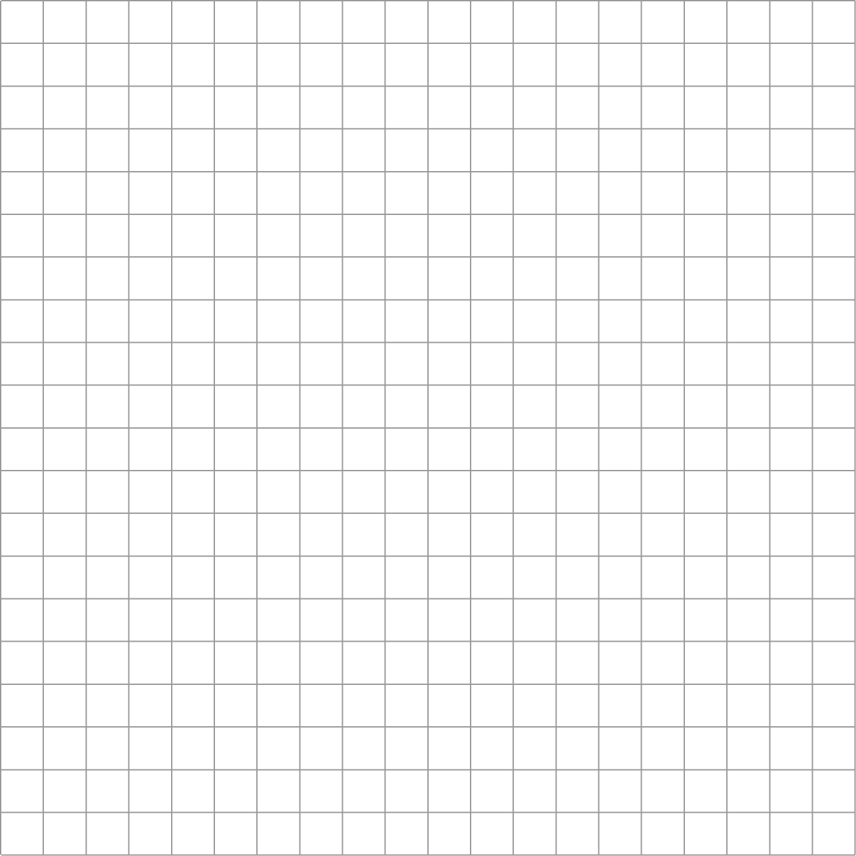

Table 2
Angle of incident light ray (°) | Angle of reflected light ray(°)
10 | 12
20 | 20
30 | 28
40 | 42
50 | 50
Graph 2

Table 3
Force used (N) | Length of rubber band (cm)
1 | 10.0
2 | 11.1
3 | 12.0
4 | 12.8
5 | 14.2
6 | 15.8
7 | 17.1
8 | 18.0
Graph 3

Describe the relationship each graph shows in as much detail as possible.
Graph 1

Graph 2

Graph 3

Questions
1 Give another example of data you could plot on a line graph or a scatter graph.

2 Give an example of data you could plot on a bar graph.

3 Describe the stages you must follow to analyse data and describe a relationship.

Extension
1 Plot this data on a scatter graph using the grid provided.
You do not need to start the scale for the y-axis at zero.
Table 4
Cooling time (s) | Water temperature (°C)
0 | 80
60 | 71
60 | 66
90 | 63
120 | 57
150 | 55
180 | 53
210 | 51
240 | 50
Graph 5

2 You cannot draw a straight line of best fit for this data. Explain how you choose the line of best fit.

3 Describe the relationship this graph shows. Use numbers to support your answer.

