The Function of the CPU
What is the Purpose of the CPU?
The CPU is often known as the 'brain of the computer'. Its job is to process data. And by processing we mean things like searching, sorting, calculating and decision making. Whenever you are on working on your computer, it is the CPU which is at the heart of everything.

The CPU follows three steps in order to process data. It is known as the Fetch - Decode - Execute cycle (aka Fetch-Execute Cycle).
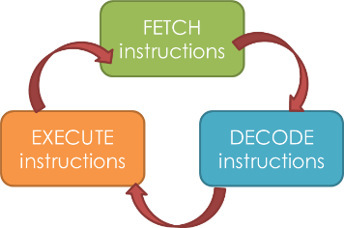

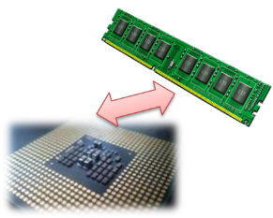
To begin with, whenever you open and work with a program, its data and instructions are loaded onto the RAM. As the RAM is accessed directly by the CPU, the CPU can get to work!

The Fetch Stage
In this step the CPU fetches some data and instructions from main memory (RAM) and then stores them in its own temporary memory called 'registers'.
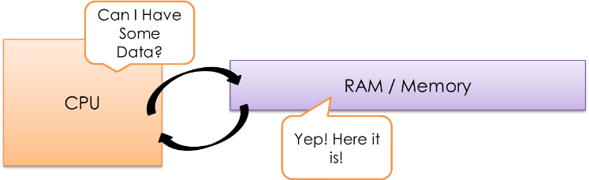

For this to happen, the CPU uses a piece of hardware path called the 'address bus'.
The address of the next item that the CPU wants is put onto the ‘address bus’.
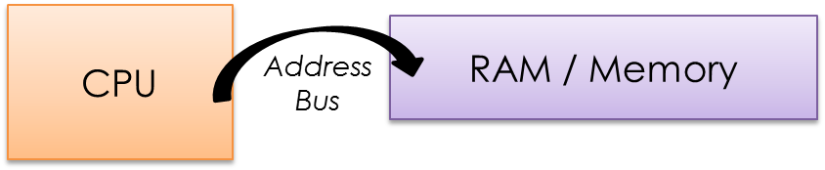

Data from this area then travels from the RAM to the CPU on another piece of hardware called the ‘Data Bus’.
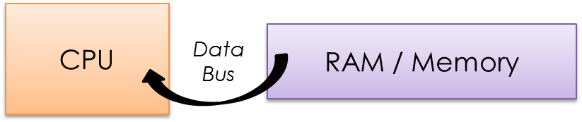

The Decode Stage
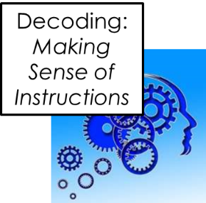
The decode step is where the CPU understands / works out what the instruction it has just fetched actually means. The CPU ‘decodes’ the instruction and gets things ready for the next step.

The Execute Stage
The Execute stage is where data processing happens. Instructions are carried out on the data. Once a cycle has been completed, another begins.

What makes up a CPU?
Now that we know the basic actions performed by the CPU it’s time to look at the areas of the CPU responsible:
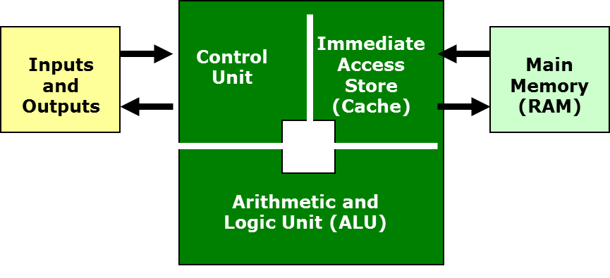
- Control Unit
- Immediate Access Store (IAS) or “Cache”
- Arithmetic and Logic Unit (ALU)

The Control Unit
There are three main jobs of the Control Unit:
- It manages and monitors hardware on the computer to ensure the correct data goes to the correct hardware.
- It manages the input and output signals ensuring these are dealt with correctly.
- It uses clock signals to synchronise the running of the Fetch-Decode-Execute cycle.

Immediate Access Store (Cache)
This part stores the data which is to be immediately processed. The CPU takes a chunk of data / instructions from the RAM and keeps it close so that it always has a constant supply of data to process. If data and instructions were moved from the RAM one instruction at a time, the CPU would work far slower because the CPU cycles much faster than the RAM can deliver data. So instead, chunks are moved from the RAM and stored on the cache so the CPU doesn’t spend wasted time waiting for a delivery of data. Efficiently coded programs will also ensure that regularly used instructions are stored in the cache so that they can be accessed regularly, at speed.

Arithmetic and Logic Unit (ALU)
This is where the CPU actually carries out the maths and logic on the data (processes it).
It has two parts:
- Arithmetic part, which performs calculations on the data, e.g. 3 + 2 = 5
- Logic part, which deals with logical operations such as is True / False / Equal to / Greater than etc.

Summary of the journey of data / instructions around the CPU
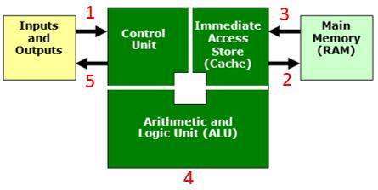
- An input device (e.g. keyboard) sends data to the CPU. The Control Unit receives this data.
- The Control Unit sends this data into main memory to be used later.
- When the time is right, the data will be transferred from main memory into cache (IAS)
- The data will then be sent to the ALU for processing
- The control unit will send the processed data back (for example to an output device such as a screen or monitor).

Questions (The question zone you choose must either match your target grade or be higher!)
Question Zone 1-3
- State the names of the 3 main components that make up the CPU. [3]
- Define the words ‘decode’ and ‘execute’, in relation to the function of the CPU. [2]
- Describe what happens during the F-D-E cycle. [3]
Question Zone 4-6
- Describe what happens during the F-D-E cycle. [3]
- Describe the roles of both the address and data bus. [2]
- Explain the job of the CPU’s control unit. [6]
Questions Zone 7-9
- Explain the job of the CPU’s control unit. [6]
- Explain, using a diagram, the journey of an instruction from input device to output device. [5]
- Discuss differences between the roles of both the RAM and the cache in how data is delivered to the CPU, during the fetch-decode-execute cycle. [4]
____________________________________________________________________________________________________________________________________________________________________________________________________________________________________________________________________________________________________________________________________________________________________________________________________________________________________________________________________________________________________________________________________________________________________________________________________________________________________________________________________________________________________________________________________________________________________________________________________________________________________________________________________________________________________________________________________________________________________________________________________________________________________________________________________________________________________________________________________________________________________________________________________________________________________________________________________________________________________________________________________________________________________________________________________________________________________________________________________________________________________________________________________________

Checklist:
 Date and title, clearly presented
 Spelling & grammar checked
 Question numbers in the margin
 Handwriting neat & legible
 Punctuation / Capital letters
Keywords / Key Terms:
Buses: The communication channels linking the CPU with the RAM and I/O devices.
Execute: The action of a CPU performing an instruction.
Decode: Making sense of an instruction.
CPU: Central Processing Unit

__________________________________________________________________________________________________________________________________________________________________________________________________________________________________________________
__________________________________________________________________________________________________________________________________________________________________________________________________________________________________________________________________________________________________________________________________________________________________________________________________________________________________________________________________________________________________________________________________________________________________________________________________________________________________________________________________________________________________________________________________________________________________________________________________________________________________________________________________________________________________________________________________________________________________________________________________________________________________________________________________________________________________________________________________________________________________________________________________________________________________________________________________________________________

State/Identify/Give/Name: Simply label a diagram, fill out a table or write a few words
Describe: Describing is ‘saying what you see’ (E.G.: A computer will have a CPU, Primary and Secondary storage etc)
Explain: Explaining is ‘saying WHY/HOW something is like that’. (E.G.: A computer will have a CPU so that it can process all of the data the computer needs to perform a range of tasks. Primary and Secondary storage is needed because…)
Discuss: Discussing is ‘looking at two sides of an issue, weighing up the two views and giving a conclusion’. Often these require a mini essay answer. (E.G.: New technology could be seen as being bad for the environment because…, but on the other hand, new technology has led to… In conclusion I believe that…)
Describe/Explain/Discuss using examples: Finally, if you are asked to give examples in any of these types of questions – YOU MUST GIVE EXAMPLES!

Stick answer sheet here

/
%
On / Above / Below
Reflections:

Score:

Percentage:

Grade:

Progress:

What Went Well?:

 I demonstrated a good level of understanding.
 I responded to the command words effectively.
 My answers were detailed / were written in depth.
 My work was well presented / legible.
 My answers effectively incorporated technical terminology.
 My responses were well structured / organised.
 My revision strategy was effective as I showed depth of understanding in my answers.
 My answers contained enough points / examples / explanations to achieve the marks available.
Even Better If…:

 My answers need to be more accurate.
 I must respond correctly to the command words.
 My answers need more detail / greater depth.
 I must take greater care over my work / write neatly.
 I must incorporate key terminology into my answers.
 I must better organise my answers to improve its clarity.
 I need to improve my revision strategy as I did not demonstrate a depth of understanding in my answers.
 My answers didn’t contain enough points / examples / explanations to achieve the marks available.
________________________________________________________________________________________________________________________________________________________________________________________________________________________________________________________________________________________________________
Further thoughts:

The Von Neumann Architecture
Von Neumann
Before 1945, computers were essentially preprogramed machines. This meant that a computer would typically be set up, with wires and switches to perform a specific task. In this way, a computer program was considered to be part of the machine. The only thing it would be given is data to be processed.
In 1945, a mathematician from the USA called John Von Neumann, had an idea. He wondered if it would be possible to create a computer where the program (and its data) could be stored together, independent of ‘the machine’. This meant that the same computer could work, no matter what program it was given. No more hours setting up machines, instead, the time would be spent on creating the program instructions!

Von Neumann Architecture
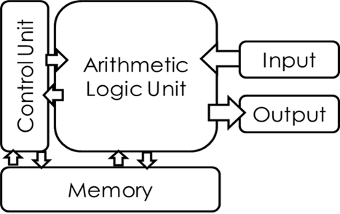
In the Von Neumann architecture, the data and instructions could be held together in memory and then fetched, decoded and executed one at a time. This meant that simple programs could be written containing both instructions and data and be executed by a computer without having to rewire the circuitry of the machine. It wasn’t long before computer scientists invented a simple coding language which would make programming software, accessible to the masses.

Assembly Language and the Von Neumann Architecture
All ‘Von Neumann’ CPUs have an instruction set. This means that it has a list of instructions that it understands and knows what to do with. Surprisingly, a CPU’s instruction set only consists of a few simple instructions.
Here is an example instruction set:
Instruction | Purpose
ADD | Add numbers together
SUB | Subtract numbers from each other
STA | Store value in the accumulator
LDA | Load value from the accumulator
BRA | Branch to a different part of the program (often used to repeat code)
OUT | Output a value (after processing)

A CPU is able to perform each of these instructions and it does so using some very important parts of the Von Neumann Architecture. These parts are called registers, which are simply tiny memory locations (memory stores). The important ones have special names. The following registers are used during each Fetch-Decode-Execute cycle in order to carry out each instruction:
The Accumulator (A)
The Program Counter (C)
The Memory Address Register (MAR)
The Instruction Register (IR)
The Memory Data Register (MDR)
Let’s take a look at how these registers carry out simple instructions in a typical F-D-E cycle.
An Example of the Von Neumann Architecture at work…
Below is an example of some instructions and data from a program which has just been loaded into the CPU ready for processing.
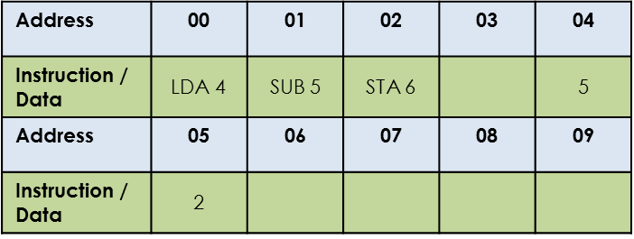
The loaded program in CPU Memory:
Memory locations 00-02 currently hold instructions and locations 04-05 hold the data that the instructions will work on.

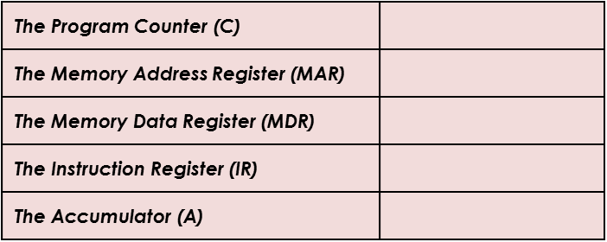
Specialised CPU Registers:
Before the CPU fetches the first instruction, these specialised registers (as discussed on the last slide) start off empty.

FETCH STAGE
In the first part of the cycle, the instructions and data are fetched from the CPU memory and loaded into the specialised registers:
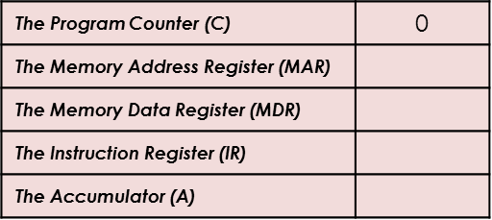
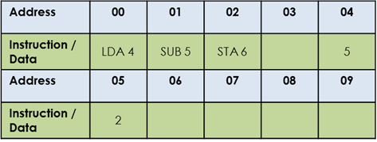
The program counter starts at 0 and its purpose is to keep track of the number of steps carried out.

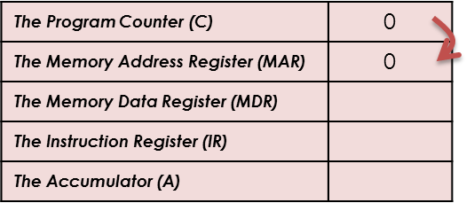
As it’s the first step, the counter value is copied to the MAR.
This represents the address of the first instruction to be fetched.

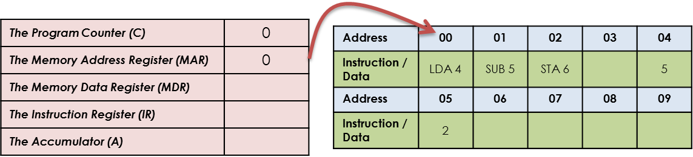
The program uses the value in the MAR to look up the appropriate instruction by looking in address 00.

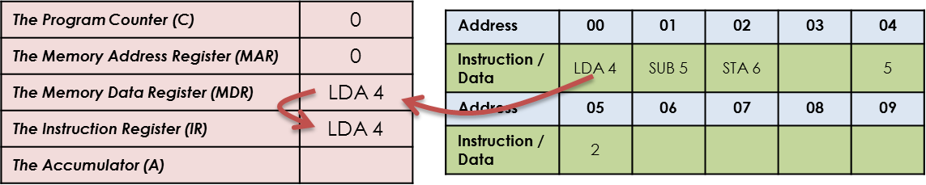

This instruction is then loaded into the MDR…

…and then moved to the IR, ready to be decoded by the CPU.

DECODE STAGE
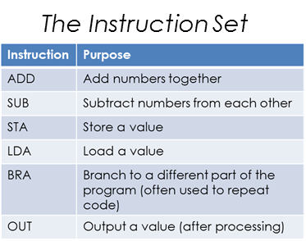
Now that the CPU has fetched the first instruction, it needs to decode it.
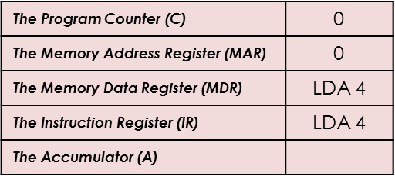
It does this by looking up the IR instruction in its character set.
It recognises LDA 4 as meaning LOAD the contents of address 04.

The CPU has now decoded the first instruction and is ready to execute it!

EXECUTE STAGE
Now that the CPU has made sense of the instruction, it now needs to execute the instruction.
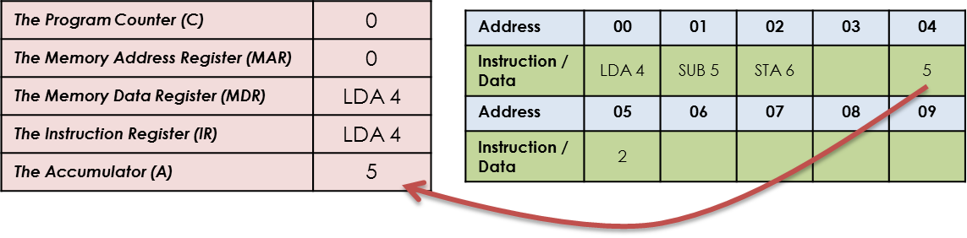
The instruction is execute and the value of address 04 is LOADED into the accumulator.

Because the first cycle has now been completed, the program counter is updated to 1, ready for the next cycle.
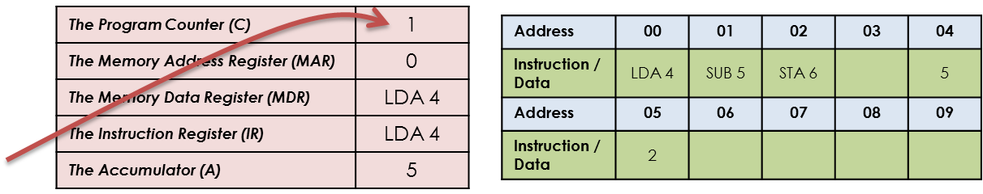

FETCH STAGE
Now the second cycle begins and the next instruction is fetched from memory.
The program counter is now at 1 and the value of 5 is in the accumulator.
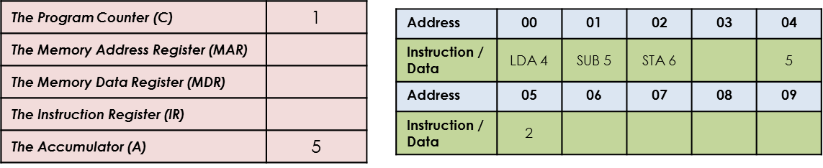

Like before, the counter value is copied to the MAR.
This represents the address of the next instruction to be fetched.
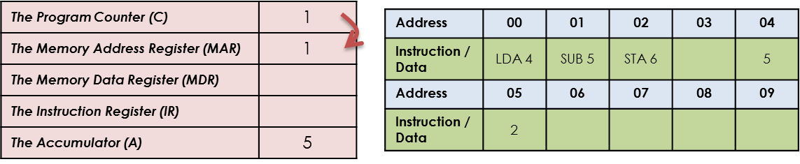

The program uses the value in the MAR to look up the appropriate instruction by looking in address 01.
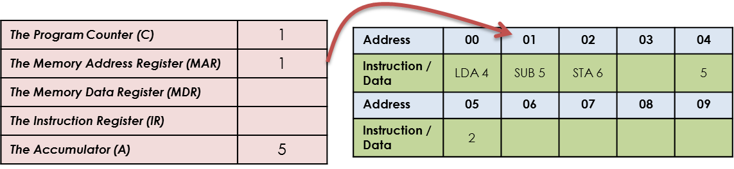

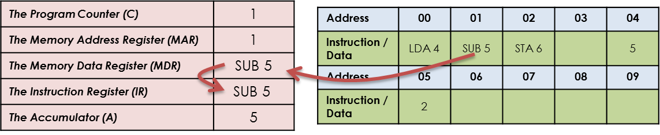
This instruction is then loaded into the MDR…

…and then moved to the IR, ready to be decoded by the CPU.

DECODE STAGE
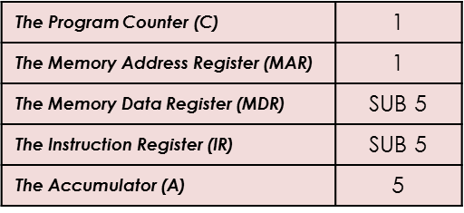
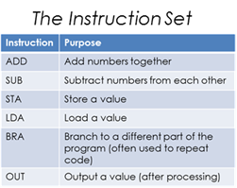
Now that the CPU has fetched the next instruction, it needs to decode it.
It does this by looking up the IR instruction in its character set.
It recognises SUB 5 as meaning SUBTRACT the contents of address 05 from the accumulator.

The CPU has now decoded the first instruction and is ready to execute it!

EXECUTE STAGE
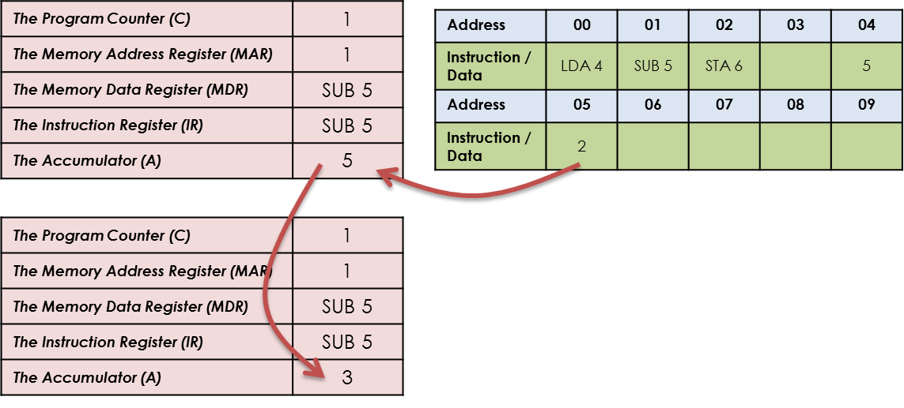
Now that the CPU has made sense of the instruction, it now needs to execute the instruction.
The instruction is execute and the value of address 05 is SUBTRACTED from the value in the accumulator.

The program has now been run and the result is 3.

Questions (The question zone you choose must either match your target grade or be higher!)
Question Zone 1-3
- State the assembly language instruction used to stores data in the accumulator. [1]
- Define the term ‘instruction set’. [2]
- Describe the role of each of the 5 main CPU registers. [5]
Question Zone 4-6
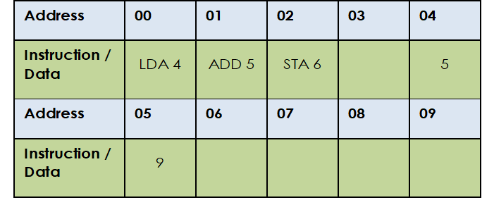
- Describe the role of each of the 5 main CPU registers. [5]
- Using the example program in the table provided, describe the purpose of the program making reference to the instructions and data given. [4]
- Explain the difference between the MAR and the MDR. [2]
Question Zone 7-9
- Explain the difference between the MAR and the MDR. [2]
- Using the example program in the table above, explain the process involved in fetching, decoding and executing the first instruction. Make sure that you reference the major registers in your answer. [5]
- Discuss the importance of Von Neumann in the development of computer technology. [5]

____________________________________________________________________________________________________________________________________________________________________________________________________________________________________________________________________________________________________________________________________________________________________________________________________________________________________________________________________________________________________________________________________________________________________________________________________________________________________________________________________________________________________________________________________________________________________________________________________________________________________________________________________________________________________________________________________________________________________________________________________________________________________________________________________________________________________________________________________________________________________________________________________________________________________________________________________________________________________________________________________________________________________________________________________________________________________________________________________________________________________________________________________________

Checklist:
 Date and title, clearly presented
 Spelling & grammar checked
 Question numbers in the margin
 Handwriting neat & legible
 Punctuation / Capital letters
Keywords / Key Terms:
Register: A small amount of fast storage in the CPU.
CPU Architecture: The design of the CPU (how it has been constructed).
Accumulator: A specialised CPU registered which stored the intermediate results of a F-D-E cycle.

____________________________________________________________________________________________________________________________________________________________________________________________________________________________________________________________________________________________________________________________________________________________________________________________________________________________________________________________________________________________________________________________________________________________________________________________________________________________________________________________________________________________________________________________________________________________________________________________________________________________________________________________________________________________________________________________________________________________________________________________________________________________________________________________________________________________________________________________________________________________________________________________________________________________________________________________________________________________________________________________________________________________________________________________________________________________________________________________________________________________________________________________________________

State/Identify/Give/Name: Simply label a diagram, fill out a table or write a few words
Describe: Describing is ‘saying what you see’ (E.G.: A computer will have a CPU, Primary and Secondary storage etc)
Explain: Explaining is ‘saying WHY/HOW something is like that’. (E.G.: A computer will have a CPU so that it can process all of the data the computer needs to perform a range of tasks. Primary and Secondary storage is needed because…)
Discuss: Discussing is ‘looking at two sides of an issue, weighing up the two views and giving a conclusion’. Often these require a mini essay answer. (E.G.: New technology could be seen as being bad for the environment because…, but on the other hand, new technology has led to… In conclusion I believe that…)
Describe/Explain/Discuss using examples: Finally, if you are asked to give examples in any of these types of questions – YOU MUST GIVE EXAMPLES!

Stick answer sheet here

/
%
On / Above / Below
Reflections:

Score:

Percentage:

Grade:

Progress:

What Went Well?:

 I demonstrated a good level of understanding.
 I responded to the command words effectively.
 My answers were detailed / were written in depth.
 My work was well presented / legible.
 My answers effectively incorporated technical terminology.
 My responses were well structured / organised.
 My revision strategy was effective as I showed depth of understanding in my answers.
 My answers contained enough points / examples / explanations to achieve the marks available.
Even Better If…:

 My answers need to be more accurate.
 I must respond correctly to the command words.
 My answers need more detail / greater depth.
 I must take greater care over my work / write neatly.
 I must incorporate key terminology into my answers.
 I must better organise my answers to improve its clarity.
 I need to improve my revision strategy as I did not demonstrate a depth of understanding in my answers.
 My answers didn’t contain enough points / examples / explanations to achieve the marks available.
________________________________________________________________________________________________________________________________________________________________________________________________________________________________________________________________________________________________________
Further thoughts:

Characteristics of the CPU
Introduction
There are a number of common characteristics of a CPU. For your exam, you need to understand what these characteristics are and how they affect the performance of a computer. The next few pages will introduce these characteristics and explain their importance.

Clock Speed
The speed of the Fetch-Decode-Execute cycle is determined by the CPU’s clock chip. This chip uses a vibrating crystal that maintains a constant rate. The speed of the clock is measured in hertz (Hz) which is the amount of cycles per second. A clock speed of 500Hz means 500 cycles per second. Current computers have CPU clock speeds of 3GHz which means 3 Billion cycles per second.
Overclocking
It is possible to increase the clock speed for a CPU. This is known as overclocking. In theory, if the clock is faster than the CPU can perform more calculations and perform faster.
The problem is that CPUs get hotter the more work they do – so overclocking is dangerous without the appropriate heat management.

The Cache
As we have just seen CPUs can work very quickly indeed but unfortunately CPUs can only work when supplied with data. The RAM (that supplies the data) cannot work at the same speed. To overcome this the CPU’s cache memory will not just copy the instruction needed at that time, instead it will also copy the continuing instructions. Cache memory has read speeds similar to the CPU and is therefore much faster than RAM.
So, to improve efficiency the CPU’s ‘Control Unit’ will look first in the cache for the next instruction to see if it has already been copied which reduces the time taken to access data. If the cache is larger, it is more likely that the next required instruction has already been transferred from the RAM to the CPU thus improving process time.
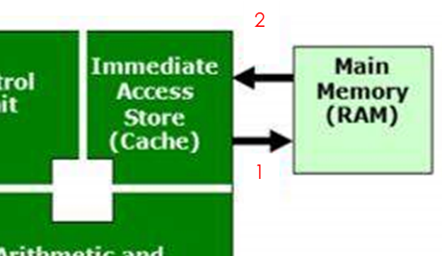
1. If the required data is not in the cache, the control unit will request it from RAM

2. Data/Instructions (and future instructions) copied to cache for quicker access

CPU Cores
CPUs of today are pretty much at the limit of today’s technology. So if CPUs can’t go faster, the solution its to add 2 CPU chips, or 4, or 8, etc). These chips are called ‘cores’. Because the various cores can each carry out their own Fetch – Decode – Execute cycle it means that instructions can be processed at the same time. Allowing a CPU to process MORE data during the same time period.
There are two ways in which a CPU with more than one core can process more instructions in the same time period:
- They can carry out Parallel Processing which is when the same program can have two instructions processed at the same time.
- More cores also enables Multi-Tasking where each core can each process two different programs’ instructions at the same time.
Either way, more cores means more instructions being processed at once. However, it doesn’t necessarily mean CPUs work faster as some programs do not allow more than one instruction to be processed at once, so be careful when answering exam questions on this!
Embedded Systems
For your exam, you will also need to understand what an embedded system is. When we think of a computer, you usually think of a PC and as many of you know, a PC is made up of various components including a motherboard, CPU, RAM, input devices etc. But of course a computer is any programmable machine…or any electronic device which takes in data, processes it and then outputs the result.
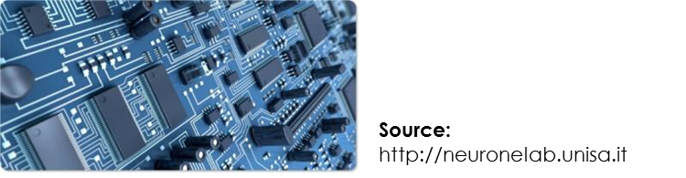
So when you consider devices like cameras and watches, as these are programmable machines, they can also be called computers. The main difference is that these computers run specific tasks – they are not general purpose. Because of this, they do not need to have separate components as these devices won’t need updating when new software / hardware is released. These systems instead have all of their components arranged together on a single circuit board.

As a result they are known as embedded systems as all of their hardware is embedded together as one.

Questions (The question zone you choose must either match your target grade or be higher!)
Question Zone 1-3
- State what is meant by the CPU’s clock speed and what is meant by the term overclocking. [3]
- Describe what is meant by the term ‘cores’, when it comes to CPU architecture. [2]
- Describe the role of cache in a computer system. [3]
Question Zone 4-6
- Describe the role of cache in a computer system. [3]
- Explain the effects that a higher clock speed will have on the performance of a CPU. [4]
- Explain the term ‘parallel processing’ in relation to CPU cores. [4]
Question Zone 7-9
- Explain, using examples, the term ‘parallel processing’ in relation to CPU cores. [4]
- Explain the need for cache memory and the reason why larger cache will improve performance. [5]
- Discuss the accuracy of the statement “A CPU with more cores will always outperform those with fewer”. [5]

____________________________________________________________________________________________________________________________________________________________________________________________________________________________________________________________________________________________________________________________________________________________________________________________________________________________________________________________________________________________________________________________________________________________________________________________________________________________________________________________________________________________________________________________________________________________________________________________________________________________________________________________________________________________________________________________________________________________________________________________________________________________________________________________________________________________________________________________________________________________________________________________________________________________________________________________________________________________________________________________________________________________________________________________________________________________________________________________________________________________________________________________________________

Checklist:
 Date and title, clearly presented
 Spelling & grammar checked
 Question numbers in the margin
 Handwriting neat & legible
 Punctuation / Capital letters
Keywords / Key Terms:
Cache: A relatively small amount of memory located next to the CPU, used to supply the CPU with regularly required instructions / data at speed.
Clock Speed: The amount of F-D-E cycles that can be performed per second.
CPU Cores: An independent processing unit that is able to fetch, decode and execute instructions.

____________________________________________________________________________________________________________________________________________________________________________________________________________________________________________________________________________________________________________________________________________________________________________________________________________________________________________________________________________________________________________________________________________________________________________________________________________________________________________________________________________________________________________________________________________________________________________________________________________________________________________________________________________________________________________________________________________________________________________________________________________________________________________________________________________________________________________________________________________________________________________________________________________________________________________________________________________________________________________________________________________________________________________________________________________________________________________________________________________________________________________________________________________

State/Identify/Give/Name: Simply label a diagram, fill out a table or write a few words
Describe: Describing is ‘saying what you see’ (E.G.: A computer will have a CPU, Primary and Secondary storage etc)
Explain: Explaining is ‘saying WHY/HOW something is like that’. (E.G.: A computer will have a CPU so that it can process all of the data the computer needs to perform a range of tasks. Primary and Secondary storage is needed because…)
Discuss: Discussing is ‘looking at two sides of an issue, weighing up the two views and giving a conclusion’. Often these require a mini essay answer. (E.G.: New technology could be seen as being bad for the environment because…, but on the other hand, new technology has led to… In conclusion I believe that…)
Describe/Explain/Discuss using examples: Finally, if you are asked to give examples in any of these types of questions – YOU MUST GIVE EXAMPLES!

Stick answer sheet here

/
%
On / Above / Below
Reflections:

Score:

Percentage:

Grade:

Progress:

What Went Well?:

 I demonstrated a good level of understanding.
 I responded to the command words effectively.
 My answers were detailed / were written in depth.
 My work was well presented / legible.
 My answers effectively incorporated technical terminology.
 My responses were well structured / organised.
 My revision strategy was effective as I showed depth of understanding in my answers.
 My answers contained enough points / examples / explanations to achieve the marks available.
Even Better If…:

 My answers need to be more accurate.
 I must respond correctly to the command words.
 My answers need more detail / greater depth.
 I must take greater care over my work / write neatly.
 I must incorporate key terminology into my answers.
 I must better organise my answers to improve its clarity.
 I need to improve my revision strategy as I did not demonstrate a depth of understanding in my answers.
 My answers didn’t contain enough points / examples / explanations to achieve the marks available.
________________________________________________________________________________________________________________________________________________________________________________________________________________________________________________________________________________________________________
Further thoughts:

Memory
Introduction
Memory is where binary data (0s and 1s) is stored. There are several devices in a modern computer which store data. They store this data in different ways and for different purposes. We shall now take a look at each type of memory device:
- RAM
- ROM
- Virtual Memory
RAM Random Access Memory – AKA Main Memory
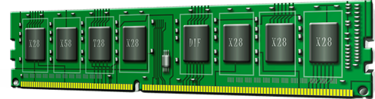
RAM is needed to store programs that are currently being used. They help to enable ‘multi-tasking’, which means having several programs open and using them all at the same time. It does this by copying the data needed by programs at that time so that it can be passed to the CPU when it needs to process that data. It also stores all the instructions/modules from the open programs that the CPU will require for processing.
RAM stores data as small charges of electricity in tiny transistors etched into a circuit in the device. The charge needs to be refreshed every few milliseconds otherwise the charge leaks away. RAM is therefore volatile memory – it loses data when there is no power.
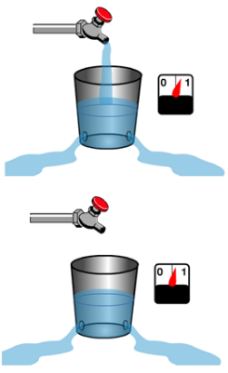
When programs are opened by the user, they are loaded from the hard disk onto the RAM. This is so that the CPU can access the data and instructions at an acceptable rate. If the CPU reads the program instructions and data from a hard disk, the data access would be extremely slow – this is why RAM is so important.
How does RAM store data?
Ram holds data using capacitors and transistors. A capacitor can be thought of as a sink or bucket holding water. When it is full it’s holding a ‘bit’ of data (1), when it is empty it represents a zero (0). But obviously in RAM it holds an electrical current (not water). The transistor acts as a switch that lets the computer read the what is in the capacitor (bucket) or fill it up or empty it (change its state).
Image Source: http://www.howstuffworks.com/ram.htm
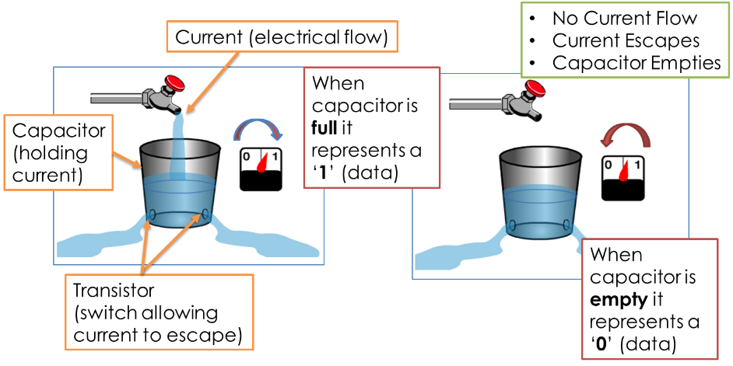
How Capacitors and Transistors Work – a brief overview!

Types of RAM
Dynamic RAM
1 transistor and 1 capacitor for each bit – hold a small charge for a few milliseconds then needs to be refreshed. Because it needs refreshing, there is a limit as to how fast data can be read on this type of RAM. Power is always needed.
Static RAM
4-5 transistors wired together for each bit of data, but it does not lose its charge No need to refresh every few milliseconds – therefore much faster as they don’t need refreshing. Does still need constant electricity supply. Faster but more expensive!

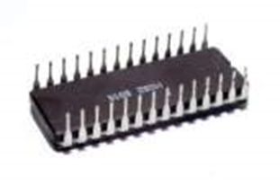
ROM - Read Only Memory
When you switch off your computer the data that the CPU can access (i.e. the RAM) loses its data. This is a problem because, when you restart your computer, data must be in the RAM for the computer to work. This is where ROM comes in.
ROM is a special memory chip that can store data even without power – it is non-volatile. It is used by a computer to store the boot sequence instructions – everything the computer needs to boot (start-up) and load the operating system. When you switch on your computer, data in the ROM is accessed by the CPU in order to start the computer and load the operating system successfully. The data on ROM cannot easily be over written by the user.
Like the RAM it is classed as Primary Storage (memory that is directly accessed by the CPU) & has fast data access rates. Modern ROM chips are now made of flash memory. This is a suitable type of storage technology because it doesn’t need constant power supply to hold data.
How Flash Memory Works
Flash memory works by sending a large electric current to force electrons through a barrier and trapping them in position.
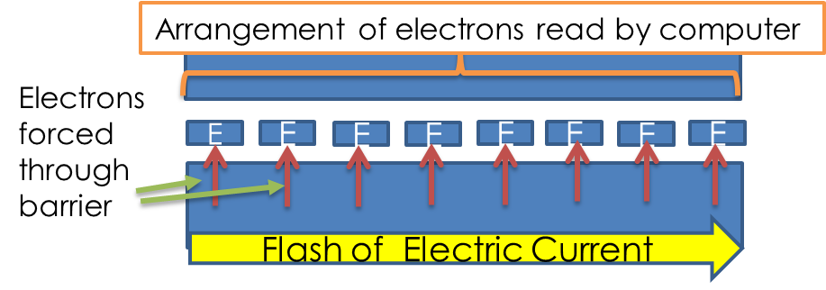

The flash of the electric current used to achieve this gives us the name for this type of memory. The different arrangement of electrons gives us data.

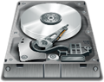
Virtual Memory
If you are browsing the internet and listening to music, the RAM should cope fine. If you then decide to play a game with good graphics then this may overload the RAM as too many programs (and their data) will need to be loaded onto the RAM. So that the system doesn’t grind to a halt and freeze up, the computer will relocate programs that have not been recently used to secondary storage (e.g.: the hard disk). This process will take time as hard-disk data speeds are much slower – but when it is done the system should be nice and fast again. Often the operating system will use the hard disk as virtual memory. A lot of programs need to be loaded as part of the operating system but many can sit on the hard-disk as they are used infrequently.
How the amount of RAM affects performance
So as we’ve just seen, RAM is needed to supply to the CPU with data and instructions from programs currently in use and when it gets full, the system runs slower as a result of the need to use virtual memory. Therefore the following is true:
- Smaller amounts of RAM – limited multi-tasking and greater need to use slower virtual memory
- Larger amounts of RAM – greater storage of programs / data leading to faster performance and effective multi-tasking.
Cache Memory
We have already seen cache memory when studying the workings of the CPU. We will now look at it in a little more detail.
As we have seen before, RAM will hold a copy of data and instructions (program) that are currently being used by the user. And unfortunately, as the CPU processes data faster than the RAM can supply it with data, system performance can suffer. This is where cache comes in…
Cache is simply a few Mb of memory that sits inside the CPU. Being located in the CPU means that data access speed is equal to the CPU’s speed. CPU performance is therefore maintained. Well written programs will make sure that ‘sets’ of regularly used instructions are copied to the cache so that the program can run more efficiently and much faster. Poorly written programs will tend to need to fetch the instructions they require from the RAM one at a time and so, as access to the RAM is slow, the program performs less efficiently.

Questions (The question zone you choose must either match your target grade or be higher!)
Question Zone 1-3
- State the difference between ‘volatile’ and ‘non-volatile’ memory. [2]
- Describe the purpose of RAM and ROM. [2]
- What is virtual memory and why is it important. [3]
Question Zone 4-6
- What is virtual memory and why is it important. [3]
- Explain the effects of the amount of RAM a computer has on its performance. [4]
- Explain, using a diagram, how flash memory technology works. [4]
Question Zone 7-9
- Explain, using a diagram, how flash memory technology works. [4]
- Explain, using a diagram, how RAM memory technology works. [5]
- Discuss the relative importance of ROM, RAM and Virtual Memory in a computer system. [5]

____________________________________________________________________________________________________________________________________________________________________________________________________________________________________________________________________________________________________________________________________________________________________________________________________________________________________________________________________________________________________________________________________________________________________________________________________________________________________________________________________________________________________________________________________________________________________________________________________________________________________________________________________________________________________________________________________________________________________________________________________________________________________________________________________________________________________________________________________________________________________________________________________________________________________________________________________________________________________________________________________________________________________________________________________________________________________________________________________________________________________________________________________________
Stick answer sheet here
________________________________________________________________________________________________________________________________________________________________________________________________________________________________________________________________________________________________________
____________________________________________________________________________________________________________________________________________________________________________________________________________________________________________________________________________________________________________________________________________________________________________________________________________________________________________________________________________________________________________________________________________________________________________________________________________________________________________________________________________________________________________________________________________________________________________________________________________________________________________________________________________________________________________________________________________________________________________________________________________________________________________________________________________________________________________________________________________________________________________________________________________________________________________________________________________________________________________________________________________________________________________________________________________________________________________________________________________________________________________________________________________
State/Identify/Give/Name: Simply label a diagram, fill out a table or write a few words
Describe: Describing is ‘saying what you see’ (E.G.: A computer will have a CPU, Primary and Secondary storage etc)
Explain: Explaining is ‘saying WHY/HOW something is like that’. (E.G.: A computer will have a CPU so that it can process all of the data the computer needs to perform a range of tasks. Primary and Secondary storage is needed because…)
Discuss: Discussing is ‘looking at two sides of an issue, weighing up the two views and giving a conclusion’. Often these require a mini essay answer. (E.G.: New technology could be seen as being bad for the environment because…, but on the other hand, new technology has led to… In conclusion I believe that…)
Describe/Explain/Discuss using examples: Finally, if you are asked to give examples in any of these types of questions – YOU MUST GIVE EXAMPLES!
/
%
On / Above / Below
Reflections:

What Went Well?:

Even Better If…:

Further thoughts:

 I demonstrated a good level of understanding.
 I responded to the command words effectively.
 My answers were detailed / were written in depth.
 My work was well presented / legible.
 My answers effectively incorporated technical terminology.
Score:

Percentage:

Grade:

Progress:

 My answers need to be more accurate.
 I must respond correctly to the command words.
 My answers need more detail / greater depth.
 I must take greater care over my work / write neatly.
 I must incorporate key terminology into my answers.
 I must better organise my answers to improve its clarity
 I need to improve my revision strategy as I did not demonstrated a depth of understanding in my answers.
 My answers didn’t contain enough points / examples / explanations to achieve the marks available.
 My responses were well structured / organised.
 My revision strategy was effective as I showed depth of understanding in my answers.
 My answers contained enough points / examples / explanations to achieve the marks available.

Checklist:
 Date and title, clearly presented
 Spelling & grammar checked
 Question numbers in the margin
 Handwriting neat & legible
 Punctuation / Capital letters
Keywords / Key Terms:
RAM: Random Access Memory – It is where programs are loaded when the user opens them. It is a volatile memory device.
ROM: Read Only Memory – It is a non-volatile memory device, which stores the boot up scripts.
Virtual Memory: When the RAM is full a proportion of secondary storage (often the hard disk) is used as an overflow allowing programs to continue to function, albeit slower.

____________________________________________________________________________________________________________________________________________________________________________________________________________________________________________________________________________________________________________________________________________________________________________________________________________________________________________________________________________________________________________________________________________________________________________________________________________________________________________________________________________________________________________________________________________________________________________________________________________________________________________________________________________________________________________________________________________________________________________________________________________________________________________________________________________________________________________________________________________________________________________________________________________________________________________________________________________________________________________________________________________________________________________________________________________________________________________________________________________________________________________________________________________

State/Identify/Give/Name: Simply label a diagram, fill out a table or write a few words
Describe: Describing is ‘saying what you see’ (E.G.: A computer will have a CPU, Primary and Secondary storage etc)
Explain: Explaining is ‘saying WHY/HOW something is like that’. (E.G.: A computer will have a CPU so that it can process all of the data the computer needs to perform a range of tasks. Primary and Secondary storage is needed because…)
Discuss: Discussing is ‘looking at two sides of an issue, weighing up the two views and giving a conclusion’. Often these require a mini essay answer. (E.G.: New technology could be seen as being bad for the environment because…, but on the other hand, new technology has led to… In conclusion I believe that…)
Describe/Explain/Discuss using examples: Finally, if you are asked to give examples in any of these types of questions – YOU MUST GIVE EXAMPLES!

Stick answer sheet here

/
%
On / Above / Below
Reflections:

Score:

Percentage:

Grade:

Progress:

What Went Well?:

 I demonstrated a good level of understanding.
 I responded to the command words effectively.
 My answers were detailed / were written in depth.
 My work was well presented / legible.
 My answers effectively incorporated technical terminology.
 My responses were well structured / organised.
 My revision strategy was effective as I showed depth of understanding in my answers.
 My answers contained enough points / examples / explanations to achieve the marks available.
Even Better If…:

 My answers need to be more accurate.
 I must respond correctly to the command words.
 My answers need more detail / greater depth.
 I must take greater care over my work / write neatly.
 I must incorporate key terminology into my answers.
 I must better organise my answers to improve its clarity.
 I need to improve my revision strategy as I did not demonstrate a depth of understanding in my answers.
 My answers didn’t contain enough points / examples / explanations to achieve the marks available.
________________________________________________________________________________________________________________________________________________________________________________________________________________________________________________________________________________________________________
Further thoughts:

Storage
Introduction
In everyday computer use, we need a way to write data, rewrite data, store data when the computer is switched off and retrieve data the next time we switch our computer back on. We have already looked at system/primary memory:
- RAM allows us to write data and store it…but the data is lost when it is switched off (volatile).
- ROM allows us to store data when it has no power (non-volatile)…but we cannot write to it.
We therefore need another device/medium by which we can re-write data when we want AND store the data when the computer has no power. This is where SECONDARY STORAGE comes in!
Storage Technologies:
Magnetic storage
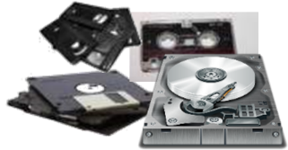
Magnetic storage uses different patterns of magnetisation in a magnetisable material to store data (tape/hard disk). Magnetised points on a pattern represents ‘1’ and demagnetised points represent ‘0’
Optical storage
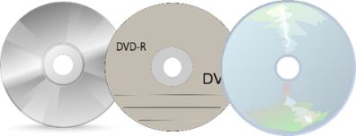
Optical storage consists of ‘marks’ arranged in patterns. When writing to optical media the laser burns ‘pits’ into the shiny surface (land). When reading optical media a light (laser) is shined on its surface. When it hits land the beam reflects (0) but when it hits the pits, it doesn’t (1).
Solid State Storage (Flash)
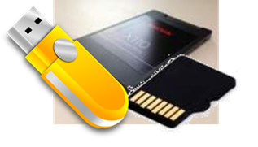
They work by sending a large electric current to force electrons through a barrier and trapping them in position. The flash of the electric current used to achieve this gives us the name for this type of memory. The different arrangement of electrons gives us data.
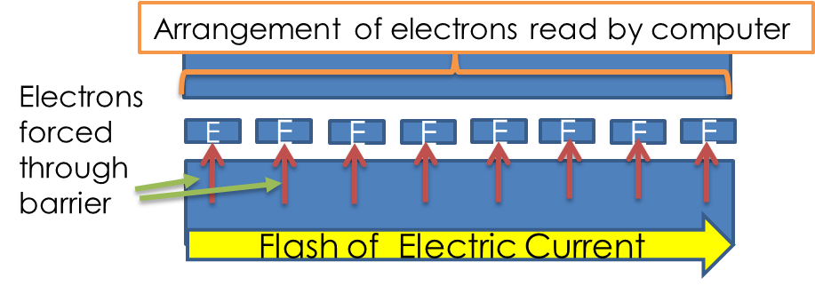

Magnetic Storage Performance
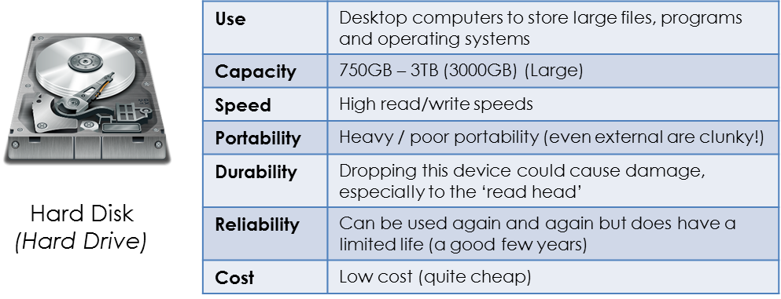

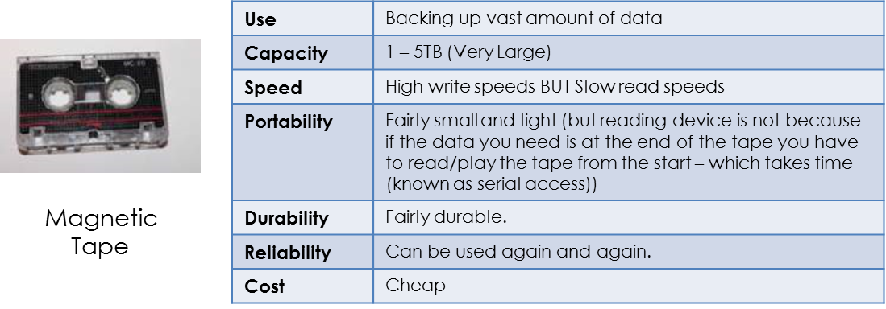

Optical Storage
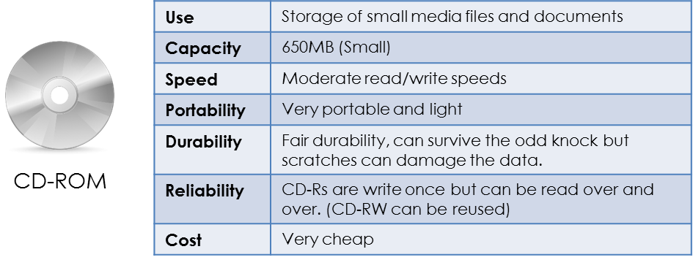

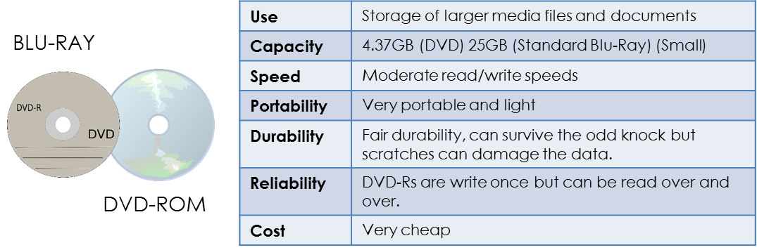

Solid State / Flash Storage
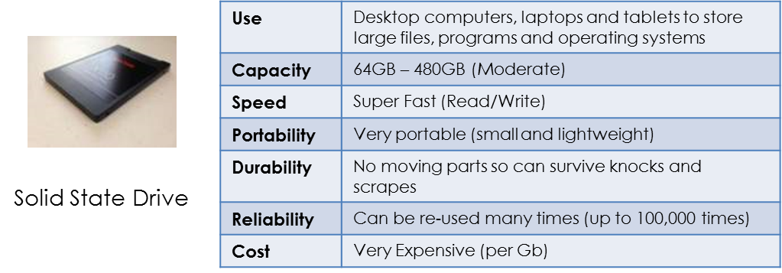

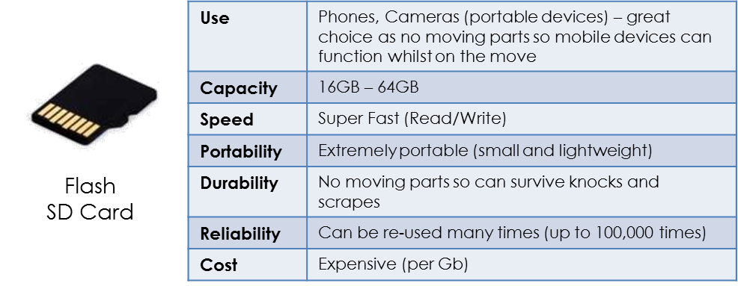

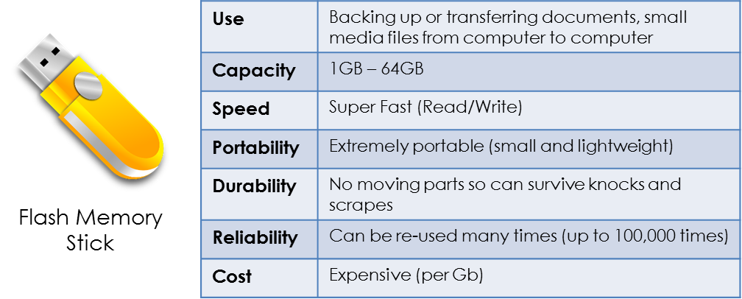

Network Attached Storage (NAS)
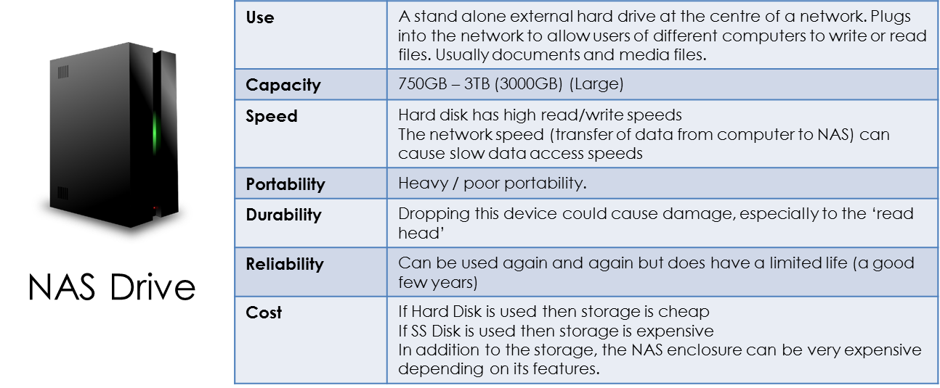

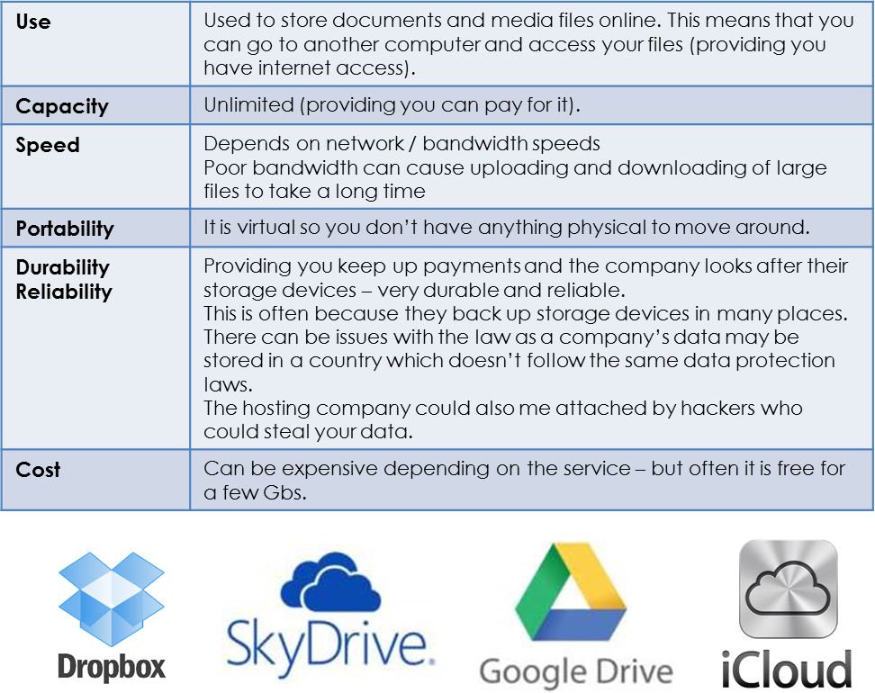
Cloud Storage (online storage)

Questions (The question zone you choose must either match your target grade or be higher!)
Question Zone 1-3
- State the 3 different storage technologies. [3]
- Describe how optical storage devices store data. [3]
- What is the need for secondary storage if a computer system already has primary memory (RAM/ROM)? [3]
Question Zone 4-6
- What is the need for secondary storage if a computer system already has primary memory (RAM/ROM)? [3]
- Which secondary storage technology would be most appropriate for a mobile phone? Explain your answer. [4]
- Magnetic tape storage can store large capacities but there is a major drawback when it comes to reading data from this technology. Explain the drawback. [3]
Question Zone 7-9
- Magnetic tape storage can store large capacities but there is a major drawback when it comes to reading data from this technology. Explain the drawback. [3]
- Explain which storage device is best suited to storing an operating system. [5]
- Discuss the relative advantages and disadvantages of the 3 main storage technologies (optical, magnetic (hard disks), solid state). [5]

____________________________________________________________________________________________________________________________________________________________________________________________________________________________________________________________________________________________________________________________________________________________________________________________________________________________________________________________________________________________________________________________________________________________________________________________________________________________________________________________________________________________________________________________________________________________________________________________________________________________________________________________________________________________________________________________________________________________________________________________________________________________________________________________________________________________________________________________________________________________________________________________________________________________________________________________________________________________________________________________________________________________________________________________________________________________________________________________________________________________________________________________________________
Stick answer sheet here
________________________________________________________________________________________________________________________________________________________________________________________________________________________________________________________________________________________________________
____________________________________________________________________________________________________________________________________________________________________________________________________________________________________________________________________________________________________________________________________________________________________________________________________________________________________________________________________________________________________________________________________________________________________________________________________________________________________________________________________________________________________________________________________________________________________________________________________________________________________________________________________________________________________________________________________________________________________________________________________________________________________________________________________________________________________________________________________________________________________________________________________________________________________________________________________________________________________________________________________________________________________________________________________________________________________________________________________________________________________________________________________________
State/Identify/Give/Name: Simply label a diagram, fill out a table or write a few words
Describe: Describing is ‘saying what you see’ (E.G.: A computer will have a CPU, Primary and Secondary storage etc)
Explain: Explaining is ‘saying WHY/HOW something is like that’. (E.G.: A computer will have a CPU so that it can process all of the data the computer needs to perform a range of tasks. Primary and Secondary storage is needed because…)
Discuss: Discussing is ‘looking at two sides of an issue, weighing up the two views and giving a conclusion’. Often these require a mini essay answer. (E.G.: New technology could be seen as being bad for the environment because…, but on the other hand, new technology has led to… In conclusion I believe that…)
Describe/Explain/Discuss using examples: Finally, if you are asked to give examples in any of these types of questions – YOU MUST GIVE EXAMPLES!
/
%
On / Above / Below
Reflections:

What Went Well?:

Even Better If…:

Further thoughts:

 I demonstrated a good level of understanding.
 I responded to the command words effectively.
 My answers were detailed / were written in depth.
 My work was well presented / legible.
 My answers effectively incorporated technical terminology.
Score:

Percentage:

Grade:

Progress:

 My answers need to be more accurate.
 I must respond correctly to the command words.
 My answers need more detail / greater depth.
 I must take greater care over my work / write neatly.
 I must incorporate key terminology into my answers.
 I must better organise my answers to improve its clarity
 I need to improve my revision strategy as I did not demonstrated a depth of understanding in my answers.
 My answers didn’t contain enough points / examples / explanations to achieve the marks available.
 My responses were well structured / organised.
 My revision strategy was effective as I showed depth of understanding in my answers.
 My answers contained enough points / examples / explanations to achieve the marks available.

Checklist:
 Date and title, clearly presented
 Spelling & grammar checked
 Question numbers in the margin
 Handwriting neat & legible
 Punctuation / Capital letters
Keywords / Key Terms:
Magnetic Storage Technology: Using materials with magnetic properties (ability to change polarity (north/south)) to store data (0/1).
Optical Storage Technology: Using reflective material to store data by burning ‘pits’ and leaving ‘land’. Data is read by shining a laser and seeing which elements reflect (0) and which do not (1).
Solid State Storage Technology: Using circuitry, which traps electrons into specific orders in order to store data.

____________________________________________________________________________________________________________________________________________________________________________________________________________________________________________________________________________________________________________________________________________________________________________________________________________________________________________________________________________________________________________________________________________________________________________________________________________________________________________________________________________________________________________________________________________________________________________________________________________________________________________________________________________________________________________________________________________________________________________________________________________________________________________________________________________________________________________________________________________________________________________________________________________________________________________________________________________________________________________________________________________________________________________________________________________________________________________________________________________________________________________________________________________

State/Identify/Give/Name: Simply label a diagram, fill out a table or write a few words
Describe: Describing is ‘saying what you see’ (E.G.: A computer will have a CPU, Primary and Secondary storage etc)
Explain: Explaining is ‘saying WHY/HOW something is like that’. (E.G.: A computer will have a CPU so that it can process all of the data the computer needs to perform a range of tasks. Primary and Secondary storage is needed because…)
Discuss: Discussing is ‘looking at two sides of an issue, weighing up the two views and giving a conclusion’. Often these require a mini essay answer. (E.G.: New technology could be seen as being bad for the environment because…, but on the other hand, new technology has led to… In conclusion I believe that…)
Describe/Explain/Discuss using examples: Finally, if you are asked to give examples in any of these types of questions – YOU MUST GIVE EXAMPLES!

Stick answer sheet here

/
%
On / Above / Below
Reflections:

Score:

Percentage:

Grade:

Progress:

What Went Well?:

 I demonstrated a good level of understanding.
 I responded to the command words effectively.
 My answers were detailed / were written in depth.
 My work was well presented / legible.
 My answers effectively incorporated technical terminology.
 My responses were well structured / organised.
 My revision strategy was effective as I showed depth of understanding in my answers.
 My answers contained enough points / examples / explanations to achieve the marks available.
Even Better If…:

 My answers need to be more accurate.
 I must respond correctly to the command words.
 My answers need more detail / greater depth.
 I must take greater care over my work / write neatly.
 I must incorporate key terminology into my answers.
 I must better organise my answers to improve its clarity.
 I need to improve my revision strategy as I did not demonstrate a depth of understanding in my answers.
 My answers didn’t contain enough points / examples / explanations to achieve the marks available.
________________________________________________________________________________________________________________________________________________________________________________________________________________________________________________________________________________________________________
Further thoughts:

