Information page for Year 11:
Below you will find information about your post 16 options, what work you should be doing, exam grades and a few points to keep you motivated.
We will update this page as we have more information.
If you are feeling a little rubbish and annoyed about the current situation and how it has affected your final year at Secondary school, please have a read of the letter below. Learning is so much more than just exams and the letter below hopefully will prove to you that in the end everything will sort itself out.

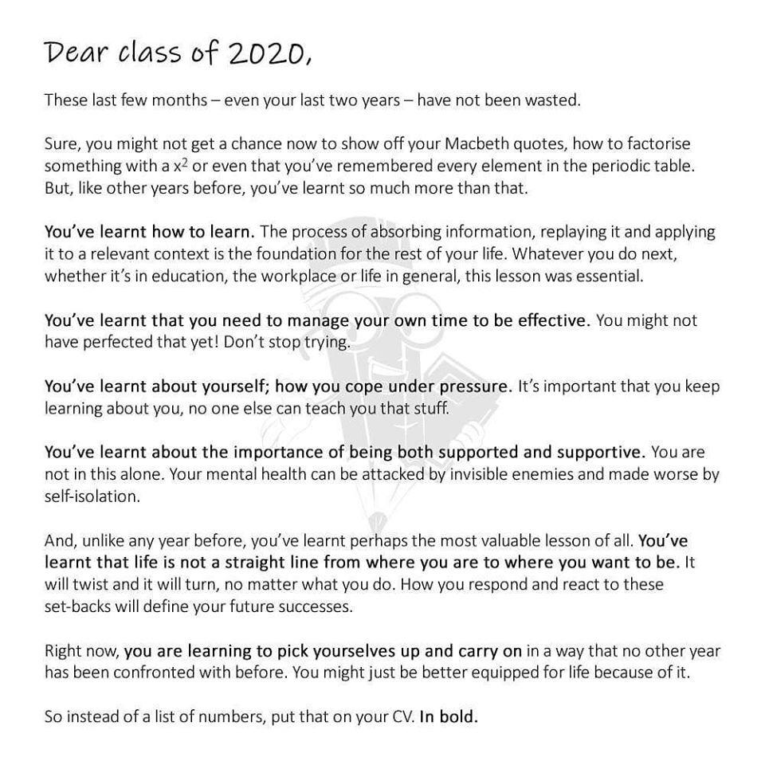

Post 16
https://www.ebpsouth.co.uk/career-support-through-coronavirus
This link has information about Post16 options and will explain what to do in terms of college places, interviews as well as apprenticeships.
It will answer many questions as well about things like getting a job, looking after your mental health, and developing your CV.
Exam grades:
We will update this section as we receive more information.
Here are the latest links which may answer some of your questions.
https://www.gov.uk/government/publications/coronavirus-covid-19-cancellation-of-gcses-as-and-a-levels-in-2020/coronavirus-covid-19-cancellation-of-gcses-as-and-a-levels-in-2020

Revision:
We would suggest any pupils who were on the borderline of achieving a grade 4 should continue revising Maths and English. That way if you don't get the grade 4 and you need to retake the exam at college you will be in a much better position.
There are lots of question packs and links to websites which could be used on the school website: https://www.mayfield.portsmouth.sch.uk/about-us/emergency-closure (look under year 11)
If you need any further help please email Mrs Head and she will do her best to find out for you. head@mayfield.portsmouth.sch.uk

As well as English and Maths revision it is important that you keep learning. You want to ensure you are in the best possible position to access your chosen Post 16 pathway.
It would be a good idea to focus on subjects you will need in college. Perhaps also contact your college and ask their advice – they will be only too happy to support you.
As a minimum keep revising your GCSE subjects. You will already have revision checklists for all your subjects which you can use. Past papers are great to check your progress in your subjects.
On the school website there are lot of resources to support your revision.
https://www.mayfield.portsmouth.sch.uk/about-us/emergency-closure (look under year 11)

- CGP have a selection of getting ready for A level books for Maths, Physics, Biology, Chemistry and Psychology. If you look on Amazon, they are available free on kindle.
https://www.cgpbooks.co.uk/secondary-books/as-and-a-level/essential-maths-skills-head-start-to-a-level

