Dear Parent/Carer,

Although the school is currently closed due to Coronavirus, we are continuing to provide educational tasks for your children to complete.

In year 10, we suggest that children try to complete;
- 1.5 hours per week of English, Maths and Science (ie 4.5 hours a week in total)
- 1.5 hours per week of their 3 option subjects (ie 4.5 hours a week in total)
- 30 minutes of PE per day
- 30 minutes of reading per day

Home learning tasks can be supplemented with work from a number of websites (see the school home learning page on the website for examples of these).

Teachers will set a weekly programme for your child to work through at home. This will be available for you to access on the school website every Monday. Please note that to access the work on a mobile or laptop you may need to install Word (available here for Android and here for Apple) and Powerpoint (available here for Android and here for Apple). If accessing the work on a laptop then pupils should be able to use Office 365 through their web browser and won't need to install any extra programs. If you have any problems accessing the work then please email Mr Gibson (gibsonr@mayfield.portsmouth.sch.uk).

Whilst it is important for your child to keep up with their learning at home, we appreciate that this can be a stressful time for children and adults. Looking after mental health is vital. Therefore, we suggest that the day is broken up into manageable learning chunks, interspersed with physical exercise, fun activities and time together as a family. Activities such as the 30 day lego challenge and the daily Joe Wicks PE lessons could be a good place to start.

As well as educational learning, the children could also begin to learn different life skills – make a meal for the family, sew on a button, write a letter to a distant family member, bake a cake using a recipe book etc.

We hope you are all keeping well and staying positive.

Core subject work for all pupils

English
Year 10s should work on your knowledge, understanding and development of your poetry analysis skills as part of the GCSE Literature course. The lessons found here are based on each of the 15 poems from the Power and Conflict Poetry Anthology. You can add notes to your anthologies/make notes separately and work through the tasks on paper. Every student should aim to work on 1 of these per week. Pick the less familiar poems first - be resilient!
As well as this, you will apply your understanding of poetic techniques to the Unseen Poetry task set here. There is an unseen poetry question on GCSE Literature Paper 2. Remember to TWIST!
In addition, we want you to work on your spelling! You can find the fourth week’s spellings here. Remember, use your strategies: look, cover, write and check. Also, if any of the words are unfamiliar, look them up using a dictionary or online.
Also, in preparation for your GCSEs, we’d like you to look at reading comprehension. Attempt a minimum of ONE task a day from the modern texts booklet you can find here. For our more able, or those hoping to exceed a Grade 5 at GCSE, have a go at a more challenging text from here as well. Time yourself, have only 10-15 minutes to read before trying the questions. You will have unseen texts on GCSE English Language Papers 1 and 2.
Finally, have a look at the PiXL Lit App: https://englishapp.pixl.org.uk/ you can log-on using the same information as Maths (see below). Try to revise the characters, narrative, themes and quotations for the texts you have read: An Inspector Calls, A Christmas Carol and Romeo and Juliet.
You could also always read a book!

Maths
First task - 1 Hour PIXL Maths APP (https://mathsapp.pixl.org.uk/PMA2.html)
Make sure that you click ‘allow Adobe’
PIXL Login
School ID - MF2916
User ID - Usual school login (16SbloggsJ)
Password - PASSWORD
Your teacher has set the relevant tasks. Once logged on:
1. Click "Select task"
2. Click "Homework Task" - This brings up the most recent HW set by your teachers.
3. Complete the questions set. If you need support click on "Video" or "Power Point".
If you click "Previous HW task" - brings up previous task questions
If you click "Homework Results" you can see your marks for each of your homeworks you have completed.
If you cannot access PIXL please email Mr Ralph on the following ralphs@mayfield.portsmouth.sch.uk with your: Name, Year, School Username, and Maths Class and he will help you.
Second task - 30 mins on Maths box https://www.mathsbox.org.uk/1304.html
Scroll to the bottom on the page and Select W/B 13th April 2020
Set 1 - Answer and mark the Higher A questions.
Set 2 - Answer and mark the Higher B questions
Set 3&4 - Answer and mark the Foundation A questions/ If you get lots incorrect try the Foundation B questions. If you still get lots correct try the Foundation AA questions

Science
Please write any answers on paper, you do not need to print out any sheets (although feel free if you want to).
The suns out and there are lots of flowers in bloom but how do these plants get their energy to grow? This week you are going to be looking at Photosynthesis (B4 Bioenergetics), and how it supports all living things on this planet. Click on this link -> Photosynthesis to access and complete the task sheet

Please make sure you give yourself enough time to review your work from last week, check the answers you put down against the mark scheme found here, and correcting any mistakes in a different colour pen.

Extension

If you have any questions, or would like to send some examples of your work to us please email them to Mr Hoad – Hoad-James@mayfield.portsmouth.sch.uk.

PE
The key benefits of doing PE are enjoyment, challenge and improved mental health. Therefore, we suggest that you should undertake 30 minutes of physical activity every day. This could include jogging, cycling, or some form of indoor exercise (for example Joe Wicks daily PE activity on YouTube) with other people in your household.
You could also create a training log to record how your fitness progresses. Things you could record are:
- Distances and times achieved
- Heart rates
- How does your body feel?
- Plan for future sessions

PSHE
Over the last couple of weeks, you have been continuing to develop your thoughts on careers and the future and have started to think about your post-16 options. This week, you will continue with this careers focus, by considering the changing careers world.
- Make a list of 5 jobs that you can think of, which did not exist 20 years ago. You may like to talk to a parent, carer or grandparent for help. Remember to stay safe – only speak to people that you know and can trust, and stick to the government guidance on social distancing – e.g. If you’re speaking to a grandparent who you do not live with, this could be done over the phone.
- Why do you think careers are always changing?
- Read the Guardian article, Reality check: life behind Insta-glam image of ‘influencers’ which can be found here and consider:
  - Do you think that young people are influenced too much by social media vloggers in terms of their career goals?
  - Why do you think it is always important to have a ‘plan B’ when it comes to careers?

Option Subject Based Work
(only to be completed by pupils who study these subjects)

Art
Create an double observational drawing page. For this week you will need to fill a whole A3 page drawing anything you can find to draw in front of you that links to in the kitchen. You can choose the media you would prefer to use, however remember to show a range of tone (not making your work too dark). Use this first page to show off your skills and create a large observational drawing/ outcome.

Business Studies
A full guide is available in the Student SharePoint, select “WFH Year 10”.
Your main task is to complete the weekly deadlines seen on the document above, this is on Seneca Learning. I will be able to track your progress. If you’re in class 10A click here, if you are in class 10C click here. You will need to create an account, please use your school email.
Additional tasks, including a movie/documentary list will also be found in the SharePoint section linked above. However, remember those are optional, additional materials and not a replacement to the Seneca learning tasks.
Please do read through the document first, but any questions feel free to email me on batchelort@mayfield.portsmouth.sch.uk.
Stay safe. I look forward to seeing your progress on Seneca Learning.

Computing
During your computing time this week we would like you to work on your programming skills. If you are a confident programmer then you can do any of the following tasks:
- Carry on working through the homework tasks you have been using all year (click here)
- Start work on these advanced challenges (this is a new booklet many of you won’t have seen before – click here)
- Continue working on any program you have begun this year (for example your text based adventure game)
If you are not feeling so confident with your programming skills then you may want to use the Codecademy Python course – although it is set up for Python 2 there are only a few small differences to what you have been taught (click here).

Dance
Practical: (25 minutes)
This link teaches you a routine – you must be warmed up first, so warm yourselves up for 5-10 minutes depending on how your body is feeling.
https://www.youtube.com/watch?v=x4K_sNxCmEE&t=80s
Section A/B: (20 minutes)
- List 8 things you can do to avoid injury in a dance lesson
- What are the benefits of a warm up?
- What happens to the body during a warm up?
- What are the benefits of a cool down?
- What happens to the body during a cool down?
- Describe an exercise that you would do before you started a contact work lesson
- If an injury occurs, what is the process that you should follow?
Once you think you are done use Quizlet to check your answers and make corrections to any that you may have got wrong.
Section C: (45 minutes)
YAY ESSAY TIME!!!!!
Essay Questions - Use a timer for each question (you should get quicker by question 3).....
- 5 minutes to plan your answer
- 12 minutes to answer the question
Remember: DESCRIBE/INTERPRATE/LINK your answers, use a different colour for each area if that helps
Remember: Plan your answers, make notes before you attempt to write your answers.
Remember: Choose 3 points that you are going to talk about.
Q1. How does the aural setting help support the mood in Alinha Curva?
Q2. How do the costumes help support the choreographic intention in Shadows?
Q3. How is the lighting used to help the choreographic intention in Emancipation of Expressionism?
If you would like Miss Taylor to mark your answers, email it directly (send a clear photo of your work) to taylor-hayley@mayfield.portsmouth.sch.uk

Drama
Ensure that you have completed the semiotics part of section 2 of your portfolio which should include;
- Lighting plan and cue sheet and analysis
- Sound and music and analysis
- Set design and Analysis
- Props and analysis
- Costume design/ photo and analysis

French
Task 1 – https://forms.gle/YcXV8ZHhRmgpZKw29
You are to follow the link to a Google Form retrieval quiz
Please complete the relevant information with your name and your teacher.
There are 10 questions and each question is worth 3 marks. You will be completing one of these retrieval quizzes every week so keep a track of your scores and see where your strengths are and where you need a bit more work on.

Task 2 – Bitesize revise and test
https://www.bbc.co.uk/bitesize/guides/zk2t47h/revision/1
Follow the link to BBC Bitesize and complete the “revise” activities regarding Celebrations and Festivals. Complete the revision tasks first and create your own notes based on this topic. Refer to your revision notes throughout the week and then after revising this topic, go back to this link and complete the “Test” part. Any gaps in your knowledge from the test should be further revised in a different manner by creating another resource or more spaced timing.

Task 3 – Reading and Writing
Read the text on the next page and answer questions at the side.
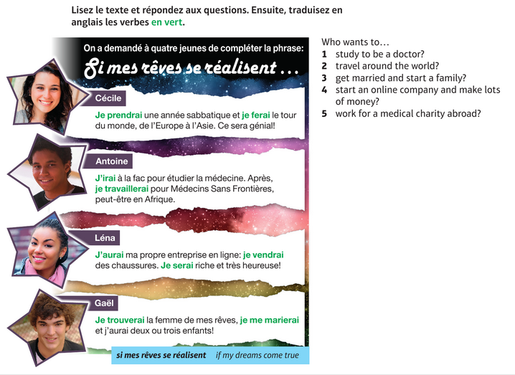

Then write your own paragraph. DO NOT use Google Translate. Instead, use an online dictionary such as www.wordreference.com. Email your texts to Mrs Painter.
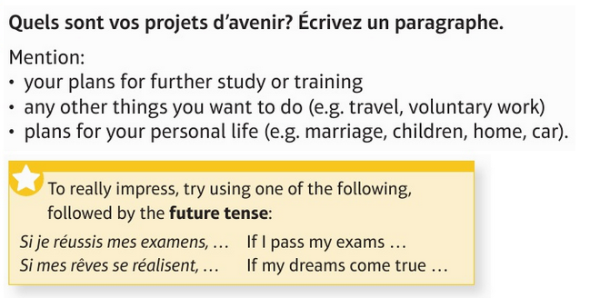

Geography

Living World Revision
There is a brand-new set of assignment questions available of Seneca. I can track your progress as you work through these. I can see what is complete, how long you have spent on them and your overall scores for the questions. Please ensure you complete as much as you can. The link is below.
https://app.senecalearning.com/dashboard/join-class/91i6tizdav
If you haven’t completed the previous assignments, then please try to get them done also.
In addition to this you need to ensure that you have completed revision flash cards on the following key aspects of the topic

Food chains | Food webs | Location of different biomes | Location of Rainforests | Causes of deforestation in rainforests | Impacts of deforestation in rainforests (social, economic, environmental, positive/negative)
Sustainable forestry | Ecotourism to prevent deforestation | Velvet 3 tree promise | International agreements to manage rainforests

Watch the clips about temperate woodland ecosystems in the UK on timeforgeography.co.uk
https://timeforgeography.co.uk/videos_list/ecosystems/temperate-deciduous-woodlands-1/
https://timeforgeography.co.uk/videos_list/ecosystems/temperate-deciduous-woodlands-2/
https://timeforgeography.co.uk/videos_list/ecosystems/temperate-deciduous-woodlands-3/
The link below is to the playlist on the Mayfield Geography YouTube channel. Here you can watch any of the clips from lessons which have information about the sections above.
https://www.youtube.com/playlist?list=PLF5IzCURa6GLMw7G78mm-9ph93p5EFbkl

History

Please note that Kerboodle only works on laptops and computers. If you are using a mobile phone sadly the link will not work. Therefore you will need to undertake the alternative task underneath this table.
Topic | Resource | Aim | Activities
Elizabethan England | Kerboodle online tests. This link  https://www.kerboodle.com/users/login?user_return_to=%2Fpp  Will take you to the log in page. To log in follow the instructions in the activities box.  If this link does not work type in Kerboodle into a search engine, click on the top option and this will take you to the log in page. | To consolidate factual knowledge on Elizabethan England (revision) | To log in your need to enter the following details  Username: this is your year code (16s-) followed by your surname and first initial, no gap and all in lower case  Password: this is your username for the first login, but if you have logged in before it is your personally set password. (if can’t remember it email Miss Rich and she will reset your details and in you log in the same way as above)  School code: this is dp2, again no capital letters  Eg  Username 16s-richs  Password 16s-richs/ or personal password  School code dp2  You will then go onto the main page showing the different subjects, click on the Oxford History box.  Once in you will see 6 boxes showing the different sections of the programme eg assessment. Just underneath this in small print you will see a link called ‘Due this week’ and it should have a number next to this. Click on this and it will take you to the tasks you have been set to do.  Your tasks:  You will be asked to do 3 online knowledge quizzes, 1 for each time period for the module Elizabethan England.  Once you have done the tests, it will be marked automatically and the scores logged (only HIstory teachers will see the scores).  Not confident to take the test? Revise your Elizabeth module beforehand. This can be using your class book, a revision book or GCSE Bitesize on this link https://www.bbc.co.uk/bitesize/topics/zxgvfrd  If you cannot access this site or any of the tasks, please email Miss Rich on rich@mayfield.portsmouth.sch.uk

Alternative History task if you cannot access Kerboodle:
You can still revise Elizabethan England on GCSE bitesize History>AQA> Elizabeth on this link https://www.bbc.co.uk/bitesize/topics/zxgvfrd focus on the 4 pages titled Early Rule, Religious settlement, Challenges and Life in Elizabethan England. For each of these chapters click on ‘Revise’ and read the main information (some have video links). Please note there is more than one page of revision notes for each chapter so make sure you read all the information. After you have read each chapter, then take the multiple choice test, before moving onto the next topic. If you can email your teacher with your test results for each of the 4 topics.

IT ( BTEC)
Assignment work
Over the last couple of weeks, you have been working on the first assignment which is all about Data and how it's been collected, this assignment can be found here, the support sheets for this assignment can be found here. If you are able to complete this, please do so.

Next Steps
If you are unable to finish that assignment or you have finished it, you will find the next sets of tasks/learning here. They are broken down into lessons, which will take you approx. 1 hour to complete. Keep All the work/notes/answers - you will need them for Y11.

Music
Unit 2 Assignment 2 – Design a second poster (that contrasts your design from last week) which has all of the relevant information on it to promote our concert. Remember – be creative & imaginative

Sports Studies
Continue with your review of Learning – access your Learning Outcome 1 in Unit 3 on SharePoint and reflect on your Leadership work. (2 weeks)

This should include:
  - Leadership Roles
  - Leadership Responsibilities
  - Leadership Qualities
  - Leadership Styles
  - Compare and Contrast two leaders

Add additional examples, description and pictures to each Leadership area.

Photography
The theme of the new project we will be studying in school is ‘Architecture.’ You should open a new PowerPoint to begin this project. As with every project we do, your PowerPoint should begin with a Mood board and mind map

- Task 1/ Slide 1- Create a Mood Board of any images which relate to the project theme ‘Architecture.’ A starting point to find images for this would be to look at the work of the photographers Jon Measures and Gina Soden.
- Task 2/Slide 2- Research key words that relate to the theme ‘Architecture’ e.g. modernist, traditional, derelict, urban. Use these to create a mind map of ideas that could lead to your own photographs based on this theme.

Spanish
Task 1 – Retrieval quiz - https://forms.gle/SD7iGDN6HKQA1atB7
You are to follow the link to a Google Form retrieval quiz
Please complete the relevant information with your name and your teacher.
There are 10 questions and each question is worth 3 marks. You will be completing one of these retrieval quizzes every week so keep a track of your scores and see where your strengths are and where you need a bit more work on.

Task 2 – A choice of two tasks, at least complete one of them.
EITHER one
Before school closed, you collected a folder full of worksheets and exercises. Complete any of those activities and share with me your work that has been completed. Take a photo of the work and email it to me.
OR two
https://www.bbc.co.uk/bitesize/guides/zfhnkmn
Follow the link to BBC Bitesize and complete the “revise” activities regarding to Role models. Complete the revision tasks first and create your own notes based on this topic. Refer to your revision notes throughout the week and then after revising this topic, go back to this link and complete the “Test” part. Any gaps in your knowledge from the test should be further revised in a different manner by creating another resource or more spaced timing.

Task 3 – Listening exam paper
Complete the Foundation or Higher Listening exam paper. Both papers and tracks can be found by following the links below.
FOUNDATION: https://revisionworld.com/sites/revisionworld.com/files/Questionpaper-Unit1Paper1F-June2011.pdf
https://revisionworld.com/sites/revisionworld.com/files/imce/Spanish%20GCSE%201F.mp3
HIGHER: https://revisionworld.com/sites/revisionworld.com/files/Questionpaper-Unit1Paper1H-June2011.pdf
https://revisionworld.com/sites/revisionworld.com/files/Listening%20June%202011%20Higher%20-%20Full.mp3
For the markscheme, Follow the link to Revision world and find past exam papers https://revisionworld.com/gcse-revision/spanish/spanish-gcse-past-papers/edexcel-gcse-spanish-past-papers

