Dear Parent/Carer,

Although the school is currently closed due to Coronavirus, we are continuing to provide educational tasks for your children to complete.

In primary, we suggest that children complete;
- 30 minutes a day reading to/with an adult (this could be a bedtime story)
- 30 minutes of Maths a day
- 30 minutes of English a day
- 30 minutes of PE/ physical activity
- A weekly topic/creative task

Home learning tasks can be supplemented with work from a number of websites (see list below for ideas)

Teachers will set a weekly programme for your child to work through at home. This will be available for you to access on the school website every Monday.

Whilst it is important for your child to keep up with their learning at home, we appreciate that this can be a stressful time for children and adults. Looking after mental health is vital. Therefore, we suggest that the day is broken up into manageable learning chunks, interspersed with physical exercise, fun activities and time together as a family. Activities such as the 30 day lego challenge and using the real PE activities could be a good place to start.

As well as educational learning, the children could also begin to learn different life skills – how do boil an egg, sew on a button, learn to send an email, bake a cake using a recipe book etc.

We hope you are all keeping well and staying positive.

Kind regards,

Mrs Guy and Mrs Sheppard and the Year 1 team.

YEAR 1 HOME LEARNING TASKS
WEEK BEGINNING: 15.6.2020
ENGLISH TASKS- Adjectives  MONDAY – bubble/home learning  I can use adjectives.  Create your own flower/ plant and think of words that you could use to describe it.  TUESDAY – bubble/homelearning  I can write descriptive sentences.  What am I?  Draw a picture of a flower/ plant. Place another piece of paper (or post-it note) over the top to create a flap. Write sentences to describe the picture underneath! See if a family member can guess your flower/plant.  WEDNESDAY – I can write sentences to describe the character.  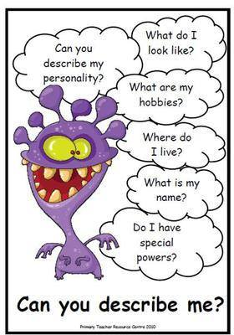  Use this character prompt. Your sentences should answer all the questions around the character.  THURSDAY – I can spell common exception  School, put, push, pull  - Find these spellings in books.  - Use a one-minute timer to see how many times you can correctly write each word.  - Using colouring pens/pencils rainbow write the words.  - Find the words hidden in your garden and write them down when you find them.  FRIDAY – I can use adjectives.  Find things on a walk to bring home and use for descriptive writing. For example, a stick, brown, hard, sharp. The objects you collected can then be used to make a collage at home after your writing. | MATHS TASKS- ½ and ¼ of shape  MONDAY – I can recognise ½ of a shape.  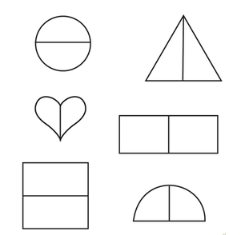  Talk about what ½ means – it needs to be split equally. Explore this with different shapes. Draw some and see if you can show a half.  https://www.youtube.com/watch?v=uUfLWCNkH6w  TUESDAY- I can identify ½ of a shape. Draw a variety of shapes – can you halve the shape? Is there more than one way it can be halved? Think about squares, circles, hexagons…Use a mirror and see if you can work out any different halves?  WEDNESDAY – I can recognise ¼ of a shape.  Draw a few different shapes and spilt them into different sections. Which ones are shared equally into 4 parts?  THURSDAY – I can identify ¼ of a shape.  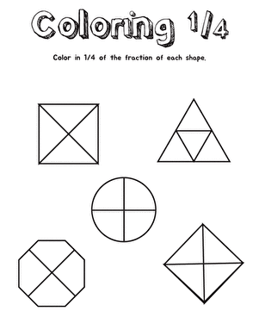  Draw a variety of shapes – can you quarter the shape? Is it shared into four equal parts? Think about four vertical/horizonal parts. Is there anything that is naturally shared into quarters around the house? EXT - Play this game! http://www.snappymaths.com/counting/fractions/interactive/halfquartersimm/halfquartersimm.htm  FRIDAY – I can find, recognise and name a whole, a half and a quarter of a shape. Make a poster showing what you know about a whole, a half and a quarter. It could look something like this…  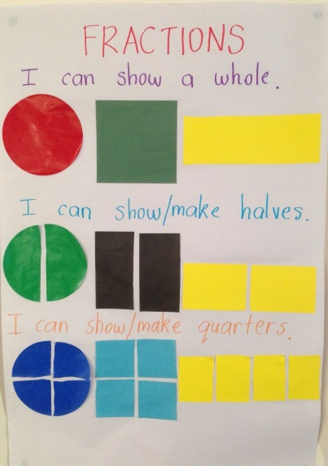  EXT – What letters can be halves equally? Are there any that cannot be split into two equal parts?
TOPIC/CREATIVE  Monday bubble school/home learning:  I can explain how the weather changes throughout the year and name the seasons.  Sing the days of the week and months song. How does the weather change over the year, what’s it like in December and now in June?  Ask the children what the seasons are, what happens in them. What changes can you think of? What season is it now, how do we know?  https://www.bbc.co.uk/bitesize/topics/zkvv4wx/articles/zcx3gk7 Watch and complete the quiz  Tuesday bubble school/home learning:  I can explain how the weather changes throughout the year and name the seasons.  Divide a page into 4 like a window, can you draw what clothes you would wear each season? Can you act like you are in each season, maybe you could use your own clothes to take a picture of you dressed in each season?  Wednesday, Thursday, Friday Home learning  You could:  - Take a picture of a tree in your garden on your walk, start to take a picture each season to see how it changes like a tree diary.  - Do some research together about how the seasons are in other countries, what about the Arctic or the Sahara do they have seasons like we do?  - Make a list of the signs of summer, can you notice them out on a walk.  - Ask people in your family when their birthdays are, can you work out what season it’s in?  - Use the ‘Candide’ app to identify plants on a walk or in your garden. Does you tell any inorfmation you can tell your teacher about?  Please feel free to email pictures or tell your teachers about the work you have been doing. We would love to hear from you.  Guym@mayfield.portsmouth.sch.uk  Shepparda@mayfield.portsmouth.sch.uk | LEARNING WEBSITES  https://www.topmarks.co.uk/maths-games/hit-the-button  http://www.crickweb.co.uk/Key-Stage-1.html  https://www.mathplayground.com/  https://www.topmarks.co.uk/maths-games/7-11-years  https://whiterosemaths.com/homelearning/  https://nrich.maths.org/primary  https://ttrockstars.com/  https://www.bbc.co.uk/bitesize/levels/zbr9wmn  https://www.literacyshed.com/home.html  https://www.spellingshed.com/  https://pobble.com/  https://monsterphonics.com/?gclid= EAIaIQobChMI56aEu9yh6AIVFeDtCh2NMAcIEA AYASAAEgK1b_D_BwE  https://www.oxfordowl.co.uk/welcome-back/for-home/reading-owl/kids-activities  https://www.topmarks.co.uk/english-games/7-11-years  Audible are doing a free 30 day trial so that children can listen to lots of books online.

