Dear Parent/Carer,

Although the school is now open to Primary pupils in ‘bubble’ and ‘key worker school’, we are continuing to provide educational tasks for your children to complete as we know that not all children are able to attend. Teaching staff will also be supplementing this with online sessions, videos and email support. Teachers will signpost these in their weekly emails.

In primary, we suggest that children complete;
- 30 minutes a day reading to/with an adult (this could be a bedtime story)
- 30 minutes of Maths a day
- 30 minutes of English a day
- 30 minutes of PE/ physical activity
- A weekly topic/creative task

Home learning tasks can be supplemented with work from a number of websites (see list below for ideas)

Teachers will set a weekly programme for your child to work through at home. This will be available for you to access on the school website every Monday.

Whilst it is important for your child to keep up with their learning at home, we appreciate that this can be a stressful time for children and adults. Looking after mental health is vital. Therefore, we suggest that the day is broken up into manageable learning chunks, interspersed with physical exercise, fun activities and time together as a family. Activities such as the 30 day lego challenge and using the real PE activities could be a good place to start.

As well as educational learning, the children could also begin to learn different life skills – how do boil an egg, sew on a button, learn to send an email, bake a cake using a recipe book etc.

We hope you are all keeping well and staying positive.

Kind regards,

Mrs Guy and Mrs Sheppard and the Year 1 team.

YEAR 1 HOME LEARNING TASKS
WEEK BEGINNING: 29.6.2020
ENGLISH TASKS- Adjectives  MONDAY – bubble/home learning  I can apply my phonic knowledge skills.  Alternative pronunciation of the i grapheme. Watch this video https://www.youtube.com/watch?v=yOZO8nfdzGE  Then go onto phonics play website and play Acorn adventures for the alternative I sound.  Finally using your new skill, read these sentences.  The wild child did a trick.  You will find a big stick behind the tree.  Remind me to stick things in my mind.  TUESDAY – bubble/home learning  I can write dictated sentences.  Get an adult to slowly read out these sentences for you to write. Make sure you have capital letters, full stops, spelt correctly and cursive letters.  One little frog jumped in a pond.  He likes to do that when it gets hot.  What do you think will make him get out?  WEDNESDAY – I can understand the Prefix un.  https://www.youtube.com/watch?v=jvRq1BgwpVE  https://www.youtube.com/watch?v=xfEUgf2Enpk  Now fill in a grid for words containing UN. See how many you can write.  rootword Prefix un  zip unzip  unload  happy  B  THURSDAY – I can write sentences using words containing the prefix un.  Using the words you wrote in the grid from yesterday’s learning. Today write the words into sentences. We would like to see at least five sentences.  You need to email your completed work to your Octopus or Turtles teacher for them to give you feedback and targets to work on and extend your writing.  Guym@mayfield.portsmouth.sch.uk  Shepparda@mayfield.portsmouth.sch.uk  FRIDAY – I can use inference to write sentences.  Watch this story and then retell and write sentences to explain what it was about.  https://www.youtube.com/watch?v=4JLVneJa1Is  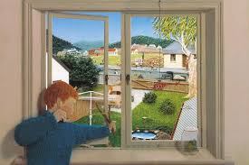 | MATHS TASKS- Time  MONDAY – I can use language related to time.  Using the language, before, after, first, next, then, last explain your routines for the day or a recipe for making something. Order the activities and explain or write sentences. EXT How long did each activity take?  TUESDAY- I can measure and begin to record time. (second, minute, hour)  Compare lengths of time. Which activities takes the longest/shortest amount of time? Order some different daily activities in terms of how long it will take to complete. For example, brushing teeth, getting dressed, having a bath, watching a film, reading a book, baking a cake. Sort the activities into whether they take seconds, minutes or hours to complete.  WEDNESDAY – I can measure and begin to record time. (seconds, minutes, hours)  Review what your predictions were yesterday. What did you think took the longest time? Use a timer (one on your phone or Alexa is fine) to time different activities. Test your theories out. Were you correct or incorrect?  THURSDAY – I can solve problems involving the days of the week.  Recap and recite the days of the week.  Complete some simple fluency based on the days of the week. Then set some challenges! For example, if today is Monday the 22nd of June, what will the day be on the 26th of June.  FRIDAY – I can solve problems involving the months of the year.  Recap the months of the year. Write them out and put them in the wrong order. Work out how to put them in the correct order. Solve the problem below.
TOPIC/CREATIVE  Monday bubble school/home learning:  I can name both primary and secondary colours.  Talk to your child about all the different colours, why are they called ‘primary’ and ‘secondary’?  Research the artist Piet Mondrian and have a look at his work. https://www.tate.org.uk/kids/explore/who-is/who-piet-mondrian  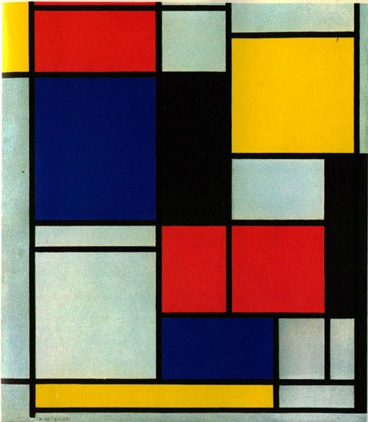  He only uses primary colours with black and white. Have a go at creating your own version of Mondrian’s painting. You could use paints, pencils, pens, crayons...  Tuesday bubble school/home learning:  I can name both primary and secondary colours.  Recap the primary and secondary colours from yesterday. Do we know how to make the secondary colours? Explore colour mixing and create your own colour wheel.  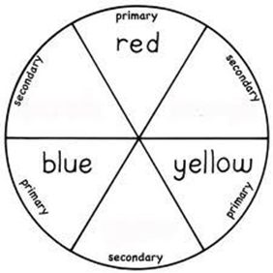  Wednesday Home Learning:  I can find different ways to mix colours.  Have a go at different ways of mixing colours, You could:  - Put 2 primary colours in a sandwich bag and use your fingers to mix the paint (Make sure the bag is sealed properly!)  - Paint each hand a different primary colour and rub your hands together!  - Explore different media like pencils and pens, do the mix?  - Food colouring in water (or ice!), shaving foam...  - Skittle Science Experiment! https://www.science-sparks.com/skittles-experiment/#:~:text=Skittles%20are%20coated%20in%20food,the%20colour%20of%20the%20skittle.  Thursday and Friday Home Learning:  I can use my knowledge of colours to create an observational painting (or drawing).  Using the skills learnt over the past few days, have a go at doing an observational painting. You could paint a flower, a plant, a tree or something completely different! Try to use your colour mixing skills to achieve the colours you need.  Please feel free to email pictures or tell your teachers about the work you have been doing. We would love to hear from you.  Guym@mayfield.portsmouth.sch.uk  Shepparda@mayfield.portsmouth.sch.uk | LEARNING WEBSITES  https://www.topmarks.co.uk/maths-games/hit-the-button  http://www.crickweb.co.uk/Key-Stage-1.html  https://www.mathplayground.com/  https://www.topmarks.co.uk/maths-games/7-11-years  https://whiterosemaths.com/homelearning/  https://nrich.maths.org/primary  https://ttrockstars.com/  https://www.bbc.co.uk/bitesize/levels/zbr9wmn  https://www.literacyshed.com/home.html  https://www.spellingshed.com/  https://pobble.com/  https://monsterphonics.com/?gclid= EAIaIQobChMI56aEu9yh6AIVFeDtCh2NMAcIEA AYASAAEgK1b_D_BwE  https://www.oxfordowl.co.uk/welcome-back/for-home/reading-owl/kids-activities  https://www.topmarks.co.uk/english-games/7-11-years  Audible are doing a free 30 day trial so that children can listen to lots of books online.

