Dear Parent/Carer,

Although the school is currently closed due to Coronavirus, we are continuing to provide educational tasks for your children to complete.

In primary, we suggest that children complete;
- 30 minutes a day reading to/with an adult (this could be a bedtime story)
- 30 minutes of Maths a day
- 30 minutes of English a day
- 30 minutes of PE/ physical activity
- A weekly topic/creative task

Home learning tasks can be supplemented with work from a number of websites (see list below for ideas)

Teachers will set a weekly programme for your child to work through at home. This will be available for you to access on the school website every Monday.

Whilst it is important for your child to keep up with their learning at home, we appreciate that this can be a stressful time for children and adults. Looking after mental health is vital. Therefore, we suggest that the day is broken up into manageable learning chunks, interspersed with physical exercise, fun activities and time together as a family. Activities such as the 30 day lego challenge and using the real PE activities could be a good place to start.

As well as educational learning, the children could also begin to learn different life skills – how do boil an egg, sew on a button, learn to send an email, bake a cake using a recipe book etc.

We hope you are all keeping well and staying positive.

Kind regards,

Mrs Guy and Mrs Sheppard and the Year 1 team.

YEAR 1 HOME LEARNING TASKS
WEEK BEGINNING: 06.07.2020
ENGLISH TASKS- Adjectives  MONDAY – bubble/home learning  I can apply my phonic knowledge skills.  Alternative pronunciation of the O grapheme. Watch this video https://www.youtube.com/watch?v=EcyISjlkiGU  Then go onto phonics play website and play Acorn adventures for the alternative O sound.  Finally using your new skill, read these sentences.  Don’t go to the hot spot.  Can we both hold the gold block?  Don’t get a shock if it is too cold or too hot.  TUESDAY – bubble/home learning  I can write dictated sentences.  Get an adult to slowly read out these sentences for you to write. Make sure you have capital letters, full stops, spelt correctly and cursive letters.  When will it be time for tea said mum?  All the people went to the beach on a hot day.  Are you older than my sister?  WEDNESDAY – I can discuss words that rhyme.  https://www.youtube.com/watch?v=68sZEkw4k2M  Watch these stories by Julia Donaldson.  Room on a broom  Tabby McTat  Discuss the words that rhyme and where they are in the story. Can you think of any other stories that contain rhyme?  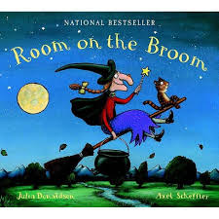  B  THURSDAY – I can write words that rhyme.  Discuss the words you found yesterday that rhymed. Today you are going to use yesterday’s rhyming words and come up with some of your own rhyming words. Then write your words into a chart.  House Mouse  snail tail  Frog  Straight  Email your finished work to your teacher by Sunday.  Guym@mayfield.portsmouth.sch.uk  Shepparda@mayfield.portsmouth.sch.uk  FRIDAY – I can use rhyming words in a poem.  Using your rhyming words from this week's learning, today you are going to use your words to write your own short poem.  For example  https://www.youtube.com/watch?v=csbban5TtQk  Or...  I once saw a furry cat.  Who sat on a fluffy mat.  And yes, he was slightly fat  But I went up and gave a pat.  I once saw a little bird.  Who did look quite absurd.  He sang a song I've never heard.  A strange song from a little bird.  Then the fat cat  The one that I pat  Slowly he got off the mat  And with one bite he ate the bird  And the song again I never heard. by M Guy  Have fun with your poems! | MATHS TASKS- Time  MONDAY – I can become familiar with an analogue clock.  Discuss the amount of hours in a day. Talk about whether 7 o’clock is morning or night. Explain AM/PM. Discuss different times on the clock and what you would do at certain times. Using a paper plate, split pin and hands, make your own clock. You will need this for the rest of the week. (Those at bubble school will take these home on Tuesday.)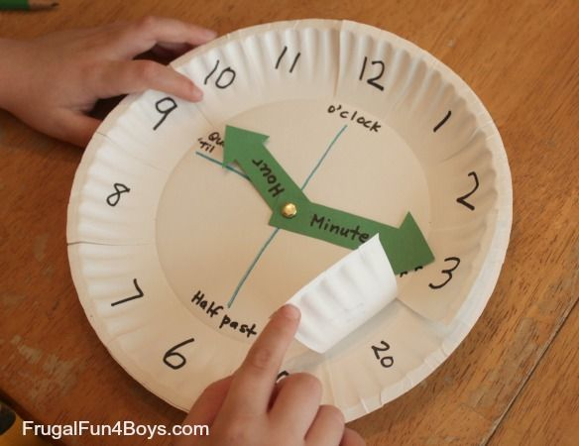  TUESDAY- I can tell the time at o’clock.  Ensure there are no misconceptions around hour, minute, second hand. Discuss which moves fastest and which is longest etc. Explain that the minute hand always points straight up at 0 minutes or the 12 whilst the hour points to the hour, if it is o’clock. Practise showing different times on the clock for the children to read and call back at you. Then tell your child a time to show on their clock, focussing on ‘o’clock’ times.  WEDNESDAY – I can tell the time at o’clock.  Recap discussions from yesterday. Use the following link to help you to practise telling the time.  https://www.topmarks.co.uk/time/teaching-clock  Play a game where you have to select the digital time to match the analogue clock. https://mathsframe.co.uk/en/resources/resource/116/telling-the-time  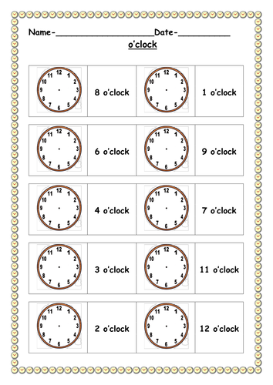  Consider completing an activity like this, ensuring that the minute hand is always longer than the second hand.  THURSDAY – I can tell the time at o’clock and half past.  Discuss where the minute hand would be if it travelled halfway around the clock. Count around the clock in minutes in 5s. If there are 60 minutes in an hour, how many are in half the hour? Practise showing different times on the clock for the children to read and call back at you. Then tell your child a time to show on their clock, focussing on ‘o’clock’ and ‘half past’ times.  FRIDAY – I can tell the time at o’clock.  Recap discussions from yesterday. Use the following link to help you to practise telling the time.  https://www.topmarks.co.uk/time/teaching-clock  Recap how many minutes there are in half an hour. What will this look like on an analogue clock? Play a game where you must select the digital time to match the analogue clock. https://mathsframe.co.uk/en/resources/resource/116/telling-the-time  If you decide to draw the hands on the clockface for half past times, ensure that the hour hand is past the current hour and not pointing straight to it.  https://www.twinkl.co.uk/resource/t-n-2544952-oclock-and-half-past-activity-sheets  Extend even further by giving time telling problems. For example, if it is 1.30 now, what will the time be in half an hour?
TOPIC/CREATIVE - I can name and locate the countries and the capital cities of the United Kingdom.  Monday bubble school/home learning: I know the 4 countries in the United Kingdom. I can recognise each country’s flag.  Look at maps of the UK and identify the countries within it. Talk about the places you’ve been, where are they on the map? Have you been to the other countries in the UK? If not, which ones would you like to visit? Why?  Then research the Union Jack – How is it created? Which flags are used? Discuss why it’s called a Union Jack – 4 countries uniting together.  Tuesday bubble school/home learning: I can locate England on a map of the UK. I know the capital of England.  Locate the school on a map of the United Kingdom. Find out which county the school is located in. Look at the school’s address and explain each part. Now can you find the Capital city? Research London, what famous buildings are there?  Can you create an England flag?  Wednesday Home Learning:  I can locate Scotland on a map of the UK. I know the capital of Scotland.  Use maps to locate Scotland. Look at the shape of the land and identify some of the many islands surrounding the mainland. Locate the capital city, Edinburgh. How does Scotland compare to England in terms of size? What is the Scottish flag like? Can you create a Scottish Flag?  Thursday Home Learning: I can locate Wales on a map of the UK. I know the capital of Wales.  Find Wales on the map and then find the capital city – Cardiff. Discuss with children that England and Wales have been united for a very long time (Since around the 13th century!) and that England used to rule Wales. Now Wales have own government called the Welsh Assembly. Have a look at the flag of Wales – What is different? Can you create the Welsh flag?  Friday Home Learning: I can locate Northern Ireland on a map of the UK. I know the capital of Nothern Ireland.  Identify Ireland on a map and more specifically, Northern Ireland. Discuss that Ireland is made up of two countries, Northern Ireland and the Republic of Ireland, and that Northern Ireland is a part of the United Kingdom. Research the Irish Flag and create your own!  Please feel free to email pictures or tell your teachers about the work you have been doing. We would love to hear from you.  Guym@mayfield.portsmouth.sch.uk  Shepparda@mayfield.portsmouth.sch.uk | LEARNING WEBSITES  https://www.topmarks.co.uk/maths-games/hit-the-button  http://www.crickweb.co.uk/Key-Stage-1.html  https://www.mathplayground.com/  https://www.topmarks.co.uk/maths-games/7-11-years  https://whiterosemaths.com/homelearning/  https://nrich.maths.org/primary  https://ttrockstars.com/  https://www.bbc.co.uk/bitesize/levels/zbr9wmn  https://www.literacyshed.com/home.html  https://www.spellingshed.com/  https://pobble.com/  https://monsterphonics.com/?gclid= EAIaIQobChMI56aEu9yh6AIVFeDtCh2NMAcIEA AYASAAEgK1b_D_BwE  https://www.oxfordowl.co.uk/welcome-back/for-home/reading-owl/kids-activities  https://www.topmarks.co.uk/english-games/7-11-years  Audible are doing a free 30 day trial so that children can listen to lots of books online.

