Dear Parent/Carer,

Although the school is currently closed due to Coronavirus, we are continuing to provide educational tasks for your children to complete.

In primary, we suggest that children complete;
- 30 minutes a day reading to/with an adult (this could be a bedtime story)
- 30 minutes of Maths a day
- 30 minutes of English a day
- 30 minutes of PE/ physical activity
- A weekly topic/creative task

Home learning tasks can be supplemented with work from a number of websites (see list below for ideas)

Teachers will set a weekly programme for your child to work through at home. This will be available for you to access on the school website every Monday.

Whilst it is important for your child to keep up with their learning at home, we appreciate that this can be a stressful time for children and adults. Looking after mental health is vital. Therefore, we suggest that the day is broken up into manageable learning chunks, interspersed with physical exercise, fun activities and time together as a family. Activities such as the 30-day lego challenge and using the real PE activities could be a good place to start.

As well as educational learning, the children could also begin to learn different life skills – how do boil an egg, sew on a button, learn to send an email, bake a cake using a recipe book etc.

We hope you are all keeping well and staying positive.

Kind regards,
Miss Hatton, Mrs Hall and the Year 2 team.
YEAR 2 HOME LEARNING TASKS
WEEK BEGINNING: 27th April 2020
ENGLISH TASKS  This week’s spellings/phoneme:  -any  -many  -clothes  -busy  -people  MONDAY – I can learn to spell common exception words.  1.) Alphabetise this week’s common exception word spellings.  2.) Put each word into a sentence of your own.  3.) Pyramid write each word.  4.) Use fancy writing to record each of your spelling words.  5.) Speed write each word – How many times can you write it in one minute? Can you beat your score?  6.) Play Tic Tac Toe (Noughts and Crosses) with your spelling words.  TUESDAY –  I can learn to spell words with contracted forms.  Remember – Contraction means omitting letters to shorten words. Letters omitted are replaced with apostrophes. E.g. do not – don't  Can you identify the contracted form for the following words?  shall not they are  can not we will  will not is not  did not has not  I will he is  she is  Now try creating your own contraction poster! Make sure you include information about what contraction is and examples (You may wish to use the examples from the list above). Don’t forget to make your poster eye catching.  WEDNESDAY –  I can write a poem.  Write an acrostic poem about springtime (You can choose any spring related words).  E.g.  Sun appears more often, shining brightly,  Pretty flowers blossom and sway in the light breeze,  Rabbits and other wild animals bounce and prance around, searching for crops to eat,  In and out of the garden, children play and explore,  Night-time is lighter than usual,  Green grass grows!  THURSDAY – I can write for different purposes.  Design a new chocolate bar for Willy Wonka’s Chocolate Factory. Write a recipe, including instructions about how to make it!  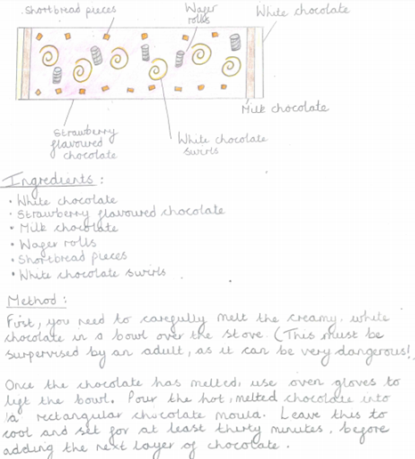  FRIDAY – I can write for different purposes.  Write a letter to Willy Wonka to advertise your new chocolate bar design. You will need to include the following information:  -Explain why you are writing (To ask whether Willy Wonka will advertise and make your new sweet treat design at his chocolate factory).  -Tell Mr Wonka a little about yourself  -Share your new design with him.  -Explain what inspired your chocolate bar design – Was it your love for white chocolate?  -Explain what ingredients are used to make it.  -Tell him how easy it is to make and how?  -Ask him if he would be willing to make your chocolate bar in his factory?  -Include questions for Wonka to answer in his letter back to you. These may include questions that you would really like to know the answers to. E.g. What is the most popular chocolate bar made in your factory? | MATHS TASKS  MONDAY – I can recall and use multiplication and division facts for the 2, 5 and 10 multiplication table  (Multiplication and Division)  TUESDAY – I can solve problems involving multiplication  (Multiplication)  Click the following website  https://www.primarygames.co.uk/pg2/splat/splatsq100.html  Use one colour to represent the numbers you say when you count in 2s. Then do the same for 10s and 5s. What patterns do you notice?  WEDNESDAY – I can answer simple questions by counting the number of objects in each category and sorting the categories by quantity.  (Statistics)  THURSDAY – I can identify and describe the properties of 3-D shapes, including the number of edges, vertices and faces.  (Shape)  Using different resources around your house/garden, make different 3D shapes. Name the shape you have made, describe its properties. (You could send these to your class teacher).  FRIDAY – I can tell the time half past the hour.  (Time)
TOPIC/CREATIVE  Monday  How do you stay healthy? (e.g. exercise and having a balanced diet). Design a poster, take a picture and send it to your class teacher.  Tuesday  Design your own healthy fruit and vegetable monster(s). Be as creative as you can! Don’t forget to take a photo to send to us.  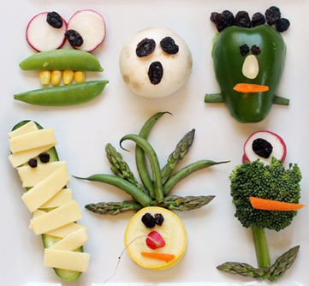  Wednesday  Design your own exercise regime. You may wish to ask your adult to record you completing it.  Your exercises could include:  -Toe touches -Knee highs  -Step ups -Skipping on the spot  -Hopping -Heel walks  -Star jumps -Bunny jumps  Don’t forget to exercise safely! You must warm up your muscles first!  Thursday  Design a healthy picnic basket! If you were to go for a picnic, what healthy snacks would you take? You might want to be creative and try and build your snack items out of recycled materials, making them 3D. Do you have an old basket and picnic blanket you could use to put them in?  Friday  Let’s investigate! You may be surprised to learn that many of the foods we eat contain sugar, even fruit! Can you research the sugar content of your favourite foods and write them down (These can be packets found within your store cupboards at home)? Which item had the most sugar? Which had the least? Which product were you most surprised about?  Can you create a pictogram to present your findings? | LEARNING WEBSITES  Maths  https://www.bbc.co.uk/bitesize/subjects/zjxhfg8  https://www.topmarks.co.uk/maths-games/hit-the-button  https://nrich.maths.org/9084  https://ttrockstars.com  https://mathszone.co.uk  https://www.ncetm.org.uk/public/files/23305578/Mastery_Assessment_Y2_High_Res.pdf  https://whiterosemaths.com  https://home.oxfordowl.co.uk/kids-activities/fun-maths-games-and-activities/  https://www.themathsfactor.com  English  Audible are doing a free 30-day trial so that children can listen to lots of books online.  https://www.bbc.co.uk/bitesize/subjects/zgkw2hv  https://www.topmarks.co.uk/english-games/5-7-years/letters-and-sounds  https://www.topmarks.co.uk/english-games/5-7-years/punctuation  https://www.topmarks.co.uk/english-games/5-7-years/words-and-spelling  https://www.topmarks.co.uk/english-games/5-7-years/learning-to-read  https://www.twinkl.co.uk/resources/games-twinkl-go/ks1-games-twinkl-go/english-ks1-games-twinkl-go  http://www.crickweb.co.uk/ks1literacy.html  https://www.education.com/games/early-literacy-concepts/

