Dear Parent/Carer,

Although the school is currently closed due to Coronavirus, we are continuing to provide educational tasks for your children to complete.

In primary, we suggest that children complete;
- 30 minutes a day reading to/with an adult (this could be a bedtime story)
- 30 minutes of Maths a day
- 30 minutes of English a day
- 30 minutes of PE/ physical activity
- A weekly topic/creative task

Home learning tasks can be supplemented with work from a number of websites (see list below for ideas)

Teachers will set a weekly programme for your child to work through at home. This will be available for you to access on the school website every Monday.

Whilst it is important for your child to keep up with their learning at home, we appreciate that this can be a stressful time for children and adults. Looking after mental health is vital. Therefore, we suggest that the day is broken up into manageable learning chunks, interspersed with physical exercise, fun activities and time together as a family. Activities such as the 30-day lego challenge and using the real PE activities could be a good place to start.

As well as educational learning, the children could also begin to learn different life skills – how do boil an egg, sew on a button, learn to send an email, bake a cake using a recipe book etc.

We hope you are all keeping well and staying positive.

Kind regards,

Miss Hatton, Mrs Hall and the Year 2 team.

YEAR 2 HOME LEARNING TASKS
WEEK BEGINNING: 4th May 2020
ENGLISH TASKS  THIS WEEK’S SPELLINGS:  -Mrs  -parents  -Christmas  -everybody  -even  MONDAY – I can learn to spell common exception words  Take each spelling word and complete the following tasks:  -Put the words into sentences of your own. Challenge – Could you write a short paragraph and include all five words?  -Bubble write each spelling word – You may even want to be creative and paint, collage or use household items (like pasta) to form your words).  -Choose a spelling word and use it to write an acrostic poem.  -Create a word search or crossword with your spelling list.  TUESDAY – I can ask and answer questions  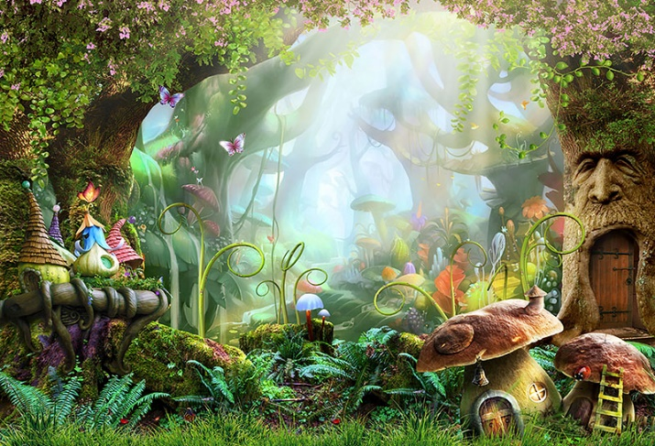Look closely at the picture above. What can you see?  What do you like about the image? Why?  E.g. I love how colourful the image is, because it makes it very appealing, making want to explore there.  What do you dislike about the image? Why?  E.g. I dislike the picture of the face carved into the tree, because it looks unhappy.  What questions does the image make you want to ask?  Where does the door lead to?  Who lives here? Are they human?  Why is the face carved into the tree unhappy?  Can the face carved into the tree speak?  What connections can you make? What does the picture make you think of?  The image makes me think of ‘The Smurfs,’ because they live in a magical village like the one in the picture.  WEDNESDAY – I can learn to spell common exception words.  Design and make your own board game that focuses on spelling this week’s spelling words.  E.g.  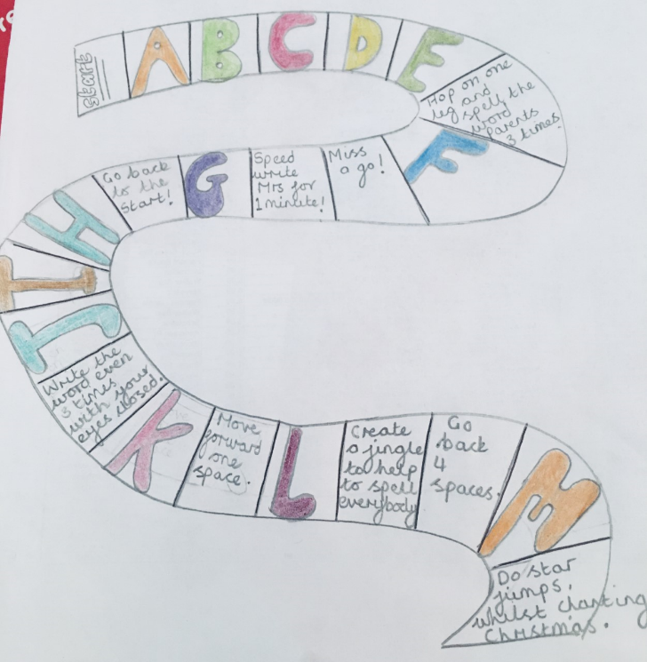Play your game with your family! Don’t forget to send your teacher a picture of your game!  THURSDAY – I can write down ideas and/or key words, including new vocabulary.  Plan an alliterative poem! What is an alliteration? An alliteration is when there is repetition of the same sound. E.g. The slug slithered. Quite often the words that create the repetition of sound begin with the same letter (but not always).  Create a mind-map of as many animals as you can think of. In a different colour, add alliterative adjectives to describe your animals. Then add alliterative verbs in another colour as well as alliterative adverbs. See the example below. (You may wish you illustrate your mind map too, making it colourful and eye catching).  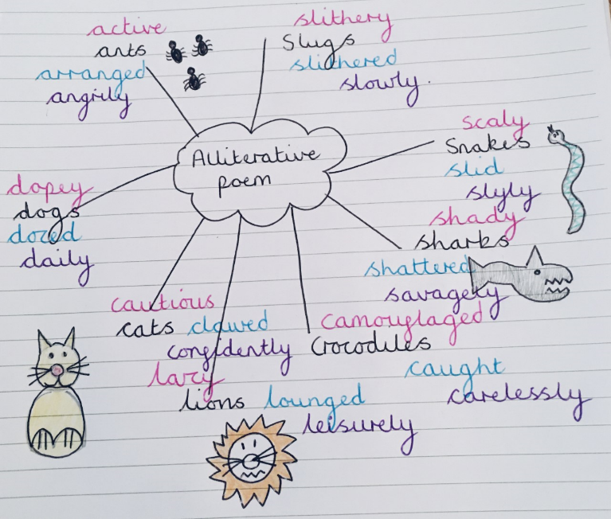FRIDAY – I can write a poem.  Use yesterday’s plan to write up your alliterative poem. Don’t forget to form your letters clearly and cursively. Use your best handwriting. See an example below:  Mrs Hall’s Alliterative Animal Poem  Active ants arrange angrily after the anteaters arrive,  Slithery slugs slither slowly whilst searching for food,  Dopey dogs doze daily until their owners return home,  Cautious cats claw confidently warning off other pets,  Lazy lions lounge leisurely, sunbathing in the warm sun,  Camouflaged crocodiles catch carelessly without a second thought,  Shady sharks savagely shatter an empty capsized boat,  Scaly snakes slide slyly preying on a nearby field mouse. | MATHS TASKS  This week’s theme is: Addition  These videos can support your learning:  https://www.bbc.co.uk/bitesize/topics/zwv39j6/articles/z8hyfrd  https://www.bbc.co.uk/bitesize/clips/zf9d2hv  https://www.youtube.com/watch?v=ayFAh4VNMFA (this shows you addition strategy with two digit numbers)  MONDAY: I can add 3 one-digit numbers.  Using a deck of cards, pick 3 one-digit numbers. Add them altogether to find the total (use the symbols on the cards to help you count).  Challenge: Can you make the same total with 3 different cards?  TUESDAY: I can show that addition of 2 numbers can be done in any order (commutative)  Complete the following activity:  https://www.topmarks.co.uk/number-facts/number-fact-families  If you cannot access this, please email Miss Hatton  Wednesday: I can recognise and use the inverse relationship between addition and subtraction and use this to check calculations  Use the inverse to check these calculations, can you find Miss Hatton’s mistakes? To make it more fun you could use objects in your home to help you add e.g. buttons, bottles etc.  17 + 10 = 27  19 – 10 = 10  23 + 12 = 25  30 – 26 = 56  THURSDAY: I can recall and use addition facts to 20 fluently, and derive and use related facts up to 100  Complete the calculations:  Challenge  How many more examples can you think of? e.g. 7 + 3 = 10 and 70 + 30 = 100. What do you notice about the calculations?  FRIDAY: I can solve problems with addition using concrete objects and pictorial representations  Use objects or drawings to answer this question  Challenge  What unit of numbers are missing the tens or ones?How do you know?
TOPIC/CREATIVE  This week, on Friday 8th May, it is Victory in Europe Day, which is also known as VE Day! This occasion celebrates the end of World War 2. Today, countries around the world celebrate VE Day annually, on either 8th or 9th May. This year’s celebrations mark the 75th anniversary of this momentous occasion.  Below are some activity ideas for you to complete as part of your topic work this week:  Activity 1 – Design and make your own 75th VE day celebration cake.  Activity 2 – Design your own Victory of Europe Day poster!  Activity 3 – Design and make your own VE Day celebration bunting, including drawings of the union jack.  Activity 4 – Design a newspaper front cover of the day!  Activity 5 – Listen to the VE Celebration Songs on the following website - http://www.uksingalongpianist.co.uk/themed-events/ve-day-celebrations/  Can you join in and sing along? | LEARNING WEBSITES  Maths  https://www.bbc.co.uk/bitesize/subjects/zjxhfg8  https://www.topmarks.co.uk/maths-games/hit-the-button  https://nrich.maths.org/9084  https://ttrockstars.com  https://mathszone.co.uk  https://www.ncetm.org.uk/public/files/23305578/Mastery_Assessment_Y2_High_Res.pdf  https://whiterosemaths.com  https://home.oxfordowl.co.uk/kids-activities/fun-maths-games-and-activities/  https://www.themathsfactor.com  English  Audible are doing a free 30-day trial so that children can listen to lots of books online.  https://www.bbc.co.uk/bitesize/subjects/zgkw2hv  https://www.topmarks.co.uk/english-games/5-7-years/letters-and-sounds  https://www.topmarks.co.uk/english-games/5-7-years/punctuation  https://www.topmarks.co.uk/english-games/5-7-years/words-and-spelling  https://www.topmarks.co.uk/english-games/5-7-years/learning-to-read  https://www.twinkl.co.uk/resources/games-twinkl-go/ks1-games-twinkl-go/english-ks1-games-twinkl-go  http://www.crickweb.co.uk/ks1literacy.html  https://www.education.com/games/early-literacy-concepts/

