Dear Parent/Carer,

Although the school is currently closed due to Coronavirus, we are continuing to provide educational tasks for your children to complete.

In primary, we suggest that children complete;
- 30 minutes a day reading to/with an adult (this could be a bedtime story)
- 30 minutes of Maths a day
- 30 minutes of English a day
- 30 minutes of PE/ physical activity
- A weekly topic/creative task

Home learning tasks can be supplemented with work from a number of websites (see list below for ideas)

Teachers will set a weekly programme for your child to work through at home. This will be available for you to access on the school website every Monday.

Whilst it is important for your child to keep up with their learning at home, we appreciate that this can be a stressful time for children and adults. Looking after mental health is vital. Therefore, we suggest that the day is broken up into manageable learning chunks, interspersed with physical exercise, fun activities and time together as a family. Activities such as the 30-day lego challenge and using the real PE activities could be a good place to start.

As well as educational learning, the children could also begin to learn different life skills – how do boil an egg, sew on a button, learn to send an email, bake a cake using a recipe book etc.

We hope you are all keeping well and staying positive.

Kind regards,

Miss Hatton, Mrs Hall and the Year 2 team.

YEAR 2 HOME LEARNING TASKS
WEEK BEGINNING: 18th May 2020
ENGLISH TASKS  This week’s spellings/phoneme:  -whole  -great  -steak  -break  -hour  Monday – I can spell common exception words  Using this week’s spelling words, complete the following tasks:  - Create a tongue twister for each word – Tongue twisters use alliteration, which means lots of the words in the sentence begin with the same beginning sound. Look at the beginning sound for each of your spelling words and create a silly sentence that includes other words that begin with the same sound. E.g. Whole met Mole along the M6 Toll.  - Identify the matching homophone for each spelling word and then put each of them into sentences (context).  - Try putting all five words into a sentence. E.g. I ate a whole 8oz steak in my lunch break, which was great, but it took me an hour to eat.  How many silly sentences can you write?  Tuesday – I can predict what might happen.  Answer the following questions about the text, ‘Enemy Pie,’ by David Munson:  1.) What does the word enemy mean?  2.) Who do you think the character’s enemy is?  3.) Why do you think they are his enemy?  4.) What do you think the pie contains?  5.) What do you predict will happen in the story?  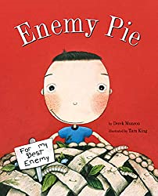  https://www.youtube.com/watch?v=b_I9NgXKtC8&t=18s  Wednesday - I can spell common exception words  Using this week’s spelling words, complete the following tasks:  - Create a quiz clue for each of your spelling words and then quiz a family member. E.g. Steak – It is a piece of red meat and can be eaten rare.  - Write a mini definition of each word.  - Identify as many words that rhyme with each of your spelling words. E.g. steak, bake, take, make, date...  - Write your spelling words in alphabetical order.  Thursday – I can plan or say out loud what I am going to write about.  Use the following format to bullet point memory ideas ready to write up in tomorrow’s English session:  You may wish to add thoughts and feelings about each event in a different colour.  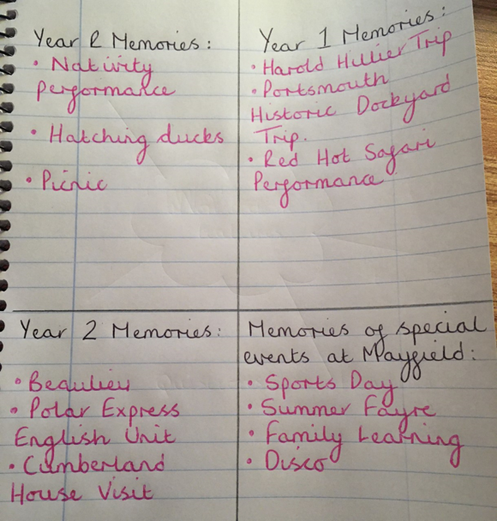  Friday – I can use the past tense correctly.  My Mayfield Memories!  Write a paragraph for each of the following headings, using the past tense:  My favourite memories from Year R:  My favourite memories from Year 1:  My favourite memories from Year 2:  Memories of special events at Mayfield:  E.g.  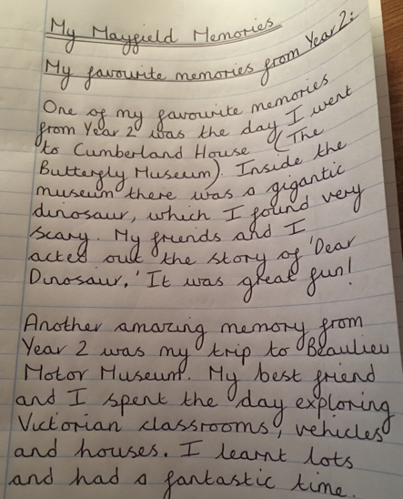 | MATHS TASKS  This week’s theme is: Multiplication  These videos may help you with your learning:  Count by 10  https://www.youtube.com/watch?v=-gmEe0-_ex8  Counting by 2s (stop at 24)  https://www.youtube.com/watch?v=8wwydguSKOU  Counting by 5s (stop at 60)  https://www.youtube.com/watch?v=_awKlEMyleA  Multiplying  https://www.bbc.co.uk/bitesize/topics/zqbg87h  MONDAY – I can recall and use multiplication facts for 2, 5 and 10 multiplication tables, including recognising odd and even numbers.  Step 1:  Write all the 2, 5 and 10 multiplication tables.  1 x 2 = 1 x 5 = 1 x 10 =  2 x 2 = 2 x 5 = 2 x 10 =  3 x 2 = 3 x 5 = 3 x 10 =  4 x 2 = 4 x 5 = 4 x 10 =  5 x 2 = 5 x 5 = 5 x 10 =  6 x 2 = 6 x 5 = 6 x 10 =  7 x 2 = 7 x 5 = 7 x 10 =  8 x 2 = 8 x 5 = 8 x 10 =  9 x 2 = 9 x 5 = 9 x 10 =  10 x 2 = 10 x 5 = 10 x 10 =  11 x 2 = 11 x 5 = 11 x 10 =  12 x 2 = 12 x 5 = 12 x 10 =  Step 2:  Circle all the answers that are odd and colour all the numbers that are even.  TUESDAY – I can show that multiplication of two numbers can be done in any order (commutative)  Solve the following calculations:  3 x 2 =  2 x 3 =  4 x 5 =  5 x 4 =  8 x 10 =  10 x 8 =  11 x 2 =  2 x 11 =  6 x 5 =  5 x 6 =  0 x 10 =  10 x 0 =  What do you notice? Why do you think this is?  WEDNESDAY – I can solve problems involving multiplication using arrays  Step 1 – Watch the following video to learn about arrays  https://www.youtube.com/watch?v=XOyOVDMjUdo  Step 2 – Complete the activity below  THURSDAY – I can solve problems involving multiplication using repeated addition including problems in contexts.  FRIDAY – I can solve problems involving multiplication using materials and mental methods including problems in contexts.  (Please find answers to these questions at the bottom of this document)
TOPIC/CREATIVE - Seaside Theme  Monday  Research or ask an adult what the seaside was like in the past. Put two pictures of a seaside (now and then) and compare the two. You can label the pictures or write a paragraph about their similarities and differences.  https://www.twinkl.co.uk/resource/t-t-5652-seaside-holidays-now-and-then-powerpoint  Tuesday  Imagine you’re going on a daytrip to the seaside. You can take only 5 items. What items would you take with you? Explain your reasons why.  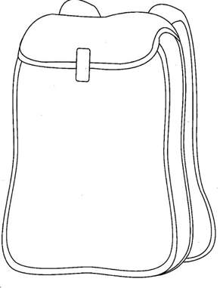  You can either...  - Draw a rucksack and the items inside it you would take with you. In addition to this you would need to explain why.  - Find a rucksack and the items you’d take along with you, photograph them and then create a power-point with a written paragraph next to each item explaining why.  Wednesday:  Write a senses poem about the seaside. Imagine you’re standing on the pebbles, listening to the waves crashing against the shoreline. What can you hear? What can you smell? What can you see? What can you taste? What can you feel?  E.g.  I can feel the cold water hitting my skin, as it hits the stones and sprays into the air.  I can feel the soft breeze brushing against my cheeks.  I can hear seagulls squawking and shrieking loudly from the sky above.  I can hear the waves hitting the shoreline and whistling as the roll back into the sea.  I can see children running in and out of the cold water, hopping around on the pebbles, trying to reach their picnic blankets.  Thursday:  Design a new swimming costume or pair of swim shorts that could be worn in the sea. What makes them special? Do they have a special cord that inflates a rubber ring, when pulled? Is there a secret compartment, holding a whistle that can be blown to alert for help if you find yourself in danger?  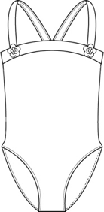  Describe your swimwear designs using expanded noun phrases and don’t forget to include details about their special features.  Friday:  Imagine you are on holiday at the Seaside. Use your imagination to write your teacher a postcard. What information could you include?  Use the following prompts to help you:  -What the weather is like?  -What activities you have been doing?  -Who you are on holiday with?  -What has been your holiday highlight?  -Which part would you rather forget?  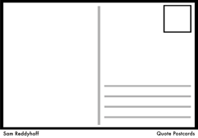  Don’t forget to illustrate your postcard and design your own stamp! | LEARNING WEBSITES  Maths  https://www.bbc.co.uk/bitesize/subjects/zjxhfg8  https://www.topmarks.co.uk/maths-games/hit-the-button  https://nrich.maths.org/9084  https://ttrockstars.com  https://mathszone.co.uk  https://www.ncetm.org.uk/public/files/23305578/Mastery_Assessment_Y2_High_Res.pdf  https://whiterosemaths.com  https://home.oxfordowl.co.uk/kids-activities/fun-maths-games-and-activities/  https://www.themathsfactor.com  English  Audible are doing a free 30-day trial so that children can listen to lots of books online.  https://www.bbc.co.uk/bitesize/subjects/zgkw2hv  https://www.topmarks.co.uk/english-games/5-7-years/letters-and-sounds  https://www.topmarks.co.uk/english-games/5-7-years/punctuation  https://www.topmarks.co.uk/english-games/5-7-years/words-and-spelling  https://www.topmarks.co.uk/english-games/5-7-years/learning-to-read  https://www.twinkl.co.uk/resources/games-twinkl-go/ks1-games-twinkl-go/english-ks1-games-twinkl-go  http://www.crickweb.co.uk/ks1literacy.html  https://www.education.com/games/early-literacy-concepts/
Maths Answers
Monday – I can recall and use multiplication facts for 2, 5 and 10 multiplication tables, including recognising odd and even numbers.
1 x 2 = 2 1 x 5 = 5 1 x 10 = 10
2 x 2 = 4 2 x 5 = 10 2 x 10 = 20
3 x 2 = 6 3 x 5 = 15 3 x 10 = 30
4 x 2 = 8 4 x 5 = 20 4 x 10 = 40
5 x 2 = 10 5 x 5 = 25 5 x 10 = 50
6 x 2 = 12 6 x 5 = 30 6 x 10 = 60
7 x 2 = 14 7 x 5 = 35 7 x 10 = 70
8 x 2 = 16 8 x 5 = 40 8 x 10 = 80
9 x 2 = 18 9 x 5 = 45 9 x 10 = 90
10 x 2 = 20 10 x 5 = 50 10 x 10 = 100
11 x 2 = 22 11 x 5 = 55 11 x 10 = 110
12 x 2 = 24 12 x 5 = 60 12 x 10 = 120

Even numbers Odd numbers
Tuesday - I can show that multiplication of two numbers can be done in any order (commutative)
3 x 2 = 6
2 x 3 = 6
4 x 5 = 20
5 x 4 = 20
8 x 10 = 80
10 x 8 = 80
11 x 2 = 22
2 x 11 = 22
6 x 5 = 30
5 x 6 = 30
0 x 10 = 0
10 x 0 = 0

What do you notice? Why do you think this is? The numbers are the same because the same numbers are used but in a different place within the number sentence.

Wednesday - I can solve problems involving multiplication using arrays

Thursday - I can solve problems involving multiplication using repeated addition including problems in contexts.

Friday - I can solve problems involving multiplication using materials and mental methods including problems in contexts.
£5 x 3 = £15. Sally spends £15.
£20 - £15 = £5
Sally woud get £5 change.

