Dear Parent/Carer,

Although the school is currently closed due to Coronavirus, we are continuing to provide educational tasks for your children to complete.

In primary, we suggest that children complete;
- 30 minutes a day reading to/with an adult (this could be a bedtime story)
- 30 minutes of Maths a day
- 30 minutes of English a day
- 30 minutes of PE/ physical activity
- A weekly topic/creative task

Home learning tasks can be supplemented with work from a number of websites (see list below for ideas)

Teachers will set a weekly programme for your child to work through at home. This will be available for you to access on the school website every Monday.

Whilst it is important for your child to keep up with their learning at home, we appreciate that this can be a stressful time for children and adults. Looking after mental health is vital. Therefore, we suggest that the day is broken up into manageable learning chunks, interspersed with physical exercise, fun activities and time together as a family. Activities such as the 30-day lego challenge and using the real PE activities could be a good place to start.

As well as educational learning, the children could also begin to learn different life skills – how do boil an egg, sew on a button, learn to send an email, bake a cake using a recipe book etc.

We hope you are all keeping well and staying positive.

Kind regards,

Miss Hatton, Mrs Hall and the Year 2 team.

YEAR 2 HOME LEARNING TASKS
WEEK BEGINNING: 1st June 2020
ENGLISH TASKS
This week’s spellings/phoneme:
-climb -again -clothes -wild -past

MONDAY- I can spell common exception words.
Use this week’s spelling words to complete the following tasks:
- How many different words can you make using the letters that make up each of your spelling words?
You can earn points for each word you create (see the point chart below). Why not play against an adult or sibling? Who can earn the most points and win?
2 letter word – 2 points
3 letter word – 5 points
4 letter word – 10 points
5+ letter word – 20 points
- Create a set of quiz questions for each of your spelling words. Present your mini spelling quiz to an adult or sibling and see if they get them right.
E.g. - Firefighters need to do this in order to reach fires at great heights (climb).
To repeat something (again).
Material you wear (clothes).
TUESDAY – I can make inferences.
Use the following link to watch Benji Davies read his book, ‘Grandad’s Island,’ aloud:
https://clpe.org.uk/powerofpictures/books-and-teaching-sequences-0/grandads-island
Once you have listened to the story, answer the following questions, using full sentences:
-How do you think Syd felt when Grandad revealed the big, metal door? Explain why.
-What do you think Syd was thinking as he stood on the top deck of the enormous ship? Explain why.
-How did Syd feel about the island? Explain how you know – Use evidence from the story.
-How do you think Syd felt, when Grandad told him he was going to stay on the island? Explain why.
-Why do you think the metal door disappeared? Explain.
-Is Grandad feeling lonely on the island? Explain how you know.
WEDNESDAY – I can spell common exception words.
Use this week’s spelling words to complete the following tasks:
- Create a spelling scribble poster like the one below:
(You may need to repeat your spellings more than once to complete your colourful scribble art).
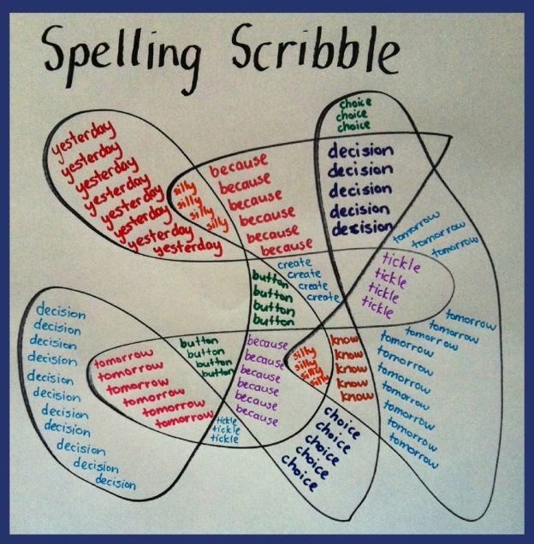
- Play a game of Tic Tac Toe, but using the following grid:
(You might need to copy out the grid).
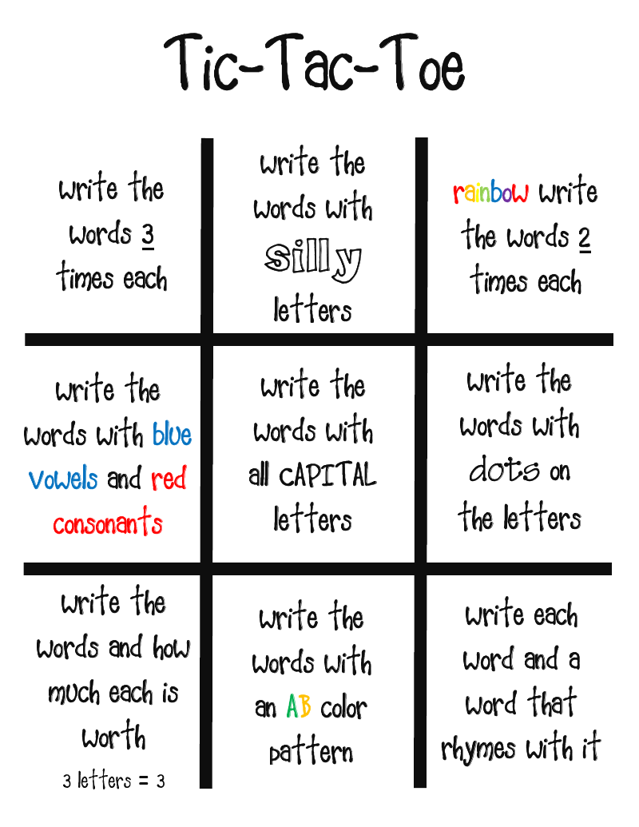
THURSDAY – I can write down ideas and/or key words, including new vocabulary
Imagine that you are Syd and that you’re going to write Grandad a letter to send back with the Toucan.
Use and re-create the following planning grid headings to record some ideas:
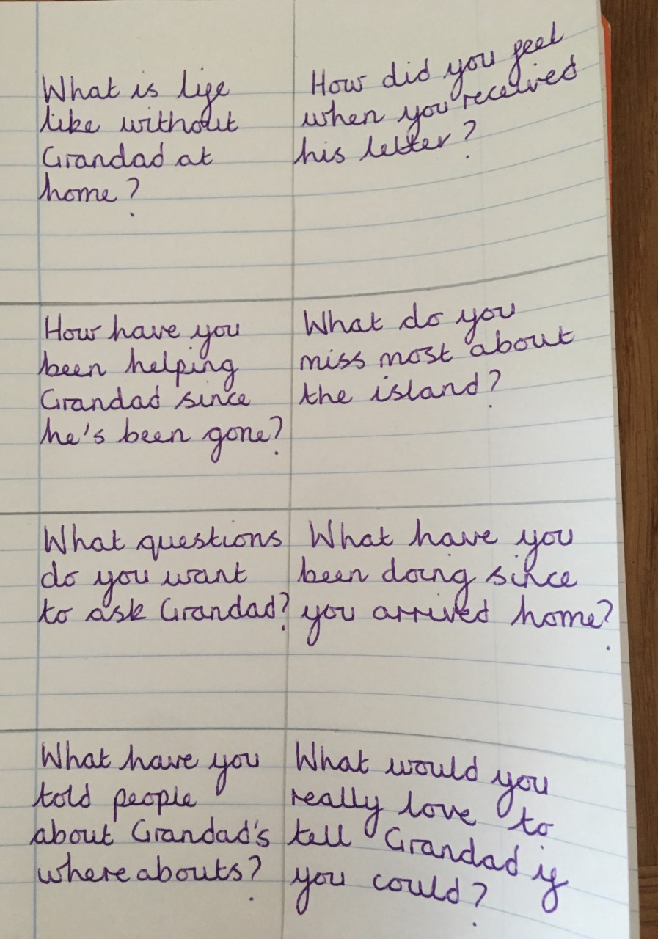
FRIDAY – I can write for different purposes.
Use your planning grid from yesterday’s task to write a letter to Grandad in role as Syd.
Think about how you will begin your letter? What information will you include? How will you end it?
See the example below:
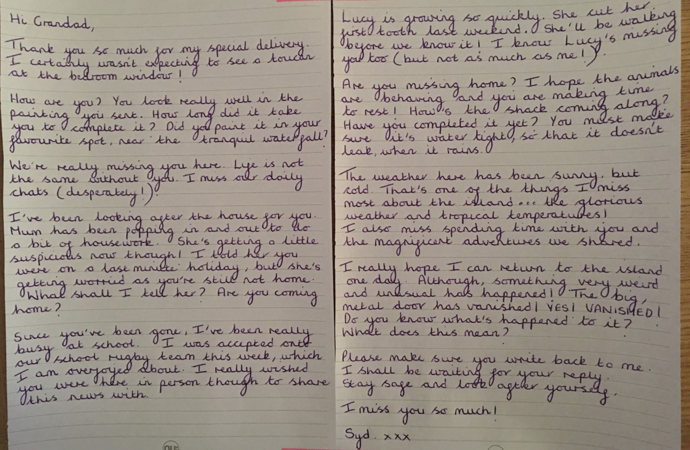
MATHS TASKS
This week's theme is: Shape

Videos you could watch to help you with your learning:

2D shapes song
https://www.youtube.com/watch?v=OEbRDtCAFdU

3D shapes song
https://www.youtube.com/watch?v=guNdJ5MtX1A

All about shapes
https://www.bbc.co.uk/bitesize/topics/zjv39j6

Monday: I can recognise and identify properties of 2D and 3D shapes
Go on a shape hunt around your home. What shapes can you find? Take photos!

Challenge: Give yourself a time limit. E.g. you have 5 minutes to find as many shapes as possible.

Tuesday: I can identify properties of 2D shapes

Task 2 – Create a picture using 2D shapes, can you name the shapes you have used? Send your pictures to your class teacher.

Wednesday: I can identify properties of 2D shapes

To make this fun you could use objects in your home to make rectangles. Examples; cocktail sticks, straws, pencils.

Thursday: I can describe the properties of 3D shapes

Friday: I can compare 3D shapes
Find 3D shapes in your home, what shapes are similar? What shapes are different? What are the properties of these shapes?
TOPIC/CREATIVE – Tragic Titanic!

This half term we are learning about the ‘Tragic Titanic’. Your task this week is to research about the Titanic. Write down all the interesting facts you find. Be creative!

So you don’t miss out on the school trip, take a virtual tour at the SeaCity Museum!
https://seacitymuseum.co.uk/online-activities

You could use these links to support you with your research:
All about the titanic PowerPoint: https://www.twinkl.co.uk/resource/t-h-214-all-about-the-titanic-information-powerpoint

A child’s survivor story: https://www.bbc.co.uk/programmes/p029z376

Twenty top Titanic facts: https://www.natgeokids.com/uk/discover/history/general-history/would-you-have-survived-the-titanic/

Titanic facts and figures: https://www.bbc.co.uk/bitesize/topics/z8mpfg8/articles/zng8jty
LEARNING WEBSITES
Maths
https://www.bbc.co.uk/bitesize/subjects/zjxhfg8
https://www.topmarks.co.uk/maths-games/hit-the-button
https://nrich.maths.org/9084
https://ttrockstars.com
https://mathszone.co.uk
https://www.ncetm.org.uk/public/files/23305578/Mastery_Assessment_Y2_High_Res.pdf
https://whiterosemaths.com
https://home.oxfordowl.co.uk/kids-activities/fun-maths-games-and-activities/
https://www.themathsfactor.com

English
Audible are doing a free 30-day trial so that children can listen to lots of books online.
https://www.bbc.co.uk/bitesize/subjects/zgkw2hv
https://www.topmarks.co.uk/english-games/5-7-years/letters-and-sounds
https://www.topmarks.co.uk/english-games/5-7-years/punctuation
https://www.topmarks.co.uk/english-games/5-7-years/words-and-spelling
https://www.topmarks.co.uk/english-games/5-7-years/learning-to-read
https://www.twinkl.co.uk/resources/games-twinkl-go/ks1-games-twinkl-go/english-ks1-games-twinkl-go
http://www.crickweb.co.uk/ks1literacy.html
https://www.education.com/games/early-literacy-concepts/
Maths Answers
Tuesday - I can identify properties of 2D shapes

Wednesday – I can identify properties of 2D shapes

Thursday - I can describe the properties of 3D shapes

