Dear Parent/Carer,

Although the school is currently closed due to Coronavirus, we are continuing to provide educational tasks for your children to complete.

In primary, we suggest that children complete;
- 30 minutes a day reading to/with an adult (this could be a bedtime story)
- 30 minutes of Maths a day
- 30 minutes of English a day
- 30 minutes of PE/ physical activity
- A weekly topic/creative task

Home learning tasks can be supplemented with work from a number of websites (see list below for ideas)

Teachers will set a weekly programme for your child to work through at home. This will be available for you to access on the school website every Monday.

Whilst it is important for your child to keep up with their learning at home, we appreciate that this can be a stressful time for children and adults. Looking after mental health is vital. Therefore, we suggest that the day is broken up into manageable learning chunks, interspersed with physical exercise, fun activities and time together as a family. Activities such as the 30-day lego challenge and using the real PE activities could be a good place to start.

As well as educational learning, the children could also begin to learn different life skills – how do boil an egg, sew on a button, learn to send an email, bake a cake using a recipe book etc.

We hope you are all keeping well and staying positive.

Kind regards,

Miss Hatton, Mrs Hall and the Year 2 team.

YEAR 2 HOME LEARNING TASKS
WEEK BEGINNING: 8th June 2020
ENGLISH TASKS
This week’s spellings/phoneme:
-pretty -old -cold -fast -find
MONDAY – I can spell common exception words
Use this week’s spelling words to complete the following activities:
- Create spelling spirals for each of this week’s spelling words.
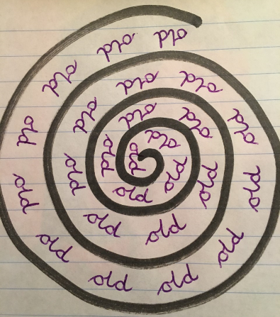
- Write each spelling word, using 5 different resources (You can use alternative resources, if you do not have the ones on the suggested activity sheet):
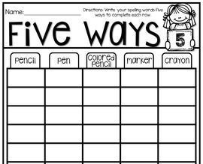

TUESDAY – I can make predictions based on what is said or done
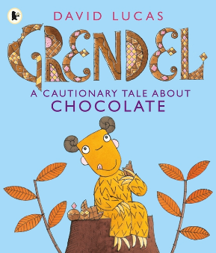
In a moment, you will need to follow the link below to watch David Lucas read and present one of his books called, ‘Grendel A Cautionary Tale About Chocolate.’ Before watching the clip, write a predictive paragraph, detailing what you think the story might be about. What does the word cautionary mean? Does something go wrong in the story? What goes wrong? What does this have to do with chocolate?
After you have written your prediction, watch the online reading - https://clpe.org.uk/powerofpictures/books-and-teaching-sequences-0/grendel-cautionary-tale-about-chocolate
What did Grendel’s mother wish for at the end of the story? What do you predict will happen next? What do you think Grendel’s mother will use her other wishes for? Write your answers in full sentences.

WEDNESDAY – I can spell common exception words
Use this week’s spelling words to complete the following activity:
- Play Spelling Roll-A-Word. The aim of the game is to complete each activity for all five words. How quickly can you roll numbers 1-6 for each word? The game is on!
Remember: Synonym means an alternative word with a similar meaning e.g. cross/angry/fuming
Antonym means the opposite e.g. night/day, left/right, up/down
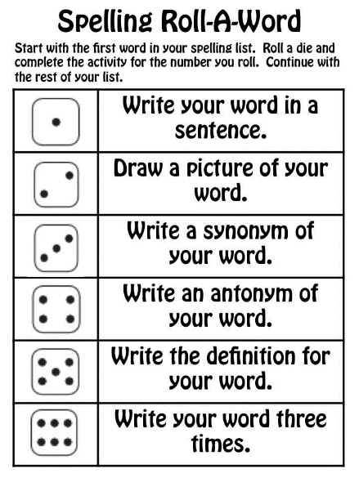
THURSDAY – I can consider what I am going to write about before beginning
Following on from Tuesday’s task based on the book, ‘Grendel A Cautionary Tale About Chocolate,’ we are going to think carefully about what we would wish for, if we were lucky enough to open a chocolate egg and find a special note like Grendel did.

Today’s task is to design and create your own wish jar! You will need to design your jar first, before making it, using recycled items only! You will need to make sure that it represents you (includes things or pictures of things that you like), is eye-catching and big enough to fill with lots of exciting wishes.
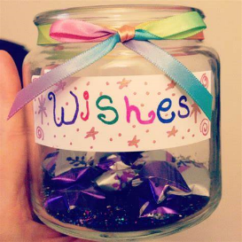
FRIDAY – I can write for different purposes.
Today, you are going to think carefully about what you would wish for. Remember in the story, Grendel quickly regretted wishing that everything she touched, turned to chocolate. If you had three wishes, what would they be?
Share and discuss these with your adult, before writing them onto small slips of paper and posting them in your wish jar. Spend time writing out each wish in more detail, including the reasons why you chose to wish for it.
See the example below:
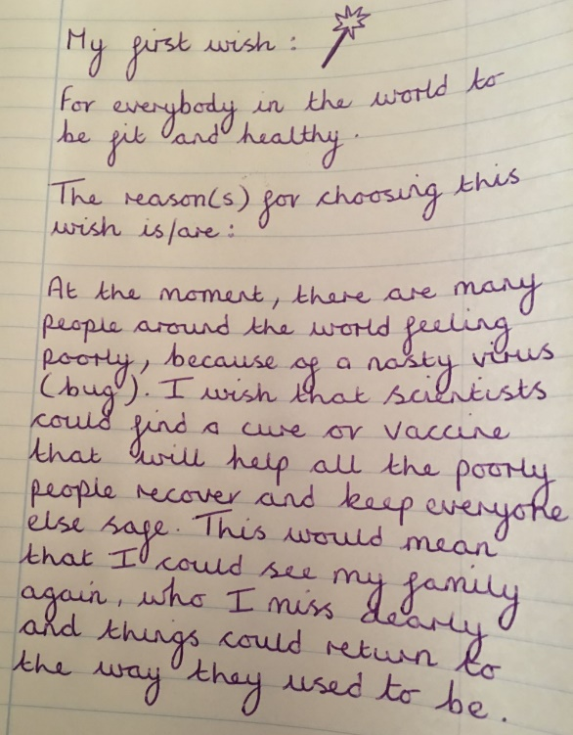

MATHS TASKS
This week's theme is: Division

Videos you could watch to help you with your learning:

What is division?
https://www.bbc.co.uk/bitesize/topics/zqbg87h/articles/z9jxhv4

How to divide using arrays
https://www.bbc.co.uk/bitesize/topics/zqbg87h/articles/z9pc8mn

MONDAY – I can solve problems involving division
Draw and cut out 15 people.

You’ll need to make one group of 5 people and another group of 10 people to complete the following activity.

TUESDAY – I can recall and use division facts for the 2 times table
If you have coins, this may help you with this activity. If not, you could draw the coins. What coins could you use to make 24p?

WEDNESDAY – I can recall and use division facts for the 5 times table
Activity 1 – Find objects in your house e.g. lego, pencils. Can you put these into 5 groups? How many are in each group
There are ______ pencils/lego etc
There are ______ groups
There are ______ in each group
___ ÷ ____ = _____
___ x ____ = _____
Activity 2:

THURSDAY – I can recall and use division facts for the 10 times table

Once you have explored this and found the answer. Create a poster to show this. You could draw apples, people etc. Once you have made this, send it to your class teacher!

FRIDAY – Applying all objectives into one task
Design your own board game for division. Perhaps you could make your board game with different materials e.g. cardboard, milk bottle tops for the counters. Take a photo when you play your game. Who will win?

(Please find answers on the bottom of this document)
TOPIC/CREATIVE – Terrible Titanic!
Here are some ideas you could complete this week, you could select a few or you could complete all tasks (this is optional). Have fun!

Task 1 – Look around your home, what materials would be suitable for a boat?
Task 2 – Find materials around your home and test to see how they change shape. Does the material bend, twist, stretch and can you squash it?
Task 3 – Now chose the best material and make your very own Titanic!
Task 4 – Can you remember the 7 continents and 5 oceans from Year 1? Now use Google Earth to explore these. Find out where the Titanic hit the iceberg. Can you locate this on the globe?
Task 5 – Create a map using a key. If you would like you could make a boat and use directional language to move your boat in different directions.

LEARNING WEBSITES

Maths
https://www.bbc.co.uk/bitesize/subjects/zjxhfg8
https://www.topmarks.co.uk/maths-games/hit-the-button
https://nrich.maths.org/9084
https://ttrockstars.com
https://mathszone.co.uk
https://www.ncetm.org.uk/public/files/23305578/Mastery_Assessment_Y2_High_Res.pdf
https://whiterosemaths.com
https://home.oxfordowl.co.uk/kids-activities/fun-maths-games-and-activities/
https://www.themathsfactor.com

English
Audible are doing a free 30-day trial so that children can listen to lots of books online.
https://www.bbc.co.uk/bitesize/subjects/zgkw2hv
https://www.topmarks.co.uk/english-games/5-7-years/letters-and-sounds
https://www.topmarks.co.uk/english-games/5-7-years/punctuation
https://www.topmarks.co.uk/english-games/5-7-years/words-and-spelling
https://www.topmarks.co.uk/english-games/5-7-years/learning-to-read
https://www.twinkl.co.uk/resources/games-twinkl-go/ks1-games-twinkl-go/english-ks1-games-twinkl-go
http://www.crickweb.co.uk/ks1literacy.html
https://www.education.com/games/early-literacy-concepts/

Maths Answers
Wednesday - I can interpret pictograms

Thursday – I can interpret pictograms

