Dear Parent/Carer,

Although the school is currently closed due to Coronavirus, we are continuing to provide educational tasks for your children to complete.

In primary, we suggest that children complete;
- 30 minutes a day reading to/with an adult (this could be a bedtime story)
- 30 minutes of Maths a day
- 30 minutes of English a day
- 30 minutes of PE/ physical activity
- A weekly topic/creative task

Home learning tasks can be supplemented with work from a number of websites (see list below for ideas)

Teachers will set a weekly programme for your child to work through at home. This will be available for you to access on the school website every Monday.

Whilst it is important for your child to keep up with their learning at home, we appreciate that this can be a stressful time for children and adults. Looking after mental health is vital. Therefore, we suggest that the day is broken up into manageable learning chunks, interspersed with physical exercise, fun activities and time together as a family. Activities such as the 30-day lego challenge and using the real PE activities could be a good place to start.

As well as educational learning, the children could also begin to learn different life skills – how do boil an egg, sew on a button, learn to send an email, bake a cake using a recipe book etc.

We hope you are all keeping well and staying positive.

Kind regards,

Miss Hatton, Mrs Hall and the Year 2 team.

YEAR 2 HOME LEARNING TASKS
WEEK BEGINNING: 15th June 2020
ENGLISH TASKS
This week’s spellings/phoneme: Words ending in ‘tion’
station, fiction, motion, national, section
MONDAY – I can spell words ending in ‘tion’
1.) Put each word into a sentence of your own. Can you include a conjunction too?
(when, if, that, because, or, but, and)
2.) Find the definition of each word in a dictionary and create a mini glossary. Don’t forget to alphabetise your words!
3.) Create a mind-map of as many words as you can ending in ‘tion.’

TUESDAY – I can answer questions.
Listen to the online story, ‘Here Comes Frankie!’ by Tim Hopgood and then answer the following questions, using full sentences: https://clpe.org.uk/powerofpictures/books-and-teaching-sequences/here-comes-frankie
1.) Looking at the illustration on the front cover, what do you think the story might be about?
2.) How would you feel about living along Ellington Avenue? Explain why.
3.) How do you think Frankie felt before and after he got his trumpet? How did his feelings change? Explain why.
4.) How did his Mum and Dad feel about him getting a trumpet? Explain how you know, using evidence from the book.
5.) Which of our six super learning powers (resourceful, ready, resilient, respectful, responsible, reflective) did Frankie display throughout the story? Explain why.

WEDNESDAY – I can spell words ending in ‘tion’
1.) Pyramid write each of this week’s spelling words.
2.) Collage the word – Cut out letters from magazines or newspapers to form each spelling word.
3.) Muddle the letters in each spelling word and see if your adult can guess which words they are! You could ask your adults to muddle the letters too, so that you can have a go!
4.) Use the following British Sign Language Alphabet Poster to practise signing this week’s spelling words:
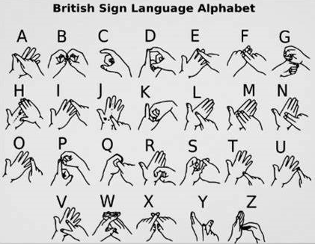
THURSDAY – I can write down ideas and/or key words, including new vocabulary
Create your own storyboard of the text, ‘Here Comes Frankie!’ written by Tim Hopgood. You may wish to annotate your story map with key words or short sentences to help remind you of the story. You will need this plan in preparation for tomorrow’s writing task! Alternatively, use the example storyboard below and add your own annotations.
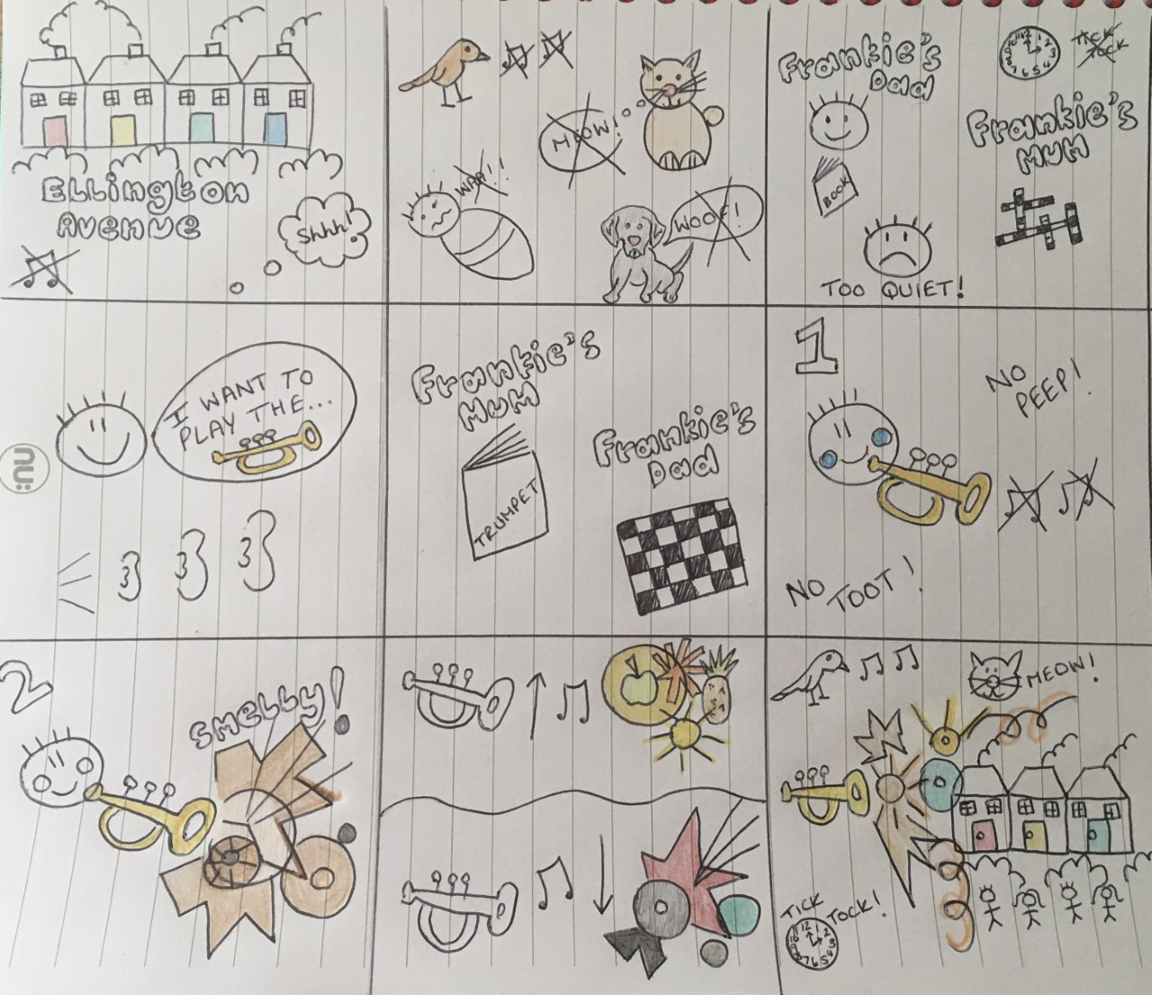
FRIDAY – I can write for different purposes.
Using your storyboard plan from yesterday’s home learning activity, re-write the story of, ‘Here Comes Frankie!’ in your own words. You may wish to try and write it from Frankie’s viewpoint! Can you include a range of conjunctions (when, if, that, because, or, but, and) and examples of expanded noun phrases e.g. colourful bubbles! You are more than welcome to use the story starter below:

There once lived a boy named Frankie on a very usual street. A street that was deadly silent! Not a sound could be heard from miles around. There were no sweet sounds of birds tweeting in trees or children chattering and playing in nearby adventure playgrounds. Just...silence! Peace and quiet swept through the town!

MATHS TASKS
This week's theme is: Statistics
In Year 2 we only look at tally charts, pictograms and block diagrams.

Videos you could watch to help you with your learning:
How to collect data
https://www.bbc.co.uk/bitesize/topics/zg6tyrd/articles/zgg9pbk

How to use simple data tables
https://www.bbc.co.uk/bitesize/topics/zv2mn39/articles/z3c2gdm

MONDAY – I can construct a tally chart
Option 1: On your daily walk, record how many different colour cars you see
e.g.
red - |||
blue - ||||
Remember if you have 5 you put a diagonal line through the 4 straight lines.

Option 2: Go on a hunt around your house, record how many objects are of different colours e.g. you may find a green book so you would put a tally mark next to green.

TUESDAY – I can construct a pictogram
Ask as many family and friends what their favourite fruit is. Record this as a pictogram.
An example:

WEDNESDAY – I can interpret pictograms
Option 1: Answer the following questions about your pictogram
Which fruit was the most popular?
Which fruit was the least popular?
What does each symbol represent? E.g. 1 person, 2 people.
How many people like ____ and _____? E.g. How many people liked bananas and apples

Option 2: Complete the following activity

THURSDAY – I can interpret pictograms

Option 1: Answer the following questions about the pictogram shown above (look at the key carefully)
How many ice-creams were sold on Tuesday?
How many ice-creams were sold at the weekend?
Which day sold the most ice-creams?
Which day sold the least ice-creams?

Option 2: Answer the following questions

FRIDAY – I can construct a block diagram
Think of a question you would like to ask. E.g. how do you get to school? What colour hair do you have? What is your favourite animal?

Ask your friends and family the question you choose. Then, make a block diagram (make sure these are blocks)
Example:

(Please find answers on the bottom of this document)
TOPIC/CREATIVE – Terrible Titanic!

Task 1 – What is weather? What are the different weather types? Find out the weather forecast for this week. What do the symbols mean shown on a map?
Record the weather for each day this week. https://www.bbc.co.uk/bitesize/clips/z9g87ty
Task 2 - What is the weather like in each of the four seasons? Draw four trees to represent each of the seasons e.g. Spring will have blossom on the trees, Autumn would have brown/red leaves falling off.
Task 3– What is the weather like in the UK? What is the weather like in Antartica? https://www.bbc.co.uk/bitesize/topics/zyhp34j/articles/zjg46v4
Task 4 – Draw two pictures to show the contrast in weather between United Kingdom and Antartica
Task 5 – Send your weather pattern from this week to your class teacher

LEARNING WEBSITES

Maths
https://www.bbc.co.uk/bitesize/subjects/zjxhfg8
https://www.topmarks.co.uk/maths-games/hit-the-button
https://nrich.maths.org/9084
https://ttrockstars.com
https://mathszone.co.uk
https://www.ncetm.org.uk/public/files/23305578/Mastery_Assessment_Y2_High_Res.pdf
https://whiterosemaths.com
https://home.oxfordowl.co.uk/kids-activities/fun-maths-games-and-activities/
https://www.themathsfactor.com

English
Audible are doing a free 30-day trial so that children can listen to lots of books online.
https://www.bbc.co.uk/bitesize/subjects/zgkw2hv
https://www.topmarks.co.uk/english-games/5-7-years/letters-and-sounds
https://www.topmarks.co.uk/english-games/5-7-years/punctuation
https://www.topmarks.co.uk/english-games/5-7-years/words-and-spelling
https://www.topmarks.co.uk/english-games/5-7-years/learning-to-read
https://www.twinkl.co.uk/resources/games-twinkl-go/ks1-games-twinkl-go/english-ks1-games-twinkl-go
http://www.crickweb.co.uk/ks1literacy.html
https://www.education.com/games/early-literacy-concepts/

Maths Answers
Wednesday - I can interpret pictograms

Thursday – I can interpret pictograms

