Dear Parent/Carer,

Although the school is currently closed due to Coronavirus, we are continuing to provide educational tasks for your children to complete.

In primary, we suggest that children complete;
- 30 minutes a day reading to/with an adult (this could be a bedtime story)
- 30 minutes of Maths a day
- 30 minutes of English a day
- 30 minutes of PE/ physical activity
- A weekly topic/creative task

Home learning tasks can be supplemented with work from a number of websites (see list below for ideas)

Teachers will set a weekly programme for your child to work through at home. This will be available for you to access on the school website every Monday.

Whilst it is important for your child to keep up with their learning at home, we appreciate that this can be a stressful time for children and adults. Looking after mental health is vital. Therefore, we suggest that the day is broken up into manageable learning chunks, interspersed with physical exercise, fun activities and time together as a family. Activities such as the 30-day lego challenge and using the real PE activities could be a good place to start.

As well as educational learning, the children could also begin to learn different life skills – how do boil an egg, sew on a button, learn to send an email, bake a cake using a recipe book etc.

We hope you are all keeping well and staying positive.

Kind regards,

Miss Hatton, Mrs Hall and the Year 2 team.

YEAR 2 HOME LEARNING TASKS
WEEK BEGINNING: 11th May 2020
ENGLISH TASKS  This week’s spellings/phoneme:  - beautiful  - because  - children  - father  - improve  MONDAY – I can spell common exception words  Using this week’s common exception words, play battleships. This is a two-player game, so you will need to play with an adult or an older sibling. You will need to draw two grids like the one below for each player:  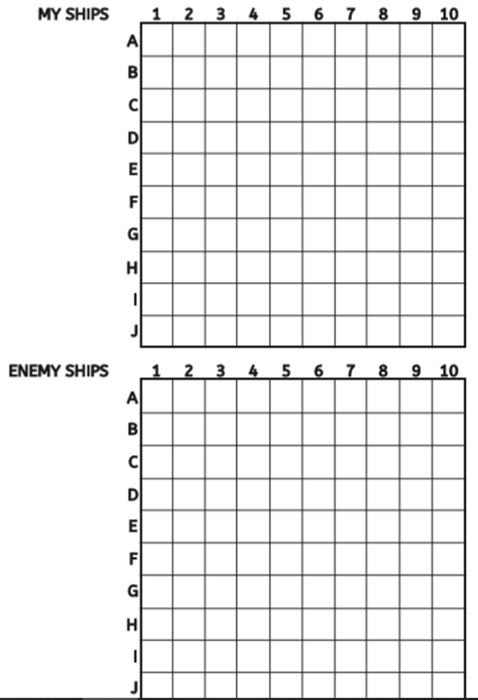  You will need to sit back-to-back with your partner, so that they cannot see where you have placed your ships (spelling words). Place your five spelling words onto your grid, making sure you place each letter in a different square. Your words must not overlap but can run vertically or horizontally across the grid. Take turns in firing at your enemy's ships (spelling words) by shouting out a plot point e.g. D3. Mark your shots on your enemy grid according to your enemy’s reply – Mark an ’X' to show a direct hit and an ’M’ to record a miss.  When your enemy fires at you, shout hit if the plot point includes a letter of one of your spelling words or miss if it is blank. Mark your partner’s shots on ‘My Ships’ grid. When your enemy has hit all the letters in your word, this means the ship has sunk and you must tell them.  The first person to sink all their enemy’s ships (spelling words) is the winner.  TUESDAY – I can be introduced to non-fiction books  Choose a non-fiction book to read and enjoy. Spend time investigating non-fiction features. E.g. Titles, big bold text, headings etc. Create a non-fiction feature mind-map. How many can you find?  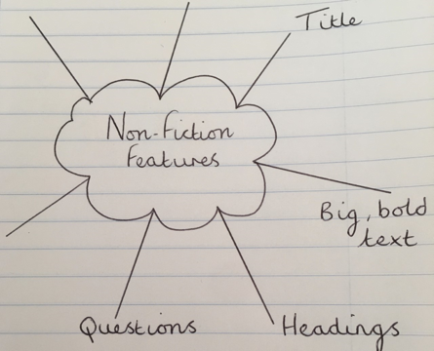  Once you have created your non-fiction feature mind-map, create a fact-file about the subject of your chosen book. You may wish to design a fact-file poster, using some of the non-fiction features. E.g. text boxes. Or you may wish you create a fact-file power-point.  WEDNESDAY – I can spell common exception words  Design your own alphabet code like the one below:  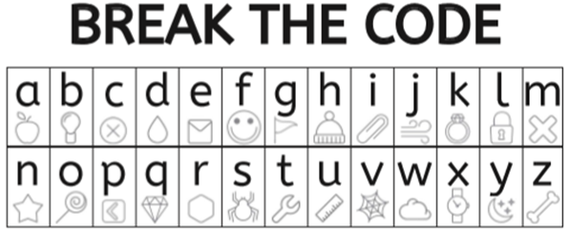 Begin by coding each of this week’s spelling words for your adult or siblings to crack. Then attempt to put each word into a sentence, before coding that too. Can your adult/sibling crack the sentence? Maybe your adult/sibling could put each spelling word into a sentence as well for you to identify?  THURSDAY – I can write down ideas and/or key words, including new vocabulary.  Design an animal or unusual creature (Be as imaginative as you can!). Describe your animal, using expanded noun phrases (See the example below).  Bullet point some planning ideas under the following headings:  -What does your animal like to eat?  -Where does your animal live? Why?  -What special features does your animal have or display?  -What does your animal look-like?  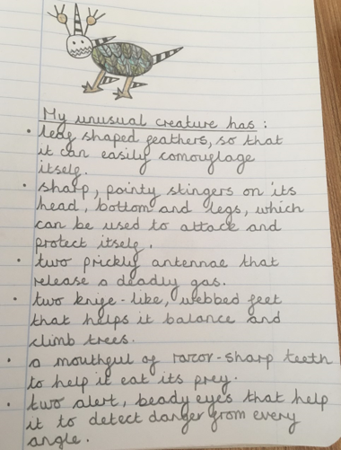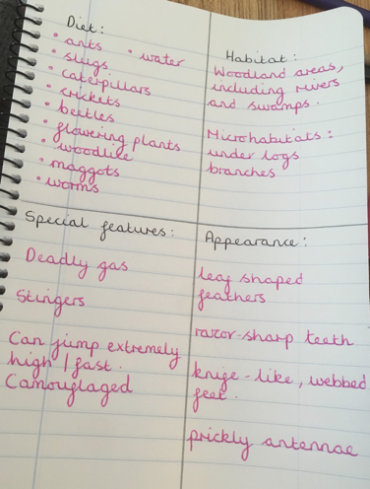  FRIDAY – I can write for different purposes.  Create a non-fiction information poster about your animal or unusual creature. You will need to refer to your non-fiction feature mind-map, to include as many of these features in your information poster as you can.  -You will need to create a title for your poster.  -You will need to use the following sub-headings:  -Diet  -Habitat  -Special features  -Appearance  Can you include expanded noun phrases and the following conjunctions – (when, if, because, or, and, but, that) in your written paragraphs?  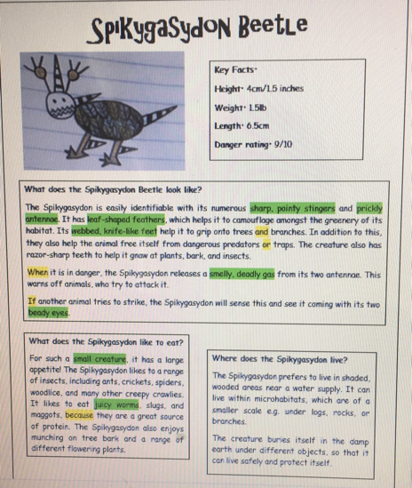 | MATHS TASKS  This week’s theme is: Subtraction  Monday: I can subtract a one-digit number from a two-digit number  Make a number line, it could be:  0 – 20  0 – 30  0 – 50  Draw or find a picture of a frog and cut it out. Practise subtracting a one-digit number from a two-digit number by making the frog jump backwards.  16 – 4 = 12  finish start  10 11 12 13 14 15 16 17 18 19  TUESDAY: I can subtract two two-digit numbers  Set up a shop!  - Give your shop a name.  - Find some objects in your home and give them a price e.g. a teddy could be 23p.  Example of how to play: Ask someone to come and buy your teddy. They give you 25p. To work out how much change to give them you need to work out 25p – 23p so you would give them 2p change.  (remember you are practising subtracting two two-digit numbers)  If you don’t have money at home, make the coins and notes with paper. I would love to see photos and videos of your shop!  WEDNESDAY: I can recall and use subtraction facts to 20 fluently, and derive and use related facts up to 100 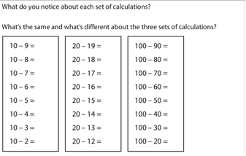  THURSDAY – I can recognise and use the inverse relationship and use this to check calculations.  56 – 23 = 33. Miss Hatton says this is wrong because she did the inverse and worked out 56 + 23 = 79. Is Miss Hatton correct? Prove it.  FRIDAY – I can apply my knowledge of mental and written methods  How many numbers can you think of to make the sentence correct?  67 - ___ < 67 – 24  Challenge: What do you notice?
TOPIC/CREATIVE  Science Objectives:  - Describe the importance for humans of exercise, eating the right amounts of different types of food, and hygiene  - Find out about and describe the basic needs of animals, including humans, for survival (water, food and air)  - Find out and describe how plants need water, light and a suitable temperature to grow and stay healthy  Task 1  How many of the following can you complete in 1 minute?  - Star jumps  - Sit ups  - Hops  - Burpees  How does it make you feel after these? What is happening to your heartbeat? Why is exercise important?  Task 2  What do humans need to stay healthy? Record the activities you do to stay healthy. Perhaps take pictures or videos to share with your teacher.  https://www.bbc.co.uk/bitesize/topics/z9yycdm/articles/zxvkd2p  Task 3  Look in your garden. What do plants need in order to grow? https://www.bbc.co.uk/bitesize/topics/zpxnyrd/articles/zxxsyrd  Record your learning in a creative way e.g. poster, PowerPoint, story strip, leaflet etc | LEARNING WEBSITES  Maths  https://www.bbc.co.uk/bitesize/subjects/zjxhfg8  https://www.topmarks.co.uk/maths-games/hit-the-button  https://nrich.maths.org/9084  https://ttrockstars.com  https://mathszone.co.uk  https://www.ncetm.org.uk/public/files/23305578/Mastery_Assessment_Y2_High_Res.pdf  https://whiterosemaths.com  https://home.oxfordowl.co.uk/kids-activities/fun-maths-games-and-activities/  https://www.themathsfactor.com  English  Audible are doing a free 30-day trial so that children can listen to lots of books online.  https://www.bbc.co.uk/bitesize/subjects/zgkw2hv  https://www.topmarks.co.uk/english-games/5-7-years/letters-and-sounds  https://www.topmarks.co.uk/english-games/5-7-years/punctuation  https://www.topmarks.co.uk/english-games/5-7-years/words-and-spelling  https://www.topmarks.co.uk/english-games/5-7-years/learning-to-read  https://www.twinkl.co.uk/resources/games-twinkl-go/ks1-games-twinkl-go/english-ks1-games-twinkl-go  http://www.crickweb.co.uk/ks1literacy.html  https://www.education.com/games/early-literacy-concepts/

