Dear Parent/Carer,

Although the school is open to all primary pupils, we are continuing to provide educational tasks as we know that not all children are able to attend. We are also offering opportunities for children to reconnect with school and learn with their teachers through online sessions, pre recorded videos/tasks and home learning support. Each teacher will be posting further information in their weekly email.

In primary, we suggest that children complete;
- 30 minutes a day reading to/with an adult (this could be a bedtime story)
- 30 minutes of Maths a day
- 30 minutes of English a day
- 30 minutes of PE/ physical activity
- A weekly topic/creative task

Home learning tasks can be supplemented with work from a number of websites (see list below for ideas)

Teachers will set a weekly programme for your child to work through at home. This will be available for you to access on the school website every Monday.

Whilst it is important for your child to keep up with their learning at home, we appreciate that this can be a stressful time for children and adults. Looking after mental health is vital. Therefore, we suggest that the day is broken up into manageable learning chunks, interspersed with physical exercise, fun activities and time together as a family. Activities such as the 30-day lego challenge and using the real PE activities could be a good place to start.

As well as educational learning, the children could also begin to learn different life skills – how do boil an egg, sew on a button, learn to send an email, bake a cake using a recipe book etc.

We hope you are all keeping well and staying positive.

Kind regards,

Miss Hatton, Mrs Hall and the Year 2 team.

YEAR 2 HOME LEARNING TASKS
WEEK BEGINNING: 20th July 2020
Bubble School – Every Monday and Tuesday

This will be the last home learning pack for the year. We hope you have a well deserved rest and enjoy your Summer holiday. Well done for all your hard work and for being resilient!
ENGLISH TASKS
This week’s spellings/phoneme:
L.O. – I can spell words which contain the ‘l’ sound, spelt -le, -el, -al, -il
-circle, -metal, -tunnel, -pencil, -travel
Use the following strategies to help you learn this week’s spellings.
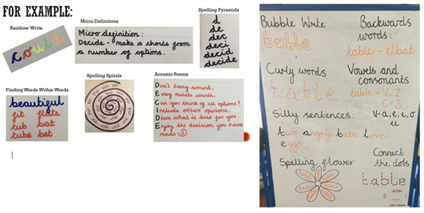
Monday - L.O. – I can spell words which contain the ‘l’ sound, spelt -le, -el, -al, -il
We have already spent time learning words that contain the /l/ sound, spelt -le. This is the most common way of spelling words with this sound ending; however, today we are going to look at the alternative ways of spelling the /l/ sound at the end of words.
Spelling Rules:
-The –le spelling is the most common spelling for this sound at the end of words.
-The –el spelling is much less common than –le. The –el spelling is used after m, n, r, s, v, w and more often than not after s.
-Not many nouns end in –al, but many adjectives do.
-There are not many words that end in -il.

Use these spelling rules to help you answer the ‘Which Spelling?’ questions on the power-point link below:
https://mayfieldschoolpo2.sharepoint.com/:p:/g/admin-staff/EWIZb6x_Gm1Lqyksr0xBaqUByrfbC6fyEHlXPKdmJk-P2Q
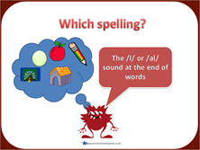
How many /l/ word endings did you get right? How many other -le, -el, -al, -il words can you think of? Add them to the following grid.
le | el | al | il
circle | kennel | crystal | pencil
triangle | parcel | hospital | stencil
kettle | towel | animal | fossil
apple | barrel | oval
juggle | camel | pedal
table | squirrel
purple
beetle

Now try putting the words into sentences. How many /l/ ending words can you include in one sentence? Can you include an example from each column?
Extension – Why not complete the -le, -el, -il and -al mini assessment check?
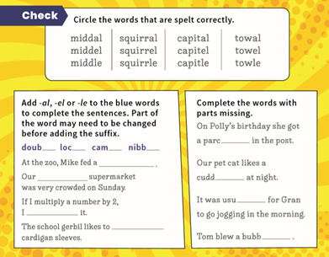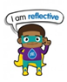
Tuesday – I can write for different purposes.
Today, we are going to reflect on our year in Y2. In your own creative way, you will need to answer the following questions, using full sentences and a range of conjunctions (when, if, that, because, and, or, but). You may wish to use each question as a sub-heading and record a written answer underneath or you may wish to design a ‘My Year in Y2!’ poster/power-point. Please send your final piece of work to your class teacher, as they would love to read it!
- What have been your Y2 highlights? What have you enjoyed most?
- Which trip did you enjoy most? Why? (Beaulieu/Cumberland House)
- What friends did you make this year?
- Which lessons have you enjoyed the most? Why?
- Which of the super learning powers have you displayed this year? Give examples.
- What are you going to miss most about Y2?
- What are you most looking forward to in Y3?
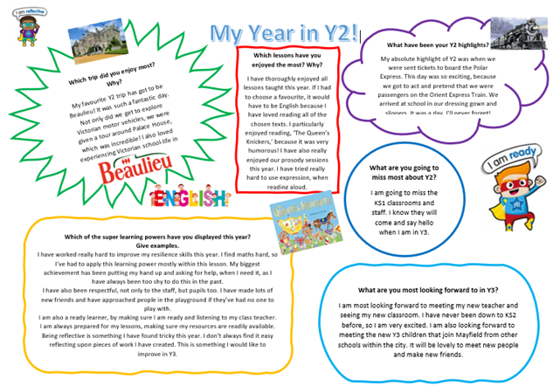
MATHS TASKS
This week's theme is: Time
We haven’t had the chance to teach Time in Year 2. However, in Year 1 children learnt about telling the time to the hour and half past the hour. These two days we will be recapping this learning as well as introducing quarter past and quarter to.
This interactive clock may help you with your learning: https://www.topmarks.co.uk/time/teaching-clock

MONDAY
L.O: I can tell the time including quarter past/to the hour

Starter
Why do we need to tell the time?
What helps us to know what the time is? How many objects can you think of?

Work through PowerPoint
https://www.twinkl.co.uk/resource/t-n-7132-telling-the-time-powerpoint

Task
Use the template to make your own clock. Can you identify where the numbers go? What does the small hand represent? What does the big hand represent?

Once you have made your clock, practise telling the time.
e.g. Show me 4 o’clock, half past 6, quarter past 1, quarter to 9

TUESDAY
L.O: I can tell and write the time including quarter past/to the hour and draw the hands on a clock face to show these times

Starter:
Using your clock, show the following times:
- Quarter past 3
- Quarter past 7
- Quarter to 2
- Quarter to 10
- Quarter past 12
- Quarter to 8
What number is the long hand pointing to when it is quarter past 1?
What number is the short hand pointing to when it is quarter past ____?

Games: http://www.scootle.edu.au/ec/viewing/L9643/index.html
http://www.ictgames.com/mobilePage/hickoryDickory/index.html (Level 1)

Task:
Use your clock you made yesterday to help you with your learning. Show the time on your clock then copy this onto the sheet.
Draw the hands on the clock to match the time shown.

TOPIC/CREATIVE – Terrible Titanic!

Monday
As we have come to the end of our topic, your task is to make a poster to show everything you have learnt about the Titanic. How much have you learnt? What is the most interesting fact you found?

Tuesday
Make a poster to show what you are looking forward to next year in Year 3.
LEARNING WEBSITES

Maths
https://www.bbc.co.uk/bitesize/subjects/zjxhfg8
https://www.topmarks.co.uk/maths-games/hit-the-button
https://nrich.maths.org/9084
https://ttrockstars.com
https://mathszone.co.uk
https://www.ncetm.org.uk/public/files/23305578/Mastery_Assessment_Y2_High_Res.pdf
https://whiterosemaths.com
https://home.oxfordowl.co.uk/kids-activities/fun-maths-games-and-activities/
https://www.themathsfactor.com

English
Audible are doing a free 30-day trial so that children can listen to lots of books online.
https://www.bbc.co.uk/bitesize/subjects/zgkw2hv
https://www.topmarks.co.uk/english-games/5-7-years/letters-and-sounds
https://www.topmarks.co.uk/english-games/5-7-years/punctuation
https://www.topmarks.co.uk/english-games/5-7-years/words-and-spelling
https://www.topmarks.co.uk/english-games/5-7-years/learning-to-read
https://www.twinkl.co.uk/resources/games-twinkl-go/ks1-games-twinkl-go/english-ks1-games-twinkl-go
http://www.crickweb.co.uk/ks1literacy.html
https://www.education.com/games/early-literacy-concepts/

