Dear Parent/Carer,

Although the school is currently closed due to Coronavirus, we are continuing to provide educational tasks for your children to complete.

In primary, we suggest that children complete;
- 30 minutes a day reading to/with an adult (this could be a bedtime story)
- 30 minutes of Maths a day
- 30 minutes of English a day
- 30 minutes of PE/ physical activity
- A weekly topic/creative task

Home learning tasks can be supplemented with work from a number of websites (see list below for ideas)

Teachers will set a weekly programme for your child to work through at home. This will be available for you to access on the school website every Monday.

Whilst it is important for your child to keep up with their learning at home, we appreciate that this can be a stressful time for children and adults. Looking after mental health is vital. Therefore, we suggest that the day is broken up into manageable learning chunks, interspersed with physical exercise, fun activities and time together as a family. Activities such as the 30-day lego challenge and using the real PE activities could be a good place to start.

As well as educational learning, the children could also begin to learn different life skills – how do boil an egg, sew on a button, learn to send an email, bake a cake using a recipe book etc.

We hope you are all keeping well and staying positive.

Kind regards,

Miss Hatton, Mrs Hall and the Year 2 team.

YEAR 2 HOME LEARNING TASKS
WEEK BEGINNING: 22nd June 2020
Bubble School – Every Monday and Tuesday
To support you with your learning at home, we are available to contact via email or Microsoft Teams on the following days:
Mrs Hall – Wednesday 10am – 12pm and 1pm – 3pm
Miss Hatton – Friday 10am – 12pm and 1pm – 3pm
ENGLISH TASKS
This week’s spellings/phoneme:
badge, change, bridge, village, edge
Ideas to help you learn this week’s spellings:
Put the words into sentences of your own. | Bubble write each spelling word.
Find the definition of your spellings using a dictionary or write your own micro-definition. | Create silly mnemonics for each spelling word.
Alphabetise your spellings. | Underline the trickiest part of the word to spell and create a memorable way of remembering this.
Words within words – What other words can you make from the letters that make up each spelling word? | Illustrate the words.
Choose a spelling word and use it to write an acrostic poem. | Speed write each word – How many times can you write each word in one minute?
Write a short story, using all your spelling words. | Create a wordsearch or crossword with your spelling list.
Rainbow write each of your spelling words. | Write rhymes for each word.
Create a spelling pyramid for each word. | Play charades with your spelling words.
Draw around the word (boxes), so that you become familiar with the number of ascenders and descenders. | Design a board game to play with your spelling words – Don’t forget to write instructions too!
Do your words contain pre-fixes or suffixes? What are they? What are the root words? Explain how the prefixes/suffixes change the meanings of the words. | Play Tic Tac Toe (Noughts and Crosses) with your spelling words
Vowel and consonant challenge – How many vowels and consonants make up each word? | Play hangman with your spelling words.
Write out the whole alphabet on a long strip of paper. Spell out each word by driving a toy car to each letter in the right order! You could draw lines for the route if you wish. | Cut out letters or magazine to make your spelling words.

MONDAY - I can predict what might happen
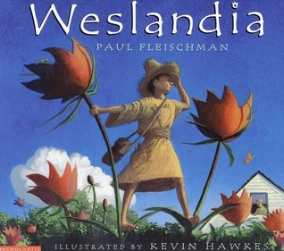
Look at the front cover of the text. What is the significance of the title? Is it the name of the character? Is it the name of a place/area?
What questions do the illustration make you want to ask?
E.g.
Why is the boy standing on the leaves of the plant?
Is the story set in a different country?
What is the other character thinking when he sees the boy standing on the plants?
Who is he? How did the plants grow so big?

What do you think might happen in the story? Create a mind-map of possible ideas and then write a predictive paragraph, using conjunctions (when, if, that, because, or, but, and).

E.g.
I predict the text is about a young boy, who is very green fingered, meaning he loves growing plants and gardening. He buys some magical seeds, which he plants at the bottom of his garden. The plants grow so tall that they tower over the village. The boy becomes famous and is given an important role to watch over the town for intruders; however, one night, the boy fails to keep the community safe, when he falls asleep. A group of disrespectful people from a nearby village break into his garden and steal his left-over seeds. They trample all over his crops, leaving them wilting and barely surviving. The thieves try to plant the stolen seeds in their own town, hoping to receive the same attention that the boy did, but the seeds do not flower. Instead, they grow into ugly looking vines! They approach the boy to seek advice, but the boy declines and refuses to help them.

Once you have finished writing and editing your predictive paragraph, think about what connections you can make? What other texts do Weslandia make you think of? Why?

TUESDAY – I can use expanded noun phrases to describe and specify
What is an expanded noun phrase?
Watch the following BBC Learning Clip to help remind you:
https://www.bbc.co.uk/bitesize/topics/zwwp8mn/articles/z3nfw6f
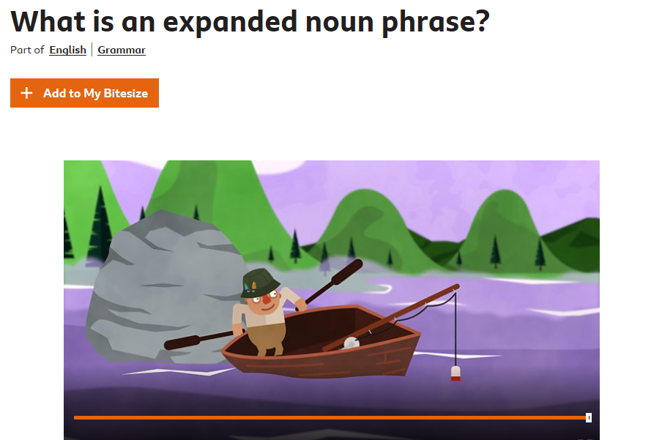
Look at the Weslandia front cover and spend time identifying nouns. You will need to record these in your red, home learning book. How can we expand these noun phrases? What adjectives can you think of to describe the nouns? Add these to your home learning books too. Can you create expanded noun phrases to describe the objects in the picture?
E.g. Mammoth, red flowers with green leaves. Orange, spotty butterfly with long antennae

Imagine that you are there with the young boy, what can you see, hear, touch, smell and taste? Can you use your expanded noun phrases to write a setting description?

E.g.
Mammoth, red flowers with long green leaves sway in the cool breeze, whilst orange, spotty butterflies flutter in circles. Fluffy, white clouds fill the azure coloured sky, while the sun beams down on the village below. The sound of rustling leaves echo through the young boy’s garden, while the birds sing and tweet loudly. The smell of freshly cut grass and fragrant flowers waft through the air, leaving a sweet scent for passers-by. A deafening shriek from the boy’s neighbour, startles the boy and the wild creatures, who are minding their own business.

WEDNESDAY – I can make inferences.
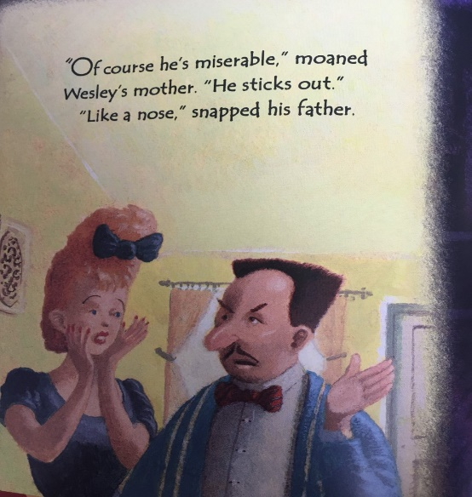

Read page 1 (Weslandia) and then answer the following questions:
Who are the characters talking about?
What do you think the phrase, ‘He sticks out like a nose,’ means?
Why would this make him miserable?
How are Wesley’s mother and father feeling? Explain how you know.
Can you think an alternative synonym (a word with a similar meaning) to replace the word miserable?

THURSDAY – I can learn how to use the possessive apostrophe (Singular)
Follow the link below and watch Mrs Hall’s Possessive Apostrophe Teaching Clip:
https://mayfieldschoolpo2.sharepoint.com/:v:/g/admin-staff/EdhaY_Yuya1CtJRAPYxiCtQB6kqI-1n0t8lEA4kxSAxZbg?e=ddbzEv
After having watched the teaching clip, convert the following possessive phrases into their possessive apostrophe form:
E.g. The velvet dress belonging to his mother looked very elegant à His mother’s velvet dress looked elegant.
- The red bow tie belonging to his father sat comfortably around his neck.
- The black bow belonging the lady was placed carefully in her hair.
- The blue jacket belonging to Mr Davies looked very smart.
- The straw, top hat belonging to the boy protected his head from the sun.
- The white, beach house belonging to the neighbour was situated next to the magical garden.
Now try converting the following possessive apostrophe examples into their possessive phrases:
E.g. Wesley’s satchel à The satchel belonging to Wesley
- The neighbour’s window overlooked the magical garden.
- Wesley’s plants grew as tall as a house.
- Mrs Fellows’ hair was pristinely presented.
- Mr Fellows’ moustache was triangular shaped.
- The man’s facial expression showed how angry he was.
FRIDAY – Words containing the /dʒ/ sound spelt as ge and dge
This week’s spelling words - badge, change, bridge, village, edge
Spelling Rule:
The letter j is never used to create the /dʒ/ sound at the end of English words.
The ending ‘dge’ is used after a short vowel sound - a, e, i, o, u (a-a-a-a – short vowel sound – dge ending)
After all other sounds, whether vowels or consonants, the /dʒ/ sound is spelt -ge at the end of words.
Words often ending in -ge contain long vowel sounds (long vowel sound – consonant before -ge ending)
Spelling Activities:
- Split a page in your red home learning book in half, label the two columns with -dge and -ge.
- Discuss each word and why it belongs in each column - fudge, charge, dodge, bulge, edge, huge
- What does the word dodge and bulge mean? Write your own mini definitions. When might these words be useful? When might we use the word dodge and bulge?
- Can you put the /dʒ/ words into sentences? Make sure you orally rehearse your ideas, before recording them. Can you improve your sentence by adding a conjunction? (when, if, that, because, or, and, but) Can you improve your sentences by using adjectives to create expanded noun phrases? Let’s upskill our work!
- Extension task - Create a /dʒ/ spelling poster, which includes the key spelling rules for -dge and -ge word endings.
MATHS TASKS
This week's theme is: Geometry

MONDAY
L.O: I can name some common 2D and 3D shapes and describe some of their properties.
BBC Bitesize: What are 2D shapes?
https://www.bbc.co.uk/bitesize/topics/zjv39j6/articles/ztpwdmn

BBC Bitesize: What are 3D shapes?
https://www.bbc.co.uk/bitesize/topics/zjv39j6/articles/zcsjqty

Starter: Name the 2D shape: https://www.ictgames.com/mobilePage/shiftingShapes/index.html

What shapes can you see in your classroom/house?

Task:

Pink Mastery Questions:
What is the difference between a 2-D and 3-D shapes? How do you know a shape is 2D or 3D?
Write the name of each shape shown in this question

TUESDAY
L.O: I can name and describe properties of 2D and 3D shapes (sides and vertices)
Starter: Properties of 3D shapes
http://www.learnalberta.ca/content/me3usa/flash/index.html?goLesson=14

Click the 3D shape option

Task:

Pink Mastery Questions:
What is a side?
What are vertices?
How many vertices does a rectangle have?
How can you check that you have counted all the sides? Do all shapes that have 4 sides and 4 vertices look the same? Prove it

WEDNESDAY
L.O: I can name and describe properties of 2D and 3D shapes (faces)

Starter: What are the properties of 3D shape (recap video) https://www.bbc.co.uk/bitesize/topics/zjv39j6/articles/zgqpk2p

Task:

Pink Mastery Questions:
What do we mean by the ‘face’ of a shape?
What is an edge?
What real life objects have 6 faces like a cube? Which 2-D shapes can you see on different 3-D shapes?

THURSDAY
L.O: I can describe similarities and differences of 2D and 3D shapes, using their properties

Starter: Recall all 2D and 3D shapes. Write them on class whiteboard/paper

Task:
Sort the 2D shapes shown on the poster
How have you grouped them?
What are the shapes similarities/differences?

Now do the same with the 3D shapes.

Pink Mastery Questions:
How do you know you have sorted your shapes correctly?
What are the shapes similarities/differences?
Can you sort your shapes in a different way?

Please send this work to your class teacher to receive feedback.

FRIDAY
Practise Times Tables (2s, 5s and 10s): http://www.timestables.me.uk/ (select 2, 5 and 10) or you could practise writing your times tables on paper.
Send your scores/picture of your paper to your class teacher.

L.O: I can name and describe properties of 2D and 3D shapes (faces)
Starter: What do you know about 2D and 3D properties (e.g. line of symmetry, faces)

Task:
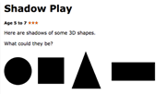
Explain how you know what 3D shapes made these shadows.

Pink Mastery Questions:
How did you know you were correct?
What if I showed a shadow of the shapes other faces, would it still be the same shape? How do you know?
Can you name the 2D faces on other 3D shapes?

Optional: To check your understanding of Shape you could take the White Rose Assessment.
https://wrm-13b48.kxcdn.com/wp-content/uploads/2019/01/Primary_Spring_Mini_Assessments/Spring-Block-3-Year-2-Properties-of-Shape_Assessment.pdf

(Please find answers on the bottom of this document)
TOPIC/CREATIVE – Terrible Titanic!
L.O: I can name the continents of the world and locate them on a map
L.O: I can name the world’s oceans and locate them on a map

Continents and Oceans song:
https://www.youtube.com/watch?v=_P-x4zP9rPo
Continents song:
https://www.youtube.com/watch?v=K6DSMZ8b3LE

Can you find these on a map? Now locate these on your own map. Write the name of the 5 oceans and 7 continents. You could colour these in to make them clear.
https://www.freeusandworldmaps.com/html/World_Projections/WorldPrint.html

Tasks you could complete throughout the week
- Find out facts about one of these continents
- What ocean did the Titanic sail through?
- In which ocean did the Titanic sink?
Send your answers to these questions along with a picture of you map to your class teacher by Monday 29th June
LEARNING WEBSITES

Maths
https://www.bbc.co.uk/bitesize/subjects/zjxhfg8
https://www.topmarks.co.uk/maths-games/hit-the-button
https://nrich.maths.org/9084
https://ttrockstars.com
https://mathszone.co.uk
https://www.ncetm.org.uk/public/files/23305578/Mastery_Assessment_Y2_High_Res.pdf
https://whiterosemaths.com
https://home.oxfordowl.co.uk/kids-activities/fun-maths-games-and-activities/
https://www.themathsfactor.com

English
Audible are doing a free 30-day trial so that children can listen to lots of books online.
https://www.bbc.co.uk/bitesize/subjects/zgkw2hv
https://www.topmarks.co.uk/english-games/5-7-years/letters-and-sounds
https://www.topmarks.co.uk/english-games/5-7-years/punctuation
https://www.topmarks.co.uk/english-games/5-7-years/words-and-spelling
https://www.topmarks.co.uk/english-games/5-7-years/learning-to-read
https://www.twinkl.co.uk/resources/games-twinkl-go/ks1-games-twinkl-go/english-ks1-games-twinkl-go
http://www.crickweb.co.uk/ks1literacy.html
https://www.education.com/games/early-literacy-concepts/

Maths Answers
Monday

Tuesday

Wednesday

Thursday
Children could sort shapes in a variety of ways e.g. number of sides, edges etc
Friday

A – Sphere
B – Cube
C – Triangular based pyramid or Triangular prism
D – Cuboid

Children to explain how they knew which shapes made these shadows using appropriate terminology e.g. sides, vertices

