Dear Parent/Carer,

Although the school is open to all primary pupils, we are continuing to provide educational tasks as we know that not all children are able to attend. We are also offering opportunities for children to reconnect with school and learn with their teachers through online sessions, pre recorded videos/tasks and home learning support. Each teacher will be posting further information in their weekly email.

In primary, we suggest that children complete;
- 30 minutes a day reading to/with an adult (this could be a bedtime story)
- 30 minutes of Maths a day
- 30 minutes of English a day
- 30 minutes of PE/ physical activity
- A weekly topic/creative task

Home learning tasks can be supplemented with work from a number of websites (see list below for ideas)

Teachers will set a weekly programme for your child to work through at home. This will be available for you to access on the school website every Monday.

Whilst it is important for your child to keep up with their learning at home, we appreciate that this can be a stressful time for children and adults. Looking after mental health is vital. Therefore, we suggest that the day is broken up into manageable learning chunks, interspersed with physical exercise, fun activities and time together as a family. Activities such as the 30-day lego challenge and using the real PE activities could be a good place to start.

As well as educational learning, the children could also begin to learn different life skills – how do boil an egg, sew on a button, learn to send an email, bake a cake using a recipe book etc.

We hope you are all keeping well and staying positive.

Kind regards,

Miss Hatton, Mrs Hall and the Year 2 team.

YEAR 2 HOME LEARNING TASKS
WEEK BEGINNING: 29th June 2020
Bubble School – Every Monday and Tuesday
To support you with your learning at home, we are available to contact via email or Microsoft Teams on the following days:
Mrs Hall – Wednesday 10am – 12pm and 1pm – 3pm
Miss Hatton – Friday 10am – 12pm and 1pm – 3pm
Please send Wednesday’s English task through to your teacher via email, so that they can read and provide some feedback to you! You will need to submit this by Monday 6th July.
ENGLISH TASKS
This week’s spellings/phoneme:
cinema, space, fancy, circus, circle
Ideas to help you learn this week’s spellings:
Put the words into sentences of your own. | Bubble write each spelling word.
Find the definition of your spellings using a dictionary or write your own micro-definition. | Create silly mnemonics for each spelling word.
Alphabetise your spellings. | Underline the trickiest part of the word to spell and create a memorable way of remembering this.
Words within words – What other words can you make from the letters that make up each spelling word? | Illustrate the words.
Choose a spelling word and use it to write an acrostic poem. | Speed write each word – How many times can you write each word in one minute?
Write a short story, using all your spelling words. | Create a wordsearch or crossword with your spelling list.
Rainbow write each of your spelling words. | Write rhymes for each word.
Create a spelling pyramid for each word. | Play charades with your spelling words.
Draw around the word (boxes), so that you become familiar with the number of ascenders and descenders. | Design a board game to play with your spelling words – Don’t forget to write instructions too!
Do your words contain pre-fixes or suffixes? What are they? What are the root words? Explain how the prefixes/suffixes change the meanings of the words. | Play Tic Tac Toe (Noughts and Crosses) with your spelling words
Vowel and consonant challenge – How many vowels and consonants make up each word? | Play hangman with your spelling words.
Write out the whole alphabet on a long strip of paper. Spell out each word by driving a toy car to each letter in the right order! You could draw lines for the route if you wish. | Cut out letters or magazine to make your spelling words.

MONDAY – I can make inferences.
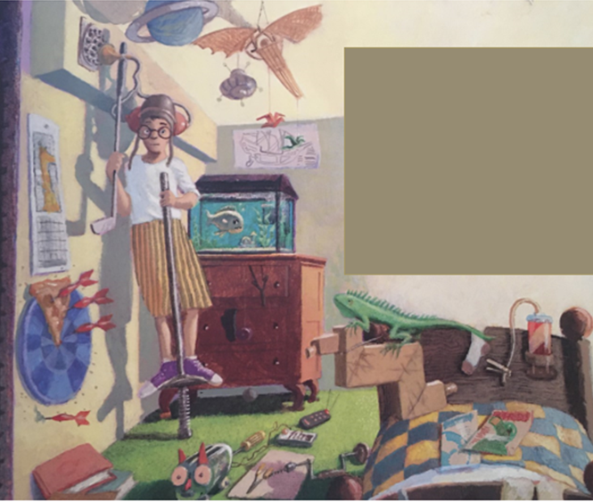
Look closely at the next page from the text, ‘Weslandia.’
What do you think the boy is doing?
Why is he doing this?
What can you infer about him from the clues in this picture? (Infer means to interpret from the clues given) How many inferences can you make? You will need to have recorded at least four, using full sentences and the subordinating conjunction, ‘because.’
E.g. I can infer that the boy is an animal lover. I know this, because he has a tank full of fish and a bearded dragon. He also has non-fiction magazines on his bed, with parrots of the front cover.
What is the container for that is strapped to his bed? Why has the tube been cut and pegged?
Why is there are a slice of pizza pinned to the dart board?
TUESDAY – I can discuss and clarify the meaning of words.
1.) Read through the text that matches the illustration from the Monday’s home-learning task. Find the definition of these words in a dictionary to form a mini glossary – Don't forget glossaries are alphabetised:
-vent
-outcast
-civilisation
-alarming
-bribe
If you don’t have a dictionary at home, the following website can help you: https://www.thefreedictionary.com/
2.) Can you summarise the main idea of this paragraph in only ten words?
3.) How do you think it made the boy feel, hearing what his Mum and Dad were saying about him? Explain.
4.) Does the boy agree with what his Mum and Dad said? How do you know?
5.) What do you think happens next? How does the boy react? How does this change your original prediction of the front cover?

WEDNESDAY – I can participate in discussions about books.
Live reading of Weslandia by Paul Fleischman at 1.00pm
Mrs Hall will present and read the whole story via Microsoft Teams. She will ask a variety of different questions, which can be answered by typing in the live chat feed.
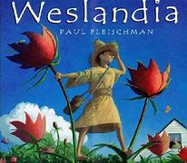
THURSDAY – I can discuss and express views about a text.
After having listened to the text, ‘Weslandia,’ being read aloud yesterday by Mrs Hall, can you write a book review about it and send it to your class teacher? Use the following headings to create your book review. You can present it as a hand-written review poster or power-point presentation. You may also wish to illustrate your favourite part!
-Name of the text.
-Author and llustrator.
-What is the story about?
-Who is the main character and what is he/she like?
-Which part of the story did you like most? Why?
-What was your least favourite part? Why?
-Would you recommend this book? What rating would you issue it out of 5 stars?

FRIDAY – I can spell words that contain the /s/ sound spelt c before e, i and y
What do you notice about this week’s spelling words? They all have the /s/ sound but are spelt with a /c/.
Spelling Rule:
When the /s/ appears before i, e and y, it is always spelt with a /c/.
Use the following clues to see if you can identify other words that follow this rule:
- You begin at a starting line and get ready to go!
- If left out too long, it will begin to melt!
- This is where prisoners are kept!
- You must fasten these otherwise you might trip!
- You do this on the dance floor at a DISCO!
- You do this on a trampoline!
- A three-wheeled bike.
- You should do this with used items to help save the planet!
- You take this when you’re poorly to make you feel better.
- You should do this regularly to keep you fit and healthy!
Did you manage to identify the words from the clues above?
Now try having a go yourself. Write your own clues for the following words: nice, city, rice, cereal, face, pencil, certificate, bracelet, parcel, celery
Once you have written your clues, have a go at learning to spell words with the /s/ sound, spelt /c/ by playing the online games on the following website:
https://spellingframe.co.uk/spelling-rule/81/4-The-s-sound-spelt-c-before-e-i-and-y
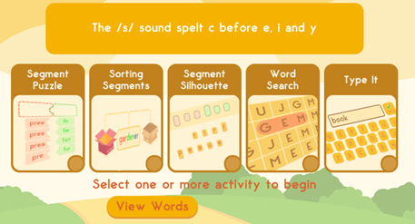
Guess the Word:
Can you guess which /s/ sound, spelt /c/ words are shown below:
___ i ___ y
c___ ___e ____ l
___ r i ___ y ___l e
b___ u ___ ___ e
___ e ___ y ___ l ___
c___ n ___ ___ a
ce ___ ___ i f ___ ___ a t ___

Now try putting the words into sentences of your own. Can you use a conjunction too to expand and link ideas?

MATHS TASKS
This week's theme is: Statistics

MONDAY
L.O: I can interpret and construct simple tally charts

Starter:
Data Organisation and Tally Charts: https://www.bbc.co.uk/bitesize/clips/z7r9jxs

Task: Use the data below to make a tally chart.

Pink Mastery Questions:
True or False? Danny collected the most ladybirds. Prove it.
How many ladybirds did Aisha and Ben collect compared to Carmel and Danny? How do you know?
Why is it easier to see this data on a tally chart?

TUESDAY
L.O: I can construct simple pictograms

Starter:
Understanding Pictograms: https://www.bbc.co.uk/bitesize/clips/zg4d2hv

Task: Children to make a clear pictogram using this data

Pink Mastery Questions:
Write 3 statements about this pictogram.
Write questions for your teacher to answer about this pictogram.
True or False? The children played 15 games altogether. Prove it.

Send this task to your teacher by Friday 3rd July for them provide feedback.

WEDNESDAY
L.O: I can interpret simple pictograms

Starter: Recap of pictograms: https://www.bbc.co.uk/bitesize/clips/zg4d2hv

Task:

Pink Mastery Questions:
What can you tell me about this pictogram?
If each circle represented 2, how many children chose red?
If each circle represented 5. How many children liked blue/red/yellow/green?
Think of your own questions to ask about this pictogram.

THURSDAY
Miss Hatton will be recording a lesson for you to watch prior to this task.

L.O: I can construct block diagrams

Starter:

Task:

Pink Mastery Questions:
How is a block diagram different to a pictogram?
Which colour came second in terms of popularity? How do you know?
Could each block be worth 2? Why?
Create your own questions about your block diagram.

FRIDAY
Practise Times Tables (2s, 5s and 10s): http://www.timestables.me.uk/ (select 2, 5 and 10) or you could practise writing your times tables on paper.

L.O: I can construct and interpret simple block diagrams.

Starter: What are the different ways you can represent data? How is this represented differently?

Task:

Pink Mastery Questions:
Put the correct data onto the block diagram.
True or False? Ron scored the most points. Prove it.
Why couldn’t Data 2 be displayed on the block diagram? Prove it.

Optional: To check your understanding of Shape you could take the White Rose Assessment.
https://wrm-13b48.kxcdn.com/wp-content/uploads/2019/01/Primary_Spring_Mini_Assessments/Spring-Block-2-Year-2-Statistics.pdf

(Please find answers on the bottom of this document)

TOPIC/CREATIVE – Terrible Titanic!

Task 1
L.O: I can use drawing to develop and share my ideas and imagination

What would you see if you looked outside a window on the Titanic?
Draw a circle on a piece of paper. Imagine you are on the Titanic; you look out the port hole. What would you see? Draw this inside your circle. Cut out a ring (bigger than your picture) for the port hole window. Stick this over the top and then cut around this.
Examples:
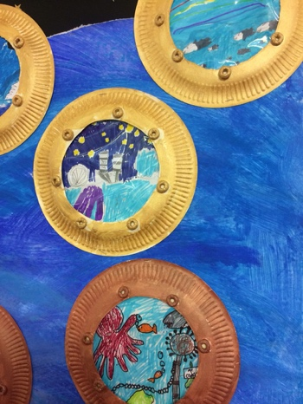

Task 2
L.O: I can use observations and ideas to suggest answers to questions
You will need:
- A plastic container filled with water
- A plastic bottle with a lid

Step 1 - https://www.bbc.co.uk/cbeebies/watch/messy-goes-to-okido-why-do-things-sink-and-float
Step 2 – Fill your container with water.
Step 3 – Put your empty plastic bottle on the water. Is the bottle floating or sinking? How do you know? What makes the boat float?
Step 3 - What happened to the Titanic? Why did it sink? https://www.bbc.co.uk/bitesize/topics/zc89k7h/articles/zytqj6f
Step 4 - How could we demonstrate this in our experiment? How could we get our boat to sink?

Send a picture/video or a summary of your experiment to your class teacher.

Task 3
L.O: I can use drawing/painting to develop and share their ideas, experiences and imagination

Step 1 - Design your own boat. Label the different part of the boat.
Step 2 - Write a paragraph to explain where you would travel and why.

Task 4
L.O: I can describe the importance for humans to eat the right amounts of different types of foods.
https://www.bbc.co.uk/bitesize/topics/z9yycdm/articles/zxvkd2p
Imagine you are the chef on the Titanic. Design a menu for your guests.

Task 5
L.O:
LEARNING WEBSITES

Maths
https://www.bbc.co.uk/bitesize/subjects/zjxhfg8
https://www.topmarks.co.uk/maths-games/hit-the-button
https://nrich.maths.org/9084
https://ttrockstars.com
https://mathszone.co.uk
https://www.ncetm.org.uk/public/files/23305578/Mastery_Assessment_Y2_High_Res.pdf
https://whiterosemaths.com
https://home.oxfordowl.co.uk/kids-activities/fun-maths-games-and-activities/
https://www.themathsfactor.com

English
Audible are doing a free 30-day trial so that children can listen to lots of books online.
https://www.bbc.co.uk/bitesize/subjects/zgkw2hv
https://www.topmarks.co.uk/english-games/5-7-years/letters-and-sounds
https://www.topmarks.co.uk/english-games/5-7-years/punctuation
https://www.topmarks.co.uk/english-games/5-7-years/words-and-spelling
https://www.topmarks.co.uk/english-games/5-7-years/learning-to-read
https://www.twinkl.co.uk/resources/games-twinkl-go/ks1-games-twinkl-go/english-ks1-games-twinkl-go
http://www.crickweb.co.uk/ks1literacy.html
https://www.education.com/games/early-literacy-concepts/

Maths Answers
Monday
True or False? Danny collected the most ladybirds. Prove it.
“False, Danny only collected 4 ladybirds. Aisha collected 7, Ben collected 8, Carmel collected 10 and Elaine collected 10. Carmel and Elaine collected the most because 10 is the biggest number.”

How many ladybirds did Aisha and Ben collect compared to Carmel and Danny? How do you know?
“Aisha collected 7 ladybirds. Ben collected 8 ladybirds. 7 + 8 = 15.
Carmel collected 10 ladybirds. Danny collected 4 ladybirds. 10 + 4 = 14.
Aisha and Ben collected one more than Carmel and Danny.”

Why is it easier to see this data on a tally chart?
“You can count the ladybirds in groups of 5 (tally marks) rather than counting them individually. It is easier to see.”
Tuesday

Sam
Tom
Sally
Ally

Wednesday

Thursday

10
9
8
7
6
5
4
3
2
1
 | Red | Green | Blue | Yellow

Friday

