Dear Parent/Carer,

As the school continues to remain closed due to Coronavirus, we are continuing to provide educational tasks for your children to complete. We have received positive feedback on the new format of the home learning daily tasks. As always, please continue to keep in touch about your child’s home learning and let us know if there are any problems.

In primary, we suggest that children try to complete;
- 30 minutes a day of independent reading/reading to an adult
- 30 minutes of maths a day
- 30 minutes of English a day
- 30 minutes of topic based/creative learning
- 30 minutes of PE/ physical activity

Home learning tasks can be supplemented with work from a number of websites (see list below for ideas.) Daily work set on the BBC website is particularly useful as it contains tutorial videos.
https://www.bbc.co.uk/bitesize/primary

Teachers will set a weekly programme for your child to work through at home. This will be available for you to access on the school website every Monday. We know that children work at different speeds and different levels, so please have a look at work in other year groups too for extra support.

Whilst it is important for your child to keep up with their learning at home, we appreciate that this can be a stressful time for children and adults. Looking after mental health is vital. Therefore, we suggest that the day is broken up into manageable learning chunks, interspersed with physical exercise, fun activities and time together as a family. Activities such as the 30 day lego challenge and using the real PE activities could be a good place to start. Setting up a weekly timetable can be a good place to start. As well as educational learning, the children could also begin to learn different life skills – how to boil an egg, sew on a button, learn to send an email, bake a cake using a recipe book etc.

Guidance for parents, regarding home learning, has been released by the government and can be found at the following link;
https://www.gov.uk/guidance/supporting-your-childrens-education-during-coronavirus-covid-19

We hope you are all keeping well and staying positive.

Kind regards,
Mrs Browne, Miss Lewis, Mrs Threadingham, Miss Williams and the year 3 team.
YEAR 3 HOME LEARNING TASKS
WEEK BEGINNING: 27th April 2020
ENGLISH TASKS  SPELLINGS FOR THIS WEEK (see list below)  Believe, Bicycle, Breath, Breathe, Build, Busy and Business.  MONDAY:  Pyramid write your spellings. Create a Look, Cover, Write, Check sheet so that you can practise. Speed write your spellings. Get someone to time how many of each word you can write in a minute.  TUESDAY -  Have a look at the front cover of ‘The Accidental Prime Minister’ and think about the questions below:  - What do you see on the front cover?  - Who do you think the main character is?  - Does the front cover tell us anything about him?  - What do you think will happen in this story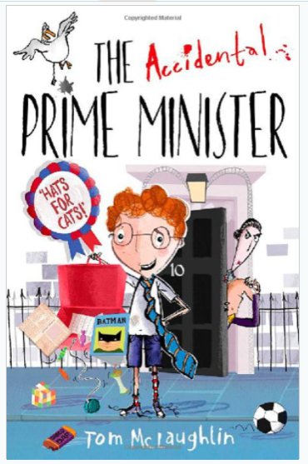  WEDNESDAY –  Have a look at the work you did yesterday and remind yourself of the answers you gave.  Next, remind yourself what a blurb is. What is the purpose of a blurb?  Write your own blurb for ‘The Accidental Prime Minister’. Think about what you can infer from the front cover and what the title of the book tells us.  THURSDAY –  Finish your blurb from yesterday if you have not yet done so. Once you have finished, purple polish your work checking for; incorrect spellings, missing punctuation and think about extending your sentences.  If you get this done quickly, practise your spellings ready for your test tomorrow!  FRIDAY -  Ask your adult to test your spellings.  Write the word SNOWY at the top of your page, how many words can you make out of the letters?  Did you know that there are over 20 different words you can make! | MATHS TASKS  MONDAY -  Flo and Jim are answering a problem: Danny has read 62 pages of the class book, Jack has read 43. How many more pages has Danny read than Jack? Flo does the calculation 62 + 43. Jim does the calculation 62–43. Who is correct? Explain how you know.  Can you create 5 similar word problems for somebody in your house to solve?  TUESDAY –  Use 12 buttons, or paper clips or dried beans etc…  Ask your child to find half of the 1/2 things.  Now find one quarter of the same group.  Find one third of the whole group.  Repeat with other numbers.  Challenge yourself by finding non unit fractions – eg 2/3, ¾ etc  WEDNESDAY –  Create a game that you can play to help you remember your times tables, use either your 3,4 or 8 times tables.  THURSDAY -  Check your column addition and subtraction sums from last week, are there any that you got wrong? Try them again, so that they are correct.  Complete 25 more column addition and subtraction sums in your book.  FRIDAY -  You need two dice and a pile of dried pasta or equivalent. Take turns to roll the two dice. Multiply the two numbers and call out the answer. If you are right, you win a piece of pasta. The first to get 10 pieces of pasta wins.
TOPIC/CREATIVE  MONDAY –  Go outside and pick up something that you find interesting. Maybe a funny shaped stone, or an interesting leaf.  Bring your item back inside and sketch it as carefully as you can. Make sure you spend time examining your item.  TUESDAY –  Can you write a definition of a:  - Mammal  - Reptile  - Insect  - Fish  - Bird  Can you also remind yourself what an exoskeleton is and what types of animal might have one.  WEDNESDAY –  Using the countries you researched last week, find each country's flag. Which flags do you like and why? Were there any that you already knew?  THURSDAY-  Help make a meal at home. It could be breakfast, lunch or dinner. Think about foods that are healthy for you and write down your recipe and how to make it.  FRIDAY-  Find a clear, empty space and practise throwing and catching. If you have someone to practise with, you can see how many times you can throw and catch without dropping or you can challenge yourself. Can you get better each time?  How many times can you throw and catch a ball in 1 minute?  Don’t have a ball? Get creative and use something else - with your adults permission!  . | LEARNING WEBSITES  https://www.topmarks.co.uk/maths-games/hit-the-button  https://www.mathplayground.com/  https://www.topmarks.co.uk/maths-games/7-11-years  https://whiterosemaths.com/homelearning/  https://nrich.maths.org/primary  https://ttrockstars.com/  https://www.bbc.co.uk/bitesize/levels/zbr9wmn  https://www.literacyshed.com/home.html  https://www.spellingshed.com/  https://pobble.com/  https://monsterphonics.com/?gclid= EAIaIQobChMI56aEu9yh6AIVFeDtCh2NMAcIEA AYASAAEgK1b_D_BwE  https://www.oxfordowl.co.uk/welcome-back/for-home/reading-owl/kids-activities  https://www.topmarks.co.uk/english-games/7-11-years  Audible are doing a free 30 day trial so that children can listen to lots of books online.
YEAR 3 SPELLING WORDS

