Dear Parent/Carer,

As the school continues to remain closed due to Coronavirus, we are continuing to provide educational tasks for your children to complete. We have received positive feedback on the new format of the home learning daily tasks. As always, please continue to keep in touch about your child’s home learning and let us know if there are any problems.

In primary, we suggest that children try to complete;
- 30 minutes a day of independent reading/reading to an adult
- 30 minutes of maths a day
- 30 minutes of English a day
- 30 minutes of topic based/creative learning
- 30 minutes of PE/ physical activity

Home learning tasks can be supplemented with work from a number of websites (see list below for ideas.) Daily work set on the BBC website is particularly useful as it contains tutorial videos.
https://www.bbc.co.uk/bitesize/primary

Teachers will set a weekly programme for your child to work through at home. This will be available for you to access on the school website every Monday. We know that children work at different speeds and different levels, so please have a look at work in other year groups too for extra support.

To help with maths and different terminology, we will try to add in some video links for tutorials and we will try to include answers for maths where possible to help the children check through their work.

Whilst it is important for your child to keep up with their learning at home, we appreciate that this can be a stressful time for children and adults. Looking after mental health is vital. Therefore, we suggest that the day is broken up into manageable learning chunks, interspersed with physical exercise, fun activities and time together as a family. Activities such as the 30 day lego challenge and using the real PE activities could be a good place to start. Setting up a weekly timetable can be a good place to start. As well as educational learning, the children could also begin to learn different life skills – how to boil an egg, sew on a button, learn to send an email, bake a cake using a recipe book etc.

Guidance for parents, regarding home learning, has been released by the government and can be found at the following link;
https://www.gov.uk/guidance/supporting-your-childrens-education-during-coronavirus-covid-19

We hope you are all keeping well and staying positive.

Mrs Browne, Miss Lewis, Mrs Threadingham, Miss Williams and the Year 3 team.

YEAR 3 HOME LEARNING TASKS
WEEK BEGINNING:
ENGLISH TASKS  MONDAY:  Spellings. This week can you keep trying the words: Imagine, increase, important, impossible  You could put them into a silly sentence. Can you put 2 of them in one sentence? Can you use a conjunction (and, if, so, but, because) to extend a sentence?  TUESDAY –  Reading comprehension.  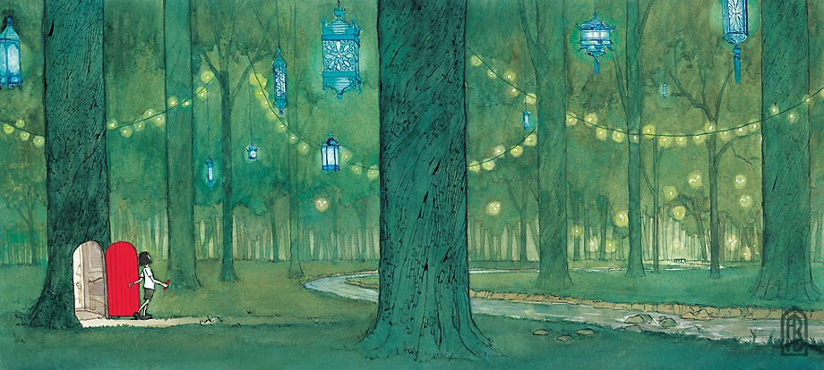  - What’s on the other side of the door?  - What is the girl holding in her hand? Why?  - How did she get to the forest?  - Where is this?  - Who hung the lanterns in the trees?  - Where does the stream lead?  - Will the girl go back through the door or stay in the forest? Predict what will happen next.  Can you describe what could be happening in this picture? Remember to check your sentences for capital letters conjunctions and full stops. To add a challenge, try using a fronted adverbial phrase;  After a while,  In the morning,  All of a sudden.  See if you can add one of our spellings too!  WEDNESDAY –  Spellings.  Pick 1 book and see if you can find any words with the spelling pattern ugh, ore, igh and make a list of them. Let us know how many you find, the winner will go on the newsletter!!  THURSDAY –  Watch the video link Minuscule Microzilla https://www.youtube.com/watch?v=64r6-QYb1do  Think about what happens to the main character and write a short diary entry. What would he write? How would he feel?  FRIDAY -  Re-watch the video link Minuscule Microzilla https://www.youtube.com/watch?v=64r6-QYb1do  What would you change to help the main character? Can you write a different ending? Could you change the middle to help him? Maybe he was horrid and you want something else to happen! Have a go at writing what you think should happen.  Don’t forget … to check your sentences for capital letters conjunctions and full stops.  Another challenge could be to add speech in using “direct speech” marks! | MATHS TASKS  If you would like further challenges, please follow the link below;  https://whiterosemaths.com/homelearning/  To help remind yourself of methods for subtraction,  please see the BBC bitesize link below;  https://www.bbc.co.uk/bitesize/articles/zfdpnrd  MONDAY –  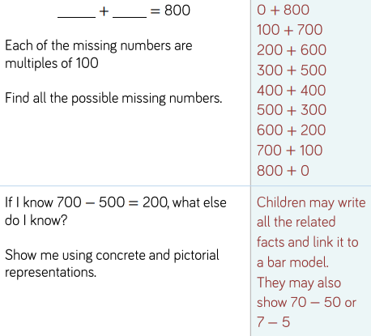  You could try writing a challenge for someone else to solve! Could you change the 800 to 81? Would it be harder or easier?  TUESDAY –  Practise your mental subtraction of 3-digit number + tens  Try 357 – 20 357 – 40 357 – 60. What do you notice about the answers?  What equipment could you use around your house to build the numbers? Could plates be hundreds, cups the tens? What could represent the ones? Good luck!  WEDNESDAY –  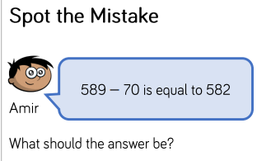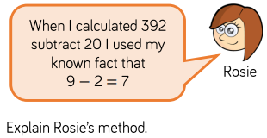  THURSDAY -  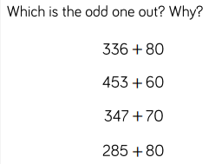 How can you explain it? Can you think of 4 subtraction sentences to try?  FRIDAY –  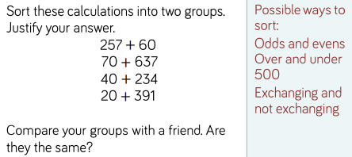  Can you create 4 of your own and sort them using the same groups?
TOPIC/CREATIVE  Monday  Look at the Stone Age and Iron Age events at the bottom of the page. Put them in chronological order from earliest to latest.  Tuesday  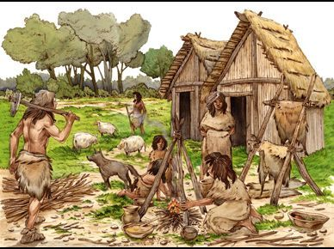  Use the picture above to write some sentences about what life was like in stone age times. Think about what people wore, what they ate and how they cooked, things they did in the day and what they lived in.  Wednesday  Think about the work you did yesterday.  Make a comparisons list in your books;  Eg  Stone Age Today  People lived in caves or huts We live in houses  Extension – are there things that they did in Stone Age times that we still do know?  Thursday  Look at the youtube clips and draw either a sabre tooth cat;  https://www.youtube.com/watch?v=9W7lRz0-llg  or a woolly mammoth;  https://www.youtube.com/watch?v=ba2CXZpsnag  Friday  Read through the information on the link below;  https://www.bbc.co.uk/bitesize/topics/z82hsbk/articles/z34djxs  Write down 10 facts you have learned.  Stone Age Quiz  https://www.proprofs.com/quiz-school/story.php?title=stone-age_1 | LEARNING WEBSITES  https://www.topmarks.co.uk/maths-games/hit-the-button  https://www.mathplayground.com/  https://www.topmarks.co.uk/maths-games/7-11-years  https://whiterosemaths.com/homelearning/  https://nrich.maths.org/primary  https://ttrockstars.com/  https://www.bbc.co.uk/bitesize/levels/zbr9wmn  https://www.literacyshed.com/home.html  https://www.spellingshed.com/  https://pobble.com/  https://monsterphonics.com/?gclid= EAIaIQobChMI56aEu9yh6AIVFeDtCh2NMAcIEA AYASAAEgK1b_D_BwE  https://www.oxfordowl.co.uk/welcome-back/for-home/reading-owl/kids-activities  https://www.topmarks.co.uk/english-games/7-11-years  Audible are doing a free 30 day trial so that children can listen to lots of books online.  Answers for Monday’s maths  Answers for Friday’s maths
YEAR 3 SPELLING WORDS

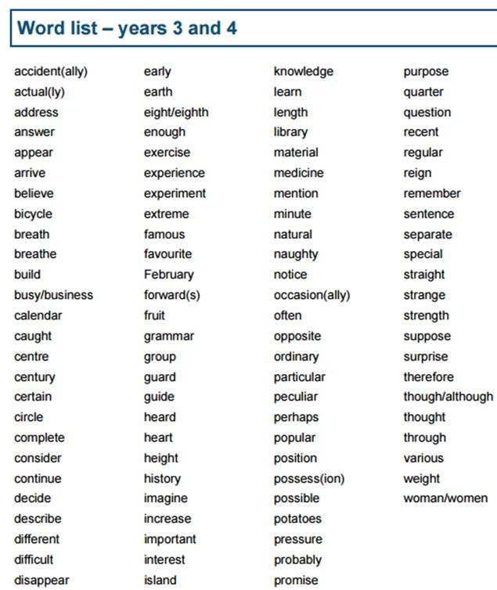

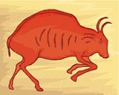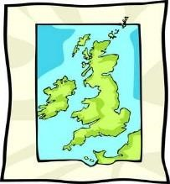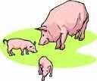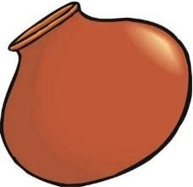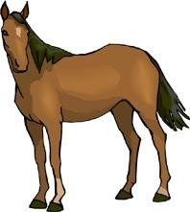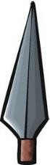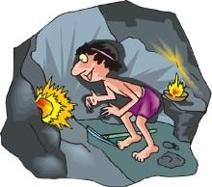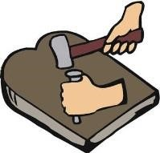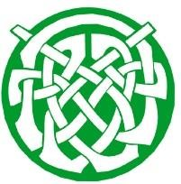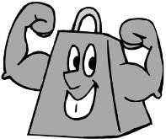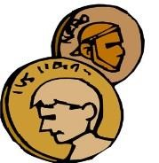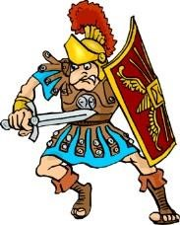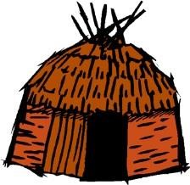
,000 BC
13

Cave paintings

6
,000 BC

Britain separated
from Europe

4,500
-
,500 BC
3

Farming begins
and spreads

4,500
-
,500 BC
3

Pottery begins
to be made

4,000
-
3
,000 BC

People begin to
ride horses

,500 BC
2

People begin
using metals

1
,800 BC

First copper
mines are dug

1,200
-
800
BC

Many more metal
objects created

1,200
-
BC
800

Celtic culture and
tribal kingdoms

800
-
BC
700

First hill forts
are created

700
-
BC
500

Iron used much
more commonly

100
BC

First coins
made and used

AD
43

Romans invaded
–

Iron Age ends!

