Dear Parent/Carer,

As the school continues to remain closed due to Coronavirus, we are continuing to provide educational tasks for your children to complete. We have received positive feedback on the new format of the home learning daily tasks. As always, please continue to keep in touch about your child’s home learning and let us know if there are any problems.

In primary, we suggest that children try to complete;
- 30 minutes a day of independent reading/reading to an adult
- 30 minutes of maths a day
- 30 minutes of English a day
- 30 minutes of topic based/creative learning
- 30 minutes of PE/ physical activity

Home learning tasks can be supplemented with work from a number of websites (see list below for ideas.) Daily work set on the BBC website is particularly useful as it contains tutorial videos.
https://www.bbc.co.uk/bitesize/primary

Teachers will set a weekly programme for your child to work through at home. This will be available for you to access on the school website every Monday. We know that children work at different speeds and different levels, so please have a look at work in other year groups too for extra support.

To help with maths and different terminology, we will try to add in some video links for tutorials and we will try to include answers for maths where possible to help the children check through their work.

Whilst it is important for your child to keep up with their learning at home, we appreciate that this can be a stressful time for children and adults. Looking after mental health is vital. Therefore, we suggest that the day is broken up into manageable learning chunks, interspersed with physical exercise, fun activities and time together as a family. Activities such as the 30 day lego challenge and using the real PE activities could be a good place to start. Setting up a weekly timetable can be a good place to start. As well as educational learning, the children could also begin to learn different life skills – how to boil an egg, sew on a button, learn to send an email, bake a cake using a recipe book etc.

Guidance for parents, regarding home learning, has been released by the government and can be found at the following link;
https://www.gov.uk/guidance/supporting-your-childrens-education-during-coronavirus-covid-19

We hope you are all keeping well and staying positive.

Kind regards,

The Year 3 team
lewisj@mayfield.portsmouth.sch.uk
browne-rebecca@mayfield.portsmouth.sch.uk
threadingham-cheryl@mayfield.portsmouth.sch.uk
Williams-kirsty@mayfield.portsmouth.sch.uk
YEAR 3 HOME LEARNING TASKS
WEEK BEGINNING: Monday 8th June 2020
ENGLISH
SPELLINGS FOR THIS WEEK:

possession, possible, potatoes, pressure, probably, promise, purpose

MONDAY –
Bubble write each of the above spellings.
A homophone is a word that sounds the same but is spelt differently and means something different. ‘Homo’ means ‘same’ and ‘phone’ means ‘sound’. where/wear there/their/they’re brake/break grate/great eight/ate weight/wait son/sun Read the sentences below and choose the correct homophone to go in them.
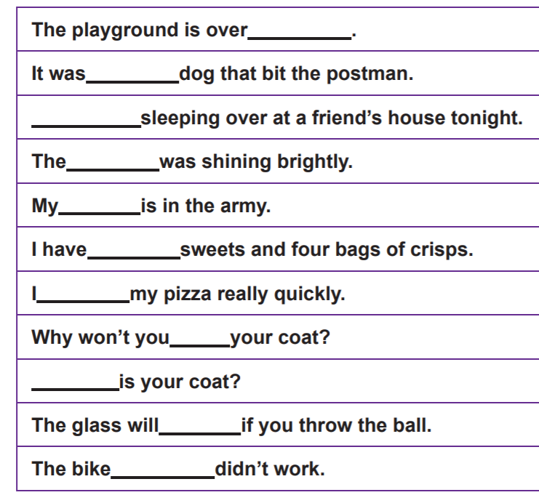
Challenge – can you think of 3 different sentences that use all of the their/there/they’re words?

TUESDAY –
Imagine you could interview one of your favourite characters from your favourite book. What would you ask them? Try to generate 8 questions. Imagine you are the character. How would they respond?

WEDNESDAY –
Read the homophones and find their meanings. Next try to create sentences that contain both or all of the words – for example, He’ll find that his heel won’t heal.

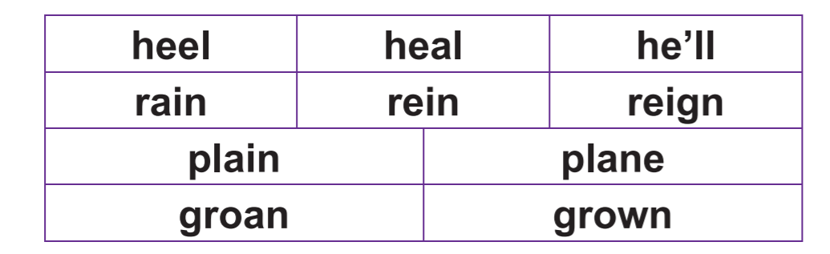

THURSDAY –
Plan a diary entry of a character from your favourite book or of someone of interest from the past. Use the checklist below to help you plan your diary entry.
https://www.bbc.co.uk/bitesize/articles/z6yxt39 (For additional support on how to write a diary entry)
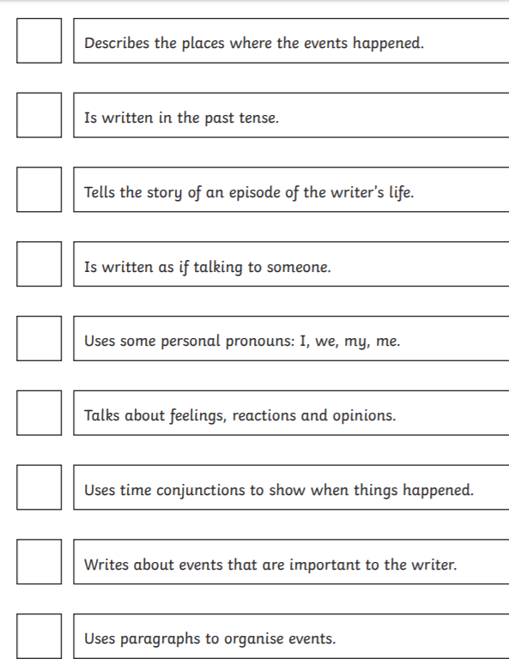
FRIDAY –
Write your diary entry including the above features. Remember to use capital letters, full stops and paragraphs. Could you also include a rhetorical question?
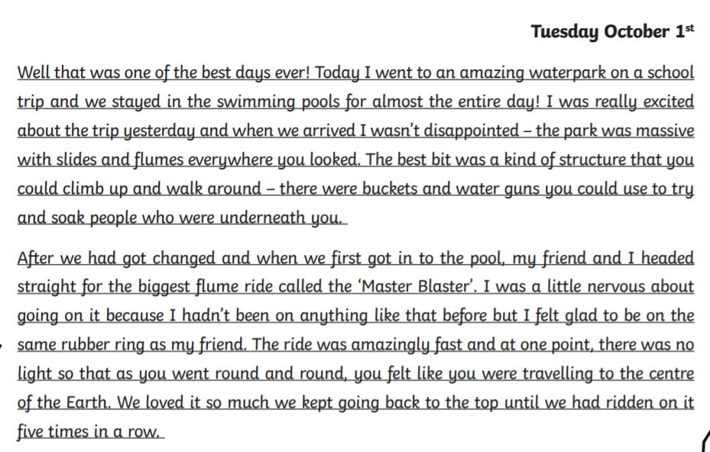
e.g.

MATHS (Data/Money)
Times tables for this week:
Continue to test yourself weekly, on your target times table.
Suggested websites:
https://www.topmarks.co.uk/maths-games/hit-the-button
http://www.timestables.me.uk/printable-pdf-quiz-generator.htm

Websites for the week:
https://www.bbc.co.uk/bitesize/topics/z7rcwmn
https://www.bbc.co.uk/bitesize/topics/z8yv4wx
https://www.bbc.co.uk/bitesize/topics/z8yv4wx/resources/3

MONDAY –
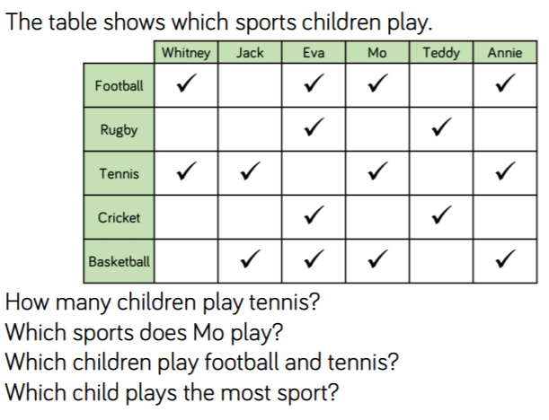
**What information can we gather from the table? Can you explain to a friend how to read the table? Where do we need to use tables in real life? What other questions could I ask and answer using the information in the table?

TUESDAY –
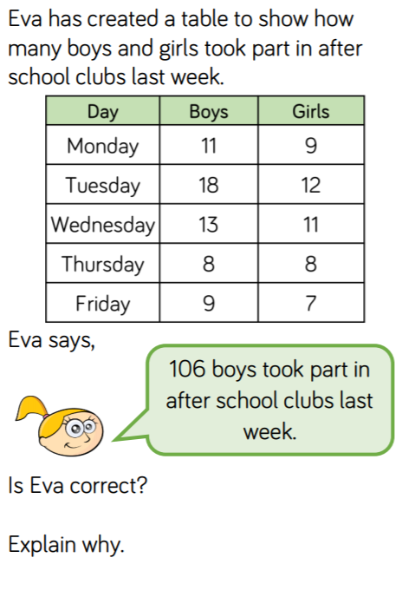
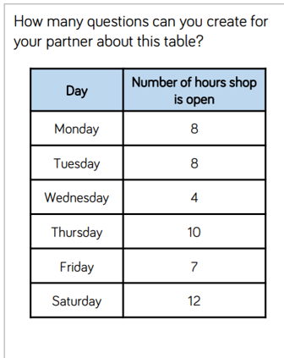

WEDNESDAY –
Discuss the following: What is the value of the coin/note? What does p mean? Why do we have different values of coins and notes? What’s the difference between £5 and 5p? Fill a jar with coins and notes and find the total amount within the jar. Repeat for different amounts. Alternatively use the picture below. *You could draw your own notes and coins!
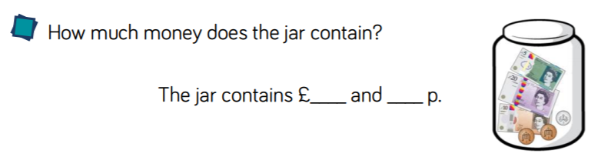
Challenge: How many ways could you make £20 using only notes and pound coins?

THURSDAY -
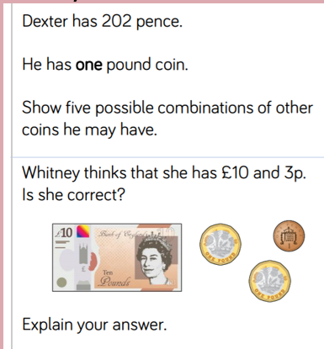

FRIDAY –
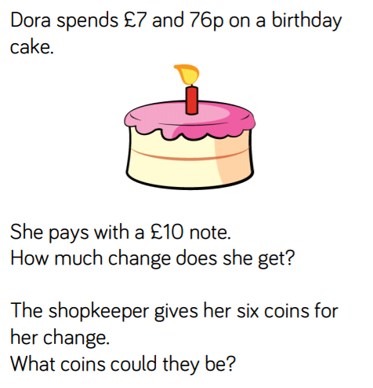
TOPIC

MONDAY –
If we try to follow these 5 things, we will be healthy both physically and mentally.
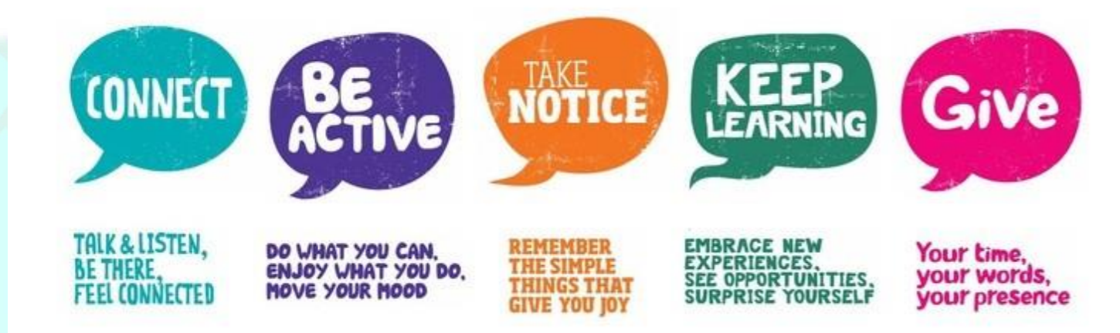
Choose one thing you could do off the list and try and do it over the next week. Create a poster of it to help you stay focused and display it in your bedroom.
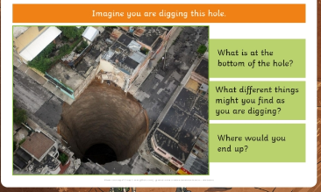
TUESDAY – Geography Focus – Extreme Earth
What is under our feet? Discuss the questions ---
and note down your ideas. Research the different layers that make up Earth. Draw a picture of the Earth’s layers and label it. EXT: Can you find out the size of each different layer? https://www.natgeokids.com/uk/discover/geography/physical-geography/structure-of-the-earth/

WEDNESDAY –
Today research one of the following: Volcanoes or Earthquakes. You could present your information as a booklet, PowerPoint or poster. Use the questions to help with your enquiry.
Volcanoes
How are they formed? What are the parts of a volcano? What happens when they erupt? Where do they happen? What does extinct, dormant and active volcanoes mean? Would you like to live near a volcano?
https://www.bbc.co.uk/bitesize/topics/z849q6f/articles/zd9cxyc
https://www.youtube.com/watch?v=VNGUdObDoLk
https://www.nhm.ac.uk/discover/how-to-make-a-volcano.html
Earthquakes
What are they? What are tectonic plates? Where do the occur? How are earthquakes measured? What is The Mercalli Scale? What are fault lines?
https://www.bbc.co.uk/bitesize/topics/z849q6f/articles/zj89t39
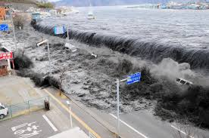
THURSDAY–
Imagine you have been told that a tsunami is about to hit your town. You have 10 minutes to pack a small suitcase. Make a list of things you would take and why. Think about things you would need, as well as things you would like to keep safe.
How do they affect the environment and people?
https://www.bbc.co.uk/newsround/45996556

FRIDAY–
Look at different artists use of techniques. (Roy Lichtenstein, William Morris, Picasso). Recreate a piece of art in the style of your chosen artist. Let’s get creative and have fun! (Could you find an art piece linked to natural disasters?)
https://thecraftyclassroom.com/crafts/famous-artist-crafts-for-kids/
https://www.bbc.co.uk/bitesize/subjects/zn3rkqt
LEARNING WEBSITES

https://www.topmarks.co.uk/maths-games/hit-the-button

https://www.mathplayground.com/

https://www.topmarks.co.uk/maths-games/7-11-years

https://whiterosemaths.com/homelearning/

https://nrich.maths.org/primary

https://ttrockstars.com/

https://www.bbc.co.uk/bitesize/levels/zbr9wmn

https://www.literacyshed.com/home.html

https://www.spellingshed.com/

https://pobble.com/

https://monsterphonics.com/?gclid= EAIaIQobChMI56aEu9yh6AIVFeDtCh2NMAcIEA AYASAAEgK1b_D_BwE

https://www.oxfordowl.co.uk/welcome-back/for-home/reading-owl/kids-activities

https://www.topmarks.co.uk/english-games/7-11-years

Audible are doing a free 30 day trial so that children can listen to lots of books online.
MATHS ANSWERS

Monday:
Answers:
- 4 children play tennis
- Football, Tennis and Basketball
- Whitney, Mo and Annie
- Eva

Tuesday
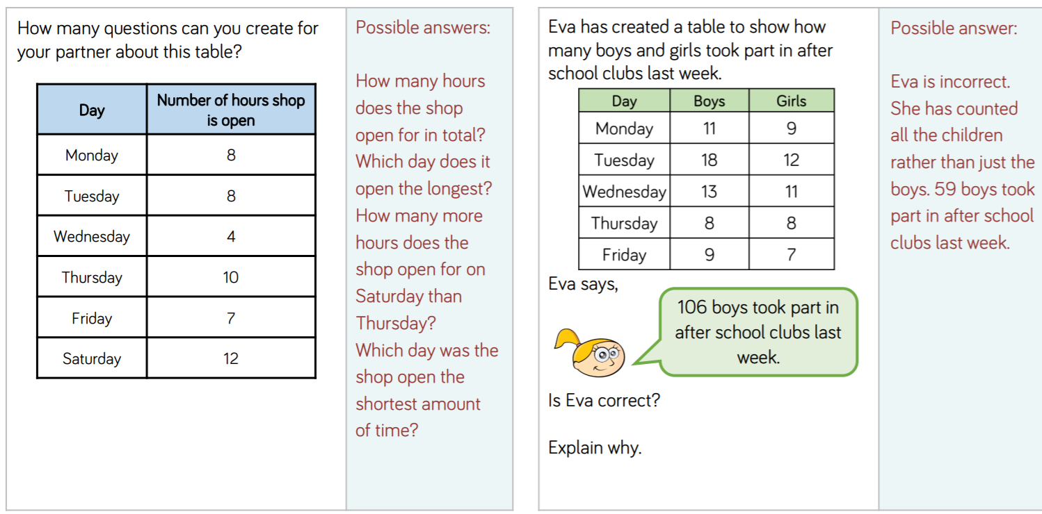

Wednesday
In the jar: £35 and 7p

Thursday
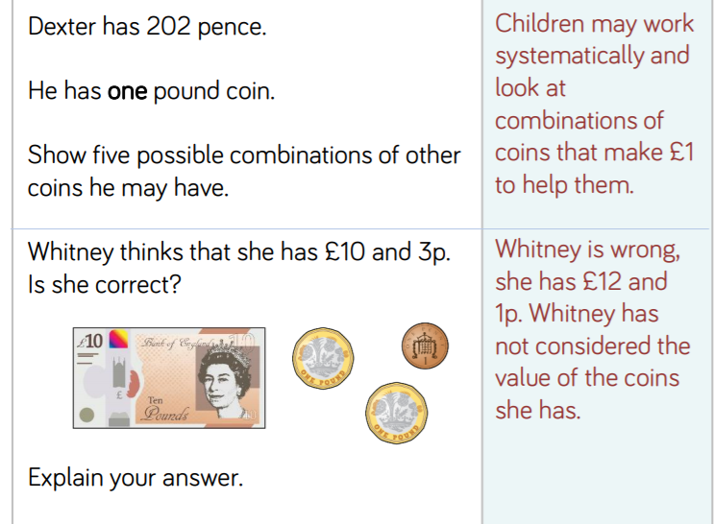

Friday

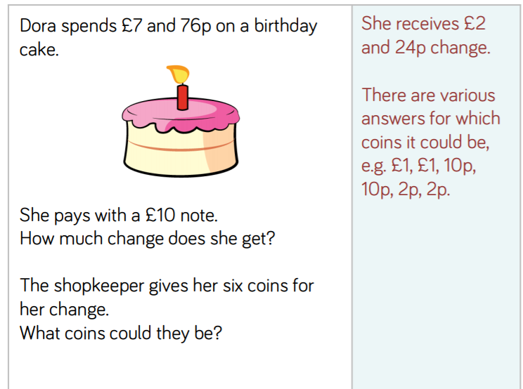

Geography

Tuesday –

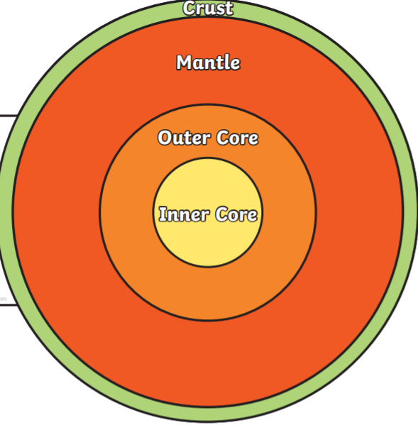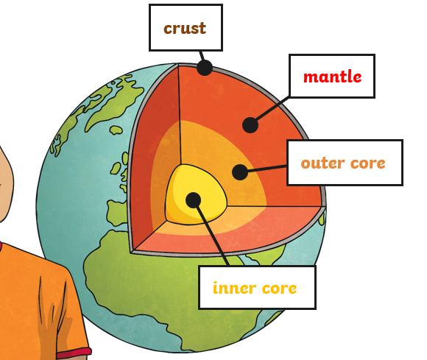

Wednesday –
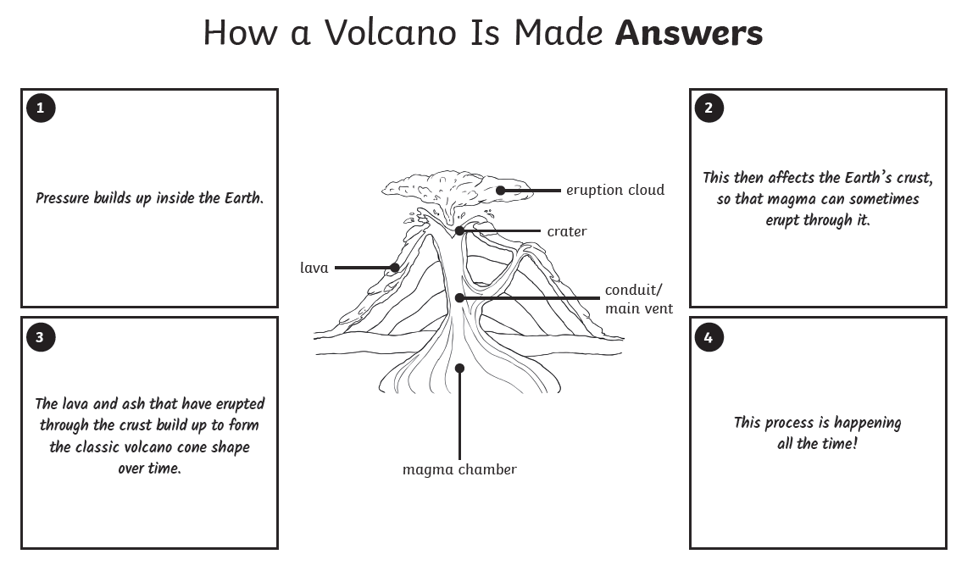

YEAR 3-4 SPELLING WORDS
