Dear Parent/Carer,

In light of the government’s latest guidance, we are very pleased that we are able to open up more on-site provision for all of our primary pupils. Your choice of provision can now be either; two days in ‘Bubble School’ or up to five days a week in ‘Key Worker School’ if you are a key worker. When the children are at school, they will access the home learning tasks, supported by their bubble teacher. When the children are at home, it is important that they continue with their home learning. The tasks that we set will be a mix of consolidation of previous work and new learning. To help the children with this work, we are including;
- The opportunity for you/your child to communicate with their class teacher via email on a set day, between certain times.
- More links to video resources/websites/ on-line clips or pre-recorded sessions from teachers.
- Feedback on a chosen piece of work (pictures/copies need to be emailed to the teacher or dropped off to a class box in the main reception area).

In primary, we suggest that children try to complete;
- 30 minutes a day of independent reading/reading to an adult
- 30 minutes of maths a day
- 30 minutes of English a day
- 30 minutes of topic based/creative learning
- 30 minutes of PE/ physical activity

Teachers will set a weekly programme for your child to work through at home. This will be available for you to access on the school website every Monday. We know that children work at different speeds and different levels, so please have a look at work in other year groups too for extra support.

Whilst it is important for your child to keep up with their learning at home, we appreciate that this can be a stressful time for children and adults. Looking after mental health is vital. Therefore, we suggest that the day is broken up into manageable learning chunks, interspersed with physical exercise, fun activities and time together as a family. Activities such as the 30 day Lego challenge and using the real PE activities could be a good place to start. Setting up a weekly timetable can be a good place to start. As well as educational learning, the children could also begin to learn different life skills – how to boil an egg, sew on a button, learn to send an email, bake a cake using a recipe book etc.

Guidance for parents, regarding home learning, has been released by the government and can be found at the following link;
https://www.gov.uk/guidance/supporting-your-childrens-education-during-coronavirus-covid-19

We hope you are all keeping well and staying positive.
We will be available via email to support parents and pupil with the tasks each week on Wednesdays between 10am-12pm and 1pm and 3pm. Please email your Friday English task to your teacher by Monday evening of the following week. Feedback will be given via email on Wednesday.

Kind regards,

The Year 3 team
lewisj@mayfield.portsmouth.sch.uk
browne-rebecca@mayfield.portsmouth.sch.uk
threadingham-cheryl@mayfield.portsmouth.sch.uk
Williams-kirsty@mayfield.portsmouth.sch.uk
YEAR 3 HOME LEARNING TASKS
WEEK BEGINNING: Monday 8th June 2020
ENGLISH
SPELLINGS FOR THIS WEEK:
certain, circle, complete, consider, continue, decide, describe
MONDAY – Speech marks
https://www.bbc.co.uk/bitesize/clips/zvftsbk
Watch the clip above to show you when you use speech marks.

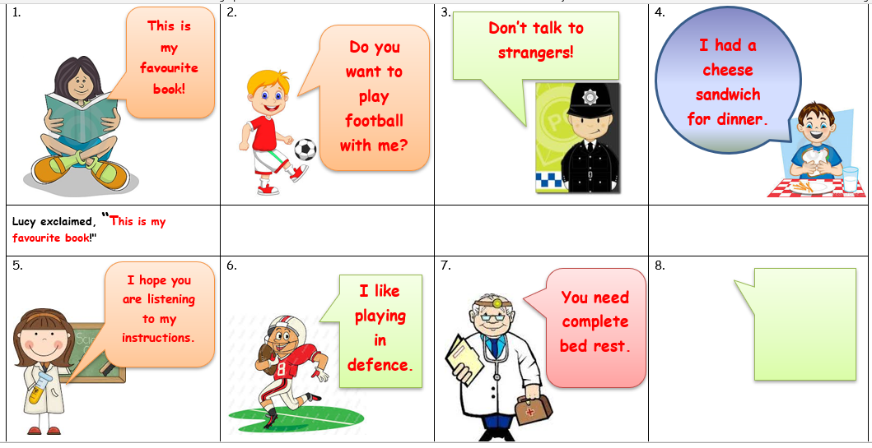
Write out the speech for each of the pictures. Remember, don’t just use the word ‘said.’

TUESDAY – Speech Marks
Find examples of speech in your book. Make a poster explaining how the rules of direct speech works.
Look at the video below to remind you how to use this punctuation.
https://www.youtube.com/watch?v=6-YFmLctwDY

WEDNESDAY – Reading comprehension activity
What did Romans do in their spare time?
Most people in Roman times did not have much spare time, they were too busy working. They liked board games. We know this because archaeologists have found counters and dice in the ground.
The Romans enjoyed watching fights between gladiators, and fights between people and animals. These bloodthirsty shows were put on in front of crowds in large arenas called amphitheatres. Gladiators fought one another, usually in pairs. They also fought wild animals such as lions or bears. When a gladiator was beaten (but still alive), the audience would wave scarves or put their thumbs out if they wanted him killed. If he'd fought well, and they wanted him to live, they would close their thumbs onto their fingers. Different types of gladiators used different weapons. For example, a man with a sword and shield might fight a man with a three-pronged spear or trident, and a big net.
Romans enjoyed the theatre. Most plays were funny comedies, though there were serious tragedies as well. Actors often wore masks to show whether their character was happy or sad! They also wore wigs - an old man had a white wig, a slave had a red wig. Roman emperors put on free shows at theatres and amphitheatres as it was a good way to make themselves popular.
In Rome there was a huge stadium called the Circus Maximus, used for chariot races. Chariot races were held in Britain too, which were thrilling but very dangerous. Chariots were small two-wheeled carts, driven by one man and pulled by four galloping horses. They raced around an oval track. There were often smashes during the seven-lap races.
- Why did many Romans have little spare time?
- What is an amphitheatre?
- How did actors show whether their characters were happy or sad?
- What is a chariot?
- Why do you think putting on free shows could help to make an emperor more popular?
- Why do you think that gladiator fights no longer happen today?
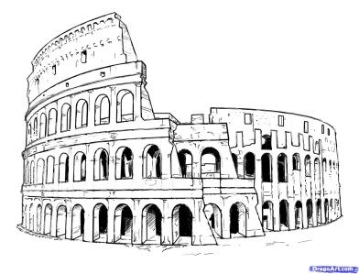
- What other questions could you ask a friend from the text above

THURSDAY – Spelling
Bubble write your words and draw a picture that shows the meaning of the word.
Use a dictionary to write the meaning of the word.
Sometimes the ‘c’ sounds like a ‘s’. Can you make a list of 15 other words where the c letter sounds like a ‘s’

FRIDAY – Speech
Write some dialogue (speech) to go along with the picture. What is the conversation the mice are having?
We would like to see a picture of your work so that we can give you some feedback on it. Please email this by Monday for feedback on Wednesday.
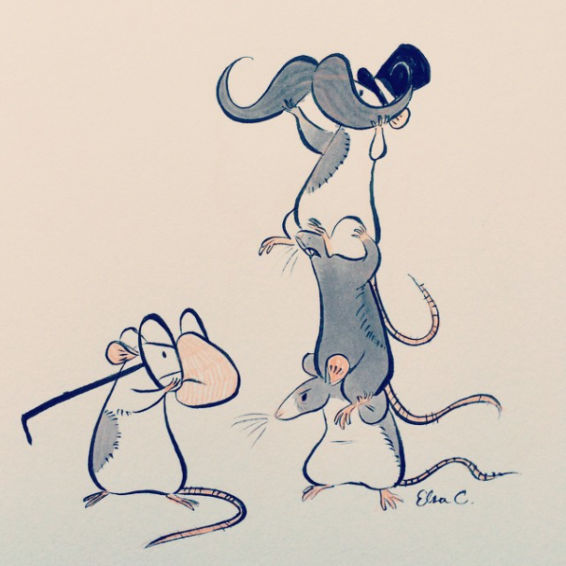
Remember;
Speech marks go around the spoken words.
The first word inside the speech marks starts with a capital letter.
Punctuation goes inside the speech marks.
Start a new line for a new speaker.
Look at the example below.
Don’t always use ‘said’
“You three needs to stop messing around!” moaned Fred.
“We’re only having some fun,” replied Tom.
Fred stared at the trio of mice in disbelief as they continued to misbehave.
“What do you think of my moustache? I think I look rather grand,” boasted Jerry as he stood on the top.

MATHS (GEOMETRY)
Times tables for this week:
Continue to test yourself weekly, on your target times table. (3 x , 4x and 8x)
Suggested websites:
https://www.topmarks.co.uk/maths-games/hit-the-button
http://www.timestables.me.uk/printable-pdf-quiz-generator.htm

Websites for the week:

MONDAY – Angles
Look at the BBC bitesize clip that explains all about angles.
https://www.bbc.co.uk/bitesize/topics/zb6tyrd/articles/zg68k7h

TUESDAY – Work for teacher feedback
Can you find objects in your home/classroom that have obtuse, right and acute angles on them?
Sort them and take a picture of them.
Order them in size of the angle. Eg, if you have found 5 objects with acute angles, put them in order from smallest acute angle to biggest acute angle.

WEDNESDAY – Different lines.
Today we are going to learn about 2 different types of lines – perpendicular and parallel.
Watch the link below.
https://www.bbc.co.uk/bitesize/topics/zb6tyrd/articles/zp327hv

Challenge – find a picture of a flag that has different types of angles and lines. Can you draw it and label the different angels and lines?

THURSDAY -
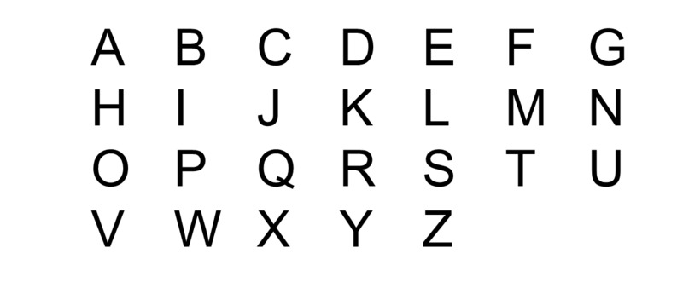
Choose at 10 different letters. Draw them out and show if they have acute, obtuse or right angles.
Do they have any parallel or perpendicular lines?

EG – the letter Z. It has parallel lines at the top and bottom and 2 acute angles.

FRIDAY –
Challenge;
Draw some other 2D shapes (with a ruler).
What different types of lines and angles do they have?

TOPIC
MONDAY – Why did the Romans invade Britain?
Read through the slides below. They are all about things that Britain had that the Romans wanted.

Which things do you think the Romans wanted most?
Write down 10 facts that you found interesting.

TUESDAY –
Cut out and order the events of the Roman Empire
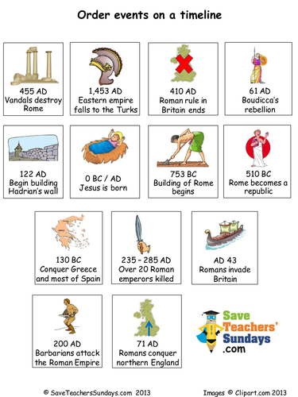

WEDNESDAY –
Roman quiz
https://www.funtrivia.com/playquiz/quiz3595042927a88.html
Research the answers for this quiz.

THURSDAY–
Sketch the Roman chariot below. Focus on each square and take your time.

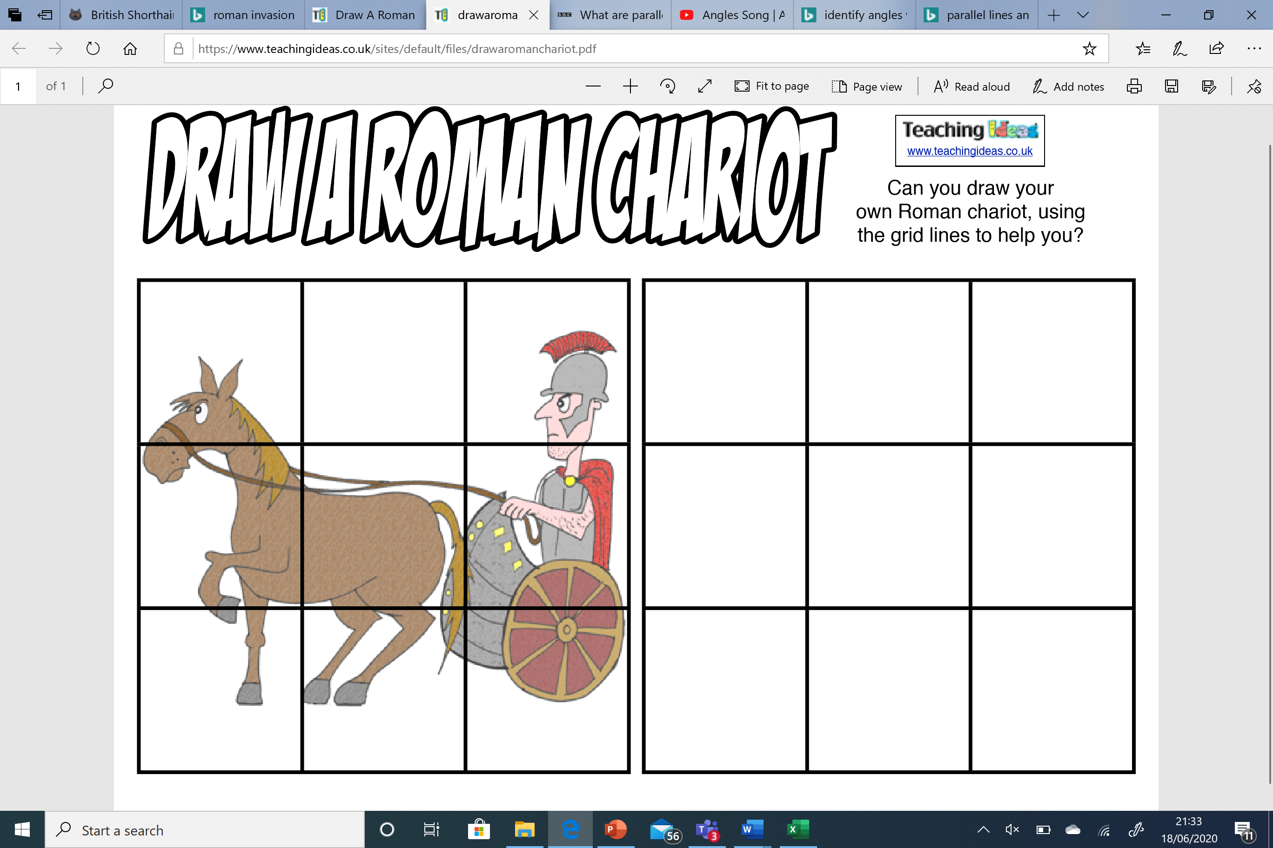

FRIDAY–
Use a dictionary/on-line research to find out the meaning of the words to do with the Roman empire;
Gladiator
Colosseum
Aqueduct
Forum
Hypocaust
Mosaic
Stylus

LEARNING WEBSITES

https://www.topmarks.co.uk/maths-games/hit-the-button

https://www.mathplayground.com/

https://www.topmarks.co.uk/maths-games/7-11-years

https://whiterosemaths.com/homelearning/

https://nrich.maths.org/primary

https://ttrockstars.com/

https://www.bbc.co.uk/bitesize/levels/zbr9wmn

https://www.literacyshed.com/home.html

https://www.spellingshed.com/

https://pobble.com/

https://monsterphonics.com/?gclid= EAIaIQobChMI56aEu9yh6AIVFeDtCh2NMAcIEA AYASAAEgK1b_D_BwE

https://www.oxfordowl.co.uk/welcome-back/for-home/reading-owl/kids-activities

https://www.topmarks.co.uk/english-games/7-11-years

Audible are doing a free 30 day trial so that children can listen to lots of books online.
MATHS ANSWERS

Monday:
Answers: 1) acute 2) right angle 3) obtuse 4) acute 5) obtuse 6)acute
2.

Friday

YEAR 3-4 SPELLING WORDS
