Dear Parent/Carer,

In light of the government’s latest guidance, we are very pleased that we are able to open up more on-site provision for all of our primary pupils. Your choice of provision can now be either; two days in ‘Bubble School’ or up to five days a week in ‘Key Worker School’ if you are a key worker. When the children are at school, they will access the home learning tasks, supported by their bubble teacher. When the children are at home, it is important that they continue with their home learning. The tasks that we set will be a mix of consolidation of previous work and new learning. To help the children with this work, we are including;
- The opportunity for you/your child to communicate with their class teacher via email on a set day, between certain times.
- More links to video resources/websites/ on-line clips or pre-recorded sessions from teachers.
- Feedback on a chosen piece of work (pictures/copies need to be emailed to the teacher or dropped off to a class box in the main reception area).
In primary, we suggest that children try to complete;
- 30 minutes a day of independent reading/reading to an adult
- 30 minutes of maths a day
- 30 minutes of English a day
- 30 minutes of topic based/creative learning
- 30 minutes of PE/ physical activity
Teachers will set a weekly programme for your child to work through at home. This will be available for you to access on the school website every Monday. We know that children work at different speeds and different levels, so please have a look at work in other year groups too for extra support.
Whilst it is important for your child to keep up with their learning at home, we appreciate that this can be a stressful time for children and adults. Looking after mental health is vital. Therefore, we suggest that the day is broken up into manageable learning chunks, interspersed with physical exercise, fun activities and time together as a family. Activities such as the 30 day Lego challenge and using the real PE activities could be a good place to start. Setting up a weekly timetable can be a good place to start. As well as educational learning, the children could also begin to learn different life skills – how to boil an egg, sew on a button, learn to send an email, bake a cake using a recipe book etc.

Guidance for parents, regarding home learning, has been released by the government and can be found at the following link;
https://www.gov.uk/guidance/supporting-your-childrens-education-during-coronavirus-covid-19
We hope you are all keeping well.

Kind regards,

The Year 3 team
Teacher emails;
lewisj@mayfield.portsmouth.sch.uk
browne-rebecca@mayfield.portsmouth.sch.uk
threadingham-cheryl@mayfield.portsmouth.sch.uk
Williams-kirsty@mayfield.portsmouth.sch.uk
YEAR 3 HOME LEARNING TASKS
WEEK BEGINNING: Monday 6th July 2020
ENGLISH

SPELLINGS FOR THIS WEEK:
Weight, woman, women, accident, accidentally, actual, actually
Useful websites:
https://www.bbc.co.uk/bitesize/topics/zr6bxyc/articles/z7vhsrd

Monday: Reading
Read chapter 2 and 3 of Roman Rescue and answer the questions below:
https://mayfieldschoolpo2.sharepoint.com/admin-staff/Shared%20Documents/Forms/AllItems.aspx?id=%2Fadmin%2Dstaff%2FShared%20Documents%2FSchool%20Closure%2FHome%20Learning%20Videos%2FHistory%20Hackers%20Roman%20Rescue%20Chapters%201%2D3%20Extract%2Epdf&parent=%2Fadmin%2Dstaff%2FShared%20Documents%2FSchool%20Closure%2FHome%20Learning%20Videos
- Who is the eldest child, how do you know?
- Underline the fronted adverbial in this sentence:
Tiring of Charlie’s whimpering, she grabbed his wrist and started her ascent.
- What does ascent mean in the above sentence?
- Read the paragraph in Chapter 3 that starts with ‘Her eyes could barely take it all in…’. What is the main purpose of this paragraph? How does it make you feel?
- What do you think will happen in chapter 4? Make sure you use clues from chapters 1-3 that might give you a clue.
Tuesday – Editing
Have a look at your character description that you completed last week. We are going to try and make this the best piece of writing – EVER!
Today I would like you to highlight 3 sentences, from your character description, and then write them out separately. You are going to try and make these sentences even better than they already are. Things you could do are:
- Using more ambitious vocabulary.
- Adding a conjunction (remember ISAWAWABUB and FANBOYS).
- Adding some more interesting punctuation.
- Checking all of your spellings are correct!
Wednesday – Spelling practise
Time to do our spellings! This week you are going to create your very own wordsearch. You can either do this online, or if you are feeling creative, try drawing your own!
Thursday - Writing
A letter to your teacher.
Today you are going to write a letter to your NEW teacher, who you’ll be with in September. You must remember the layout of a letter. Here are some suggestions of what you could talk about:
- Things you have been doing over lock down.
- Interesting facts about you and your family.
- Your favourite subject and why.
- Your least favourite subject and why.
Friday – Finishing/editing
Today you need to finish off your letter! Once all of your writing is done, you need to read through and make sure everything is spelt correctly and that your punctuation is all there!
If you send a photo of this to your class teacher, they can forward them to your new teachers for them to read!
Maths – Multiplication and Division
Times tables for this week:
Continue to test yourself weekly, on your target times table. Give yourself 30 seconds per calculation. You can include as many calculations as you wish to in the test. If you pass, move onto the next calculation. If you do not pass in time, continue to remain on that times table until you do pass.
Throughout the week use these websites to support your child’s learning:
https://www.bbc.co.uk/bitesize/articles/zb4gcqt
https://www.bbc.co.uk/bitesize/articles/zbkdjhv
https://www.topmarks.co.uk/maths-games/7-11-years/multiplication-and-division
MONDAY-
Read the statements and sort them into 3 categories – Always, Sometimes and Never.
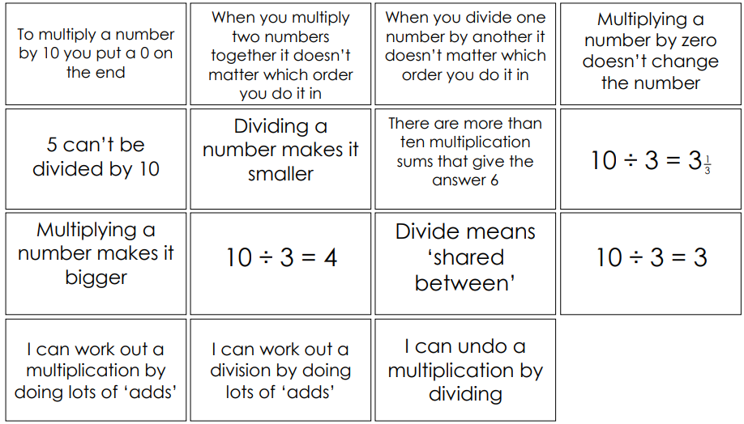
CHALLENGE –
Explain and prove your answers.
TUESDAY-
Divide 2-digit numbers by a 1-digit number by partitioning into tens and ones and sharing into equal groups. They divide numbers that involve exchanging between the tens and ones. The answers do not have remainders.
https://www.bing.com/videos/search?q=dividing+2+digit+by+1+digit+ppt&docid=608016027328710143&mid=581E10A3B88C07858D92581E10A3B88C07858D92&view=detail&FORM=VIRE
Mathematical Talk
Why have we partitioned the tens and the ones into 3 columns? What do you notice about the partitioned numbers and the divisor? Why do we partition 96 in different ways depending on the divisor?
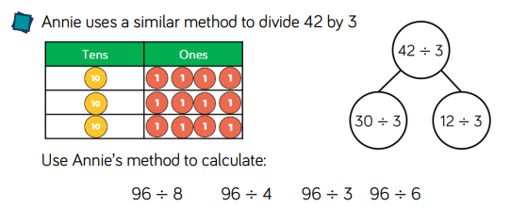
WEDNESDAY-
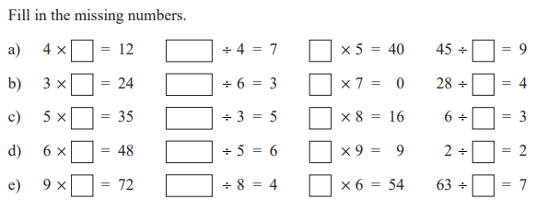
CHALLENGE
Explain what processes you used to work out your answers.
THURSDAY-
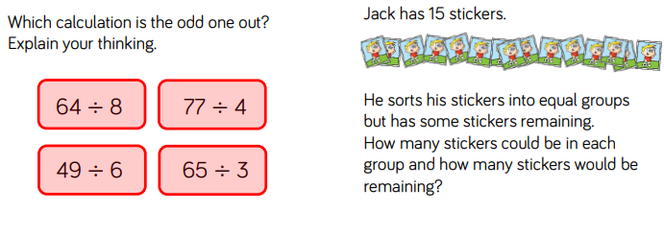
CHALLENGE
For the odd one out, can there be more than one reason for something being the odd one out?
Come up with at least 3 examples for Jack and his stickers.

FRIDAY-
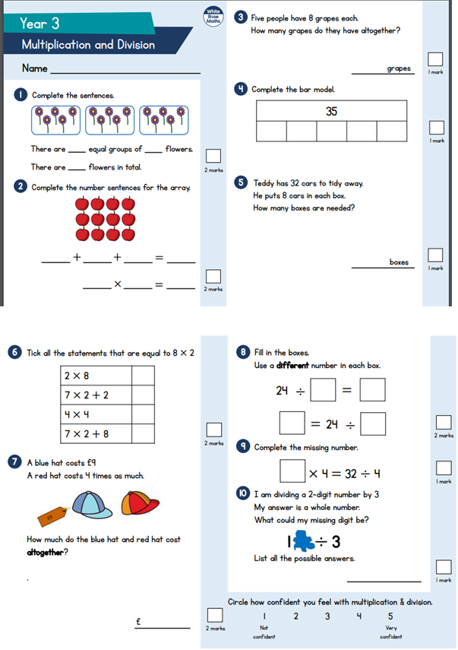

TOPIC
Monday – PSHE FIRST FLIGHT
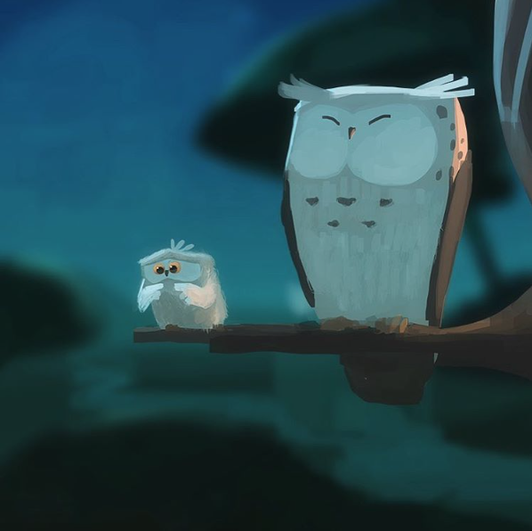
- 1) How are the owls related? 2)Which owl is about to take its first flight? How do you know? 3) How does the young owl feel about flying?
- 4) What might it be thinking? Add a thought bubble to the picture.
- 5) Is the older owl worried? 6)What advice might the older owl give to the younger one?
- 7) Think of the first time you did something new. How did you feel about it? What emotional journey did you go on? Plot your feelings on a graph.
- 8) If trying new things is scary, does that mean you should never try them?
- 9) Write ‘An Owl’s Guide to Flying’, to be used by younger owls before their first flight. Perhaps you’ll include an explanation of how flying works, the biology of wings, instructions, training advice, tips and warnings… How will you make it informative and entertaining?

- Tuesday – History
- https://www.bbc.co.uk/teach/class-clips-video/history-ks2-the-roman-invasion-animation/zmyhf4j
- Watch the link about Boudica’s rebellion against the Romans.
- Watch it a second time and make notes on what you have seen.
- Write down 10 facts about it.
- Do you think that Boudica was a good person or not? Explain your answer.

Wednesday –

Boudica

Who was Boudica?

​At the time of the Roman conquest of Britannia, there was a Celtic tribe called the Iceni tribe. They were ruled by a king, called Prasutagus, who was married to Queen Boudica.
The Roman army was strong and powerful and Celtic tribes like the Iceni tribe lived in fear. King Prasutagus wanted to protect his tribe, so he made a deal with the Romans that would allow him to continue ruling his tribe under their terms. When he died, he left instructions in his will to give half of his kingdom to the Roman Emperor and the other half to Queen Boudica.
However, the Romans did not honour Prasutagus’s will as he had intended. Instead, they took away land and farms from the Iceni tribe, increased taxes and refused to let Boudica be queen, publically flogging her instead.
​What did Boudica do about the Romans?
Boudica was not the kind of queen to take this treatment lightly. She was angry with the Romans and vowed to fight back. The people in her tribe were also cross with the way in which the Romans had treated them and it was easy for Boudica to encourage her people to join her in the fight against the Romans. When warriors from other tribes heard about Boudica’s rebellion, they decided to join her army too.
Boudica’s army launched its attack in 60 AD, when the Roman governor Suetonius Paullinus was called away. Boudica ordered her warriors to burn down Roman towns and kill as many Romans as possible. They destroyed the town of Colchester and then went on to ransack London and St. Albans.
​How did the Romans respond?
When Suetonius Paullinus heard the terrible news, he rallied more troops and called for as many soldiers as possible, but Boudica still had more than ten times as many soldiers in her army as the Romans! However, the Romans were well trained and very experienced in battle. The Romans won the battle and killed many of the Celtic warriors.
​What happened to Boudica in the end?
Boudica could not face being captured by the Romans, so she decided to poison herself instead by swallowing a deadly drink. The Romans celebrated their victory, sending a clear message of strength to any other tribes thinking of rebellion against their rule.

Questions
- Who was Boudica’s husband?
- Who was he king of?
- Why did he make a deal with the Romans?
- How did the Romans prove themselves to be untrustworthy?
- Why was it easy for Boudica to get people to join her to fight?
- Why do you think that Boudica was successful at first?
- Which towns did Boudica and her army defeat?
- Why did the Romans manage to defeat Boudica, even though she had more people in her army?
- When did all of this happen?
Thursday – What have the Romans done for us?
Look through the powerpoint
https://mayfieldschoolpo2.sharepoint.com/:p:/r/admin-staff/_layouts/15/Doc.aspx?sourcedoc=%7BEE596BFB-EBFB-4F76-826E-BC9B4FC3CE3D%7D&file=what%20have%20the%20romans%20ever%20done%20for%20us.ppt&action=edit&mobileredirect=truethat shows you all of the things that the Romans left for us after their occupation. Try and rank the different things in the order of importance. Make sure you give a reason for your order.
Friday - Roman Review
Look back on the work that you have done on the Romans over the last half term. Create a fact file/poster that includes pictures/ideas of what you have learnt. Make them bright and colourful and concentrate on your presentation. Please take a picture and email your teacher so we can see what you have learnt and give you some feedback.
LEARNING WEBSITES

https://www.topmarks.co.uk/maths-games/hit-the-button

https://www.mathplayground.com/

https://www.topmarks.co.uk/maths-games/7-11-years

https://whiterosemaths.com/homelearning/

https://nrich.maths.org/primary

https://ttrockstars.com/

https://www.bbc.co.uk/bitesize/levels/zbr9wmn

https://www.literacyshed.com/home.html

https://www.spellingshed.com/

https://pobble.com/

https://monsterphonics.com/?gclid= EAIaIQobChMI56aEu9yh6AIVFeDtCh2NMAcIEA AYASAAEgK1b_D_BwE

https://www.oxfordowl.co.uk/welcome-back/for-home/reading-owl/kids-activities

https://www.topmarks.co.uk/english-games/7-11-years

Audible are doing a free 30 day trial so that children can listen to lots of books online.
MATHS ANSWERS

Monday

Tuesday
96 ÷ 8 = 12 96 ÷ 4 = 24 96 ÷ 3= 32 96 ÷ 6= 16

Wednesday

Thursday

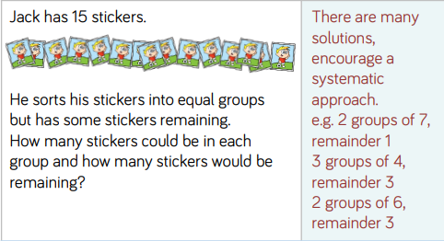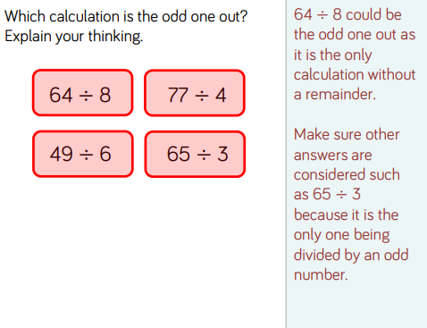

Friday

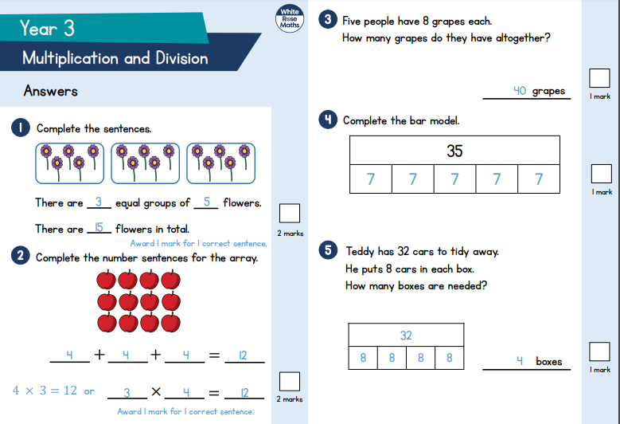
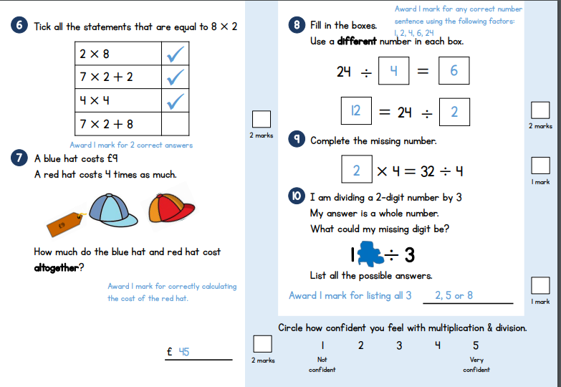

YEAR 3-4 SPELLING WORDS
