Dear Parent/Carer,

As the school continues to remain closed due to Coronavirus, we are continuing to provide educational tasks for your children to complete. We have received positive feedback on the new format of the home learning daily tasks. As always, please continue to keep in touch about your child’s home learning and let us know if there are any problems.

In primary, we suggest that children try to complete;
- 30 minutes a day of independent reading/reading to an adult
- 30 minutes of maths a day
- 30 minutes of English a day
- 30 minutes of topic based/creative learning
- 30 minutes of PE/ physical activity

Home learning tasks can be supplemented with work from a number of websites (see list below for ideas.) Daily work set on the BBC website is particularly useful as it contains tutorial videos.
https://www.bbc.co.uk/bitesize/primary

Teachers will set a weekly programme for your child to work through at home. This will be available for you to access on the school website every Monday. We know that children work at different speeds and different levels, so please have a look at work in other year groups too for extra support.

To help with maths and different terminology, we will try to add in some video links for tutorials and we will try to include answers for maths where possible to help the children check through their work.

Whilst it is important for your child to keep up with their learning at home, we appreciate that this can be a stressful time for children and adults. Looking after mental health is vital. Therefore, we suggest that the day is broken up into manageable learning chunks, interspersed with physical exercise, fun activities and time together as a family. Activities such as the 30 day lego challenge and using the real PE activities could be a good place to start. Setting up a weekly timetable can be a good place to start. As well as educational learning, the children could also begin to learn different life skills – how to boil an egg, sew on a button, learn to send an email, bake a cake using a recipe book etc.

Guidance for parents, regarding home learning, has been released by the government and can be found at the following link;
https://www.gov.uk/guidance/supporting-your-childrens-education-during-coronavirus-covid-19

We hope you are all keeping well and staying positive.

Kind regards,

The Year 3 team
Teacher emails;
lewisj@mayfield.co.uk
browne-rebecca@mayfield.portsmouth.sch.uk
threadingham-cheryl@mayfield.portsmouth.sch.uk
Williams-kirsty@mayfield.portsmouth.sch.uk
YEAR 3 HOME LEARNING TASKS
WEEK BEGINNING: Monday 1st June 2020
ENGLISH (Description focus)

SPELLINGS FOR THIS WEEK:
SPELLINGS FOR THIS WEEK:
Natural naughty notice occasion occasionally often opposite
MONDAY – Spelling
Look carefully at your spellings for this week. Can you;
Say how many consonants are in each word
Say how many vowels there are in each word
Say how many syllables there in in each words
How many different words can you make from your spellings. EG – in the word TEACHER, I could make the words;
Rate, hate, chart, he, hat, tea, rat, cat , tar, cart, cart,
TUESDAY – Reading
Book review – Choose a book that you have written and answer the following questions about it;
- What is the title of your book?
- Can you think of a better/alternative title for it?
- Who illustrated and published your book?
- Is your book fiction or non-fiction? How do you know?
- What did you like about the book?
- What did you dislike/what would you change about your book?
- Write either, 5 sentences about the main character or 5 facts if you were reading a non-fiction book
- Would you recommend this book to a friend? Yes or no? Give your reasons.
- Draw a picture of something from your book.

WEDNESDAY –
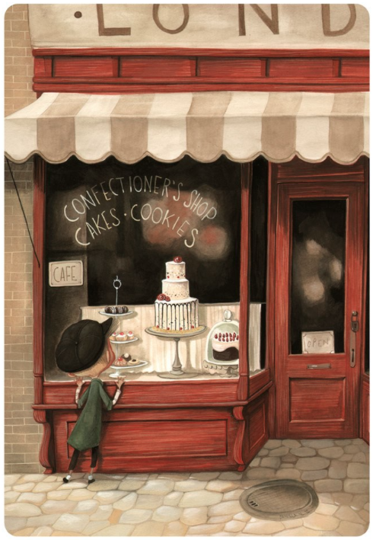
Where do you think the cake shop is?
Who do you think the boy is?
How do you think he is feeling?
Make a list of 10 adjectives that you could use to describe the cake shop.
Write some descriptive sentences about what the inside of the cake shop is like.
Who do you think owns the cake shop?

THURSDAY –
Poems
https://www.bbc.co.uk/bitesize/topics/z4mmn39/articles/ztdvw6f
Use the information in the video link about to help you write an acrostic poem all about lockdown or isolation
LOCKDOWN
ISOLATION
EG – Lockdown’s been going on for what seems like an age,
On some days it feels like I’m trapped in a cage.
‘Can it be over soon?’ I hear people say,
Keeping everyone safe is what matters each day.
Drawing and painting and reading my books,
On Wednesdays, my brother and I are the cooks.
Weekly we Skype and say hi to my nan,
Now when can we go out, oh please say we can.

Poems
Publish your work from yesterday. Write it up neatly. Use big/bold writing for the letters. Add some colour and some illustrations. Be reflective about your work and use the checklist below to see if you can improve your work.
I would try and improve my work above by adding more description.
Put a tick in the box if you think you have included the feature
Capital letter at the start of a line
Some adjectives
Emotions
Some similes – eg ‘like/as’
Adverbs
Any rhyming

MATHS (Shape Focus)

Times tables for this week:
Continue to practise your 3, 4 and 8 times tables. Chant them, write them, sing them to a catchy tune.

If you want to try some extra challenges, have a look at the link below.
https://whiterosemaths.com/homelearning/year-3/

Look at the video links below to help you with your shape work this week.
https://www.bbc.co.uk/bitesize/topics/zy72pv4

MONDAY – 3D shape

Look at the 3D shapes below and fill in the information.
Use the Bitsesize videos to help you.

TUESDAY – 3D Shape
House hunt. Can you go on a hunt around your house and see what objects you can find and sort into the following groups;
Cubes,
Cuboids
Spheres
Prisms
Other
It would be great if you could sort and label them, take a picture and show your teacher.

WEDNESDAY – Perimeter
Remember that perimeter is the distance all the way around the outside of a shape.
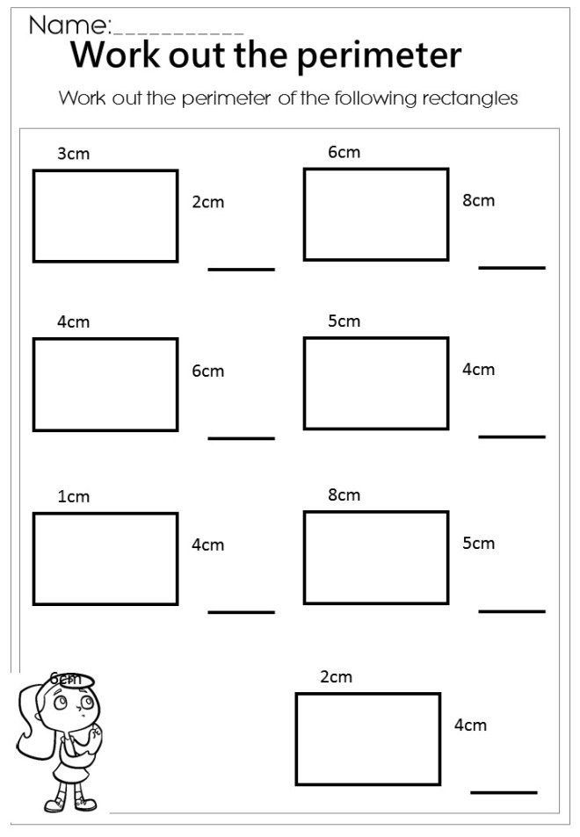

THURSDAY – Be creative.
Can you draw a 3 sided shape with a perimeter of 20 cm, a 4 sided shape with a perimeter of 20 cm and a five sided shape
with a perimeter of 20 cm. Not all sides have to be the same length and they don’t all have to be regular looking shapes.
Challenge
How many different rectangles can you create that have a perimeter of 24cm?

FRIDAY – Times tables.
Write out and answer the following times tables calculations;
1x3 = 2x 5 = 4 x 8 = 7 x 3 = 4 x 10 = 3 x 4 =

2x 8 = 8 x 2 = 9 x 3 = 8 x 5 = 6 x 3 = 9 x 2 =

4 x 4 = 7 x 5 = 2 x 5 = 3 x 3 = 12 x 4 = 11 x 10 =

7 x 8 = 6 x 4 = 3 x 10 = 6 x 8 = 7 x 2 = 0 x 8 =

9 x 8 = 6 x 2 = 7 x 10 = 11 x 3 = 12 x 5 = 6 x 8 =

TOPIC
MONDAY and TUESDAY - History – read the story of Romulus and Remus
https://www.ducksters.com/history/ancient_rome/romulus_and_remus.php
Create a storyboard that shows the main points of the story
WEDNESDAY – Geography –
Look at the map below which shows you the different countries that the Romans invaded to create the Roman Empire.
Can you work countries are shaded in blue?
Create a list of the countries that were in the Roman Empire?
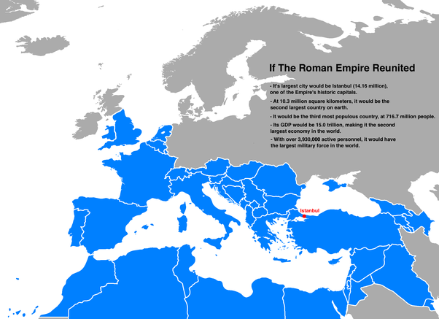

THURSDAY – Art – How to draw a Roman Soldier

https://www.bing.com/videos/search?q=you+tube+how+to+draw+a+romansoldier&qpvt=you+tube+
how+to+draw+a+romansoldier&view=detail&mid=73B4F80528E35863B93773B4F80528E35863B937&&FORM=
VRDGAR&ru=%2Fvideos%2Fsearch%3Fq%3Dyou%2Btube%2Bhow%2Bto%2Bdraw%2Ba%2Bromansoldier%26qpvt%3
Dyou%2Btube%2Bhow%2Bto%2Bdraw%2Ba%2Bromansoldier%26FORM%3DVDRE

FRIDAY – PSHE – ‘All About Me’ Create a poster that tells someone all about you. Draw a picture of yourself, talk about your appearance, hobbies, family, likes and dislikes, friends etc.

LEARNING WEBSITES

https://www.topmarks.co.uk/maths-games/hit-the-button

https://www.mathplayground.com/

https://www.topmarks.co.uk/maths-games/7-11-years

https://whiterosemaths.com/homelearning/

https://nrich.maths.org/primary

https://ttrockstars.com/

https://www.bbc.co.uk/bitesize/levels/zbr9wmn

https://www.literacyshed.com/home.html

https://www.spellingshed.com/

https://pobble.com/

https://monsterphonics.com/?gclid= EAIaIQobChMI56aEu9yh6AIVFeDtCh2NMAcIEA AYASAAEgK1b_D_BwE

https://www.oxfordowl.co.uk/welcome-back/for-home/reading-owl/kids-activities

https://www.topmarks.co.uk/english-games/7-11-years

Audible are doing a free 30 day trial so that children can listen to lots of books online.
MATHS ANSWERS

YEAR 3 -4 SPELLING WORDS
