Dear Parent/Carer,

In light of the government’s latest guidance, we are very pleased that we are able to open up more on-site provision for all of our primary pupils. Your choice of provision can now be either; two days in ‘Bubble School’ or up to five days a week in ‘Key Worker School’ if you are a key worker. When the children are at school, they will access the home learning tasks, supported by their bubble teacher. When the children are at home, it is important that they continue with their home learning. The tasks that we set will be a mix of consolidation of previous work and new learning. To help the children with this work, we are including;
- The opportunity for you/your child to communicate with their class teacher via email on a set day, between certain times.
- More links to video resources/websites/ on-line clips or pre-recorded sessions from teachers.
- Feedback on a chosen piece of work (pictures/copies need to be emailed to the teacher or dropped off to a class box in the main reception area).
In primary, we suggest that children try to complete;
- 30 minutes a day of independent reading/reading to an adult
- 30 minutes of maths a day
- 30 minutes of English a day
- 30 minutes of topic based/creative learning
- 30 minutes of PE/ physical activity
Teachers will set a weekly programme for your child to work through at home. This will be available for you to access on the school website every Monday. We know that children work at different speeds and different levels, so please have a look at work in other year groups too for extra support.
Whilst it is important for your child to keep up with their learning at home, we appreciate that this can be a stressful time for children and adults. Looking after mental health is vital. Therefore, we suggest that the day is broken up into manageable learning chunks, interspersed with physical exercise, fun activities and time together as a family. Activities such as the 30 day Lego challenge and using the real PE activities could be a good place to start. Setting up a weekly timetable can be a good place to start. As well as educational learning, the children could also begin to learn different life skills – how to boil an egg, sew on a button, learn to send an email, bake a cake using a recipe book etc.

Guidance for parents, regarding home learning, has been released by the government and can be found at the following link;
https://www.gov.uk/guidance/supporting-your-childrens-education-during-coronavirus-covid-19
We hope you are all keeping well.

Kind regards,

The Year 3 team
Teacher emails;
lewisj@mayfield.portsmouth.sch.uk
browne-rebecca@mayfield.portsmouth.sch.uk
threadingham-cheryl@mayfield.portsmouth.sch.uk
Williams-kirsty@mayfield.portsmouth.sch.uk
YEAR 3 HOME LEARNING TASKS
WEEK BEGINNING: Monday 6th July 2020
ENGLISH -
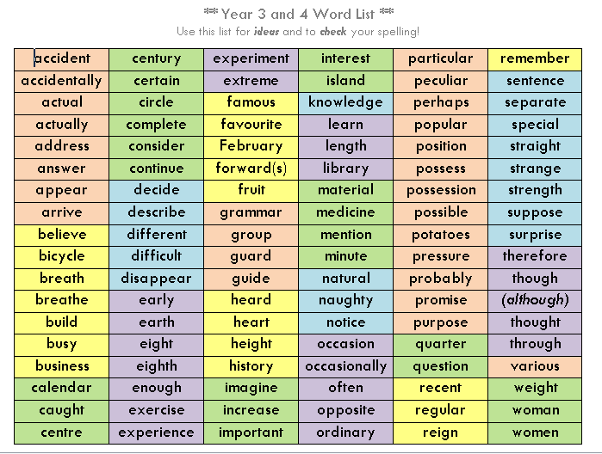
SPELLINGS FOR THIS WEEK:
Monday:
Challenge!
How many of your year 3 and 4 words can you spell, CORRECTLY?
Have a go at spelling as many as possible and then marking them at the end.
Pick 7 spellings that you got wrong and create a word search to help you remember them!
Tuesday:
Time to write one more letter!
Today would have been your last day at school! I know that so many of you are sad that you have not had a chance to say goodbye to your friends and teachers.
Today, you are going to pick ONE person from your year 3 class. This could be a friend, your teacher or you teaching assistant!
It would be lovely if you could send photos of your letters, as I am sure we would all LOVE to read them!
Maths –
Times tables for this week:
Continue to test yourself weekly, on your target times table. Give yourself 30 seconds per calculation. You can include as many calculations as you wish to in the test. If you pass, move onto the next calculation. If you do not pass in time, continue to remain on that times table until you do pass.
Throughout the week use these websites to support your child’s learning:
MONDAY-
Domino and Make 37 challenges (see attachment). Take a picture of your challenges and send them to your class teacher.
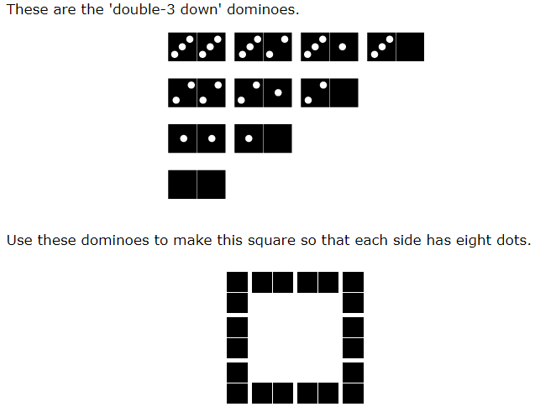
TUESDAY-
Look at these cards: Can you sort them so that they follow round in a loop?
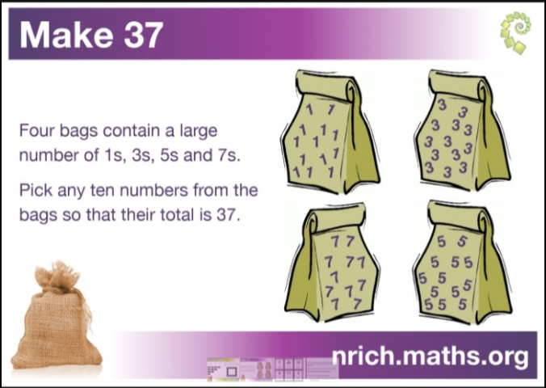
EXTRA-
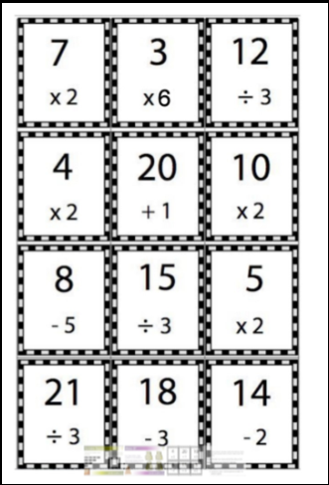

TOPIC
Monday - PSHE

Tuesday –

Wednesday –

Thursday –

Friday

LEARNING WEBSITES

https://www.topmarks.co.uk/maths-games/hit-the-button

https://www.mathplayground.com/

https://www.topmarks.co.uk/maths-games/7-11-years

https://whiterosemaths.com/homelearning/

https://nrich.maths.org/primary

https://ttrockstars.com/

https://www.bbc.co.uk/bitesize/levels/zbr9wmn

https://www.literacyshed.com/home.html

https://www.spellingshed.com/

https://pobble.com/

https://monsterphonics.com/?gclid= EAIaIQobChMI56aEu9yh6AIVFeDtCh2NMAcIEA AYASAAEgK1b_D_BwE

https://www.oxfordowl.co.uk/welcome-back/for-home/reading-owl/kids-activities

https://www.topmarks.co.uk/english-games/7-11-years

Audible are doing a free 30 day trial so that children can listen to lots of books online.
YEAR 3-4 SPELLING WORDS

