Dear Parent/Carer,

As the school continues to remain closed due to Coronavirus, we are continuing to provide educational tasks for your children to complete. We have received positive feedback on the new format of the home learning daily tasks. As always, please continue to keep in touch about your child’s home learning and let us know if there are any problems.

In primary, we suggest that children try to complete;
- 30 minutes a day of independent reading/reading to an adult
- 30 minutes of maths a day
- 30 minutes of English a day
- 30 minutes of topic based/creative learning
- 30 minutes of PE/ physical activity

Home learning tasks can be supplemented with work from a number of websites (see list below for ideas.) Daily work set on the BBC website is particularly useful as it contains tutorial videos.
https://www.bbc.co.uk/bitesize/primary

Teachers will set a weekly programme for your child to work through at home. This will be available for you to access on the school website every Monday. We know that children work at different speeds and different levels, so please have a look at work in other year groups too for extra support.

To help with maths and different terminology, we will try to add in some video links for tutorials and we will try to include answers for maths where possible to help the children check through their work.

Whilst it is important for your child to keep up with their learning at home, we appreciate that this can be a stressful time for children and adults. Looking after mental health is vital. Therefore, we suggest that the day is broken up into manageable learning chunks, interspersed with physical exercise, fun activities and time together as a family. Activities such as the 30 day lego challenge and using the real PE activities could be a good place to start. Setting up a weekly timetable can be a good place to start. As well as educational learning, the children could also begin to learn different life skills – how to boil an egg, sew on a button, learn to send an email, bake a cake using a recipe book etc.

Guidance for parents, regarding home learning, has been released by the government and can be found at the following link;
https://www.gov.uk/guidance/supporting-your-childrens-education-during-coronavirus-covid-19

We hope you are all keeping well and staying positive.

Kind regards,

The Year 3 team
Teacher emails;
lewisj@mayfield.portsmouth.sch.uk
browne-rebecca@mayfield.portsmouth.sch.uk
threadingham-cheryl@mayfield.portsmouth.sch.uk
Williams-kirsty@mayfield.portsmouth.sch.uk
YEAR 3 HOME LEARNING TASKS
WEEK BEGINNING: Monday 29th June 2020
ENGLISH (Commas)

SPELLINGS FOR THIS WEEK:
Sentence, Separate, Special, Straight, Strange, Strength, Suppose
Useful websites:
https://www.bbc.co.uk/bitesize/topics/zvwwxnb/articles/zc773k7
https://www.theschoolrun.com/what-is-a-comma
https://www.education.com/game/comma-series-quiz/

MONDAY – Commas
This week we are going to be looking at commas and all of the different ways we use them! Have a look at the slides and complete each task. Remember to read each slide and ALL of the examples really carefully, take your time!

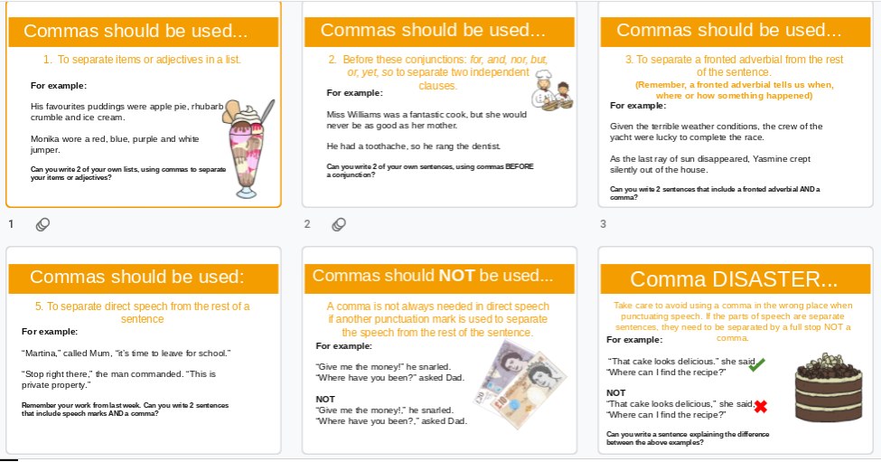

TUESDAY – Commas
Can you put the missing commas back into these sentences? Remember, we’ve been looking at: using commas in lists, using commas after a fronted adverbial, using commas before conjunctions and in speech. Use a purple pen/pencil to add in the commas so they are clear to see!

1) Ms Threadingham went to the shop and bought carrots broccoli pork and gravy granules.
2) In the morning Miss Williams must have a cup of coffee.
3) Because of the weather Mr Tait put his raincoat on.
4) “Get inside quickly” called Miss Lewis. “It’s going to rain!”
5) I needed flour eggs butter and icing sugar for the cake.
6) Miss Williams was very hungry but she had forgotten her lunch.
7) “Lana” shouted Miss Williams “where are your full stops?”
Challenge – Can you create 6 more sentences – 3 where you use the commas to separate items in a list and 3 sentences to separate fronted adverbials or go before conjunctions.
WEDNESDAY – Reading comprehension
Leisure and Entertainment in Ancient Rome Much like you all like to do today, people in Ancient Roman times liked to relax and have fun. Board games which could be played in either groups or pairs were very popular. Archaeologists today have even found some counters from Roman games. As well as games, Romans also hunted animals in their spare time. They didn't just kill animals for food; they killed them for fun too. They liked hunting deer; in fact, they enjoyed it so much that they brought deer to Britain just so that they could hunt them. Have you ever been to a concert? Or maybe a theatre show? These are types of entertainment that people go to watch in their spare time. Well, in Ancient Roman times, there was a slightly more gruesome type of entertainment. Have you ever heard of a gladiator? Gladiators were men who were used for entertainment. Lots of people would gather at an amphitheatre to watch a gladiator fight. Sometimes gladiators would fight each other and other times, they fought animals, like lions or bears. Gladiators often fought until one of them was killed. If, at the end of a fight, a gladiator was still alive, the audience would get to vote on whether or not he was to be killed or allowed to live.
The amphitheatre is where the gladiators would fight. An amphitheatre is what we now call a theatre - somewhere we go to watch a show or a concert. It was free to go to. There could be thousands of people in the audience at an amphitheatre show. Going to the baths is something else that Romans did in their spare time. There are still some Baths left from Roman times in England. They are in a place called ... Bath! Although visiting the baths was a relaxing activity for Romans, there was also another reason for going there. They went to the baths to get clean! Whilst at the baths, Romans would do some exercises and some swimming. There were some rooms in the baths, with the temperature turned up very, very high. This was designed to help Romans sweat out dirt. Their skin was then scraped with a metal stick to remove all of the dirt. This stick was called a Strigil.
- How much did it cost to go and see a show at the amphitheatre?
- What did the Romans bring to Britain to hunt?
- What did the gladiators do?
- What decision did the audience sometimes have to make at the end of a gladiator fight?
- As well as relaxing, for what other reason did Romans go to the baths?
- Why was the temperature in the rooms at the baths so hot?

THURSDAY – Spelling
Speed write! How many times can you write each word in one minute? Remember, if you get the spelling wrong it doesn’t count towards your total!
Take one of your spelling words and create an acrostic poem.

FRIDAY – Descriptive writing (remember those commas!)
Have a look at the picture below of a group of women from Ancient Rome. I would like you to write a paragraph, using the picture to help, about life as a woman in Ancient Rome.
Think about what the picture tells us and what we might have to infer.
Remember your work earlier in the week based around commas, make sure you are using your skills in your writing. We would like to see a picture of your work so that we can give you some feedback on it. Please email this by Monday for feedback on Wednesday.
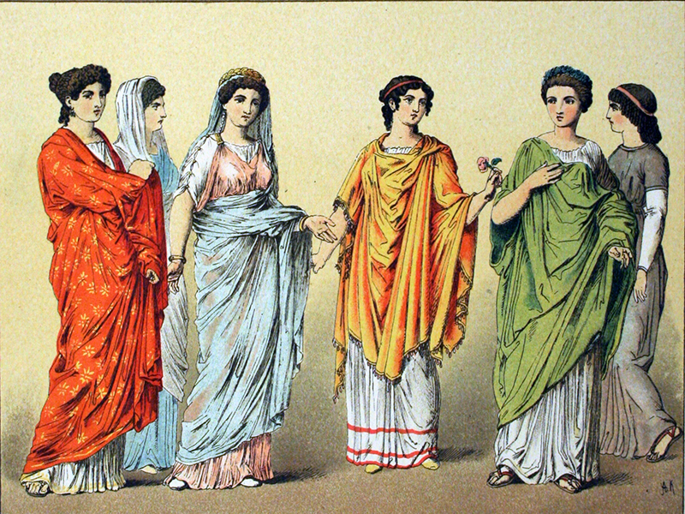

MATHS (Statistics/data)

Times tables for this week:
Continue to test yourself weekly, on your target times table. Give yourself 30 seconds per calculation. You can include as many calculations as you wish to in the test. If you pass, move onto the next calculation. If you do not pass in time, continue to remain on that times table until you do pass.
Throughout the week use these websites to support your child’s learning: ** https://www.bbc.co.uk/bitesize/articles/zmtx8hv
https://www.bbc.co.uk/bitesize/topics/z7rcwmn https://www.topmarks.co.uk/maths-games/7-11-years/data-handling
https://www.theschoolrun.com/data-handling https://mathsframe.co.uk/en/resources/resource/109/itp-data-handling
For any key Mathematical Vocabulary that you are unsure of please use:
http://www.amathsdictionaryforkids.com/
MONDAY –
Mathematical talk
What is each symbol worth? What does half of the symbol represent? Is it always possible to use half of a symbol? Why? What would each symbol represent in your pictogram? Have you used the same key as a friend? Could it be represented in different ways?
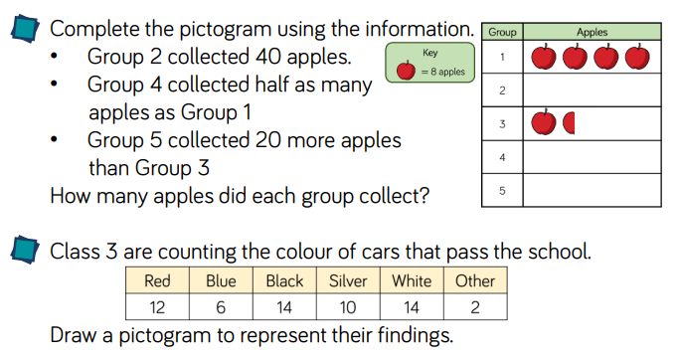

TUESDAY –
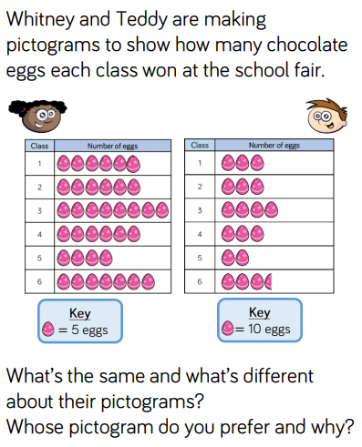

What other questions could you ask about this pictogram? For example: How many eggs did Class 1 and 5 have altogether? Create 5 more of your own.

EXT: What information can you collect and present in a pictogram? For example, favourite ice cream flavour, favourite film, size of feet etc.

WEDNESDAY –
Mathematical talk
What’s the same and what’s different about the pictogram and the bar chart? How does the bar chart help you understand the information? Which scale should we use? How can we decide whether to have a scale going up in intervals of 1, 2, 5 or 10? What other questions could you ask about the bar chart?
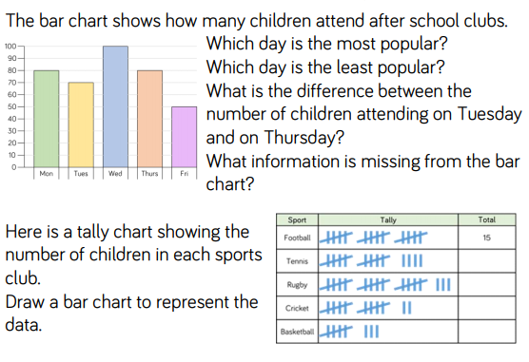
You could use this resource to draw your bar chart: https://www.mathsisfun.com/data/bar-graph.html

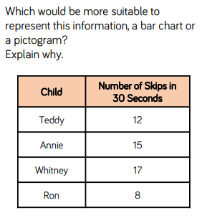
THURSDAY -

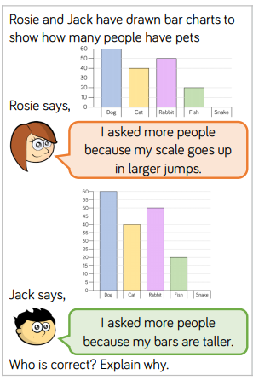

Challenge –
Choose a different way of showing Rosie’s data – eg tally chart, pictogram. Do the same with the chart.

FRIDAY –
Mathematical talk
What information can we gather from the table? Can you explain to a friend how to read the table? Where do we need to use tables in real life?
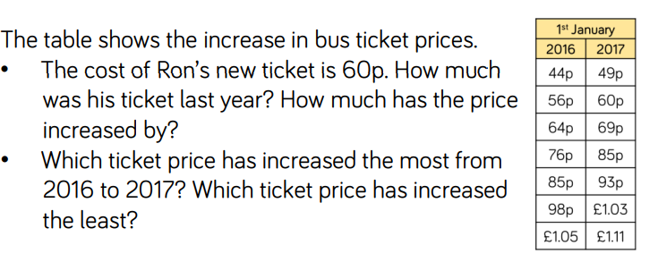
Write down: What other questions could you ask and answer using the information in the table?

TOPIC
Monday – PSHE

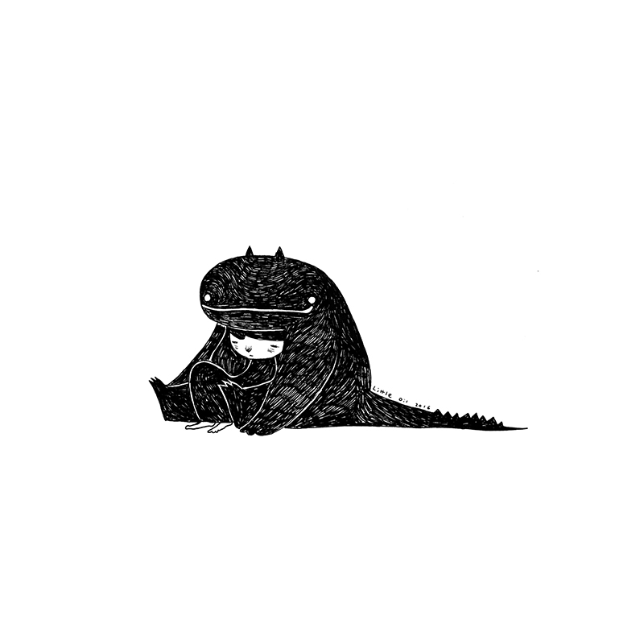
- What is the boy doing? How is he feeling? How do you know?
- Is the monster good or bad?
- Does the boy know the monster well?
- Is the monster real, or a representation of something?
- Why do you think Little Oil left so much white space around the boy and the monster?
- Imagine that the monster represents a feeling. Which feeling could it be and why?
- What does sadness feel like? What does fear feel like? What does anxiety feel like? Draw a picture of these feelings as if they were characters or monsters. Once you’ve drawn your character, what might you say to it?
- What does sadness feel like? What does fear feel like? What does anxiety feel like? Try to describe what feelings you have in your body when you feel this way. You might want to draw a diagram and label it, or draw on it to show the different physical changes that happen to you.
- Are these feelings good or bad?
- What do you do when you’re feeling sad/scared/anxious/worried? What could you do to help yourself? What could others do to help you?

TUESDAY –
Roman Numerals
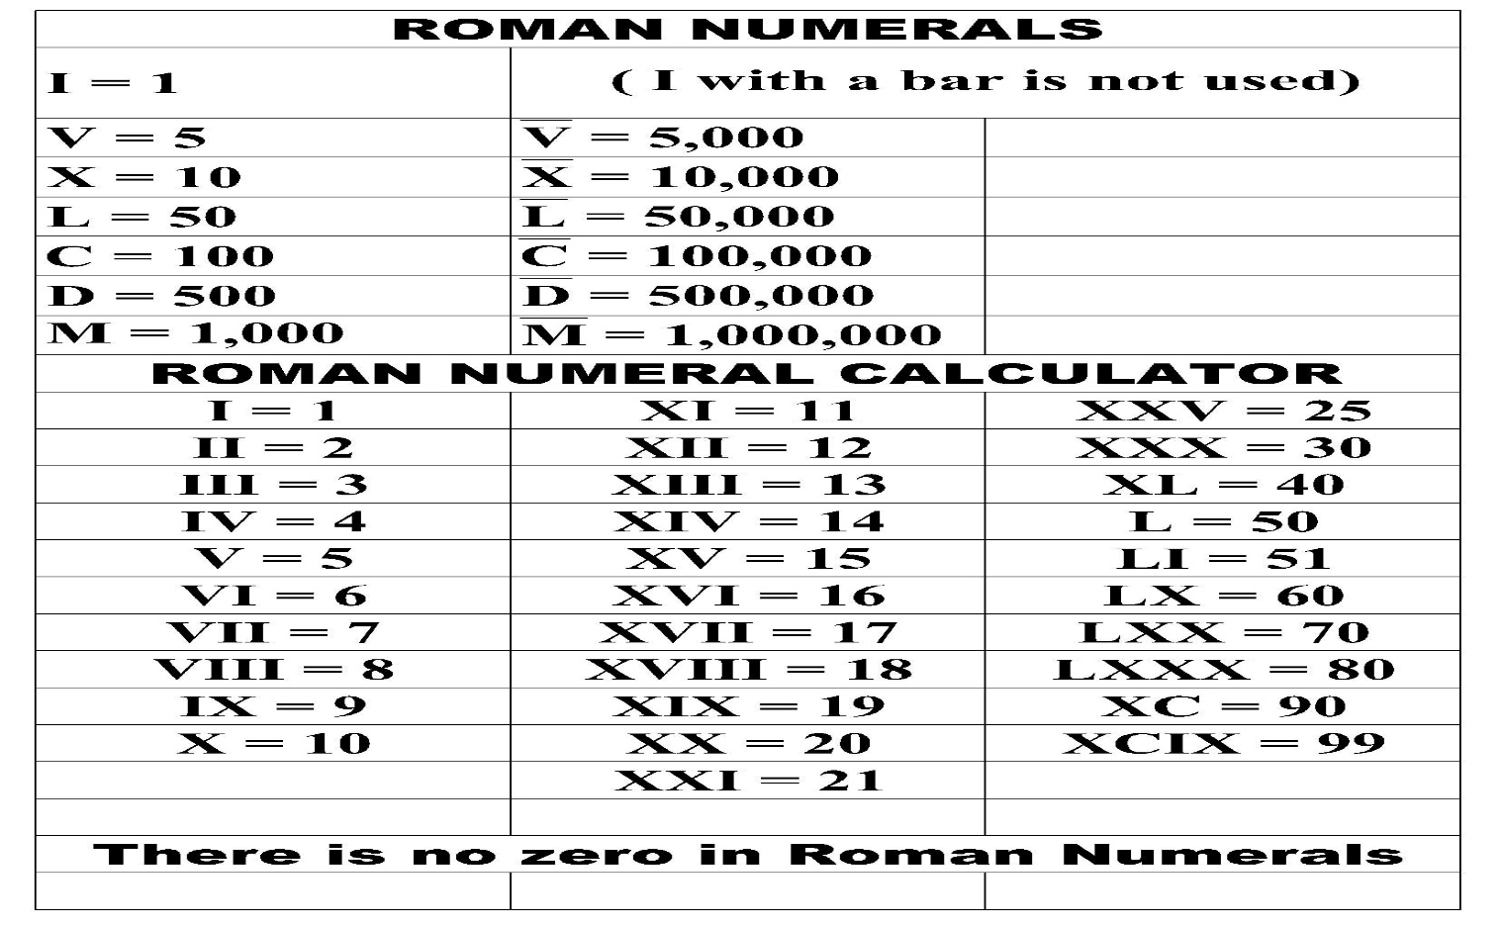

Use the numerals above to answer the questions below.

WEDNESDAY –
Answer the following comprehension questions;

1)Why do you think the Romans wanted to invade Britain?
2) How did the Celts try and protect themselves from invasion?
3)Why did the first attempt at invading fail?
4)How did the Celts persuade the Romans to leave the second time?
5) Why do you think that the third invasion was successful?
6) Why do you think they kept Caratacus as a slave?
7) How do you think Britain might have changed once the Romans were there?
8) What do the following words mean? Conquered/hostage/expedition/resistance

THURSDAY - ART
Yesterday, we learnt that the Celts in Britain built hill forts to protect themselves from the invading Romans.
Look at the picture below and try to recreate your own drawing.
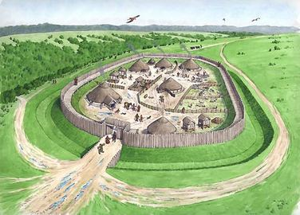

FRIDAY
When the Romans invaded Britain, they made up different names for areas in the countries. Some of the endings to those names ‘chester’ and ‘caster’ are still used in place names today. Look at the activity below to see what you can find out.

LEARNING WEBSITES

https://www.topmarks.co.uk/maths-games/hit-the-button

https://www.mathplayground.com/

https://www.topmarks.co.uk/maths-games/7-11-years

https://whiterosemaths.com/homelearning/

https://nrich.maths.org/primary

https://ttrockstars.com/

https://www.bbc.co.uk/bitesize/levels/zbr9wmn

https://www.literacyshed.com/home.html

https://www.spellingshed.com/

https://pobble.com/

https://monsterphonics.com/?gclid= EAIaIQobChMI56aEu9yh6AIVFeDtCh2NMAcIEA AYASAAEgK1b_D_BwE

https://www.oxfordowl.co.uk/welcome-back/for-home/reading-owl/kids-activities

https://www.topmarks.co.uk/english-games/7-11-years

Audible are doing a free 30 day trial so that children can listen to lots of books online.
MATHS ANSWERS

Monday
Remember the key shows that 1 apple = 8 apples so half an apple represents 4 apples!
Group 2 - (40) 5 apples to be drawn
Group 4 – (16) 2 apples to be drawn
Group 5 – (32) 4 apples to be drawn

Tuesday
Possible answer: Same image/symbol for key, same total of eggs, different values for the key

Wednesday
- Wednesday 2. Friday 3. 10 children

Thursday

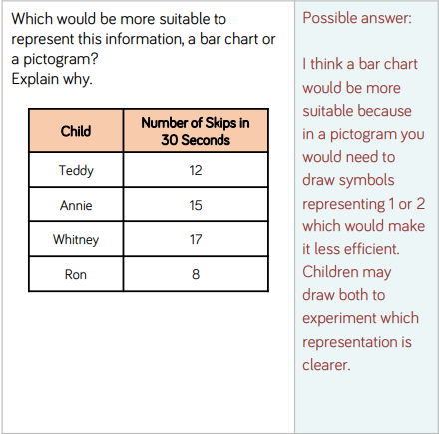
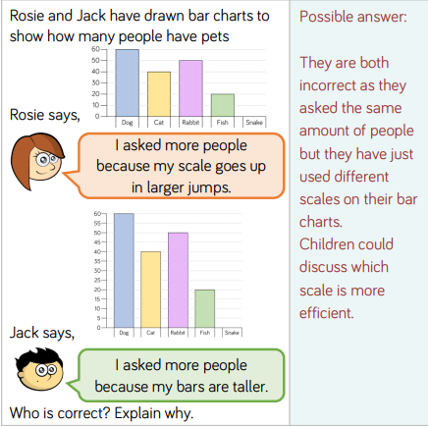

Friday
Ron’s ticket was 56p last year. The price increased by 4p.
The ticket price which increased the most from 2016 to 2017 is 76p ticket to 85p ticket.
The ticket price which increased the least from 2016 to 2017 is the 56p ticket to 60p ticket.

YEAR 3-4 SPELLING WORDS
