Dear Parent/Carer,

As the school continues to remain closed due to Coronavirus, we are continuing to provide educational tasks for your children to complete. We have received positive feedback on the new format of the home learning daily tasks. As always, please continue to keep in touch about your child’s home learning and let us know if there are any problems.

In primary, we suggest that children try to complete;
- 30 minutes a day of independent reading/reading to an adult
- 30 minutes of maths a day
- 30 minutes of English a day
- 30 minutes of topic based/creative learning
- 30 minutes of PE/ physical activity

Home learning tasks can be supplemented with work from a number of websites (see list below for ideas.) Daily work set on the BBC website is particularly useful as it contains tutorial videos.
https://www.bbc.co.uk/bitesize/primary

Teachers will set a weekly programme for your child to work through at home. This will be available for you to access on the school website every Monday. We know that children work at different speeds and different levels, so please have a look at work in other year groups too for extra support.

To help with maths and different terminology, we will try to add in some video links for tutorials and we will try to include answers for maths where possible to help the children check through their work.

Whilst it is important for your child to keep up with their learning at home, we appreciate that this can be a stressful time for children and adults. Looking after mental health is vital. Therefore, we suggest that the day is broken up into manageable learning chunks, interspersed with physical exercise, fun activities and time together as a family. Activities such as the 30 day lego challenge and using the real PE activities could be a good place to start. Setting up a weekly timetable can be a good place to start. As well as educational learning, the children could also begin to learn different life skills – how to boil an egg, sew on a button, learn to send an email, bake a cake using a recipe book etc.

Guidance for parents, regarding home learning, has been released by the government and can be found at the following link;
https://www.gov.uk/guidance/supporting-your-childrens-education-during-coronavirus-covid-19

We hope you are all keeping well and staying positive.

Kind regards,

The Year 3 team
Teacher emails;
@mayfield.portsmouth.sch.uk
********@mayfield.portsmouth.sch.uk

YEAR 3 HOME LEARNING TASKS
WEEK BEGINNING: Monday 8th June 2020
ENGLISH
SPELLINGS FOR THIS WEEK:

Ordinary, Particular, Peculiar, Perhaps, Popular, Position, Possess

MONDAY –
Using all of your spelling words write a short story. Can you use any of the words more than once? If you are not sure of the meanings, you can check the dictionary to help. Remember to use capital letters and full stops in your stories. What other punctuation could you use?

TUESDAY –
Pick one of your favourite fairy tales (mine is Beauty and the Beast!). Can you turn your story into a play? What do you think the most important parts of the story are, these are things you must include. Are there any parts of the story that are not as important, or any parts that you could leave out?
https://www.bbc.co.uk/bitesize/topics/zsn4h39/articles/zx8kng8

WEDNESDAY –
Create a word search with your spelling words. Can someone in your house try and complete it? Can you time them to see how long it takes them to find all of the words!

THURSDAY –
Plan an email to your teacher. Mind map all of the things you want to include in your email. You could include things that you did over the half term.

FRIDAY –
Write out the email you planned yesterday. Remember, an email must be punctuated in the same way as any other piece of writing. You must include full stops, capital letters and any other form of punctuation.
Can you challenge yourself to include a comma, apostrophe and an exclamation mark?

MATHS (Division focus)

Times tables for this week:
Continue to test yourself weekly, on your target times table. Give yourself 30 seconds per calculation. You can include as many calculations as you wish to in the test. If you pass, move onto the next calculation. If you do not pass in time, continue to remain on that times table until you do pass.

Websites for the week:
https://www.bbc.co.uk/bitesize/topics/zqbg87h/articles/z9jxhv4
https://www.bbc.co.uk/bitesize/topics/z36tyrd/articles/zgxdfcw
https://whiterosemaths.com/wp-content/uploads/2019/01/Year-3-2018-19-Spring-Term-Block-1-FINAL.pdf

MONDAY –
Remember to use objects to help you if you don’t have counters. You could paperclips, pennies or even some grapes!
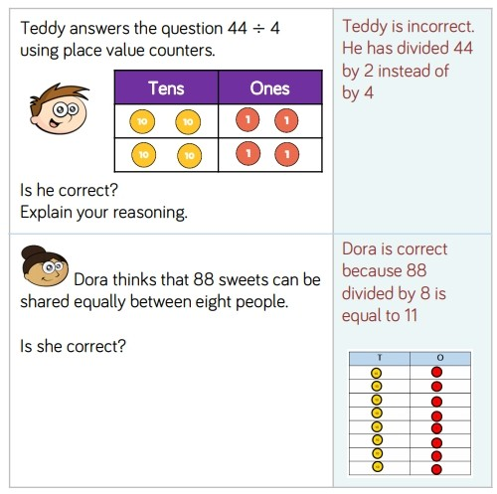
How do you know?
Can you write out the instructions for how to divide?

TUESDAY –

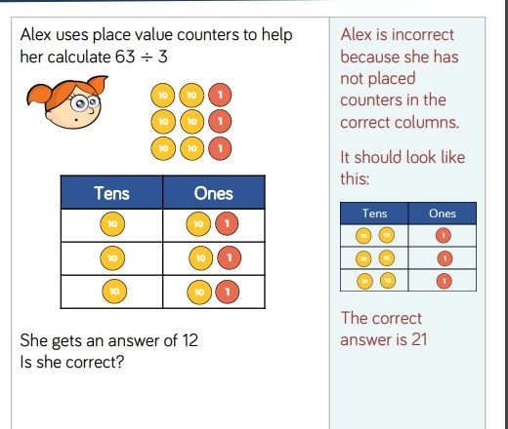
How do you know?
Can you create three of your own problems and solve them using counters (or something similar).
WEDNESDAY –

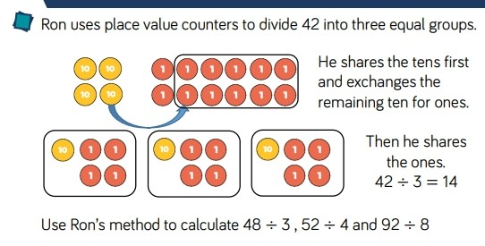
Write 10 more division sums of your own.
THURSDAY -
Can you create your own division game? Take a look at the ones below for some inspiration!
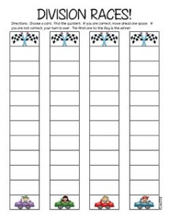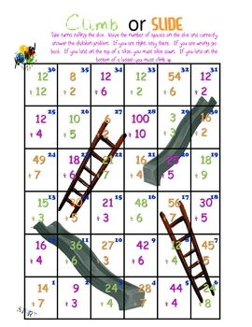

FRIDAY –
Play the game you created yesterday, keep track of who wins so you can tell your teacher! Did you manage to solve any really tricky division problems?
TOPIC

MONDAY –
Today you are going to investigate Roman mosaics. Can you find out what they are, how they were made and what images they showed? Try and find out 2 more facts that you find interesting mosaics.
http://www.bbc.co.uk/history/ancient/romans/mosaics_gallery.shtml
https://www.bbc.co.uk/bitesize/clips/zwjhfrd

TUESDAY –
Today you are going to create your own mosaic. There are many different things you could use to create one.
You can cut up small squares of coloured paper, or draw your pattern on paper and colour it in and maybe even paint! Remember the information you found yesterday and what images they liked to show.

WEDNESDAY –
Time to get active! Remember a few weeks ago when you created your own circuit? I want you to try and recreate it and see if you have gotten any faster! Are there any new skills that you have learnt that you can include in there?

THURSDAY–
Watch the video on this page and find out how much the Romans changed Britain. Can you write a paragraph explaining the main changes?
https://www.bbc.co.uk/bitesize/topics/zqtf34j/articles/z2dr4wx
FRIDAY–
PSHE - Look back on your poster from last week. This week you need to make another poster about a friend or family member. Remember to include appearance, hobbies, family, likes and dislikes, friends etc. This is a really good way to see how much you know!

LEARNING WEBSITES

https://www.topmarks.co.uk/maths-games/hit-the-button

https://www.mathplayground.com/

https://www.topmarks.co.uk/maths-games/7-11-years

https://whiterosemaths.com/homelearning/

https://nrich.maths.org/primary

https://ttrockstars.com/

https://www.bbc.co.uk/bitesize/levels/zbr9wmn

https://www.literacyshed.com/home.html

https://www.spellingshed.com/

https://pobble.com/

https://monsterphonics.com/?gclid= EAIaIQobChMI56aEu9yh6AIVFeDtCh2NMAcIEA AYASAAEgK1b_D_BwE

https://www.oxfordowl.co.uk/welcome-back/for-home/reading-owl/kids-activities

https://www.topmarks.co.uk/english-games/7-11-years

Audible are doing a free 30 day trial so that children can listen to lots of books online.
MATHS ANSWERS

Monday:

Tuesday

Wednesday
48➗3=16
52➗4=13
92➗8=11 with 4 left over or 11 and a half.

Thursday
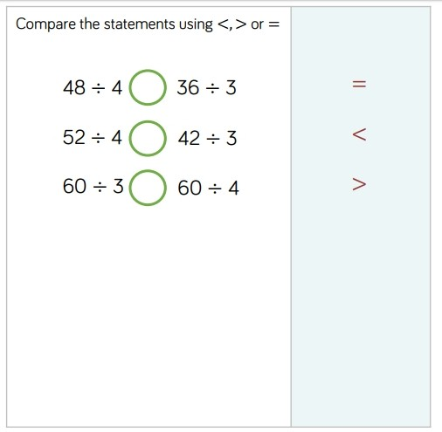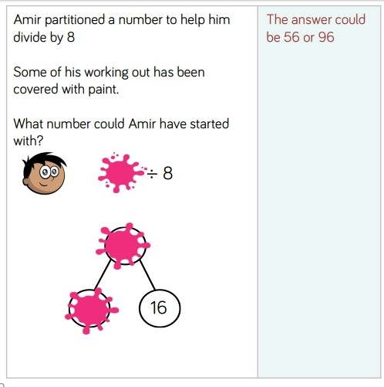

YEAR 3-4 SPELLING WORDS
