Dear Parent/Carer,

In light of the government’s latest guidance, we are very pleased that we are able to open up more on-site provision for all of our primary pupils. Your choice of provision can now be either; two days in ‘Bubble School’ or up to five days a week in ‘Key Worker School’ if you are a key worker. When the children are at school, they will access the home learning tasks, supported by their bubble teacher. When the children are at home, it is important that they continue with their home learning. The tasks that we set will be a mix of consolidation of previous work and new learning. To help the children with this work, we are including;
- The opportunity for you/your child to communicate with their class teacher via email on a set day, between certain times.
- More links to video resources/websites/ on-line clips or pre-recorded sessions from teachers.
- Feedback on a chosen piece of work (pictures/copies need to be emailed to the teacher or dropped off to a class box in the main reception area).
In primary, we suggest that children try to complete;
- 30 minutes a day of independent reading/reading to an adult
- 30 minutes of maths a day
- 30 minutes of English a day
- 30 minutes of topic based/creative learning
- 30 minutes of PE/ physical activity
Teachers will set a weekly programme for your child to work through at home. This will be available for you to access on the school website every Monday. We know that children work at different speeds and different levels, so please have a look at work in other year groups too for extra support.
Whilst it is important for your child to keep up with their learning at home, we appreciate that this can be a stressful time for children and adults. Looking after mental health is vital. Therefore, we suggest that the day is broken up into manageable learning chunks, interspersed with physical exercise, fun activities and time together as a family. Activities such as the 30 day Lego challenge and using the real PE activities could be a good place to start. Setting up a weekly timetable can be a good place to start. As well as educational learning, the children could also begin to learn different life skills – how to boil an egg, sew on a button, learn to send an email, bake a cake using a recipe book etc.

Guidance for parents, regarding home learning, has been released by the government and can be found at the following link;
https://www.gov.uk/guidance/supporting-your-childrens-education-during-coronavirus-covid-19
We hope you are all keeping well.

Kind regards,

The Year 3 team
Teacher emails;
lewisj@mayfield.portsmouth.sch.uk
browne-rebecca@mayfield.portsmouth.sch.uk
threadingham-cheryl@mayfield.portsmouth.sch.uk
Williams-kirsty@mayfield.portsmouth.sch.uk
YEAR 3 HOME LEARNING TASKS
WEEK BEGINNING: Monday 6th July 2020
ENGLISH (Reading/description)

SPELLINGS FOR THIS WEEK:
therefore, though, although, thought, through, various, weight
Useful websites:
https://www.bbc.co.uk/bitesize/topics/zs44jxs/articles/zqmyw6f
https://www.bbc.co.uk/bitesize/topics/zpccwmn/articles/zqf32nb
https://www.bbc.co.uk/bitesize/topics/zkgcwmn/articles/zd72scw
https://www.bbc.co.uk/bitesize/topics/zv63d2p/articles/zprj7ty

MONDAY – Reading
Read chapter 1 of Roman Rescue and answer the questions below:

-What is the book about?
-Who is the intended audience?
-What was your favourite part?
-Why?
-Which was your least favourite part?
-Why?
-Who would you recommend the book to?
-Why?

Use the powerpoint to help you answer the questions.

TUESDAY – Planning
Today, we are going to plan our own story based on Roman Rescue. In chapter 1 we are introduced to Tilda and Charlie Hacker. These are our MAIN CHARACTERS. Today, you are going to create your own main characters. You can choose one of these templates to complete. Either print them out or draw them yourself!
This website will help: https://www.bbc.co.uk/bitesize/topics/zpccwmn/articles/zqf32nb
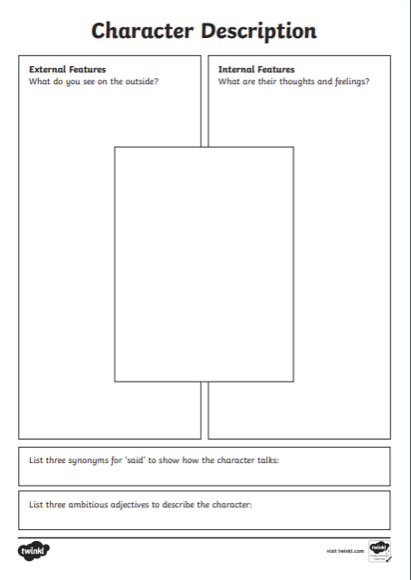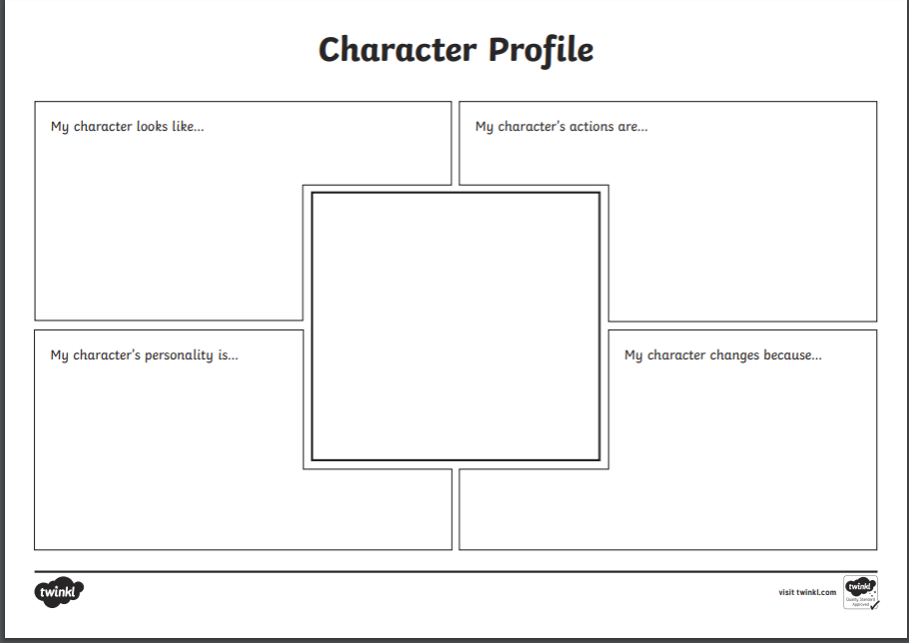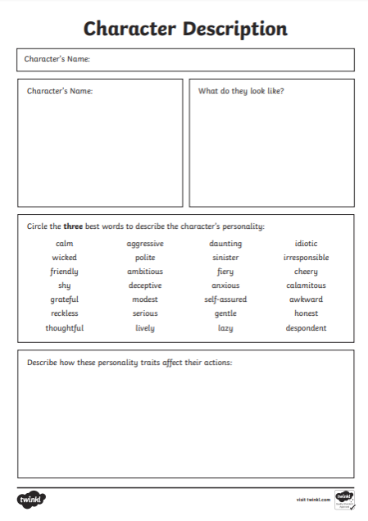
Look at the description of Charlie Hacker below:
Beneath the scruffy blonde haircut that might look more at home on a terrier, Charlie Hacker’s blue eyes threw worried glances towards the narrow door looming at the top of the stairs.
The author has used lots of descriptive language, this clearly tells us what Charlie looks like. Can you include this level of detail in your character description

WEDNESDAY – Character description paragraph
Read the character description below.
When I have finished, you are going to draw a small, and quick, picture of what YOU think that character looks like.

Deep inside the darkest cave lived a hideous creature known as Dink. Covered head to toe in grotesque white pimples and crusty mud soaked skin, you can smell Dink before you can even see him. On top of his head lives a family of lice that play all day in his bright green, unwashed hair. His enormous muscles escape from his tiny clothes, which are soaked in sweat.

Once you have drawn your picture, find the below:
Vocabulary that makes you understand the character and colour them in green.
Connectives that make you understand the character and colour them red.
Openers that make understand the character and colour them yellow.
Punctuation that makes you understand the character and colour it blue.

THURSDAY – Character description
Today you are going to write your own character description paragraph. Remind yourself of your own character description plan and the features you found in the WAGOLL. You will need to use these to help you write your own.
Things to include:
- A variety of punctuation, make sure you use more than just full stops.
- Adjectives, verbs, adverbs and nouns that help you describe your character.
- Conjunctions to help you expand your sentences.
We would like to see a picture of your work so that we can give you some feedback on it. Please email this by Monday for feedback on Wednesday.
FRIDAY – Spellings
Time to practise your spellings!
You are going to create a collage of your spelling words, a collage is a piece of art made by sticking lots of different materials such as pieces of paper or fabric onto paper.
Your spellings are: therefore, though, although, thought, through, various, weight.
Maths – Addition and Subtraction
Times tables for this week:
Continue to test yourself weekly, on your target times table. Give yourself 30 seconds per calculation. You can include as many calculations as you wish to in the test. If you pass, move onto the next calculation. If you do not pass in time, continue to remain on that times table until you do pass.
Throughout the week use these websites to support your child’s learning: https://www.bbc.co.uk/bitesize/articles/z72dwty https://www.bbc.co.uk/bitesize/articles/zvm72sg https://www.bbc.co.uk/bitesize/articles/z7psf4j https://www.bbc.co.uk/bitesize/articles/zfxx6v4 https://www.topmarks.co.uk/maths-games/7-11-years/addition-and-subtraction
MONDAY-
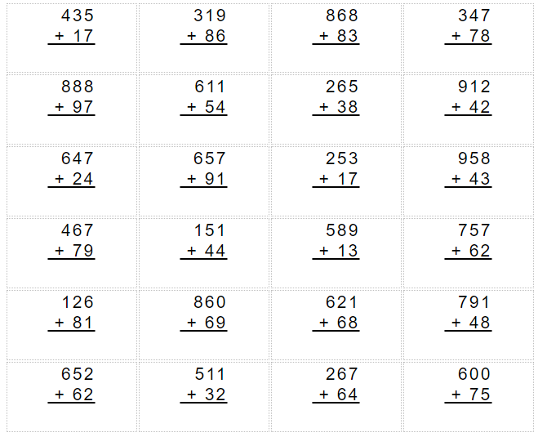

Challenge;
Which of these were harder and which were easier? Why?
Does it matter which column you start in when you are adding? Why?
How can you tell when you will need to carry digits to the next column?

TUESDAY-
Solve the calculations (a-f) using a place value grid alongside a column method to help you.
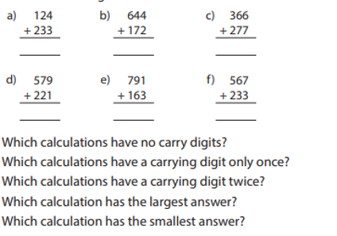
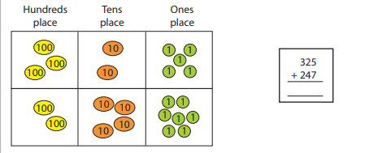

WEDNESDAY-
Watch the link below to help you and remind you of the method.
https://www.youtube.com/watch?v=1GazztzsIuY
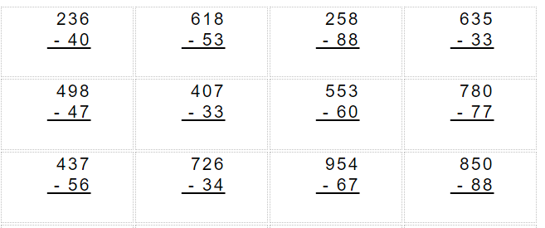

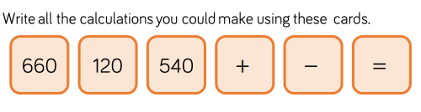

Challenge – think about the video you watched. Can you write out a set of instructions for column subtraction?

THURSDAY-
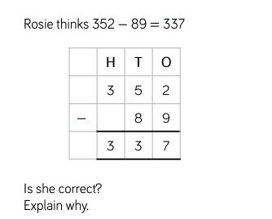
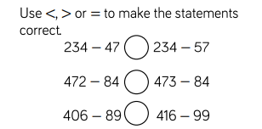

EXT: Create and solve 10 subtractions using the column method.
FRIDAY-
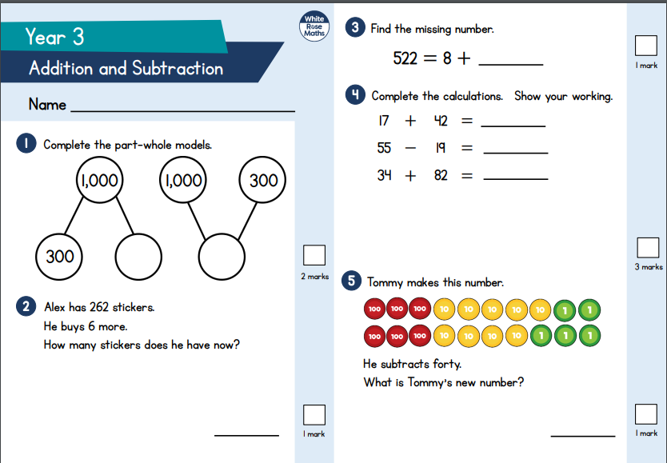
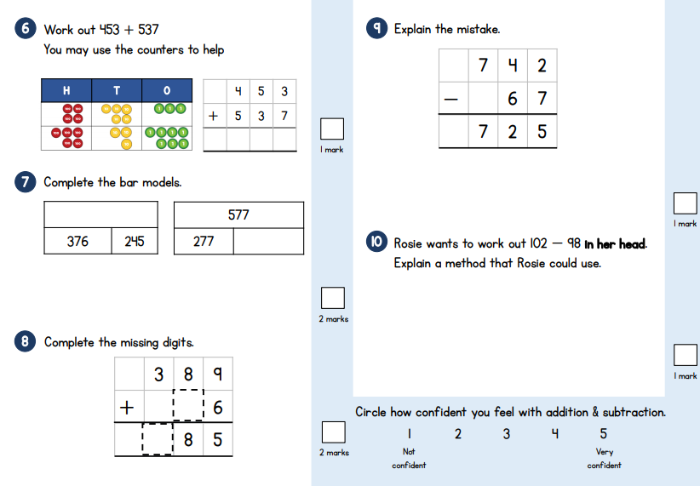
Use your addition and subtraction knowledge to solve these questions:

TOPIC
Monday - PSHE
STANLEY AND CLIVE
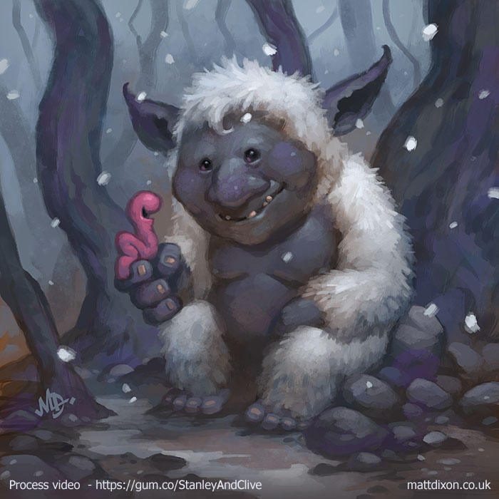
- Which one is Stanley and which one is Clive? 2) What kind of creatures are they?
- 3) Have they just met or did they already know each other? 4) How do they feel about each other? How do you know? 5) How do you feel about them?
- 6) What are they saying? Add speech bubbles to the picture, then write this scene with dialogue.
- 7) What do Stanley and Clive have in common? What are their differences? Is this a bad thing?
- 8) What makes you different? 9)Would the world be a better place if everyone was the same? Why/why not? 10) Why are Stanley and Clive friends? 11) What is friendship? 12)What makes a good friend?

Tuesday – History – Roman Gods and Goddesses
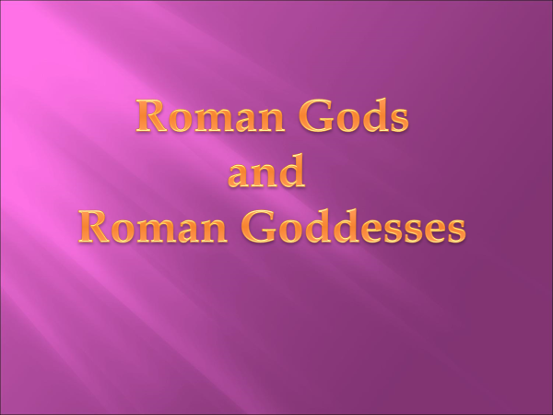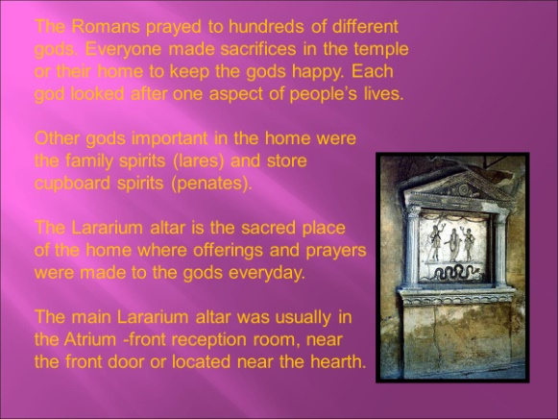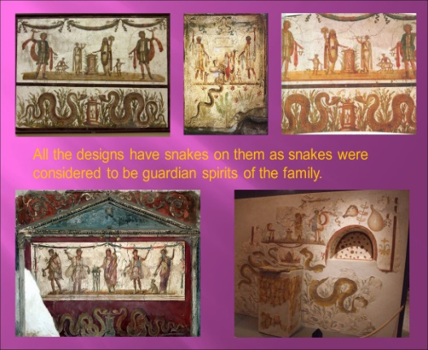

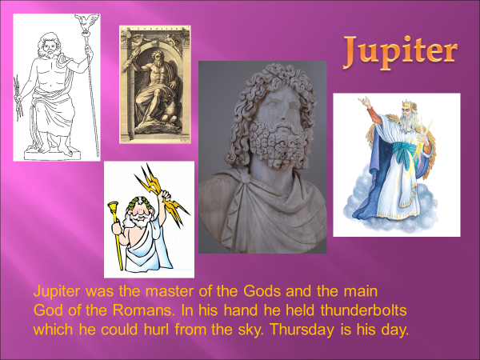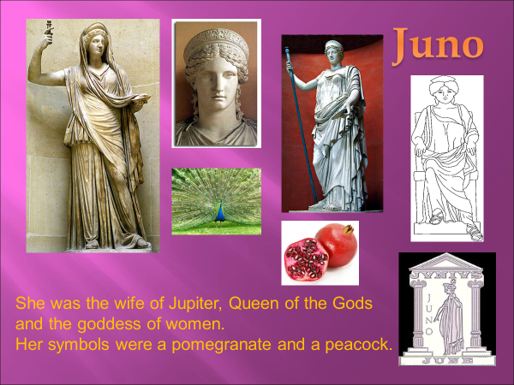

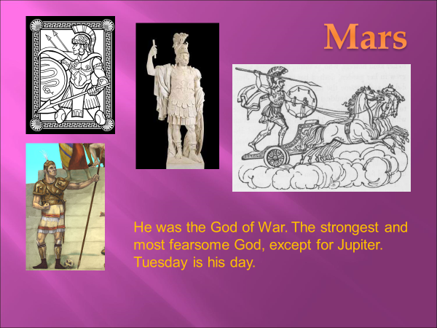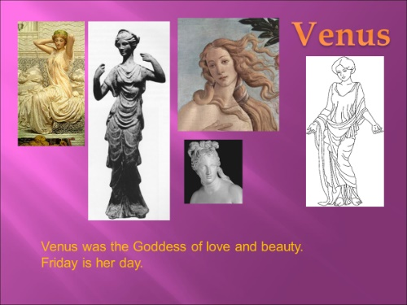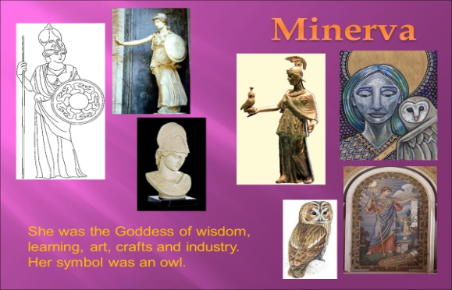
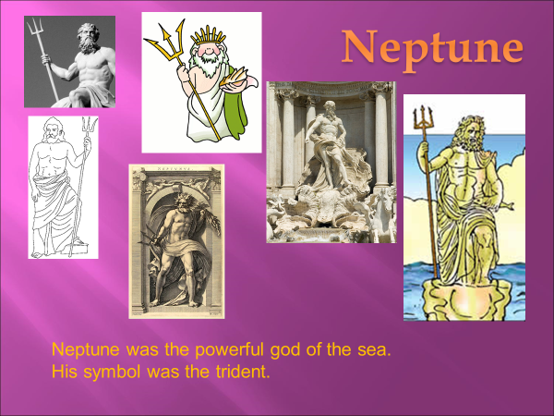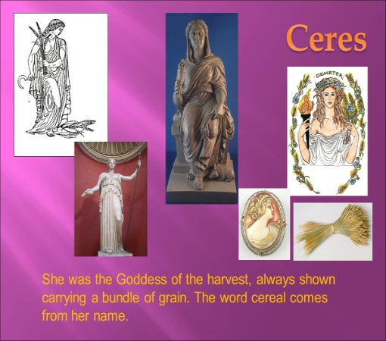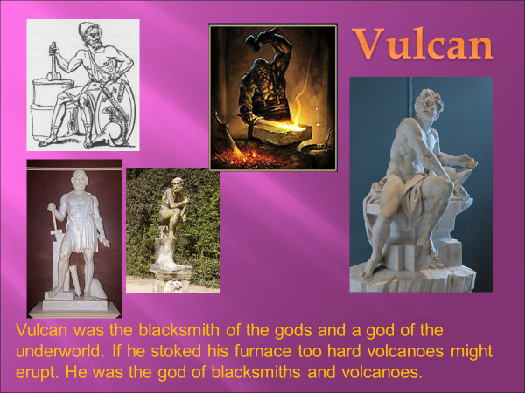
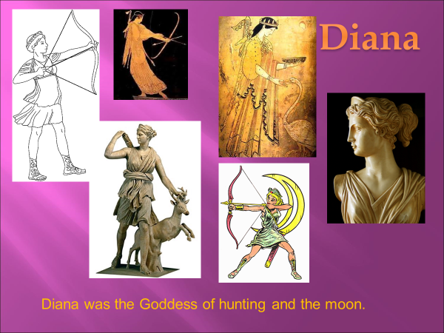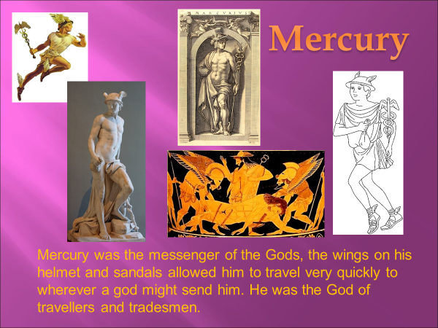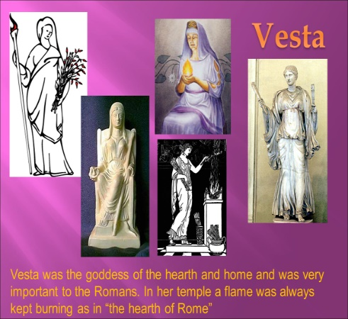
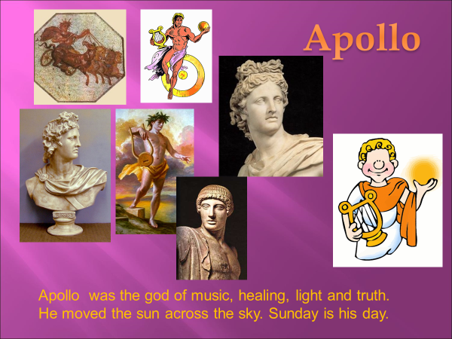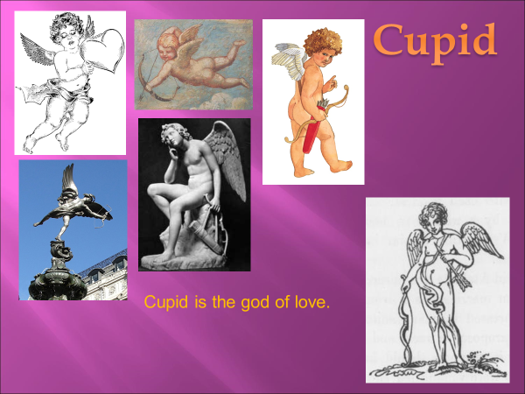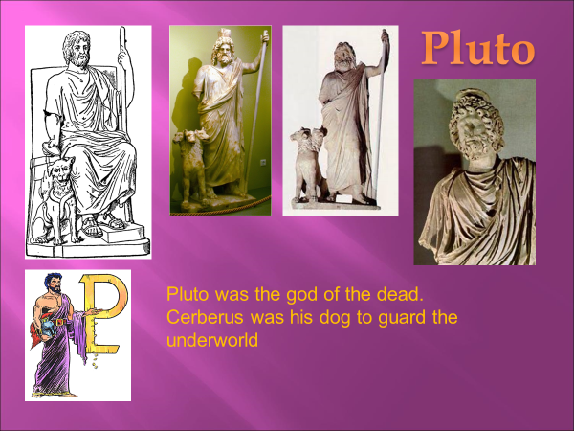
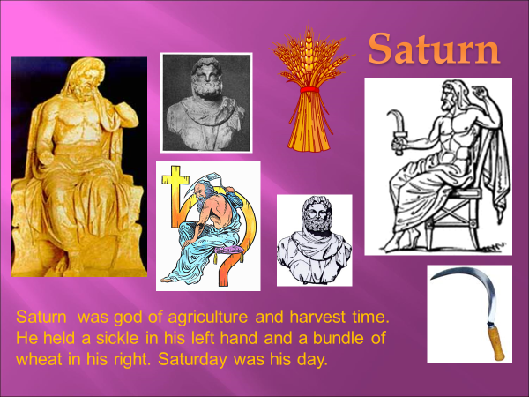

Read about all the different gods and goddesses.
Create a set of Top Trump cards that you can use to play against a friend/family member
EG
Importance – 8
Skills – 2
Weapons – 4
Strength – 7

Wednesday –
Complete your top trump cards from yesterday. Play the game with someone in your class/family

Thursday – Design a Roman god or goddess
Look back at the work from the last 2 days. Design your own Roman god or goddess. Think about;
Their name
Their skill
What they look like
What they wear (nothing modern)
What accessories (weapons/tools/animals/flowers/musical instruments etc.

Friday
Roman Religion

At first, Romans believed in many different gods and goddesses. These gods were like people, but with magical powers. The Roman gods were part of a family. People told
stories or myths about them. Each god or goddess looked after different people or things.
Saturn was once king of the gods, his place was taken by his son (Jupiter). Saturn was the god of seed-sowing. A merry Roman holiday or festival, the Saturnalia, was named after him.
Jupiter was the god of the sky, he was the most important god. Juno was Jupiter's wife and she looked after women. Neptune, Jupiter's brother, was the god of the sea.
Minerva was the goddess of wisdom and women's work, such as weaving cloth. Mars was god of war, though originally god of farming and Venus was the goddess of love.
The Romans often borrowed new gods from people they conquered. They hoped these new gods would make them stronger. They borrowed gods from Egypt, for example, such as the goddess Isis. Roman soldiers worshipped Mithras, a god from Iran. A soldier going on a journey might ask Mercury (god of travel) for help, as well as Mithras the soldiers' god and he might also make a sacrifice to Neptune (the sea god) if he had to travel by ship!

1. Name a goddess whom the Romans borrowed from another religion.
2. Why might a soldier make a sacrifice to Neptune?
3. Who was Jupiter’s wife?
4. Who was the goddess of wisdom?
5. Why did the Romans borrow gods from other countries?
6. What was Saturnalia?
7. Name something which was considered to be women’s work?
8. Who was the first King of the gods ?
9. What did Neptune carry?
10. Of which two things was Mars the god at one time or another?

LEARNING WEBSITES

https://www.topmarks.co.uk/maths-games/hit-the-button

https://www.mathplayground.com/

https://www.topmarks.co.uk/maths-games/7-11-years

https://whiterosemaths.com/homelearning/

https://nrich.maths.org/primary

https://ttrockstars.com/

https://www.bbc.co.uk/bitesize/levels/zbr9wmn

https://www.literacyshed.com/home.html

https://www.spellingshed.com/

https://pobble.com/

https://monsterphonics.com/?gclid= EAIaIQobChMI56aEu9yh6AIVFeDtCh2NMAcIEA AYASAAEgK1b_D_BwE

https://www.oxfordowl.co.uk/welcome-back/for-home/reading-owl/kids-activities

https://www.topmarks.co.uk/english-games/7-11-years

Audible are doing a free 30 day trial so that children can listen to lots of books online.
MATHS ANSWERS

Monday
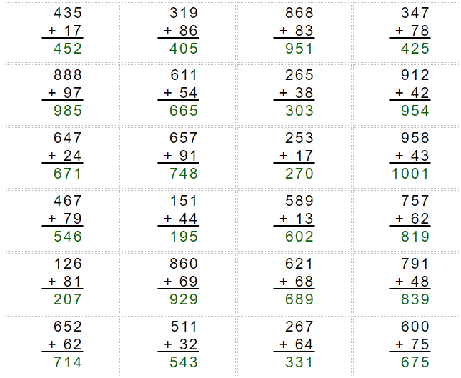

Tuesday

- 357 b) 816 c) 643 d) 800 e)954 f)800

Wednesday

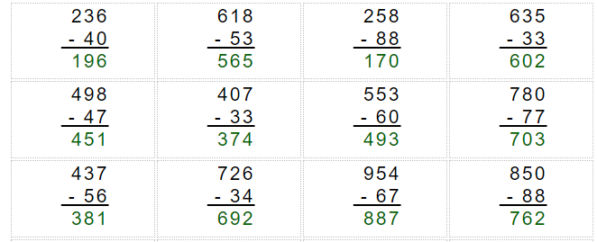

Thursday
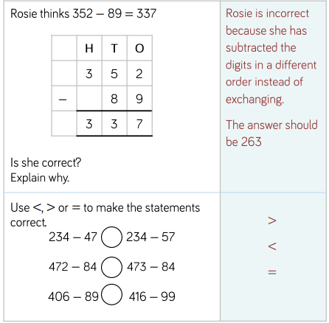

Friday
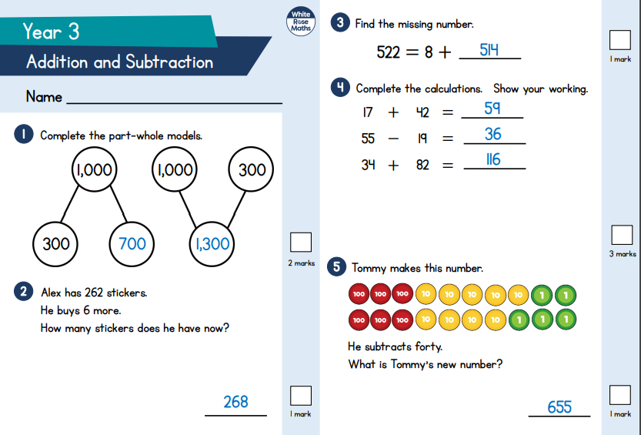
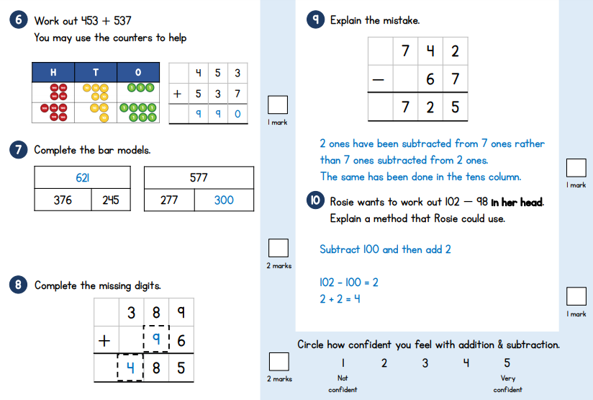

YEAR 3-4 SPELLING WORDS
