Dear Parent/Carer,

As the school continues to remain closed due to Coronavirus, we are continuing to provide educational tasks for your children to complete. We have received positive feedback on the new format of the home learning daily tasks. As always, please continue to keep in touch about your child’s home learning and let us know if there are any problems.

In primary, we suggest that children try to complete;
- 30 minutes a day of independent reading/reading to an adult
- 30 minutes of maths a day
- 30 minutes of English a day
- 30 minutes of topic based/creative learning
- 30 minutes of PE/ physical activity

Home learning tasks can be supplemented with work from a number of websites (see list below for ideas.) Daily work set on the BBC website is particularly useful as it contains tutorial videos.
https://www.bbc.co.uk/bitesize/primary

Teachers will set a weekly programme for your child to work through at home. This will be available for you to access on the school website every Monday. We know that children work at different speeds and different levels, so please have a look at work in other year groups too for extra support.

To help with maths and different terminology, we will try to add in some video links for tutorials and we will try to include answers for maths where possible to help the children check through their work.

Whilst it is important for your child to keep up with their learning at home, we appreciate that this can be a stressful time for children and adults. Looking after mental health is vital. Therefore, we suggest that the day is broken up into manageable learning chunks, interspersed with physical exercise, fun activities and time together as a family. Activities such as the 30 day lego challenge and using the real PE activities could be a good place to start. Setting up a weekly timetable can be a good place to start. As well as educational learning, the children could also begin to learn different life skills – how to boil an egg, sew on a button, learn to send an email, bake a cake using a recipe book etc.

Guidance for parents, regarding home learning, has been released by the government and can be found at the following link;
https://www.gov.uk/guidance/supporting-your-childrens-education-during-coronavirus-covid-19

We hope you are all keeping well and staying positive.

Kind regards,

The Year 4 team
Teacher emails;
pountain-christina@mayfield.portsmouth.sch.uk
campbell-morgon@mayfield.portsmouth.sch.uk
emery-vikki@mayfield.portsmouth.sch.uk

YEAR 4 HOME LEARNING TASKS
WEEK BEGINNING: 15th June
ENGLISH (Persuasive Writing
SPELLINGS FOR THIS WEEK:
island, knowledge, learn, length, library, material, medicine
MONDAY – Draw a picture that represents the meaning of each of your spelling words. Ask someone at home to guess the word you have chosen based on the picture you have drawn.

TUESDAY – Read the letter below that Mr Jeapes has written to the teaching staff at Mayfield. He is trying to persuade the teachers that we won’t need to have break times in September! What do you think? Do you agree with his arguments?
Can you find the following in the letter he has written?
- An introduction? What job does this do?
- A conclusion? What job does this do?
- Paragraphs which have the main arguments? Notice how the paragraphs only contain one idea per paragraph and then some explanation.
- Fronted adverbials that introduce the sentences that he has written? https://www.youtube.com/watch?v=Lk-_LIc3dWA
Now create a word bank mind map which contains the fronted adverbials you have found as well as any other interesting words that you have spotted. This will be useful later this week.
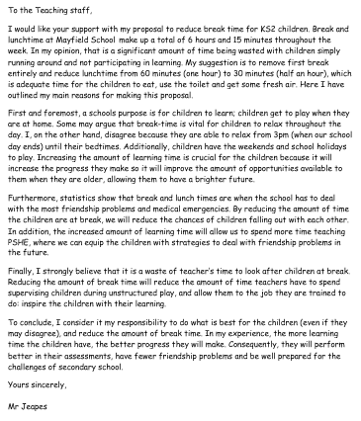
WEDNESDAY – Write your own definition of each of your spelling words. What does each word mean?
Once you have completed it check the actual meaning in a dictionary. If you don’t have a dictionary you could use an online one like this one https://kids.britannica.com/kids/browse/dictionary

THURSDAY–
Your writing challenge for this week is to write your own persuasive letter. You can choose to write back to Mr Jeapes and give him your opinion about playtimes or you could think of something else you would like to write about.
Some possible suggestions:
I should be able to go to bed when I want.
All classrooms should have a class pet.
There needs to a be a non-school uniform day every week.
You can only eat apples or oranges for the next week. Which one will you eat? Why?
I should be allowed to stay home alone.
There should be no homework at school.
Break times at school should be longer.
People should be fined for dropping litter.
Task: Plan the different parts of your letter in note form. You will use these in your letter tomorrow.
- Why are you writing the letter?
- What are the reasons you will include in your letter?
- What fronted adverbials will you include?

FRIDAY –
Use your notes from yesterday to write your letter. Remember to include the features we have discussed this week (introduction, paragraphs with reason and explanation, conclusion)
Don’t forget to edit and ‘purple polish’ as you write to make improvements.

MATHS (Money)

Times tables for this week
Continue to test yourself weekly, on your target times table. Give yourself 30 seconds per calculation. You can include as many calculations as you wish to in the test. If you pass, move onto the next calculation. If you do not pass in time, continue to remain on that times table until you do pass.

MONDAY –
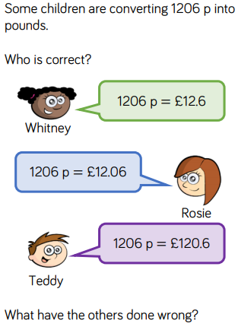
- What is the value of each digit in 1206p?
- Investigate the mistakes the other children have made and reason why they are wrong.
- What operation must you carry out when converting from pence to pounds? Provide examples.
- Can you make up the amount using notes and coins. Find at least 15 ways.

TUESDAY –
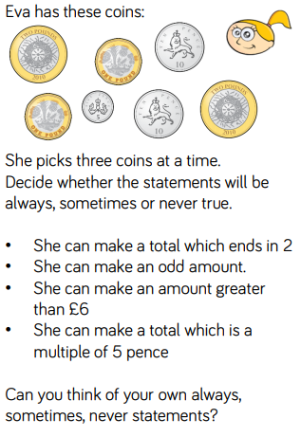
- Investigate each statement, before determining whether they are always, sometimes or never true.
- Explain your reasons for your answers.
- Explain whether your answers would change if Eva used 4 coins instead.
- Prove you are correct using practical resources.

WEDNESDAY –
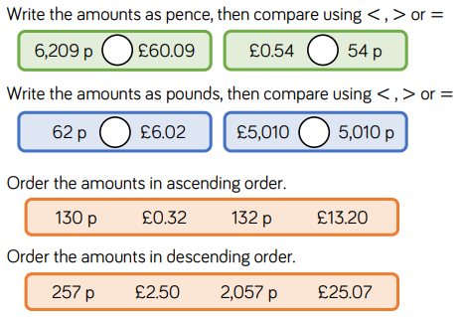
- Which amounts could fit between the amounts? Are there multiple possible answers for them all?
- Explain why the position of each digit changes its value.
- Explain what ‘ascending/descending order’ mean?

THURSDAY –
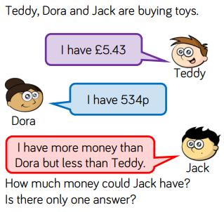
- Investigate how many different amounts that Jack could have.
- I think that Jack has £5.24. Reason whether I am correct of not.
- Explain which element of this activity is the most difficult part.

FRIDAY –
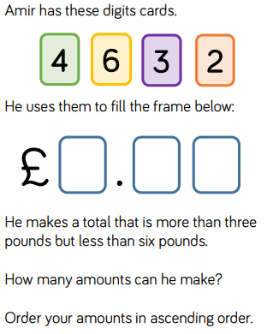
- After investigating, prove that there are no more possible answers.
- Find the largest and smallest amount you could make by only using the digit cards once. What is the difference between these amounts?
- Explain what is meant by the term ‘difference’ and determine which operation you must use to find it.
- Convert all of your amounts to pence. Explain the process of converting these.

Some useful links that may support this week’s home learning tasks:
- https://www.bbc.co.uk/bitesize/topics/z8yv4wx
- http://www.amathsdictionaryforkids.com/qr/c.html
- https://www.youtube.com/watch?v=8lXBXF5mSl8
- https://www.youtube.com/watch?v=xn6j8QrFwc4
- https://www.youtube.com/watch?v=aGWvo_EtCJs
- https://www.youtube.com/watch?v=WfpdhMuLvlY
- https://www.youtube.com/watch?v=pvjeYkiA4oo
TOPIC – Sound Theme
MONDAY - This week we would like you to find out as much as you can about sound and how it is made. Start by thinking of some questions you might like to find out the answers to in this topic.
Some example questions:
How do we hear sounds? What causes sound?
How can we change sounds that we hear? How can we change the pitch and volume of a sound?

Use the Internet to begin to find out the answers to these questions.
Here is a useful link to get you started:
https://www.bbc.co.uk/bitesize/topics/zgffr82

Make some notes about what you have found out. You may want to display these notes in some way. For example, perhaps you could make a sound poster?

TUESDAY – Find some objects in your house that make noise. How do we hear the sounds that they make?
Draw some scientific diagrams that show the objects making vibrations that transfer to the ear
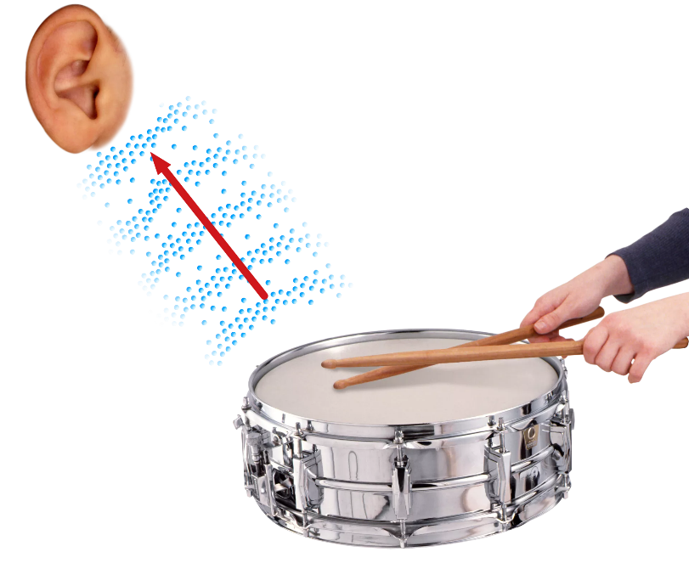
Vibrations from the ear drum travel to the brain
Vibrations travel into the ear towards ear drum
Vibrations travel through the air
Drum sticks hit the skin of the drum
Label your diagram to show what is happening.

WEDNESDAY– Investigation: What factors affect the pitch and volume of a sound?
Pitch of a sound = How high or low the sound is
Volume of a sound = How loud or quiet the sound is
Make a basic musical instrument that you could use to investigate the pitch and volume of a sound.
You could make:
A chinese container or tissue box ‘guitar’ using elastic bands https://www.youtube.com/watch?v=Ze50YgbB27c
A straw trumpet https://www.abc.net.au/science/experimentals/experiments/episode27_1.htm
A shaker using a bottle and different objects inside.

How can you change the sound that you make with your instrument? What makes a high or low sound? How do you make a loud or quiet sound?

THURSDAY- Investigation write up. Feel free to be as creative as you like with how you display your writing!
Start by writing down your scientific question - What factors affect the pitch and volume of a sound?
Now answer these questions
- What instrument did you make? How did you make it?
- How did you change the pitch (high or low)?
- How did you change the volume? (loud or quiet)?

FRIDAY- Watch this clip about how stringed instruments change their pitch
https://www.bbc.co.uk/teach/class-clips-video/music--science-ks2-how-string-instruments-make-sound/zfmd7nb
Make some notes as you watch
Create a poster that explains what how strings create a high or low pitched sound.
Key learning for this week (Taken from the National Curriculum for Year 4)
Pupils should be taught to:
- identify how sounds are made, associating some of them with something vibrating
- recognise that vibrations from sounds travel through a medium to the ear
- find patterns between the pitch of a sound and features of the object that produced it
- find patterns between the volume of a sound and the strength of the vibrations that produced it
- recognise that sounds get fainter as the distance from the sound source increases.
LEARNING WEBSITES

https://www.topmarks.co.uk/maths-games/hit-the-button

https://www.mathplayground.com/

https://www.topmarks.co.uk/maths-games/7-11-years

https://whiterosemaths.com/homelearning/

https://nrich.maths.org/primary

https://ttrockstars.com/

https://www.bbc.co.uk/bitesize/levels/zbr9wmn

https://www.literacyshed.com/home.html

https://www.spellingshed.com/

https://pobble.com/

https://monsterphonics.com/?gclid= EAIaIQobChMI56aEu9yh6AIVFeDtCh2NMAcIEA AYASAAEgK1b_D_BwE

https://www.oxfordowl.co.uk/welcome-back/for-home/reading-owl/kids-activities

https://www.topmarks.co.uk/english-games/7-11-years

Audible are doing a free 30 day trial so that children can listen to lots of books online.
MATHS ANSWERS

MONDAY –
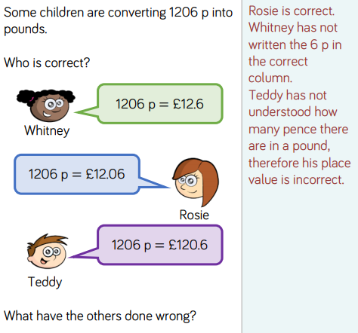

TUESDAY –
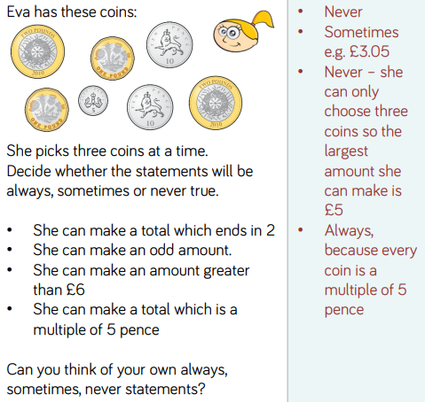

WEDNESDAY –

A) >
B) =
C) <
D) >
E) £0.32, 130p, 132p, £13.20
F) £25.07, 2,057p, 257p, £2.50

THURSDAY –
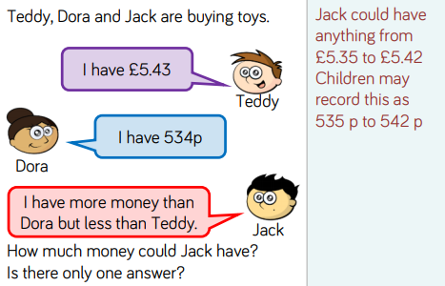

FRIDAY –
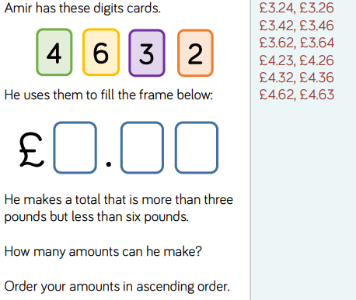

Key Vocabulary:
- Ascending – Arranged from smallest to largest.
- Descending – Arranged from largest to smallest.
- Digit – A symbol used to show a number.
- Convert – To change the form or state of something.
YEAR 3/4 SPELLING WORDS
