Dear Parent/Carer,

As the school continues to remain closed due to Coronavirus, we are continuing to provide educational tasks for your children to complete. We have received positive feedback on the new format of the home learning daily tasks. As always, please continue to keep in touch about your child’s home learning and let us know if there are any problems.

In primary, we suggest that children try to complete;
- 30 minutes a day of independent reading/reading to an adult
- 30 minutes of maths a day
- 30 minutes of English a day
- 30 minutes of topic based/creative learning
- 30 minutes of PE/ physical activity

Home learning tasks can be supplemented with work from a number of websites (see list below for ideas.) Daily work set on the BBC website is particularly useful as it contains tutorial videos.
https://www.bbc.co.uk/bitesize/primary

Teachers will set a weekly programme for your child to work through at home. This will be available for you to access on the school website every Monday. We know that children work at different speeds and different levels, so please have a look at work in other year groups too for extra support.

Whilst it is important for your child to keep up with their learning at home, we appreciate that this can be a stressful time for children and adults. Looking after mental health is vital. Therefore, we suggest that the day is broken up into manageable learning chunks, interspersed with physical exercise, fun activities and time together as a family. Activities such as the 30 day lego challenge and using the real PE activities could be a good place to start. Setting up a weekly timetable can be a good place to start. As well as educational learning, the children could also begin to learn different life skills – how to boil an egg, sew on a button, learn to send an email, bake a cake using a recipe book etc.

Guidance for parents, regarding home learning, has been released by the government and can be found at the following link;
https://www.gov.uk/guidance/supporting-your-childrens-education-during-coronavirus-covid-19

We hope you are all keeping well and staying positive.

Kind regards,
Mrs Pountain, Miss Campbell, Mrs Emery & the Year 4 team.

We would love to see some of the things you have been doing and have written our email addresses below so you can get in contact if you would like to.
Pountain-christina@mayfield.portsmouth.sch.uk
Campbell-morgon@mayfield.portsmouth.sch.uk
Emery-vikki@mayfield.portsmouth.sch.uk

YEAR 4 HOME LEARNING TASKS
WEEK BEGINNING: 27th April
ENGLISH TASKS  SPELLINGS FOR THIS WEEK (see list below)  believe, bicycle, build, business, calendar, caught, centre  MONDAY -  Draw a picture of one of your friends. Can you add labels to describe them? Think about what they look like (appearance) and what sort of person they are (personality).  TUESDAY –  Use your picture from yesterday to write a paragraph about your friend. Include all of the ideas from your labels about appearance and personality.  WEDNESDAY – Write a list of questions you would like to ask a friend. Perhaps you could ask your grown ups at home if you can call them or video chat to find out the answers?  THURSDAY – Watch this video on You Tube https://www.youtube.com/watch?v=ReMq3KX8F94 (Little Voices: What makes a good friend?).  What do you think makes a good friend? Write a paragraph which answers the question.  FRIDAY - One day very soon you will get to see your friends again. What will you say to them when you do? Can you write an imaginary conversation with your friend? Don’t forget to include speech marks and remember your SCAPS (Speech mark, Capital letter, Actual words spoken, Punctuation, Speech Mark). | MATHS TASKS  Continue to practise your times tables daily.  MONDAY –  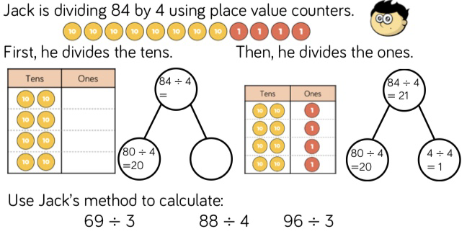  TUESDAY –  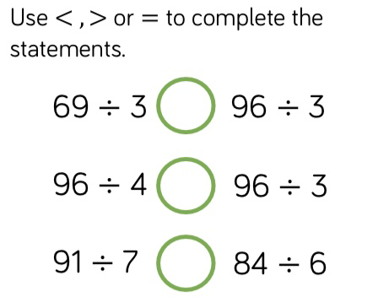  Use Jack’s method from Monday’s activity to support your working out.  WEDNESDAY –  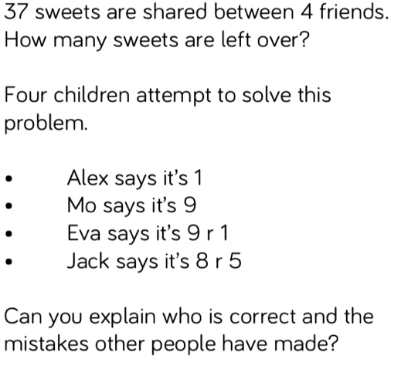  Use Jack’s method from Monday’s activity to support your working out.  THURSDAY –  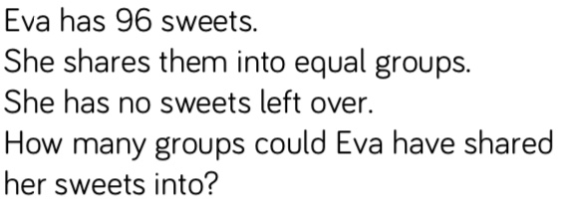  Use Jack’s method from Monday’s activity to support your working out.  FRIDAY –  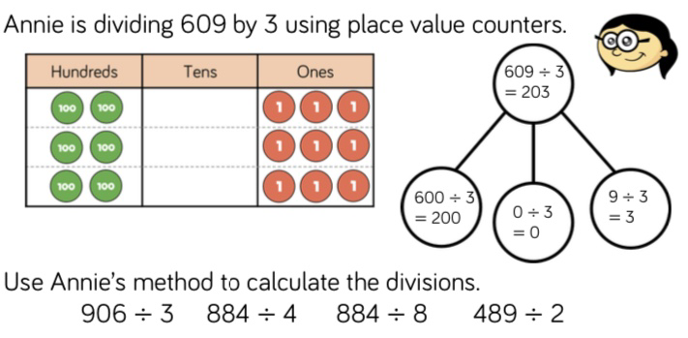
TOPIC/CREATIVE  MONDAY – Famous Friendships.  Make a list of as many famous friendships as you can. Why don’t you send your list to your teacher and see who has the most in your class? They can be friendships from your favourite books or films or television shows, they can be real people or characters. Ask your family to help you out. Here are some ideas to get you started:  Harry Potter, Hermione Granger and Ron Weasley  Winnie the Pooh and Piglet  Ant and Dec.  Snow White and the Seven Dwarves  TUESDAY – Family Friends.  Ask somebody at home to tell you all about THEIR best friend. Ask them lot of questions so that you find out as much as you can about the friendship. You could ask:  Where they met?  How long have they been friends?  What was the best day they had together?  What was the worst argument?  When did they last speak to their friend?  Who else was in their friendship group?  Now get your family member to contact that friend to check that they are okay!  WEDNESDAY/ THURSDAY  Use your creative skills to make something for your friend/s.  You could...  Make a card for your best friend and post it to them if you can.  See if you can make a friendship bracelet, see if you can find an easy to follow you tube clip and make some jewellery for you and your best friend.  Use lego to create something for them.  FRIDAY -  Create a game you could play with a friend. You could either play it once this is over or perhaps find a way to play it whilst in lockdown. | LEARNING WEBSITES  https://www.topmarks.co.uk/maths-games/hit-the-button  https://www.mathplayground.com/  https://www.topmarks.co.uk/maths-games/7-11-years  https://whiterosemaths.com/homelearning/  https://nrich.maths.org/primary  https://ttrockstars.com/  https://www.bbc.co.uk/bitesize/levels/zbr9wmn  https://www.literacyshed.com/home.html  https://www.spellingshed.com/  https://pobble.com/  https://monsterphonics.com/?gclid= EAIaIQobChMI56aEu9yh6AIVFeDtCh2NMAcIEA AYASAAEgK1b_D_BwE  https://www.oxfordowl.co.uk/welcome-back/for-home/reading-owl/kids-activities  https://www.topmarks.co.uk/english-games/7-11-years  Audible are doing a free 30 day trial so that children can listen to lots of books online.
YEAR 3/4 SPELLING WORDS

