Dear Parent/Carer,

In light of the government’s latest guidance, we are very pleased that we are able to open up more on-site provision for all of our primary pupils. Your choice of provision can now be either; two days in ‘Bubble School’ or up to five days a week in ‘Key Worker School’ if you are a key worker. When the children are at school, they will access the home learning tasks, supported by their bubble teacher. When the children are at home, it is important that they continue with their home learning. The tasks that we set will be a mix of consolidation of previous work and new learning. To help the children with this work, we are including;
- The opportunity for you/your child to communicate with their class teacher via email on a set day, between certain times.
- More links to video resources/websites/ on-line clips or pre-recorded sessions from teachers.
- Feedback on a chosen piece of work (pictures/copies need to be emailed to the teacher or dropped off to a class box in the main reception area).

In primary, we suggest that children try to complete;
- 30 minutes a day of independent reading/reading to an adult
- 30 minutes of maths a day
- 30 minutes of English a day
- 30 minutes of topic based/creative learning
- 30 minutes of PE/ physical activity

Teachers will set a weekly programme for your child to work through at home. This will be available for you to access on the school website every Monday. We know that children work at different speeds and different levels, so please have a look at work in other year groups too for extra support.

Whilst it is important for your child to keep up with their learning at home, we appreciate that this can be a stressful time for children and adults. Looking after mental health is vital. Therefore, we suggest that the day is broken up into manageable learning chunks, interspersed with physical exercise, fun activities and time together as a family. Activities such as the 30 day Lego challenge and using the real PE activities could be a good place to start. Setting up a weekly timetable can be a good place to start. As well as educational learning, the children could also begin to learn different life skills – how to boil an egg, sew on a button, learn to send an email, bake a cake using a recipe book etc.

Guidance for parents, regarding home learning, has been released by the government and can be found at the following link;
https://www.gov.uk/guidance/supporting-your-childrens-education-during-coronavirus-covid-19
We will be available via email to support parents and pupil with the tasks each week on Wednesdays between 10am-12pm and 1pm and 3pm. Please email your Friday English task to your teacher by Monday evening of the following week. Feedback will be given via email on Wednesday.
We hope you are all keeping well and staying positive.

Kind regards,

The Year 4 team
Teacher emails;
pountain-christina@mayfield.portsmouth.sch.uk
campbell-morgon@mayfield.portsmouth.sch.uk
YEAR 4 HOME LEARNING TASKS
WEEK BEGINNING: 6th July
For the remaining 4 weeks of term, Year 4 are going to be working on their ‘I Love Where I Live Topic’. This topic focusses on the geography of Portsmouth, the people who live here, famous people who have come from here and the impact of WW2 on Portsmouth and the area local to the school. We will be completing the same tasks in bubble school, KWS and as part of the home learning.
ENGLISH (WW2)
SPELLINGS FOR THIS WEEK:
opposite, ordinary, particular, peculiar, perhaps, position, possession

MONDAY –
Use the powerpoint lesson to explore the Declaration of War speech by Neville Chamberlain and the Blitz in Portsmouth. Complete the activities on the powerpoint (There are two activities which cover English and Topic for today. Click on this link for the powerpoint lesson (remember to open in desktop app)
https://mayfieldschoolpo2.sharepoint.com/:p:/r/admin-staff/_layouts/15/Doc.aspx?sourcedoc=%7BF22520CD-9F69-46BD-B291-2E1FB34365E0%7D&file=English%20home%20learning%206th%20July.pptx&action=edit&mobileredirect=true

TUESDAY – Complete the reading comprehension from Carrie’s War by Nina Bawden
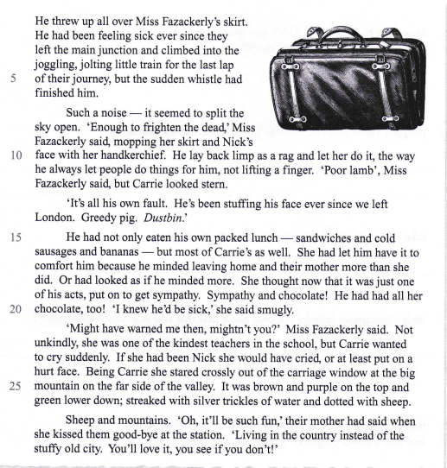
- Find and copy a phrase which show that the whistle was very loud
- Was Miss Fazackerly angry with Nick for being sick on her skirt? How can you tell?
- Why did Carrie give her lunch to Nick?
- Carrie says “smugly” that she knew Nick would be sick. What do you think the word smugly means?
- How does Carrie know Miss Fazackerly?
- Why do you think that Nick and Carrie’s mother told them that living in the country would be “such fun”?
- How do you think Nick and Carrie would have felt being evacuated from home?
Now watch a video clip based on the book. What is evacuation?
https://www.youtube.com/watch?v=LdMsoKrzvFY

As you are watching, make some notes to add to a mind map about evacuation
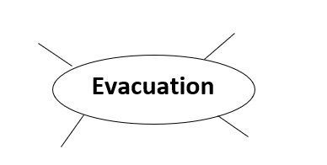
How do you think Carrie and Nick are feeling about being evacuated? How would you feel if it was you?

WEDNESDAY – Watch the clip of someone who was actually evacuated during WW2.
https://www.bbc.co.uk/teach/class-clips-video/history-ks2-an-evacuees-adventure/zk7hy9q
Stop the video and various points and discuss how you think she would be feeling.

Imagine that you were being evacuated from your home in Portsmouth. Complete the table with notes to explain how you would feel at each part. We will use these notes to write some paragraphs tomorrow.

- Your mum tells you that are going to be leaving home tomorrow and travelling to the country without her.
- You are on board the train with your friends from school and your teacher. You have no idea where you are going.
- You arrive in a small village in the countryside and are taken to live in a new home with people you have not met before. You have no idea when you are able to go home.

THURSDAY –
How would you feel if you were evacuated? Write a paragraph to explain how you are feeling and your reasons why. Remember to think about PEEE

Point - What is the point you are trying to make (I would feel...)
Evidence - Why? (this is because..)
Explanation - add some more detail to explain it clearly.
Example – give an example using the facts that you know.

FRIDAY –
Imagine that you were being asked to pack a suitcase to take with you when you are evacuated.
Which items would you pack in your suitcase? Why?

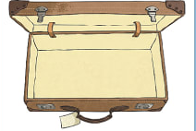

MATHS (Time)

Times tables for this week
Continue to test yourself weekly, on your target times table. Give yourself 30 seconds per calculation. You can include as many calculations as you wish to in the test. If you pass, move onto the next calculation. If you do not pass in time, continue to remain on that times table until you do pass.

MONDAY –

Watch the video lesson or work through the PowerPoint for the learning for this lesson.

You can view the video lesson here:
https://mayfieldschoolpo2.sharepoint.com/:p:/g/admin-staff/EeM_cN2tt0pMkPOE-HVTy4wBEljiq2IU4xDP3iNo43oMlg?e=7cZ2cv
It will work better in a desktop version of PowerPoint rather than the online version, so you may wish to open in desktop app.

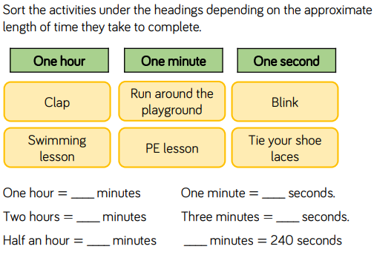
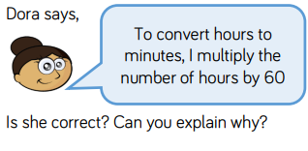
- Create a rule for converting hours to minutes and minutes to seconds. Compare the two equations that you have created.
- Show your working out and provide evidence to support each of your answers.
- Explain how you could use a clock face to check how many seconds are in a minute/how many minutes are in an hour.
- Calculate how many minutes are in 6 hours. Explain the steps that you had to make in order to complete this activity.
- Investigate whether Dora’s statement is always correct.

TUESDAY –
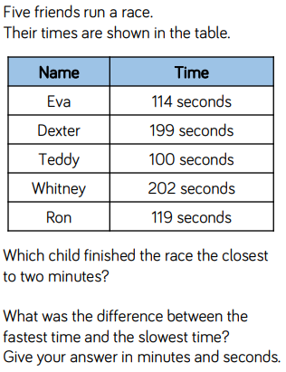
- Explain how you can calculate the difference between two of the times.
- Explain how to convert seconds to minutes, supporting with examples.
- Why do you think that the times were recorded in seconds, instead of minutes?
- I think that Dexter is closest to two minutes, because 200 seconds = 2 minutes and he was one second less. Identify and correct my mistakes.

WEDNESDAY –
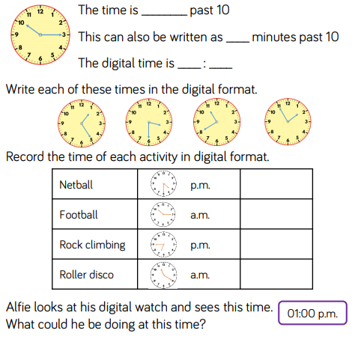
- Explain how you can ensure that you count the minutes past the hour efficiently?
- Order the activities from the earliest to the latest.
- Compare analogue and digital clocks. Which do you find most efficient and why?
- If your curfew was 19:30 and the rock-climbing activity lasted one hour, would you be able to attend? Explain your investigation.

THURSDAY –
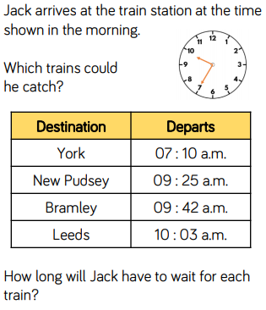
- Reason why he is unable to catch the other trains.
- Explain which train Jack would be waiting the longest for. How did you work it out?
- Investigate the relationship between 2am and 2pm on a digital clock. What do you notice? Is this relationship the same for all of the hours?

FRIDAY –
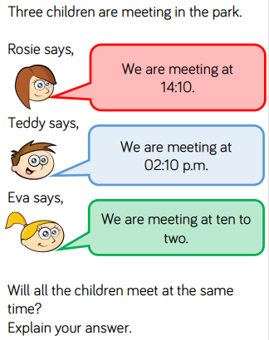
- Explain which mistakes have been made and why you think they made that error.
- Convert all of the times to 24-hour digital. Does this support your investigation?
- Correct the mistake made by ___, by writing the accurate time in words.

Some useful links that may support this week’s home learning tasks:
- https://www.bbc.co.uk/bitesize/topics/zkfycdm/articles/zcrmqty
- https://whiterosemaths.com/wp-content/uploads/2019/05/Year-4-2018-19-Summer-Block-3-Time.pdf
- https://mathsframe.co.uk/en/resources/resource/116/telling-the-time
TOPIC (Mayfield in the Blitz)
MONDAY – Please see English powerpoint. The English / Topic lesson for today has been combined.

TUESDAY and Wednesday. Create some Blitz artwork. Think about how you will make the background look like fire. Add a silhouette in the foreground – could you make it look like it is happening to Mayfield / Portsmouth?

THURSDAY – Imagine you were going to interview somebody who had experienced the Blitz. What questions would you ask them? What would you like to find out?
Challenge: Can you ask someone the questions and role play what you think the answers.

FRIDAY – Read this eyewitness account of the Blitz in Portsmouth and answer the questions.

It started fairly early in the evening. All I know is that we had hours with an unholy pounding. It really was absolutely frightening. An air raid warden came in and started screaming that my mother had left a light on upstairs in the end bedroom. It wasn’t — the top of our house was alight. It was an incendiary bomb. As we were leaving the house there was another one, caught in the rafters. We had to run out of the house — my mother, my father, my brother, my aunt, my cousin and my grandmother. As we came out of the house it was like broad daylight, we were in a ring of fire. The Guildhall was burning, everywhere you looked you were literally surrounded by fire.

We had to leave in exactly what we stood up in. That raid lasted until 5 or 6 the following morning. We had to leave our house to go to a shelter in Somers Road, in the grounds of St Peter’s Church, but the shelter in the grounds was full, so we had to go down into the bowels of the church. That absolutely petrified me because we were going deeper and deeper underground. We were lucky because we hadn’t been in there long when there was a mighty explosion which shook the boiler room where we were. The explosion was a direct hit on the shelter in the grounds which we had tried to get to previously. We were down there for five or six hours; the raids were continuous all night — ten to twelve hours on Portsmouth that night.
When we eventually came out of the church, there was devastation all the way round, complete and utter devastation. There was no electricity, no gas, no water. It was like a scene of a movie. You would have to live through it to be able to imagine what it was like.

We made our way back to our house; we were tired, cold, hungry — it was January — and we hadn’t even been able to stop to get a coat, we just ran. When we got back to the road where we lived, our house was just gutted. We had nothing. Nothing left. My father decided to try to go to another aunt’s of ours in Fratton Road, but when we got to the top of Fratton Bridge, you could see very little remained of Fratton Road. So we didn’t know what to do, we just stood on the bridge. Don’t forget we had no money. A cattle truck came along and he offered to take us all as far as Barnham (my father had relations in Bognor Regis). The truck took us to Barnham Station, where we caught a train to Bognor — only one stop along the line as I remember. Then we descended on my uncle, my father’s brother — the whole lot of us.

We had only the clothes we stood up in. I had slippers on my feet, which were sodden because of walking through all the water in the streets in Portsmouth which were awash with water and debris. We wanted something to eat and drink. My aunt Rose offered to make us some cocoa. We were all sitting bunched together, all dejected and still terrified, and she had a whistling kettle which made a sound like when the bombs came down and we all dived under the table. have no idea where we got help from, all I know is that my mother got £75 compensation from the government for the loss of everything. I don’t know whether there was any insurance but all the places, buildings, were demolished. The £75 enabled us to buy clothes and we had to live in rented accommodation in Bognor. Eventually all the family, the other relations who were in Portsmouth who we hadn’t been able to contact, came to Bognor and we all lived there until we came back to Portsmouth in 1945.

We were quite near Ford and Tangmere Airports (temporary airfields) and I can remember later on, towards D-Day, the sky being black with wave after wave of planes and gliders, which seemed to go on for hours. Because we were near Ford and Tangmere we used to get a few bombs up there but mostly what the Germans would do was come in low and strafe the buildings with their guns. I suppose what they were trying to do was get to other airfields nearby where the aircraft were.

- Are there any words that you are unsure of in the text? Look them up in a dictionary and write their definition.
If you do not have a dictionary you can use an online one https://www.dictionary.com
- How would you feel If you had to evacuate your house and go to a shelter?
- How would you feel if you could never return to your home again?

LEARNING WEBSITES

https://www.topmarks.co.uk/maths-games/hit-the-button

https://www.mathplayground.com/

https://www.topmarks.co.uk/maths-games/7-11-years

https://whiterosemaths.com/homelearning/

https://nrich.maths.org/primary

https://ttrockstars.com/

https://www.bbc.co.uk/bitesize/levels/zbr9wmn

https://www.literacyshed.com/home.html

https://www.spellingshed.com/

https://pobble.com/

https://monsterphonics.com/?gclid= EAIaIQobChMI56aEu9yh6AIVFeDtCh2NMAcIEA AYASAAEgK1b_D_BwE

https://www.oxfordowl.co.uk/welcome-back/for-home/reading-owl/kids-activities

https://www.topmarks.co.uk/english-games/7-11-years

Audible are doing a free 30 day trial so that children can listen to lots of books online.
MATHS ANSWERS (Money)

MONDAY –

- One Hour: Swimming lesson/P. E lesson.
- One Minute: Run around the playground/Tie your shoelaces.
- One Second: Clap/Blink.

A) One Hour = 60 Minutes
B) Two Hours = 120 Minutes
C) Half an Hour = 30 Minutes
D) One Minute = 60 Seconds
E) Three Minutes = 180 Seconds
F) Four Minutes = 240 Seconds
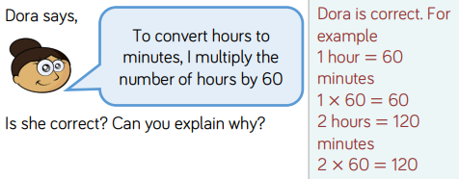
TUESDAY –
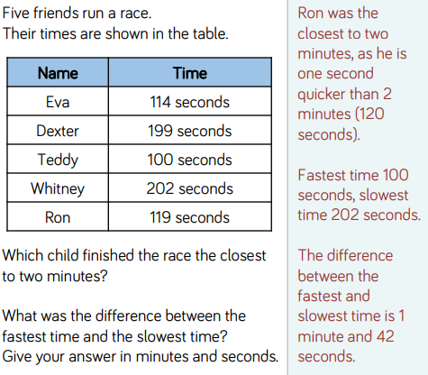
WEDNESDAY –

A) Quarter
B) 15
C) 10:15
D) 01.25
E) 03:30
F) 10:40
G) 01:55
H) 16:30
I) 10:15
J) 18:45
K) 11:20

THURSDAY –
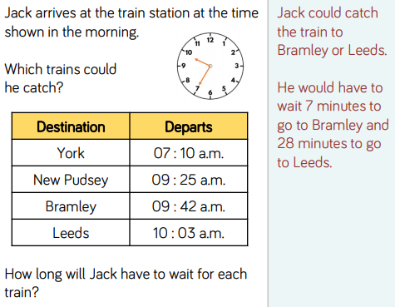
FRIDAY –
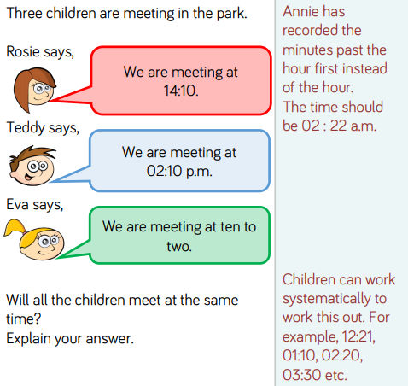
YEAR 3/4 SPELLING WORDS
