Dear Parent/Carer,

As the school continues to remain closed due to Coronavirus, we are continuing to provide educational tasks for your children to complete. We have received positive feedback on the new format of the home learning daily tasks. As always, please continue to keep in touch about your child’s home learning and let us know if there are any problems.

In primary, we suggest that children try to complete;
- 30 minutes a day of independent reading/reading to an adult
- 30 minutes of maths a day
- 30 minutes of English a day
- 30 minutes of topic based/creative learning
- 30 minutes of PE/ physical activity

Home learning tasks can be supplemented with work from a number of websites (see list below for ideas.) Daily work set on the BBC website is particularly useful as it contains tutorial videos.
https://www.bbc.co.uk/bitesize/primary

Teachers will set a weekly programme for your child to work through at home. This will be available for you to access on the school website every Monday. We know that children work at different speeds and different levels, so please have a look at work in other year groups too for extra support.

To help with maths and different terminology, we will try to add in some video links for tutorials and we will try to include answers for maths where possible to help the children check through their work.

Whilst it is important for your child to keep up with their learning at home, we appreciate that this can be a stressful time for children and adults. Looking after mental health is vital. Therefore, we suggest that the day is broken up into manageable learning chunks, interspersed with physical exercise, fun activities and time together as a family. Activities such as the 30 day lego challenge and using the real PE activities could be a good place to start. Setting up a weekly timetable can be a good place to start. As well as educational learning, the children could also begin to learn different life skills – how to boil an egg, sew on a button, learn to send an email, bake a cake using a recipe book etc.

Guidance for parents, regarding home learning, has been released by the government and can be found at the following link;
https://www.gov.uk/guidance/supporting-your-childrens-education-during-coronavirus-covid-19

We hope you are all keeping well and staying positive.
Kind regards,
Mrs Pountain, Miss Campbell, Mrs Emery & the Year 4 team.

We would love to see some of the things you have been doing and have written our email addresses below so you can get in contact if you would like to.
Pountain-christina@mayfield.portsmouth.sch.uk
Campbell-morgon@mayfield.portsmouth.sch.uk
Emery-vikki@mayfield.portsmouth.sch.uk

YEAR 4 HOME LEARNING TASKS
WEEK BEGINNING: 11th May
ENGLISH TASKS  SPELLINGS FOR THIS WEEK (see list below)  describe, different, disappear, early, earth, eighth, enough  MONDAY –  Write some silly sentences that include your spellings. Read them to someone. Can you make them so funny that they make someone else laugh?  TUESDAY –  Tim took another deep breath. Inside his chest, he could feel his heart pounding like a bass drum. Again, he took slow, deep breaths and picked up his script. Flicking through the pages, he read through his lines quietly to himself, mumbling under his breath. All his hard work over the last few months had been for tonight. Crossing his fingers tightly, he wished for good luck.  “Tim, are you ready? You’re on in 2 minutes,” said Mr. Smith.  “I think so, Sir,” said Tim in a shaky voice.  “Don’t worry, you’ll be fine, Tim. Break a leg!”  Slowly, Tim stood up and made his way towards the heavy, red velvet curtain. He pulled it to the side and stepped through.  - How do you think Tim is feeling at the beginning of the text?  - Explain how you know how he is feeling.  - What do you think Tim is waiting to do?  - What clues told you what Tim might be doing?  - Who do you think Mr. Smith is?  - Do you think “Opening Night” is a good title? Why?  - If you had to give this text a different title, what would you call it?  WEDNESDAY –  Revisit your spellings for this week. Can you create a word search that contains your words?  THURSDAY / FRIDAY– Imagine you are about to perform a play of one of your favourite stories or TV shows. Can you write a playscript that can be performed? You might like to plan out your ideas first before writing. Perhaps you might even like to get your family or friends (via video chat!) to help you perform it.  Remember to:  Write the name of the character performing followed by a colon.  Include stage directions to include movements and actions of your characters.  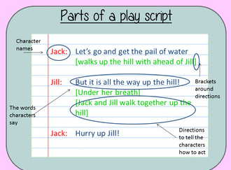 | MATHS TASKS  Continue to practise your times tables daily.  If you would like further challenges, please follow the link below;  https://whiterosemaths.com/homelearning/  To help remind yourself of methods for subtraction,  please see the BBC bitesize link below;  https://www.bbc.co.uk/bitesize/articles/zfdpnrd  MONDAY –  Task:  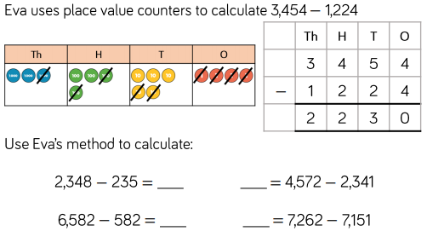  Now, investigate subtracting two 4-digit numbers, that results in a 3-digit number. How many different number sentences can you find? Use Eva’s method to support your working out.  TUESDAY –  Task:  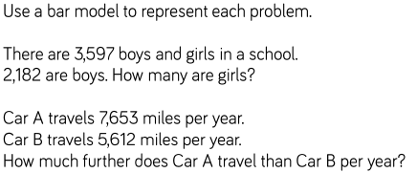  Now, create your own similar word problems for someone in your house to solve. If they are struggling, take on the role of the teacher and explain the steps they need to take, in order to solve the problem.  WEDNESDAY –  Task:  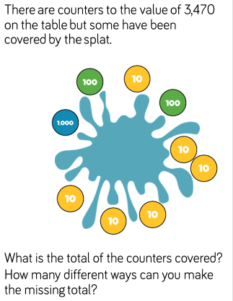  Explain how you know that there are no more possible answers, once you have finished investigating.  THURSDAY –  Task:  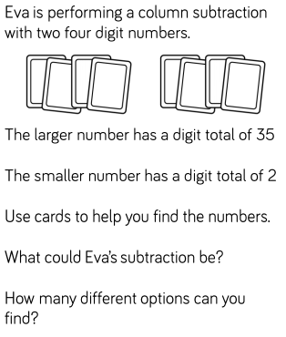  Define the term ‘total’.  Explain how you know that there are no more possible answers, once you have finished investigating.  FRIDAY -  Task:  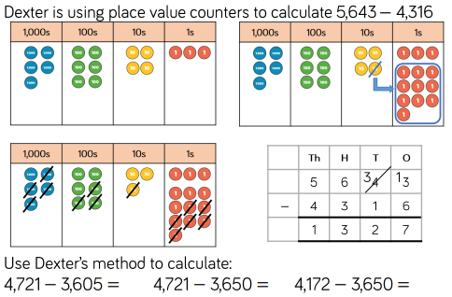  Dexter’s method is very similar to Eva’s method, but he has used exchanging between the columns. Use this method to complete the number sentences. To challenge yourself, try teaching this strategy to someone that lives in your house.
TOPIC/CREATIVE  This week, your activities are to carry some investigations that are all about weather. There are also some opportunities to have a go at making some great weather predicting apparatus.  Hopefully you will have most of the things to complete the activities for this week at home already. If you don’t perhaps instead you could complete some weather artwork or take some photographs to go with your weather diary.  MONDAY – Make a weather Vane. https://www.pbs.org/parents/crafts-and-experiments/where-is-the-wind-going-try-a-diy-weather-vane  Once you have made this note down the wind direction 3 times a day for the next week. Record your findings in a suitable way.  TUESDAY – Make a rain gauge  https://www.education.com/science-fair/article/DIY-rain-gauge/  Or/And  Make an anemometer. https://www.education.com/science-fair/article/make-anemometer/  WEDNESDAY –  Now you have all this equipment for recording the weather, make sure that you keep a weather diary for the next 2/3 weeks. Put the day, the date, and check 2 to 3 times a day. Record what the weather is like I.e. Cloudy with occasional sunshine. Or showers. Or overcast. Be creative with your vocabulary!!  Think about the best way to present your findings.  THURSDAY – Recreate a thunderstorm in your kitchen. With some very simple equipment you can find out what is really happening during a thunderstorm. https://www.lifewithmoorebabies.com/2013/05/what-causes-thunderstorm.html  Ask an adult to record your thunderstorm as a video and email it to your teacher.  FRIDAY - Shaving Foam Storm clouds  More of an arty activity. But you might be able to take some amazing photos during this activity.  https://onelittleproject.com/shaving-cream-rain-clouds/  Hopefully you will have most of the things to complete the activities for this week at home already. If you don’t perhaps instead you could complete some weather art work or take some photographs to go with your weather diary. | LEARNING WEBSITES  https://www.topmarks.co.uk/maths-games/hit-the-button  https://www.mathplayground.com/  https://www.topmarks.co.uk/maths-games/7-11-years  https://whiterosemaths.com/homelearning/  https://nrich.maths.org/primary  https://ttrockstars.com/  https://www.bbc.co.uk/bitesize/levels/zbr9wmn  https://www.literacyshed.com/home.html  https://www.spellingshed.com/  https://pobble.com/  https://monsterphonics.com/?gclid= EAIaIQobChMI56aEu9yh6AIVFeDtCh2NMAcIEA AYASAAEgK1b_D_BwE  https://www.oxfordowl.co.uk/welcome-back/for-home/reading-owl/kids-activities  https://www.topmarks.co.uk/english-games/7-11-years  Audible are doing a free 30 day trial so that children can listen to lots of books online.  Answers for Wednesday’s maths  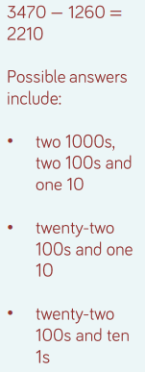  Answers for Thursday’s maths  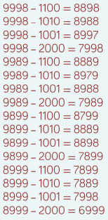
YEAR 3/4 SPELLING WORDS

