Dear Parent/Carer,

In light of the government’s latest guidance, we are very pleased that we are able to open up more on-site provision for all of our primary pupils. Your choice of provision can now be either; two days in ‘Bubble School’ or up to five days a week in ‘Key Worker School’ if you are a key worker. When the children are at school, they will access the home learning tasks, supported by their bubble teacher. When the children are at home, it is important that they continue with their home learning. The tasks that we set will be a mix of consolidation of previous work and new learning. To help the children with this work, we are including;
- The opportunity for you/your child to communicate with their class teacher via email on a set day, between certain times.
- More links to video resources/websites/ on-line clips or pre-recorded sessions from teachers.
- Feedback on a chosen piece of work (pictures/copies need to be emailed to the teacher or dropped off to a class box in the main reception area).

In primary, we suggest that children try to complete:
- 30 minutes a day of independent reading/reading to an adult
- 30 minutes of maths a day
- 30 minutes of English a day
- 30 minutes of topic based/creative learning
- 30 minutes of PE/ physical activity

Teachers will set a weekly programme for your child to work through at home. This will be available for you to access on the school website every Monday. We know that children work at different speeds and different levels, so please have a look at work in other year groups too for extra support.

Whilst it is important for your child to keep up with their learning at home, we appreciate that this can be a stressful time for children and adults. Looking after mental health is vital. Therefore, we suggest that the day is broken up into manageable learning chunks, interspersed with physical exercise, fun activities and time together as a family. Activities such as the 30 day Lego challenge and using the real PE activities could be a good place to start. Setting up a weekly timetable can be a good place to start. As well as educational learning, the children could also begin to learn different life skills – how to boil an egg, sew on a button, learn to send an email, bake a cake using a recipe book etc.

Guidance for parents, regarding home learning, has been released by the government and can be found at the following link;
https://www.gov.uk/guidance/supporting-your-childrens-education-during-coronavirus-covid-19
We will be available via email to support parents and pupil with the tasks each week on Wednesdays between 10am-12pm and 1pm and 3pm. Please email your Friday English task to your teacher by Monday evening of the following week. Feedback will be given via email on Wednesday.
We hope you are all keeping well and staying positive.

Kind regards,

The Year 4 team
Teacher emails:
pountain-christina@mayfield.portsmouth.sch.uk
campbell-morgon@mayfield.portsmouth.sch.uk
YEAR 4 HOME LEARNING TASKS
WEEK BEGINNING: 13th July
ENGLISH ()
SPELLINGS FOR THIS WEEK:
possession, possible, potatoes, pressure, probably, promise, purpose
MONDAY – Video lesson – write first paragraph of diary
Click on this link for the PowerPoint lesson (remember to open in desktop app):
https://mayfieldschoolpo2.sharepoint.com/:p:/g/admin-staff/EfiA-EiNZTtLkiiaSD2WEnEBj6IcEz4XuAhygrW-aTk0lQ?e=BJvg0H

TUESDAY –
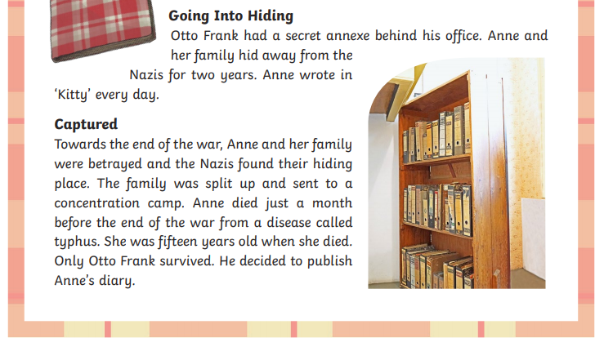

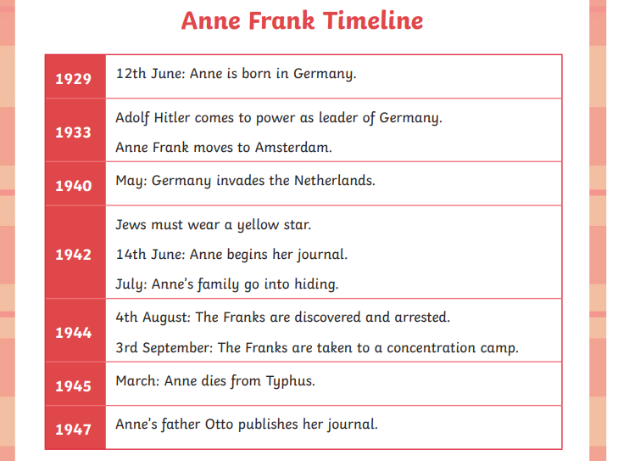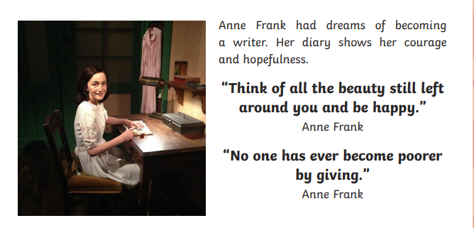

  - When and where was Anne Frank born?
  - What is the best meaning for ‘lively and outgoing’?
    - Full of life and energy
    - Naughty and mischievous
    - Quiet and laid-back
  - Use the information to find two things that Anne Frank enjoyed doing.
  - Who was Adolf Hitler?
  - When the Nazi’s invaded The Netherlands in 1940, life became hard for the Jews. What were they made to do?
  - Anne received a red journal for her thirteenth birthday. What did she name it?
  - Otto Frank had a secret annexe to hide his family from the Nazis. Why did he do this? Choose the reason that is FALSE.
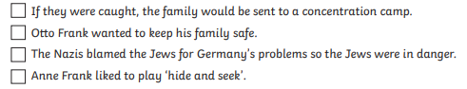
Writing challenge: Anne Frank stayed hidden in the Annexe for two years. How would you feel if you were hidden for so long?

WEDNESDAY – Planning our diary – Create a comic strip of your day as an evacuee. Think about the three parts of your day that we discussed on Monday.
- Your mum tells you that are going to be leaving home tomorrow and travelling to the country without her.
- You are on board the train with your friends from school and your teacher. You have no idea where you are going.
- You arrive in a small village in the countryside and are taken to live in a new home with people you have not met before. You have no idea when you are able to go home.

THURSDAY and FRIDAY – Use your writing from Monday’s lesson to produce your final diary.
Challenge: You may want to write a diary of your next day.

MATHS (Geometry)

Times tables for this week
Continue to test yourself weekly, on your target times table. Give yourself 30 seconds per calculation. You can include as many calculations as you wish to in the test. If you pass, move onto the next calculation. If you do not pass in time, continue to remain on that times table until you do pass.

MONDAY –
Watch the video lesson or work through the PowerPoint for the learning for this lesson.

You can view the video lesson here:
https://mayfieldschoolpo2.sharepoint.com/:p:/g/admin-staff/EWAGmxIghktMqryusaR8WgIBwb5Awh5MUzooS9_7ZWfNoQ?e=HJXicv

It will work better in a desktop version of PowerPoint rather than the online version, so you may wish to open in desktop app.

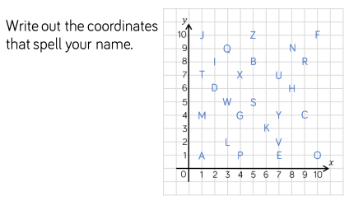
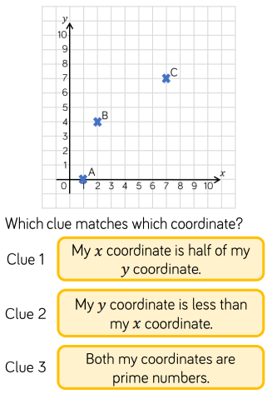
- Explain which order we read the axis in and come up with a method to remember this.
- Investigate whether it matters which order axes are read in, before reasoning.

TUESDAY –
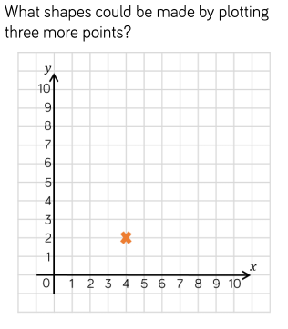
- Investigate whether you could map out a triangle by adding 3 additional coordinates.
- I plot the following co-ordinates: (6,2), (4,5) and (6,6). Reason whether I have successfully mapped out a rectangle or not.

WEDNESDAY –
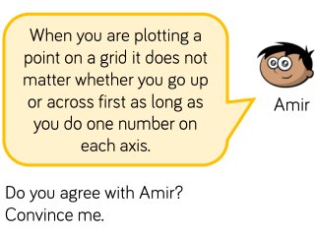
- Show the same set of co-ordinates on two separate grids, plotting the x-axis first on one and y-axis first on the other - compare the two.

THURSDAY –
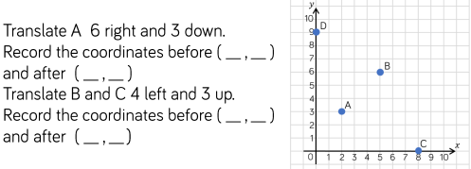
- Define the term ‘translate’.
- Explain how we translate co-ordinates on a grid.

FRIDAY –
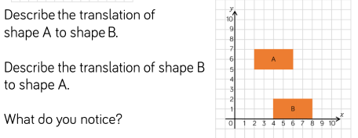
- Are there multiple possible answers?
- What do you notice about the answers to part A and part B?

Some useful links that may support this week’s home learning tasks:
- https://www.bbc.co.uk/bitesize/topics/z2dqrwx/articles/zcjs97h
- https://www.bbc.co.uk/bitesize/topics/zgthvcw/articles/z96k9qt
- https://www.theschoolrun.com/what-is-translation-of-shapes#:~:text=In%20geometry%20translation%20means%20moving,%2C%20down%2C%20left%20or%20right.
TOPIC (WW2)
MONDAY – What can you remember about the items that an evacuee would have taken with them? Can you make some of the items and dress as an evacuee.
Gas mask and box: 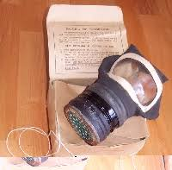
You could use these instructions or just make your own.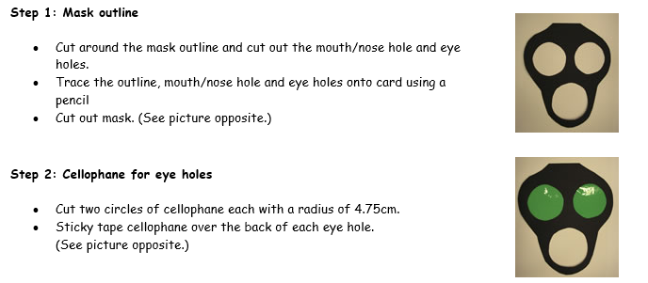
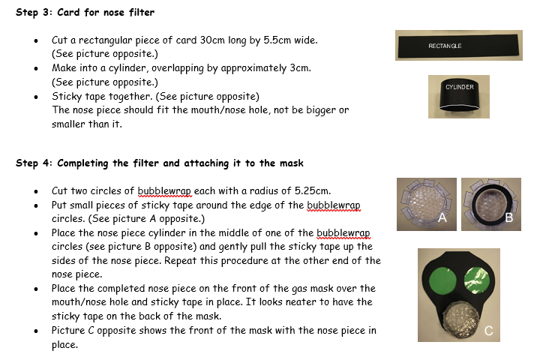

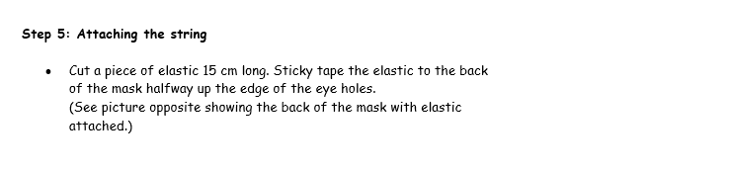
Luggage tag: 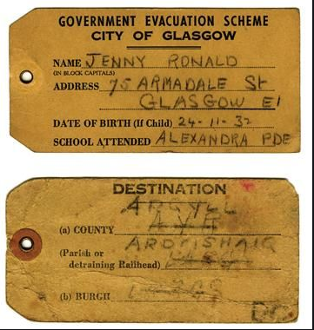

ID card
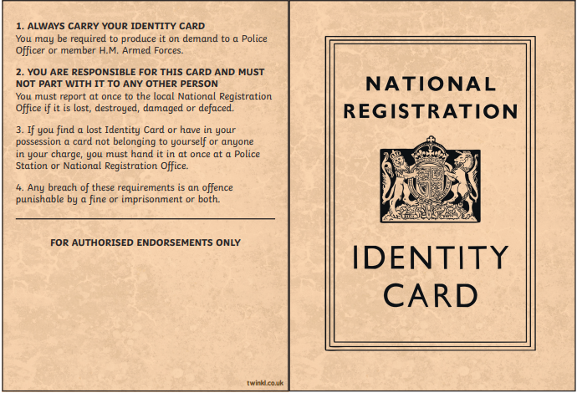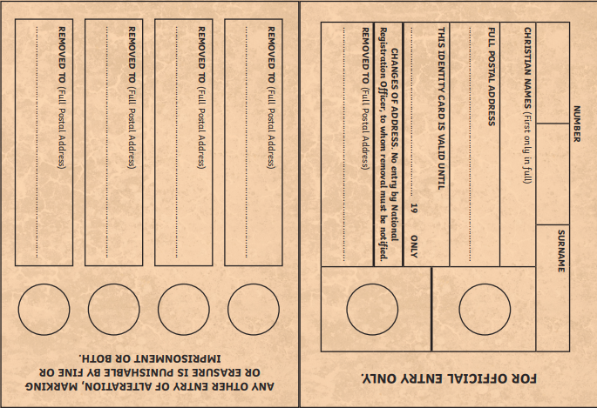

Dress as an evacuee, gas mask, tag. Draw the items you will take in your suitcase.

TUESDAY – Propaganda posters. Watch the PowerPoint and learn about propaganda posters and what they were used for in WW2

https://mayfieldschoolpo2.sharepoint.com/:p:/g/adminstaff/EYhQG2PBskFHto9N8bwbCRkBxkmLXlSSwwrm5jBRS1NunA?e=CL0vQV

WEDNESDAY – Make some notes about Anne Frank and the struggle that she went through. You can use the reading comprehension from our English lesson as well as these links:
https://www.bbc.co.uk/bitesize/topics/z7d7gwx/articles/zm4v7nb
https://www.natgeokids.com/uk/discover/history/general-history/anne-frank-facts/
http://www.primaryhomeworkhelp.co.uk/war/annefrank.html
You may also want to use the Internet to do some additional research.

THURSDAY – Use the information about Anne Frank from the reading comprehension to create an information page about her and her life.

FRIDAY – Make your own WW2 medal. You can draw it, make it out of paper or card. If you are feeling adventurous perhaps you could make it out of clay or salt dough?

LEARNING WEBSITES

https://www.topmarks.co.uk/maths-games/hit-the-button

https://www.mathplayground.com/

https://www.topmarks.co.uk/maths-games/7-11-years

https://whiterosemaths.com/homelearning/

https://nrich.maths.org/primary

https://ttrockstars.com/

https://www.bbc.co.uk/bitesize/levels/zbr9wmn

https://www.literacyshed.com/home.html

https://www.spellingshed.com/

https://pobble.com/

https://monsterphonics.com/?gclid= EAIaIQobChMI56aEu9yh6AIVFeDtCh2NMAcIEA AYASAAEgK1b_D_BwE

https://www.oxfordowl.co.uk/welcome-back/for-home/reading-owl/kids-activities

https://www.topmarks.co.uk/english-games/7-11-years

Audible are doing a free 30-day trial so that children can listen to lots of books online.
MATHS ANSWERS

MONDAY –
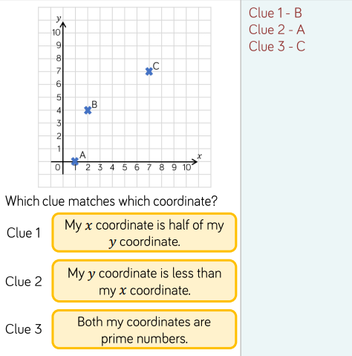
TUESDAY –
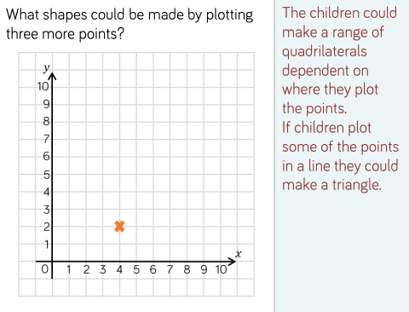
WEDNESDAY –
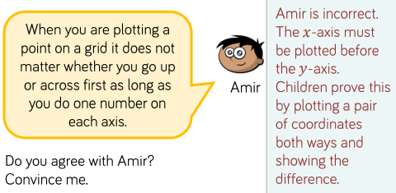
THURSDAY –
A) (2,3) to (8,0)
B) (5,6) to (1,9)
C) (8,0) to (4,3)

FRIDAY –
A to B = 2 right and 5 down
B to A = 2 left and 5 up
YEAR 3/4 SPELLING WORDS
