Dear Parent/Carer,

As the school continues to remain closed due to Coronavirus, we are continuing to provide educational tasks for your children to complete. We have received positive feedback on the new format of the home learning daily tasks. As always, please continue to keep in touch about your child’s home learning and let us know if there are any problems.

In primary, we suggest that children try to complete;
- 30 minutes a day of independent reading/reading to an adult
- 30 minutes of maths a day
- 30 minutes of English a day
- 30 minutes of topic based/creative learning
- 30 minutes of PE/ physical activity

Home learning tasks can be supplemented with work from a number of websites (see list below for ideas.) Daily work set on the BBC website is particularly useful as it contains tutorial videos.
https://www.bbc.co.uk/bitesize/primary

Teachers will set a weekly programme for your child to work through at home. This will be available for you to access on the school website every Monday. We know that children work at different speeds and different levels, so please have a look at work in other year groups too for extra support.

To help with maths and different terminology, we will try to add in some video links for tutorials and we will try to include answers for maths where possible to help the children check through their work.

Whilst it is important for your child to keep up with their learning at home, we appreciate that this can be a stressful time for children and adults. Looking after mental health is vital. Therefore, we suggest that the day is broken up into manageable learning chunks, interspersed with physical exercise, fun activities and time together as a family. Activities such as the 30 day lego challenge and using the real PE activities could be a good place to start. Setting up a weekly timetable can be a good place to start. As well as educational learning, the children could also begin to learn different life skills – how to boil an egg, sew on a button, learn to send an email, bake a cake using a recipe book etc.

Guidance for parents, regarding home learning, has been released by the government and can be found at the following link;
https://www.gov.uk/guidance/supporting-your-childrens-education-during-coronavirus-covid-19

We hope you are all keeping well and staying positive.

Kind regards,

The Year 4 team
Teacher emails;
pountain-christina@mayfield.portsmouth.sch.uk
campbell-morgon@mayfield.portsmouth.sch.uk
emery-vikki@mayfield.portsmouth.sch.uk

YEAR 4 HOME LEARNING TASKS
WEEK BEGINNING: Monday 18th May 2020
ENGLISH (Non-Fiction Texts)
SPELLINGS FOR THIS WEEK:
exercise, experience, experiment, extreme, famous, favourite, February

MONDAY – Draw a picture that represents each of your spelling words to show what the word means. E.g. For exercise you might want to draw someone riding a bike, running or going for a walk.

TUESDAY – Non-Fiction Texts
What are the features of non-fiction texts? Have a look at the two non-fiction articles linked below. What do you notice about these texts? Make a list of the features of non-fiction texts that you can remember. Now have a look at this clip on you tube to make sure you have all the features. https://www.youtube.com/watch?v=3mAl9QMJJTo
Fiction articles about Portsmouth
https://www.portsmouth.gov.uk/ext/documents-external/cul-hilsealineswildlife-leaflet.pdf
https://www.portsmouth.gov.uk/ext/documents-external/env-beesswarms-fact-sheet.pdf
Can you create a poster that will help you remember the non-fiction features?

WEDNESDAY – Vowel and consonant challenge – How many vowels and consonants make up each of your spelling words? Underline the vowels and consonants. How many syllables does each word have? What smaller words can you make from each spelling? EG, from the word strength, I could make; ten, rent, nest, her etc
Remember vowels = a,e,i,o,u and consonants are the rest of the letters in the alphabet that are not vowels (except Y which can sometimes both). Have a look at this video to help you: https://www.bbc.co.uk/bitesize/topics/zxfyjty/articles/zs2crdm
Challenge: Can you challenge yourself to find some words which have a large number of vowels or consonants?

THURSDAY and FRIDAY – Revisit the leaflet about the wildlife in Hilsea lines.
https://www.portsmouth.gov.uk/ext/documents-external/cul-hilsealineswildlife-leaflet.pdf
Imagine that Portsmouth City Council has asked you to redesign their leaflet to attract more visitors to Hilsea Lines. Create a new version of this leaflet making sure that you include all of the non-fiction features you found out about on Tuesday.

Remember to:
Include non-fiction features (Heading, Sub-heading, pictures, maps, diagrams etc).
Make it interesting for your reader so they want to visit.
Challenge: Is there any new information that you can include about the wildlife at Hilsea Lines? Perhaps if you are out walking you could have a look for the information boards and signs to see if there is any other information you can add.

MATHS (Multiplication focus)

Times tables for this week:
Continue to test yourself weekly, on your target times table. Give yourself 30 seconds per calculation. You can include as many calculations as you wish to in the test. If you pass, move onto the next calculation. If you do not pass in time, continue to remain on that times table until you do pass.

MONDAY –
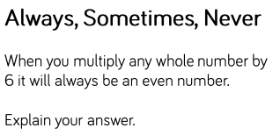
- Thoroughly investigate the six times tables. What do you notice?
- Explain whether the answer is always, sometimes or never and provide evidence to support your answer.
- Is your answer the same when multiplying two-digit numbers by six?
- Is your answer the same when multiplying three-digit numbers by six?
- What does this tell you about the three times tables?
- What does this tell you about the twelve times tables?
- Investigate whether there are any prime numbers in the six times tables.

TUESDAY –
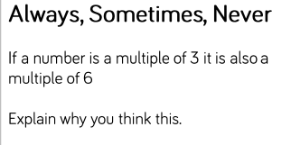
- Explain whether the answer is always, sometimes or never and provide evidence to support your answer.
- Describe the relationship between the three times tables and six times tables.
- Use the inverse operation to check your calculations.
- Use arrays to prove your calculations are correct.
- Define the term ‘multiple’.
- Compare the term ‘multiple’ and ‘factor’. How are they different? How are they similar?

WEDNESDAY –
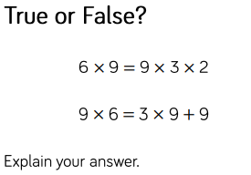
- Use arrays to support your calculations.
- Use brackets when multiplying three numbers, if it helps.
- Do 6x9 and 9x6 give you the same answer? If so, explain why.
- Create your own ‘true or false’ and challenge someone in your house to solve it.
- Could the answer to the second calculation be true and false? If so, explain why.
- Create a mind map all about multiplication. Consider the different methods you could use (provide examples), why we use it, the inverse operation and why we use it, pictorial representations for calculations (arrays) and any other information that you feel is important.

THURSDAY –
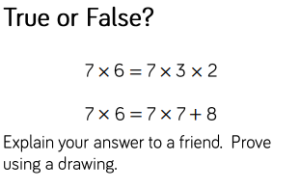
- Use arrays to support your calculations.
- Use brackets when multiplying three numbers, if it helps.
- Does it matter which order you multiply two factors in? Why/why not?
- Create your own ‘true or false’ and challenge someone in your house to solve it.
- Could the answer to the second calculation be true and false? If so, explain why.
- Create a mind map of all the different terms you could use as a synonym for multiplication.

FRIDAY –
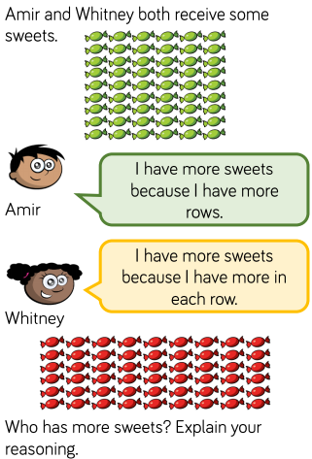
- Explain how the arrays help you to multiply efficiently.
- Explain the difference between rows and columns - use diagrams to support your explanation.
- Challenge yourself to convert the different arrays into number sentences. Describe the relationship between the two different number sentences.
- Create a similar word problem for someone else to solve. If they find it tricky, pretend you are the teacher and coach them to solve the problem.

Supportive websites for this week’s Maths:

- https://www.bbc.co.uk/bitesize/topics/z6j2tfr/articles/zv9sv9q
- https://www.mathsisfun.com/numbers/factors-multiples.html
- https://study.com/academy/lesson/what-is-a-multiple-in-math-definition-lesson-quiz.html
- https://www.bbc.co.uk/bitesize/topics/zqbg87h/articles/z3tvcj6
TOPIC
MONDAY – https://www.youtube.com/watch?v=ZrSWYE37MJs
If you have a garden or an outside space, jot down how many different habitats you have within that space. Look at Micro/Macro habitats as well as the larger, more obvious ones. Also, try and note down any organisms that could be living within those habitats.
TUESDAY – Food Chains. https://www.bbc.co.uk/bitesize/topics/zbnnb9q/articles/zwbtxsg
Look at this BBC Bitesize clip about habitats and food chains. Once you have watched this try creating your own food chains. What is the longest one you can create? Can you create a food chain that has many consumers? Create a power point to show your food chains.
http://www.primaryhomeworkhelp.co.uk/foodchains.htm
This is a website that could help you to create your food chains. Just scroll down the page a little and clip on the links.
WEDNESDAY – Interactive Quiz
Try this food chain quiz. Then try and create your own. It DOES NOT have to be interactive. Perhaps you could try out some of the questions of your family? You can use the internet to research.
https://www.zephyrus.co.uk/foodpuzzlechain.html
THURSDAY–
Choose your own habitat and make it.
You could junk model it, you could draw it, you could use an art app on the computer. You could take photos and collage them altogether. Be as creative as you can to recreate a habitat. Try making the animals that inhabit the habitat.
FRIDAY–
Research a local wildlife sanctuary.
We are very lucky that we live close to a variety of habitats, from the coast to the woodland, from marshland to urban/cityscapes. Find a local sanctuary and research them. Can we visit them? Which habitat do they preserve? Why is that habitat important? Are there any rare or endangered animals that use the sanctuary? Could we visit it a class and what would we learn from the visit?
LEARNING WEBSITES

https://www.topmarks.co.uk/maths-games/hit-the-button

https://www.mathplayground.com/

https://www.topmarks.co.uk/maths-games/7-11-years

https://whiterosemaths.com/homelearning/

https://nrich.maths.org/primary

https://ttrockstars.com/

https://www.bbc.co.uk/bitesize/levels/zbr9wmn

https://www.literacyshed.com/home.html

https://www.spellingshed.com/

https://pobble.com/

https://monsterphonics.com/?gclid= EAIaIQobChMI56aEu9yh6AIVFeDtCh2NMAcIEA AYASAAEgK1b_D_BwE

https://www.oxfordowl.co.uk/welcome-back/for-home/reading-owl/kids-activities

https://www.topmarks.co.uk/english-games/7-11-years

Audible are doing a free 30 day trial so that children can listen to lots of books online.
MATHS ANSWERS

MONDAY –
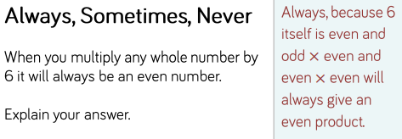

TUESDAY –
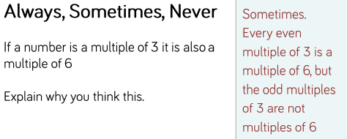

WEDNESDAY –
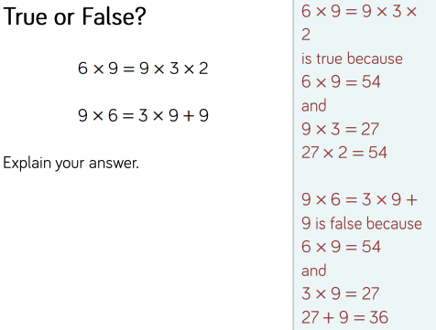

THURSDAY –
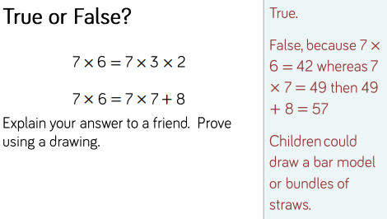

FRIDAY –
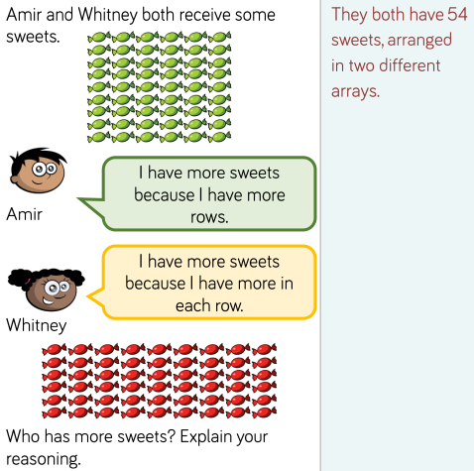

Key Terminology:

- Factor - A factor is a number that divides into another number exactly and without leaving a remainder. E.g. 4 and 6 are factors of 24 because 4 x 6 = 24.
- Multiple - A multiple of a number is that number multiplied by an integer. E.g. 33 is a multiple of 3 because 3 x 11 = 33.
- Array - Items (such as objects, numbers, etc.) arranged in rows and/or columns of equal amounts. An array displaying 4 x 3 would consist of 4 rows and 3 columns.
O O O
O O O
O O O
O O O
- Commutative Law - A law that explains that when adding or multiplying, the order of the numbers does not affect the answer. E.g. a + b = b + a AND a x b = b x a.
- Row - A horizontal line of objects.
- Column - A vertical line of objects.
YEAR 3/4 SPELLING WORDS
