Dear Parent/Carer,

As the school continues to remain closed due to Coronavirus, we are continuing to provide educational tasks for your children to complete. We have received positive feedback on the new format of the home learning daily tasks. As always, please continue to keep in touch about your child’s home learning and let us know if there are any problems.

In primary, we suggest that children try to complete;
- 30 minutes a day of independent reading/reading to an adult
- 30 minutes of maths a day
- 30 minutes of English a day
- 30 minutes of topic based/creative learning
- 30 minutes of PE/ physical activity

Home learning tasks can be supplemented with work from a number of websites (see list below for ideas.) Daily work set on the BBC website is particularly useful as it contains tutorial videos.
https://www.bbc.co.uk/bitesize/primary

Teachers will set a weekly programme for your child to work through at home. This will be available for you to access on the school website every Monday. We know that children work at different speeds and different levels, so please have a look at work in other year groups too for extra support.

To help with maths and different terminology, we will try to add in some video links for tutorials and we will try to include answers for maths where possible to help the children check through their work.

Whilst it is important for your child to keep up with their learning at home, we appreciate that this can be a stressful time for children and adults. Looking after mental health is vital. Therefore, we suggest that the day is broken up into manageable learning chunks, interspersed with physical exercise, fun activities and time together as a family. Activities such as the 30 day lego challenge and using the real PE activities could be a good place to start. Setting up a weekly timetable can be a good place to start. As well as educational learning, the children could also begin to learn different life skills – how to boil an egg, sew on a button, learn to send an email, bake a cake using a recipe book etc.

Guidance for parents, regarding home learning, has been released by the government and can be found at the following link;
https://www.gov.uk/guidance/supporting-your-childrens-education-during-coronavirus-covid-19

We hope you are all keeping well and staying positive.

Kind regards,

The Year 4 team
Teacher emails;
pountain-christina@mayfield.portsmouth.sch.uk
campbell-morgon@mayfield.portsmouth.sch.uk
emery-vikki@mayfield.portsmouth.sch.uk

YEAR 4 HOME LEARNING TASKS
WEEK BEGINNING: 1st June
ENGLISH (Letter Writing)
SPELLINGS FOR THIS WEEK:
Forward, fruit, grammar, group, guard, guide, heard

MONDAY – Write your spelling words in an interesting way to help you remember them. You might like to do bubble writing or write them in rainbow colours. Challenge: Could you create posters of your words and display them somewhere at home?

TUESDAY – Letter Writing
This week we are going to write a letter to someone that we haven’t heard from for a while. This could be for a friend, family member or even to your teacher!
Watch this link on writing informal letters and read what is expected.
https://www.youtube.com/watch?v=P3k148sIiSk
As you read, make notes of the important features of in informal letter. You will be able to use these ideas later this week. You may also want to write down some ideas of words and phrases that you like.
Challenge: Could you use the internet to find out more about writing an informal letter?

WEDNESDAY – Play tic tac toe (noughts and crosses) with your spelling words.
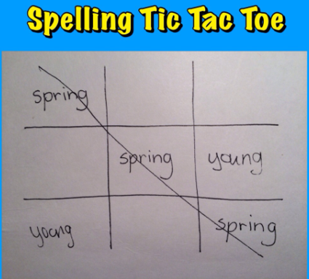 Challenge: Can you create a different game with your words?
THURSDAY– Letter Writing
Plan the letter that you are going to write. Remember to refer back to the work that you did on Tuesday and the features you will need to include. Write some notes for each part about what you will include.
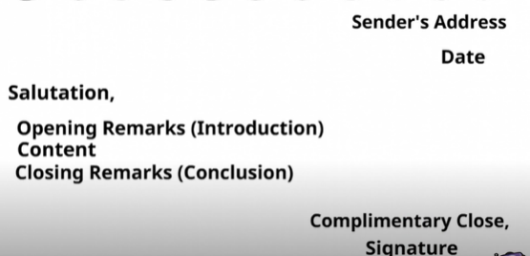

Now plan some of the other things you will include:
- What fronted adverbials could you include? https://www.bbc.co.uk/bitesize/topics/zwwp8mn/articles/zp937p3
- What are the main things you want to tell the person you are writing to? How will you put these into paragraphs? https://www.youtube.com/watch?v=9hsPNjEMOJ0 Remember to group your ideas so that there is a different idea in each paragraph.

FRIDAY – Letter Writing
Use your planned ideas to write your letter. If you get stuck have a look at some examples here: https://www.literacywagoll.com/letters.html
Here the beginning of a letter to help you get started.
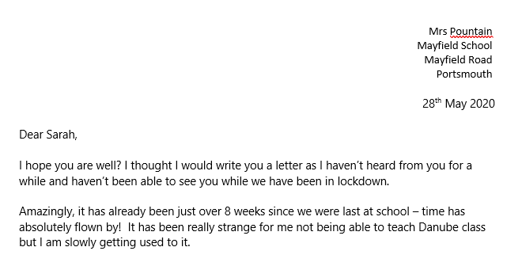

MATHS (Shape focus)

Times tables for this week:
Continue to test yourself weekly, on your target times table. Give yourself 30 seconds per calculation. You can include as many calculations as you wish to in the test. If you pass, move onto the next calculation. If you do not pass in time, continue to remain on that times table until you do pass.

Use this link on shape to help you revise with some videos before starting your tasks
https://www.bbc.co.uk/bitesize/topics/zvmxsbk
https://www.bbc.co.uk/bitesize/topics/zjbg87h

If you finish your tasks and would like more activities, have a look at the link below.
https://whiterosemaths.com/homelearning/year-4/
MONDAY –
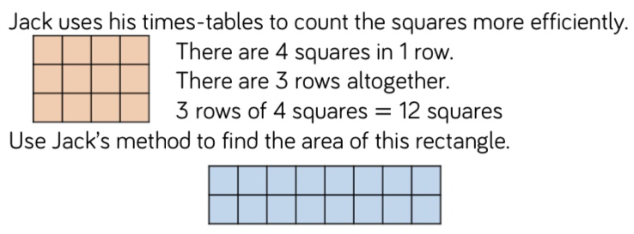
- Draw 6 of your own rectangles, before using Jack’s method to calculate the area of each rectangle – use the scaffold sentences to support your working.
- Next, order the rectangles’ area from smallest to largest.
- Explain why Jack’s method is successful.
- Investigate whether you can develop a strategy that is more efficient for calculating the area of rectangles – provide examples.
- Compare Jack’s method to using arrays.

TUESDAY –
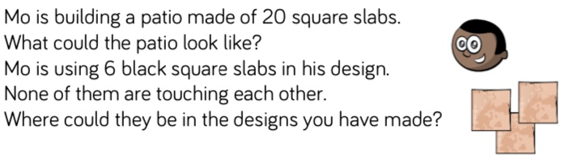
- Ensure each of the patio slabs are equal in size.
- Investigate how many different variations Mo could design.
- Reason whether there is a limit to the number of different designs you could create.
- Investigate, before reasoning, whether you think changing the orientation of the design creates a ‘new’ layout.
- Go back over the designs you have drawn and shade in 6 squares on each, remembering the rules stated in the task.

WEDNESDAY –
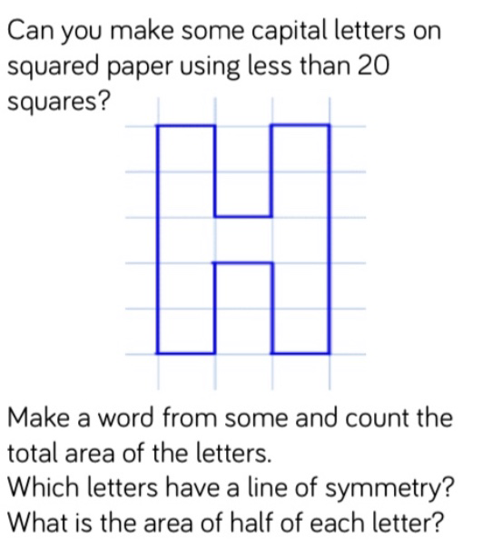
- What unit of measure should you be using?
- Explain what is meant by the term ‘line of symmetry’.
- Investigate before explaining how lines of symmetry will support you when calculating half the area.
- Create a poster/mind map about symmetry. What is it? When is it used? Why/how is it useful? Provide examples and use resources to help you investigate.
- Try using this method to draw your name, before calculating the total area of all the letters. Challenge yourself to calculate the area of all the names in your household, then order them from smallest to largest. Whose name covers the largest area?

THURSDAY –
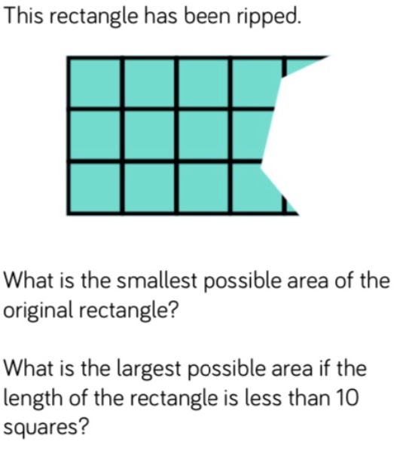
- Explain why the smallest possible area cannot be less than 12 squares?
- Investigate and reason why the area of a rectangle is different to its perimeter?
- Is this always true? Challenge yourself to find a rectangle that has the same area and perimeter
- FRIDAY –
- Explain what is meant by </> and how they are used.
- Investigate all the possible answers for Shape A and Shape C.
- Create a poster containing everything you know about area. How is it different to perimeter? Why do we need to be able to calculate it? What efficient methods do you know for calculating area? How can areas of shapes be compared? Etc.

Links to websites that may support this week’s home learning:
- http://www.amathsdictionaryforkids.com/qr/s/symmetry.html
- https://www.bbc.co.uk/bitesize/topics/zjbg87h
- https://www.youtube.com/watch?v=_uKKl8R1xBM
https://www.theschoolrun.com/what-is-area
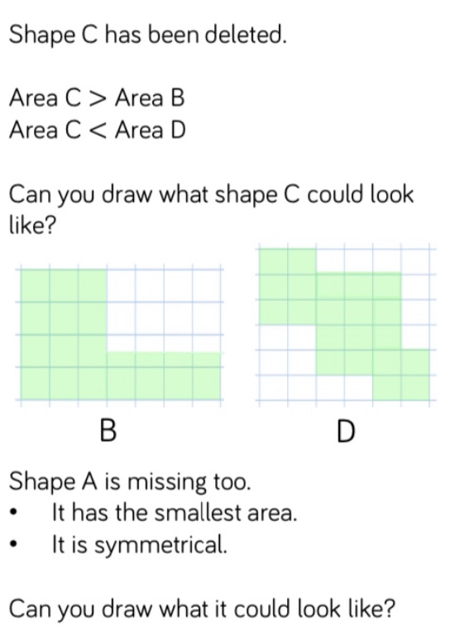

TOPIC
This week we thought it would be nice if you could research and present a History topic of your choice that you are interested in. Some possible ideas:
Pompeii and the eruption of Mount Vesuvius
WW2 - The Blitz, Evacuation, D-day
The Vikings
Ancient Egypt
Ancient Greece

MONDAY – Decide on your topic and how you might want to present the information. Could you produce a powerpoint? A poster? An information page? Remember to think about how you would make your information attractive for anyone that sees your work.
Use the Internet or books you might have to begin researching. Make some notes of important facts that you would like to include.
TUESDAY – Continue your research and note-making. Remember to think about how you will group and organise your facts.
WEDNESDAY / THURSDAY / FRIDAY – Present your information. Think about the non-fiction features that you may include. Do you have a heading? Subheadings? Have you included photographs and captions?
LEARNING WEBSITES

https://www.topmarks.co.uk/maths-games/hit-the-button

https://www.mathplayground.com/

https://www.topmarks.co.uk/maths-games/7-11-years

https://whiterosemaths.com/homelearning/

https://nrich.maths.org/primary

https://ttrockstars.com/

https://www.bbc.co.uk/bitesize/levels/zbr9wmn

https://www.literacyshed.com/home.html

https://www.spellingshed.com/

https://pobble.com/

https://monsterphonics.com/?gclid= EAIaIQobChMI56aEu9yh6AIVFeDtCh2NMAcIEA AYASAAEgK1b_D_BwE

https://www.oxfordowl.co.uk/welcome-back/for-home/reading-owl/kids-activities

https://www.topmarks.co.uk/english-games/7-11-years

Audible are doing a free 30 day trial so that children can listen to lots of books online.
MATHS ANSWERS

MONDAY –
Rectangle B: 16 squares.

TUESDAY –
As long as the patio designs are in keeping with the rules listed in the task, they will be correct.

WEDNESDAY –
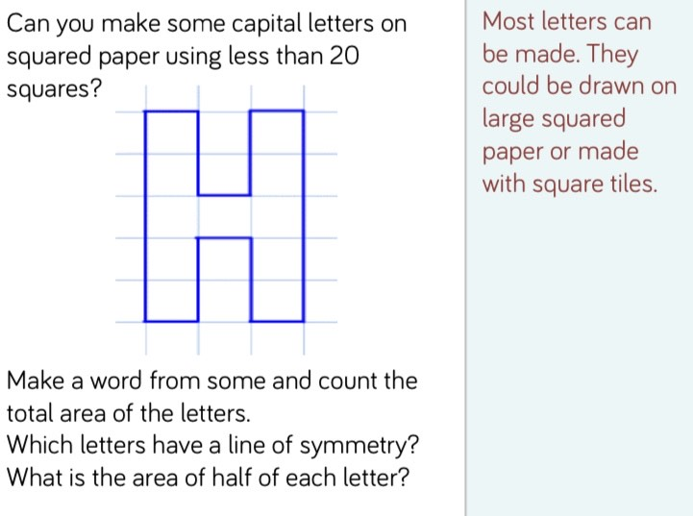

THURSDAY –
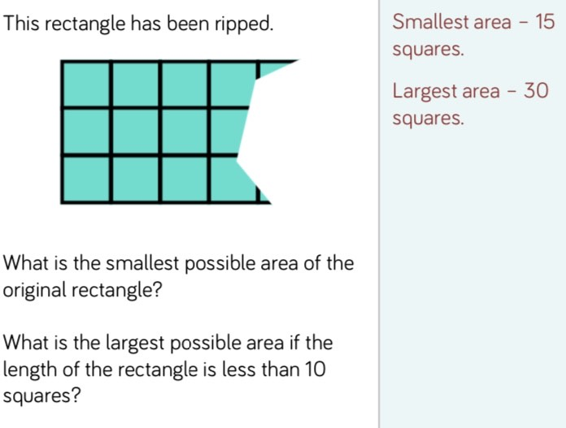

FRIDAY –
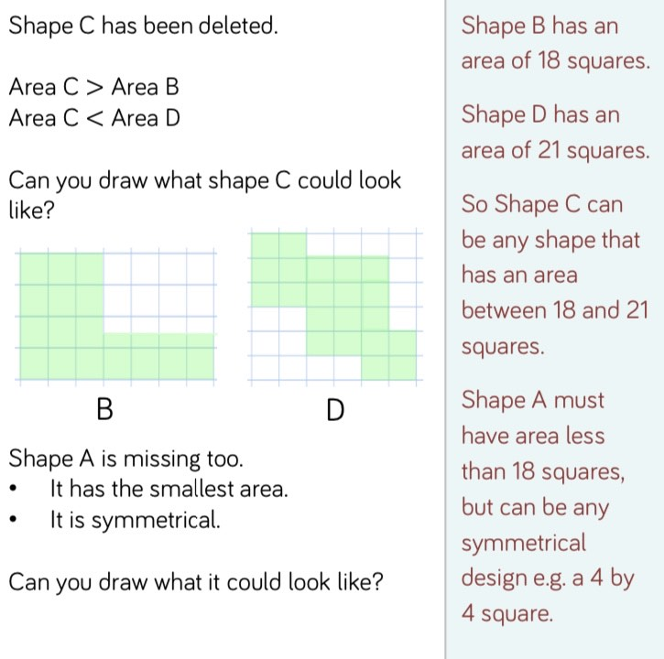

Key Terminology:

- Orientation: The way an object is facing or angled. It may have changed due to being rotated around a point.
- Area: The space that a surface covers, measured in square units.
- Perimeter: The distance around the outside of a shape, calculated by adding the lengths of all sides together.
- Symmetry: An object is symmetrical when one half is a mirror image of the other half.
YEAR 3/4 SPELLING WORDS
