Dear Parent/Carer,

In light of the government’s latest guidance, we are very pleased that we are able to open up more on-site provision for all of our primary pupils. Your choice of provision can now be either; two days in ‘Bubble School’ or up to five days a week in ‘Key Worker School’ if you are a key worker. When the children are at school, they will access the home learning tasks, supported by their bubble teacher. When the children are at home, it is important that they continue with their home learning. The tasks that we set will be a mix of consolidation of previous work and new learning. To help the children with this work, we are including;
- The opportunity for you/your child to communicate with their class teacher via email on a set day, between certain times.
- More links to video resources/websites/ on-line clips or pre-recorded sessions from teachers.
- Feedback on a chosen piece of work (pictures/copies need to be emailed to the teacher or dropped off to a class box in the main reception area).

In primary, we suggest that children try to complete;
- 30 minutes a day of independent reading/reading to an adult
- 30 minutes of maths a day
- 30 minutes of English a day
- 30 minutes of topic based/creative learning
- 30 minutes of PE/ physical activity

Teachers will set a weekly programme for your child to work through at home. This will be available for you to access on the school website every Monday. We know that children work at different speeds and different levels, so please have a look at work in other year groups too for extra support.

Whilst it is important for your child to keep up with their learning at home, we appreciate that this can be a stressful time for children and adults. Looking after mental health is vital. Therefore, we suggest that the day is broken up into manageable learning chunks, interspersed with physical exercise, fun activities and time together as a family. Activities such as the 30 day lego challenge and using the real PE activities could be a good place to start. Setting up a weekly timetable can be a good place to start. As well as educational learning, the children could also begin to learn different life skills – how to boil an egg, sew on a button, learn to send an email, bake a cake using a recipe book etc.

Guidance for parents, regarding home learning, has been released by the government and can be found at the following link;
https://www.gov.uk/guidance/supporting-your-childrens-education-during-coronavirus-covid-19
We will be available via email to support parents and pupil with the tasks each week on Wednesdays between 10am-12pm and 1pm and 3pm. Please email your Friday English task to your teacher by Monday evening of the following week. Feedback will be given via email on Wednesday.
We hope you are all keeping well and staying positive.

Kind regards,

The Year 4 team
Teacher emails;
pountain-christina@mayfield.portsmouth.sch.uk
campbell-morgon@mayfield.portsmouth.sch.uk

YEAR 4 HOME LEARNING TASKS
WEEK BEGINNING: 22nd June
For the remaining 4 weeks of term, Year 4 are going to be working on their ‘I Love Where I Live Topic’. This topic focusses on the geography of Portsmouth, the people who live here, famous people who have come from here and the impact of WW2 on Portsmouth and the area local to the school. We will be completing the same tasks in bubble school , KWS and as part of the home learning.
ENGLISH (Portsmouth)

SPELLINGS FOR THIS WEEK:
mention, minute, natural, naughty, notice, occasionally, often,

MONDAY - Watch this clip about Portsmouth to introduce our new topic. What are the things that make Portsmouth amazing? We are going to be making our own leaflets about Portsmouth over the next two weeks.
https://www.youtube.com/watch?time_continue=55&v=x3y4byWrgr4&feature=emb_logo

Who is famous and comes from Portsmouth?
Do you know anyone that is famous that comes from Portsmouth? Make a mind map of the people that you know and we will add to it! Add any information to the map that you also know – e.g. what are they famous for?

Have a look at this website. Add any names to your mind map.
https://www.thefamouspeople.com/portsmouth-1436.php
Use the Internet or books to research some other people who may come from Portsmouth. Perhaps think about famous footballers that you know, anyone that has been on TV etc. Add them to your mind map with information.

TUESDAY - Have a look at the official visitor guide to Portsmouth.
https://www.visitportsmouth.co.uk/dbimgs/24_265%20-%20Updated%20Visitor%20Guides_main(1).pdf
There should be printed copies available if you are completing this in Key Worker School.
Answer these questions:
- How many designer outlets, bars and restaurants are there at Gunwharf Quays?
- What are the names of the aircraft carriers that are based in Portsmouth?
- What are the ‘Five fab reasons’ to visit Portsmouth?
- Which attractions can you find ‘Beside the Seaside’?
- Have a look at ‘Portsmouth’s vibrant past’. Which attractions can be found in Old Portsmouth?
- On the ‘Sportsmouth’ page which sporting events and attractions does it mention?

Extension: What other questions could you ask about

WEDNESDAY - Spelling Activity. Use objects that you can find to spell out the spelling words for this week.
If you are at home, take a photograph and send it to your teacher.
Extension: Write your spellings into sentences or try and include them in a story.

THURSDAY - You task this week is to research and plan your own leaflet about Portsmouth.
Have another look at the visitor guide:
https://www.visitportsmouth.co.uk/dbimgs/24_265%20-%20Updated%20Visitor%20Guides_main(1).pdf
Answer these questions in full sentences.
- What has been included to make this guide eye-catching? (Think about pictures etc)
- Why is the guide useful for visitors to Portsmouth?
- If you were making this guide again what would you do to improve it?

What are the things you would like to include in your leaflet about Portsmouth? Choose a maximum of 5 different things that will become your sub-headings in your leaflet. E.g. you might want to include information about places to visit in Portsmouth and your sub-heading could be ‘Historical Attractions’

You may want to start Friday’s task if you have any spare time.

FRIDAY –
For each of your 5 headings from yesterday’s lesson begin to make some notes of information that you will include. Use the visitor guide but you might also want to do some Internet research too!
E.g.
Historical Attractions
Historical dockyard – HMS Victory, HMS Warrior 1860, Mary Rose. 30 million visitors every year
Southsea Castle – King Henry V111 built 1544.

Remember: Notes should not be sentences! Just jot down the important bits that you need.
MATHS (Geometry)

Times tables for this week
Continue to test yourself weekly, on your target times table. Give yourself 30 seconds per calculation. You can include as many calculations as you wish to in the test. If you pass, move onto the next calculation. If you do not pass in time, continue to remain on that times table until you do pass.

Use the following link to remind you about angles and triangles
https://www.bbc.co.uk/bitesize/topics/zb6tyrd/articles/zg68k7h
https://www.bbc.co.uk/bitesize/topics/zvmxsbk/articles/zggsfrd

MONDAY –
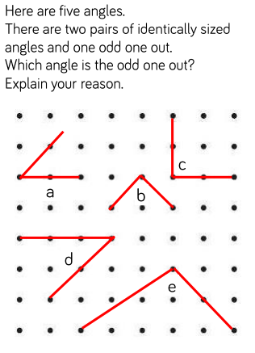
- Investigate whether there could be multiple different answers?
- Define ‘angle’.
- Investigate the different types of angles that exist and differentiate between the different types. Provide examples that are drawn accurately.
- Reason whether the length of the angle arms change the size of the angle?
TUESDAY –
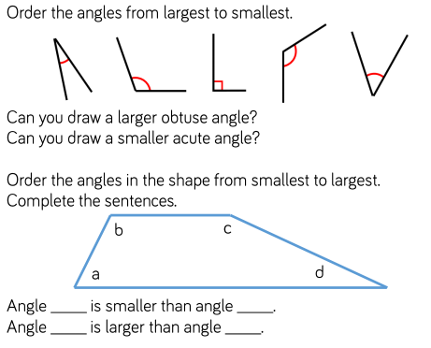
- Reason whether an equilateral triangle could also include a right-angle. Provide examples to support your answer.
- How many obtuse/acute/right angles are there in the second diagram? Support your answers with evidence.
- How can comparing each of the angles help you to determine the type of angle?
- Use the scaffold sentences to compare the four different angles. Complete as many comparative sentences as you can, including lots of detail that explains how you know you’re correct.
WEDNESDAY –
- Investigate the four different types of triangles. Use the websites listed below to support your research.
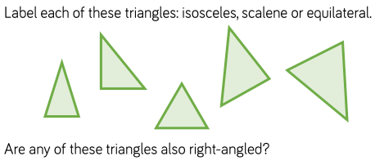
- Outline the properties of each type of triangle. Provide labelled diagrams for each type.
- Which types of triangle can also be right-angled? Explain how you know this and provide examples.
- If I rotate the triangles, do their properties change?
- I think that triangle A is a right-angle scalene. Reason whether I am correct or incorrect.
THURSDAY –
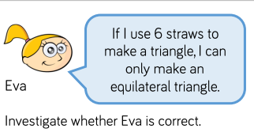
- Investigate whether the length of the straws changes your answer?
- What if you can only use 3 straws?
- Investigate whether you can make the other types of triangle.
- RUCSAC this task. Which information is not relevant and why?
- Explain why the use of the word ‘only’ is so important.
FRIDAY –
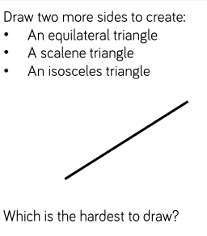
- Reason which type of triangle is most challenging to draw and why?
- Detail which equipment is vital and why it is so important to ensure that your drawings are accurate and meet the criteria for each type of triangle.
- Investigate which types of triangle you could make if you draw an additional 3 lines.
Some useful links that may support this week’s home learning tasks:
- https://www.bbc.co.uk/bitesize/topics/zvmxsbk/articles/zggsfrd
- https://www.youtube.com/watch?v=r4rySgvfDQU
- https://www.youtube.com/watch?v=2JSk0DC5q4g
TOPIC – The Geography of Portsmouth
MONDAY and TUESDAY
Task 1: Have a look at the map of Portsmouth in the visitor guide.
https://www.visitportsmouth.co.uk/dbimgs/24_265%20-%20Updated%20Visitor%20Guides_main(1).pdf

Which things is Portsmouth famous for? Generate ideas.
For example:
Mayfield School
Fratton Park
Gunwharf / Historic Dockyard
Southsea Castle
Southsea Common
Hilsea Lines
Commercial Road
Spitbank Fort
Fort Nelson

Can you find these things on the map? Mark them on your map in some way if you can.
What else do you notice about this map.

Task 2: Use the map to help you draw your own map of Portsmouth. Add as much detail as you can an make it as attractive as possible.

WEDNESDAY– Have a look at some statistics about Portsmouth taken from the 2011 census (the last time a census was done)
https://documents.hants.gov.uk/facts-figures/2011census-portsmouth-summaryfactsheet.pdf
For each graph:
- Have a look at what information the graph shows. What is the scale? What is being measured? Is it a percentage %? etc
- Look for patterns in the coloured parts. Can you see where some parts of the graph are high and lower than others?
- Read the explanation for each graph. Relate back to the graph. Can you see how this conclusion has been made?

Now see if you can complete a table using the information from each graph (one example has been done for you)
Most people in Portsmouth...  Are aged between 20 and 24 | Not many people in Portsmouth...  Are over 90 years old | I have also noticed that...  There are more younger people than older people in Portsmouth

Extension:
Can you think of any reasons that go with your table?
Is there anything else you would like to find out about the people of Portsmouth that these graphs don’t tell us?

THURSDAY - Have a look at a map of Portsmouth. Use google maps to explore the area. Zoom in and out.
https://www.google.com/maps/@50.8047148,-1.1667698,10z?hl=en-GB
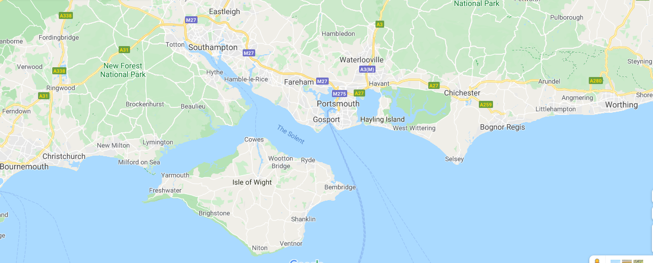Answer these questions:
- What is the name of the body of water which separates Portsmouth from the Isle of Wight?
- What are the names of the towns closest to Portsmouth (name 5)?
- Which road would you travel along from Portsmouth to get to Southampton?
Can you create some questions based on the map that you can ask a partner?
FRIDAY –
Look back at the map in the visitor guide.
Start at a location on the map. Write some instructions for how to get to somewhere.
E.g.
I start at The Hard (near Gunwharf).
I walk along St George’s road.
I then walk along Museum Road.
I turn right at the roundabout and walk along Kings Terrace until I get to Pier Rd.
Where do I end up?
Make some of your own instructions for locations. Perhaps you could share them with a partner and see if they can guess where you end up?
LEARNING WEBSITES

https://www.topmarks.co.uk/maths-games/hit-the-button

https://www.mathplayground.com/

https://www.topmarks.co.uk/maths-games/7-11-years

https://whiterosemaths.com/homelearning/

https://nrich.maths.org/primary

https://ttrockstars.com/

https://www.bbc.co.uk/bitesize/levels/zbr9wmn

https://www.literacyshed.com/home.html

https://www.spellingshed.com/

https://pobble.com/

https://monsterphonics.com/?gclid= EAIaIQobChMI56aEu9yh6AIVFeDtCh2NMAcIEA AYASAAEgK1b_D_BwE

https://www.oxfordowl.co.uk/welcome-back/for-home/reading-owl/kids-activities

https://www.topmarks.co.uk/english-games/7-11-years

Audible are doing a free 30 day trial so that children can listen to lots of books online.
MATHS ANSWERS

MONDAY –
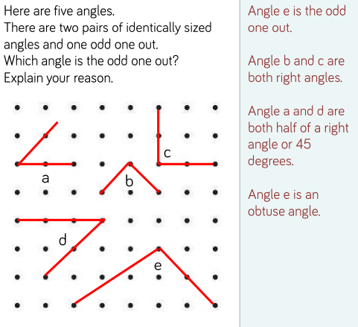

TUESDAY –
A) D, B, C, E, A
B) D, A, B, C

WEDNESDAY –
A) Isosceles
B) Scalene/Right-Angle
C) Equilateral
D) Scalene
E) Isosceles

THURSDAY –
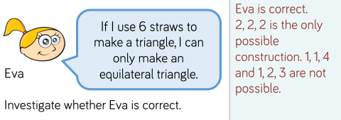

FRIDAY –
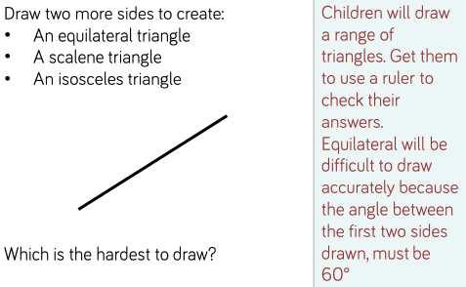

Key Vocabulary:
- Obtuse - Any angle between 90º and 180º.
- Acute - An angle measuring less than 90 degrees.
- Reflex - Any angle between 180º and 360º.
- Right-Angle - An angle measuring 90º.
- Degree - A unit for measuring the size of an angle, symbol º.
- Equilateral - A triangle with 3 equal sides and 3 equal angles.
- Isosceles - Triangle with two equal sides and two equal angles.
- Scalene - Triangle in which all three sides are a different length.
- Angle - The amount of turning between two rays called arms meeting at a common point called the vertex.
YEAR 3/4 SPELLING WORDS
