Dear Parent/Carer,

In light of the government’s latest guidance, we are very pleased that we are able to open up more on-site provision for all of our primary pupils. Your choice of provision can now be either; two days in ‘Bubble School’ or up to five days a week in ‘Key Worker School’ if you are a key worker. When the children are at school, they will access the home learning tasks, supported by their bubble teacher. When the children are at home, it is important that they continue with their home learning. The tasks that we set will be a mix of consolidation of previous work and new learning. To help the children with this work, we are including;
- The opportunity for you/your child to communicate with their class teacher via email on a set day, between certain times.
- More links to video resources/websites/ on-line clips or pre-recorded sessions from teachers.
- Feedback on a chosen piece of work (pictures/copies need to be emailed to the teacher or dropped off to a class box in the main reception area).

In primary, we suggest that children try to complete;
- 30 minutes a day of independent reading/reading to an adult
- 30 minutes of maths a day
- 30 minutes of English a day
- 30 minutes of topic based/creative learning
- 30 minutes of PE/ physical activity

Whilst it is important for your child to keep up with their learning at home, we appreciate that this can be a stressful time for children and adults. Looking after mental health is vital. Therefore, we suggest that the day is broken up into manageable learning chunks, interspersed with physical exercise, fun activities and time together as a family. Activities such as the 30 day lego challenge and using the real PE activities could be a good place to start. Setting up a weekly timetable can be a good place to start. As well as educational learning, the children could also begin to learn different life skills – how to boil an egg, sew on a button, learn to send an email, bake a cake using a recipe book etc.

Guidance for parents, regarding home learning, has been released by the government and can be found at the following link;
https://www.gov.uk/guidance/supporting-your-childrens-education-during-coronavirus-covid-19
We hope you are all keeping well and staying positive.

We will be available to answer emails and give help with work between 10-12 and 1-3 on Wednesdays.

Kind regards,

The Year 4 team
Teacher emails;
pountain-christina@mayfield.portsmouth.sch.uk
campbell-morgon@mayfield.portsmouth.sch.uk
scribbins-laura@mayfield.portsmouth.sch.uk

YEAR 4 HOME LEARNING TASKS
WEEK BEGINNING: 29th June
ENGLISH (Non-Fiction Writing – Leaflet about Portsmouth)
SPELLINGS FOR THIS WEEK:
mention, minute, natural, naughty, notice, occasionally, often

MONDAY – Watch the video lesson or work through the powerpoint for the learning for this week.
Task: Using the information in the lesson, write your first non-fiction paragraph for your leaflet about Portsmouth.
You can view the video lesson here: https://mayfieldschoolpo2.sharepoint.com/:p:/g/admin-staff/EWVd5yx4a0ZLv_fCNQlOSukBbvyZ-eb6GYDnS8ijM9izDA?e=Oaoq1O

It will work better in a desktop version of powerpoint rather than the online version so you may wish to open in desktop app.

Please note: The paragraph should be based on notes made from last week’s home learning. If you have not yet done this you need to make notes about each of your paragraphs. You can use this link to help you.
https://www.visitportsmouth.co.uk/dbimgs/24_265%20-%20Updated%20Visitor%20Guides_main(1).pdf

Once you have written your paragraph ‘purple polish’ it to ensure that it is as good as it can be.

If you are working at home, please take a photograph of your work and send it to your class teacher. You will then receive feedback on Wednesday to support you writing the other paragraphs.

TUESDAY – Reading Comprehension and Spelling
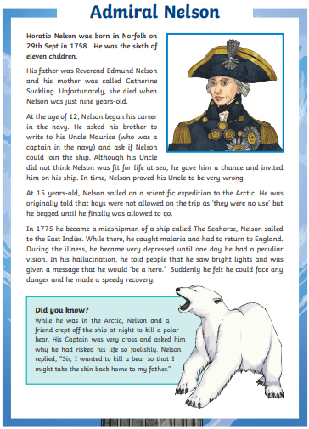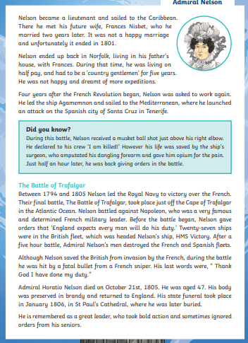

Read the comprehension and answer the questions.
- How old was Nelson when his mother died?
- Why did Nelson ask his brother to write his Uncle Maurice?
- Why do you think sailors thought boys ‘were no use’ on an expedition to the Artic?
- How did Nelson’s vision during his illness affect him?
- Why did Nelson want to kill a bear?
- Explain why you think Nelson wasn’t happy to be living like ‘a country gentleman’ in Norfolk?
- What does England expects every man to do his duty mean?
- What was used to preserve Nelson’s body when returning it to England?
- Where is he buried?
- What adjectives could you use to explain Horatio Nelson? Explain why.

Spelling activity:
Write a funny story which includes all of your spelling words for this week.

WEDNESDAY – Continue to write and ‘purple polish’ your paragraphs for your leaflet about Portsmouth using the feedback from your teacher from your first paragraph. Make sure you have a minimum of 3 different paragraphs based on different things about Portsmouth.

THURSDAY and FRIDAY – Use your previously written paragraphs to create your leaflet about Portsmouth. Don’t forget you will need:
- A heading
- Subheadings
- Pictures and captions
- Paragraphs of factual writing
- Fact boxes

Be as creative as you would like and make it as eye catching as possible.

MATHS (Statistics/Data)

Times tables for this week
Continue to test yourself weekly, on your target times table. Give yourself 30 seconds per calculation. You can include as many calculations as you wish to in the test. If you pass, move onto the next calculation. If you do not pass in time, continue to remain on that times table until you do pass.

MONDAY –
Watch the video lesson or work through the PowerPoint for the learning for this lesson.
You can view the video lesson here: https://mayfieldschoolpo2.sharepoint.com/:p:/g/admin-staff/EVs9J6vcVTNCmQALc9a3ECcB2Px8HVej6kYTh8GLI6LVkQ?e=2nTloO

It will work better in a desktop version of PowerPoint rather than the online version, so you may wish to open in desktop app.

Once you have completed the task and produced an accurate/neat bar chart and table, please send a photograph of your work to your class teacher via email. You will then receive feedback on your work on Wednesday.

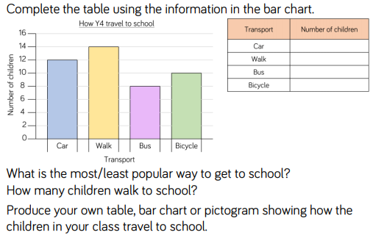
- What was the total number of people that took part in the survey?
- How many more children drive to school than cycle?
- I think that 7 children walk to school. Investigate how I worked this out, before correcting my mistake.

TUESDAY –
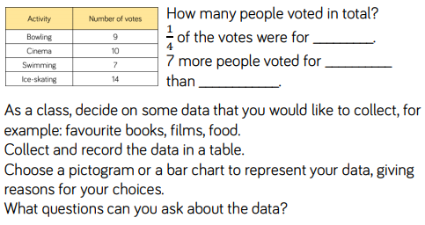
- Explain how to calculate ¼ of a group and come up with a rule that will help you to find a fraction of a number.
- Which representation of data would be most efficient and why?
- If you were to represent the data shown in the table, on a bar chart, what scale would you use on the Y-axis and reason why you have chosen this scale.

WEDNESDAY –
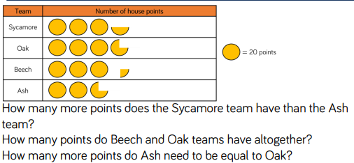
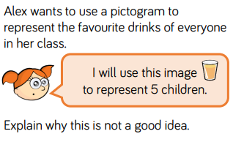
- Explain why it is important to include a key when producing pictograms.
- Reason whether circle or squares are more effective when used to represent data on a pictogram.
- If each circle represented 1 point, would the total number scored be less or more than the current total? Explain your answer and provide evidence.

THURSDAY –
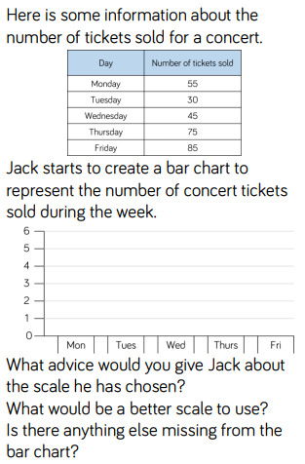
- Now attempt representing the data in the table, on a bar chart with a more appropriate scale.
- Reason why the scale you have chosen is more efficient.
- Define the term ‘efficient’ and why we should aim to be efficient when problem solving.

FRIDAY –
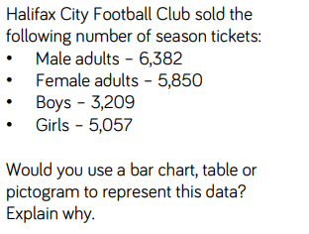
- Reason why representation would be most efficient and why?
- Is this display of data always the best option? Provide examples that argue each side.

Some useful links that may support this week’s home learning tasks:
- https://www.bbc.co.uk/bitesize/topics/z7rcwmn/articles/z8dp8mn
- https://www.youtube.com/watch?v=J2DKgCf353k
TOPIC (Sketching Reflections)
MONDAY – What can you remember about the sketching techniques we learned this year. Have a go at some of them again.
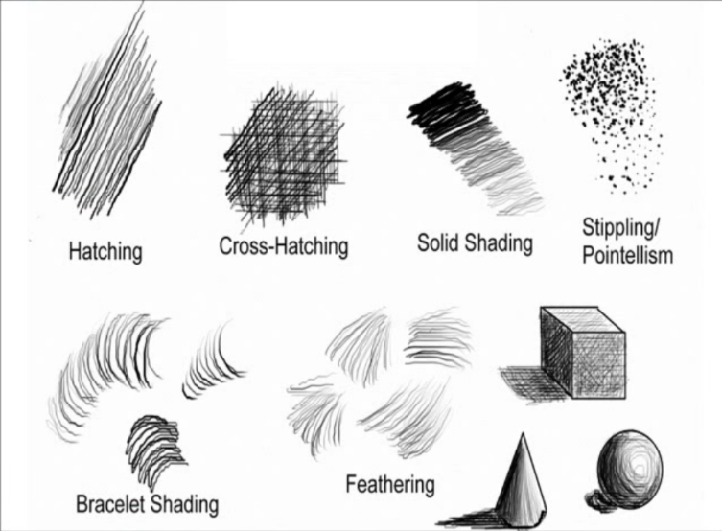

Can you use some of the techniques to sketch an object of your choice? Remember to use light strokes which build up rather than heavy ones.

TUESDAY – How can we sketch a reflection? Watch the time lapse of an artist creating a landscape sketch with
https://www.youtube.com/watch?v=3ChUtpHgs_E

What techniques does the artist use? Can you have a go at some of the techniques yourself? Could you sketch trees reflecting in the water for example?

Have a go at using your sketching skills to sketch the top of this picture without a reflection (we will add the reflection tomorrow)
WEDNESDAY –
Use the reflection techniques you learned from the artist to have a go at adding the reflections to the bottom half of the sketch you created yesterday. Watch the video again if you need additional support.

THURSDAY and FRIDAY – Using the skills you have been taught this week in sketching and reflections create your own sketched picture. You might like to sketch a woodland reflecting in the water, a boat on the sea or a different version of your spinnaker tower picture. Don’t rush. Take your time to sketch accurately. Perhaps you could sketch the top of the picture on Thursday and the reflection of Friday. If you would like to you could do more than one picture.

LEARNING WEBSITES

https://www.topmarks.co.uk/maths-games/hit-the-button

https://www.mathplayground.com/

https://www.topmarks.co.uk/maths-games/7-11-years

https://whiterosemaths.com/homelearning/

https://nrich.maths.org/primary

https://ttrockstars.com/

https://www.bbc.co.uk/bitesize/levels/zbr9wmn

https://www.literacyshed.com/home.html

https://www.spellingshed.com/

https://pobble.com/

https://monsterphonics.com/?gclid= EAIaIQobChMI56aEu9yh6AIVFeDtCh2NMAcIEA AYASAAEgK1b_D_BwE

https://www.oxfordowl.co.uk/welcome-back/for-home/reading-owl/kids-activities

https://www.topmarks.co.uk/english-games/7-11-years

Audible are doing a free 30 day trial so that children can listen to lots of books online.
MATHS ANSWERS

MONDAY –
Least Popular: Bus
Most Popular: Walk
14 children walk to school.

TUESDAY –
A) Cinema
B) 7 more people voted for ice-skating than swimming.

WEDNESDAY –
A) 15
B) 140
C) 20
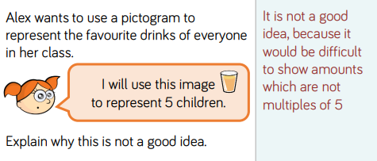
THURSDAY –
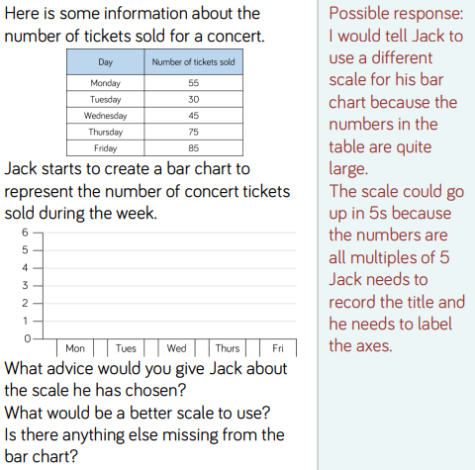
FRIDAY –
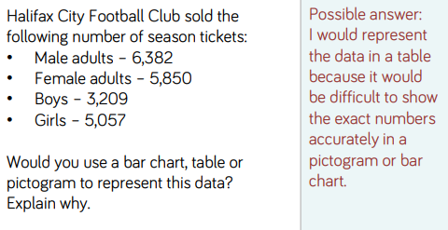
Key Vocabulary:
- Axis - Real or imaginary reference line.
- Data - Rata is a collection of information gathered by observation, questioning or measurement.
- Statistic - The collection, organisation, presentation, interpretation and analysis of data.
- Scale - A ratio between two sets of measurements.
YEAR 3/4 SPELLING WORDS
