Dear Parent/Carer,

As the school continues to remain closed due to Coronavirus, we are continuing to provide educational tasks for your children to complete. We have received positive feedback on the new format of the home learning daily tasks. As always, please continue to keep in touch about your child’s home learning and let us know if there are any problems.

In primary, we suggest that children try to complete;
- 30 minutes a day of independent reading/reading to an adult
- 30 minutes of maths a day
- 30 minutes of English a day
- 30 minutes of topic based/creative learning
- 30 minutes of PE/ physical activity

Home learning tasks can be supplemented with work from a number of websites (see list below for ideas.) Daily work set on the BBC website is particularly useful as it contains tutorial videos.
https://www.bbc.co.uk/bitesize/primary

Teachers will set a weekly programme for your child to work through at home. This will be available for you to access on the school website every Monday. We know that children work at different speeds and different levels, so please have a look at work in other year groups too for extra support.

To help with maths and different terminology, we will try to add in some video links for tutorials and we will try to include answers for maths where possible to help the children check through their work.

Whilst it is important for your child to keep up with their learning at home, we appreciate that this can be a stressful time for children and adults. Looking after mental health is vital. Therefore, we suggest that the day is broken up into manageable learning chunks, interspersed with physical exercise, fun activities and time together as a family. Activities such as the 30 day lego challenge and using the real PE activities could be a good place to start. Setting up a weekly timetable can be a good place to start. As well as educational learning, the children could also begin to learn different life skills – how to boil an egg, sew on a button, learn to send an email, bake a cake using a recipe book etc.

Guidance for parents, regarding home learning, has been released by the government and can be found at the following link;
https://www.gov.uk/guidance/supporting-your-childrens-education-during-coronavirus-covid-19

We hope you are all keeping well and staying positive.

Kind regards,

The Year 4 team
Teacher emails;
pountain-christina@mayfield.portsmouth.sch.uk
campbell-morgon@mayfield.portsmouth.sch.uk
emery-vikki@mayfield.portsmouth.sch.uk

YEAR 4 HOME LEARNING TASKS
WEEK BEGINNING:
ENGLISH (Story Writing)
SPELLINGS FOR THIS WEEK:
heart, height, history, imagine, increase, important, interest
MONDAY – Words within words – What other words can you make from the letters that make up each of your spelling words for this week? How many vowels and consonants are in t
TUESDAY –
Solitary Existence
Six months earlier, Ben had lived in the city.
Life had been busy; a constant buzz of people and traffic.
In some ways, living in the city had been comforting, as if he was part of an urban family, a melting pot of people of all ages and all walks of life.
However, Ben had tired of that life; it was now time for a change of direction.
Standing on his porch, Ben drew breath.
As the clean, cool air filled his lungs, a smile spread across his face …

Read the extract from Solitary Existence again and answer these questions.
- What can you deduce about Ben’s previous life in the city? (deduce means work out)
- How is his life different now? compare the two areas - city and country and things like going to work, getting food, meeting people
- Which of Ben’s two life experiences would you prefer?
- Where does Ben get his food from? He can't just go to the supermarket, he has to get it from the land around him so what sort of food might he get.
- What does he have inside his house? Think about what he might need for a life in the country.
- Why do you think Ben is smiling?
WEDNESDAY – Cut out letters from a magazine or newspaper and stick them together to create your spelling words.
THURSDAY– What do you think happens next in Ben’s Story? Plan some ideas which could be used in your own version of the story.
He decided to go and explore the area and him, he set off with is lunch in
his backpack. Nothing could go wrong could it?

He decided he needed to go and meet the people around him...

His grumbling stomach told him it was lunchtime, he would need to catch and forage for his lunch.

Draw a story map which shows the main ideas. Use pictures and words to show the path that the story will take.
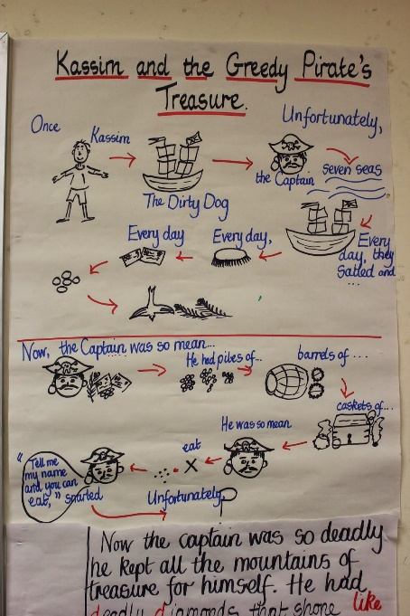
Don’t forget to plan other Year 4 writing features onto your plan.
Can you include:
Fronted Adverbials https://www.bbc.co.uk/bitesize/topics/zwwp8mn/articles/zp937p3
A range of conjunctions like while, if, although https://www.youtube.com/watch?time_continue=5&v=w6jWiE7CvSk&feature=emb_logo
Remember to also plan how you will describe what is happening in the story. Think about SPAMROD
Similes (Comparing with like or as – as quick as a flash)
Personification (Giving human or animal characteristics – the fingers of the trees…)
Alliteration (First letter the same – wild, whistling, wind)
Metaphor (Comparing something that IS something else (even when it isn’t) – the tree is a soldier)
Repitition – (Repeating – creak, creak, creak)
Onomatopeia (Words which make their own sound SMASH, CRASH)
Description (adjectives, verbs etc to create expanded noun phrases – bright-green, tumbling leaves)

FRIDAY – Write your version of Ben’s story.
Don’t forget to add all of the details that you have planned.

If you have ever thought about being a writing look at the link below for some tips!
https://www.youtube.com/watch?time_continue=93&v=aPP2pKfnbw8&feature=emb_logo

MATHS (Division Focus)

Times tables for this week:
Continue to test yourself weekly, on your target times table. Give yourself 30 seconds per calculation. You can include as many calculations as you wish to in the test. If you pass, move onto the next calculation. If you do not pass in time, continue to remain on that times table until you do pass.

MONDAY –
Use the link below to remind you of division methods
https://www.bbc.co.uk/bitesize/topics/z36tyrd

TUESDAY –
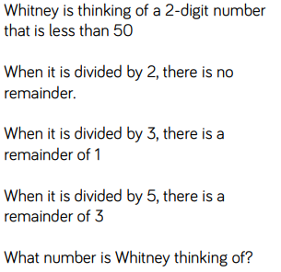
- Investigate thoroughly, before proving your answer.
- Consider working systematically and explain why you decided to work in this way.
- Explain whether there could be multiple possible answers.
- Reason whether Whitney’s number could be an odd number.

WEDNESDAY –
Make a poster that explains the rules for the short division method. Show examples when there are remainders and no remainders.

THURSDAY –
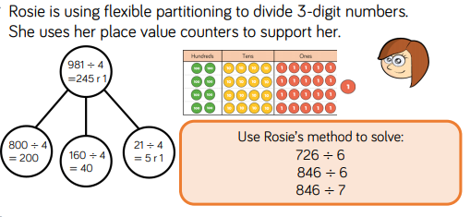
- Compare Annie’s method and Rosie’s method. How are they similar/different?
- Reason whose method you think is most efficient.
- Explain why Rosie has decided to flexibly-partition 981 in this way. What information has she used to support her calculations?

FRIDAY –
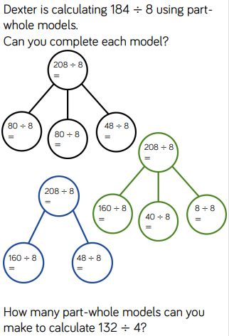
- Reason whether you think this method is beneficial.
- Explain this process in words, describing what is expected at each stage.
- How can you ensure that your working out is correct?
- Prove you are correct with a pictorial representation.

Some useful links that may support this week’s home learning tasks:
- https://www.bbc.co.uk/bitesize/topics/z36tyrd
- https://www.bbc.co.uk/bitesize/topics/z69k7ty
- http://www.amathsdictionaryforkids.com/qr/qr.html
TOPIC – Researching an artist
MONDAY -
Have you ever visited a museum or Art Gallery? Where was it? Did you enjoy it? What was your favourite exhibit? Jot down a list of all the galleries and museums you have visited and any that you would like to visit. Perhaps you could see if any of them have an online tour you can go on? The Tate museum website is a good place to start https://www.tate.org.uk/kids

TUESDAY -
Artists come in all shapes and sizes. They might paint, create sculptures, they might paint walls, or ceilings they might have lived hundreds of years ago or still be alive today. They might use paint and brushes, they might use chisel and hammers and stone, they might use spray paints and the sides of buildings. Some artists sew their works of art, or knit them, some use cameras to take picture or to make films. Art is just someone making something beautiful.
Use the internet to research some artists who have created art of your favourite animal or building or plant or flower! You might want to use the Tate website again to help you. https://www.tate.org.uk/kids
Choose one artist that you really like and would like to find out more about this week.

WEDNESDAY
Write some notes about the artist you chose yesterday. Think about what you might like to find out. Where were they born? How did they become an artist? What sort of art do they produce? How do they produce it? Keep your notes so that you can use them tomorrow.

THURSDAY
Create a fact file or a poster to display the notes that you made yesterday. Think about how you can display your notes clearly. You might want to include a heading, subheadings, paragraphs of writing, fact boxes, pictures and captions.

FRIDAY
Have a go a recreating a piece of art that your artist has made. This could be a painting, a sculpture made from ‘junk’ that you might have at home or it could just be a sketch of what you have seen.

LEARNING WEBSITES

https://www.topmarks.co.uk/maths-games/hit-the-button

https://www.mathplayground.com/

https://www.topmarks.co.uk/maths-games/7-11-years

https://whiterosemaths.com/homelearning/

https://nrich.maths.org/primary

https://ttrockstars.com/

https://www.bbc.co.uk/bitesize/levels/zbr9wmn

https://www.literacyshed.com/home.html

https://www.spellingshed.com/

https://pobble.com/

https://monsterphonics.com/?gclid= EAIaIQobChMI56aEu9yh6AIVFeDtCh2NMAcIEA AYASAAEgK1b_D_BwE

https://www.oxfordowl.co.uk/welcome-back/for-home/reading-owl/kids-activities

https://www.topmarks.co.uk/english-games/7-11-years

Audible are doing a free 30 day trial so that children can listen to lots of books online.
MATHS ANSWERS

MONDAY –
A) 86 ÷4=21r2
B) 87 ÷4=21r3
C) 88 ÷4=22
D) 97 ÷3=32r1
E) 98 ÷3=32r2
F) 99 ÷3=33

TUESDAY –
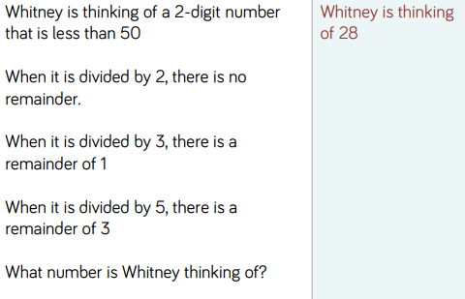

WEDNESDAY –
A) 906 ÷3=302
B) 884 ÷4=221
C) 884 ÷8=110r4
D) 489 ÷2=244r1

THURSDAY –
A) 726 ÷6=121
B) 846 ÷6=141
C) 846 ÷7=120r6

FRIDAY –
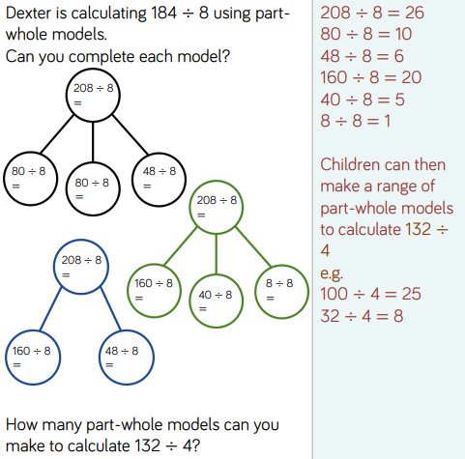

Key Vocabulary:
- Remainder: The amount left over when two integers do not divide equally.
- Systematic: To work in an orderly or methodical way.
- Inverse Operation: These are opposite operations, which can be used to check one another. Addition/subtraction and multiplication/division are the inverse of each other.
YEAR 3/4 SPELLING WORDS
