Dear Parent/Carer,

As the school continues to remain closed due to Coronavirus, we are continuing to provide educational tasks for your children to complete. We have received positive feedback on the new format of the home learning daily tasks. As always, please continue to keep in touch about your child’s home learning and let us know if there are any problems.

In primary, we suggest that children try to complete;
- 30 minutes a day of independent reading/reading to an adult
- 30 minutes of maths a day
- 30 minutes of English a day
- 30 minutes of topic based/creative learning
- 30 minutes of PE/ physical activity

Home learning tasks can be supplemented with work from a number of websites (see list below for ideas.) Daily work set on the BBC website is particularly useful as it contains tutorial videos.
https://www.bbc.co.uk/bitesize/primary

Teachers will set a weekly programme for your child to work through at home. This will be available for you to access on the school website every Monday. We know that children work at different speeds and different levels, so please have a look at work in other year groups too for extra support.

To help with maths and different terminology, we will try to add in some video links for tutorials and we will try to include answers for maths where possible to help the children check through their work.

Whilst it is important for your child to keep up with their learning at home, we appreciate that this can be a stressful time for children and adults. Looking after mental health is vital. Therefore, we suggest that the day is broken up into manageable learning chunks, interspersed with physical exercise, fun activities and time together as a family. Activities such as the 30 day lego challenge and using the real PE activities could be a good place to start. Setting up a weekly timetable can be a good place to start. As well as educational learning, the children could also begin to learn different life skills – how to boil an egg, sew on a button, learn to send an email, bake a cake using a recipe book etc.

Guidance for parents, regarding home learning, has been released by the government and can be found at the following link;
https://www.gov.uk/guidance/supporting-your-childrens-education-during-coronavirus-covid-19

We hope you are all keeping well and staying positive.
Kind regards,

The Year 5 team
YEAR 5 HOME LEARNING TASKS
WEEK BEGINNING: Monday 11th May 2020
ENGLISH (News report focus)  SPELLINGS FOR THIS WEEK:  conscience, conscious, controversy, convenience, correspond, criticise, curiosity.  MONDAY – Spelling Practice.  Using the words above, choose a spelling word and use it to write an acrostic poem. Speed write each word –How many times can you write each word in one minute?  TUESDAY – Reading Comprehension.  Summarise a book you have read, using only four illustrations. Don’t forget to annotate your pictures. Include only pictures of the four KEY points in the book. Could you explain what makes these points key points? What point wouldn’t be key and why.  WEDNESDAY- Spelling Practice.  Using your spellings, create a wordsearch or crossword with your spelling list. Rainbow write each of your spelling words. Write rhymes for each word.  THURSDAY/FRIDAY– Writing.  Plan and write a news report about communities coming together on Thursday evenings to applaud NHS and other key workers. Use the reading task to help you pick out the key points that you want to make. Remember the following things that we included in our Moon Landing news report:  - Past perfect tense.  - Headline.  - Direct and indirect speech.  - Brackets for parenthesis.  - Picture and caption  - Emotive language  Check your work at the end. Do you think you have used all of the features listed above? | MATHS (Subtraction)  Times tables for this week:  Continue to test yourself weekly, on your target times table. Give yourself 30 seconds per calculation. You can include as many calculations as you wish to in the test. If you pass, move onto the next calculation. If you do not pass in time, continue to remain on that times table until you do pass.  If you would like further challenges, please follow the link below;  https://whiterosemaths.com/homelearning/year-5/  To help remind yourself of methods for subtraction,  please see the BBC bitesize link below;  https://www.bbc.co.uk/bitesize/articles/zfdpnrd  MONDAY –  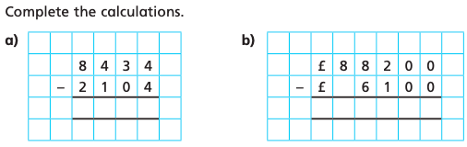  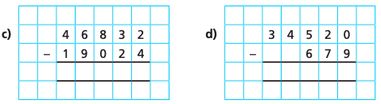  Create instructions for how to use the column subtraction method. Could you create your own?  TUESDAY –  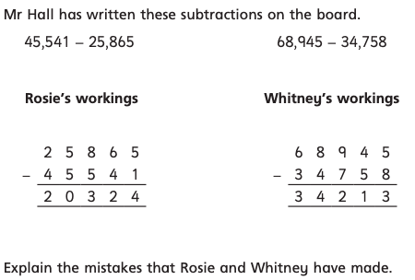  Show the correct workings for Rosie and Eva’s subtractions.  WEDNESDAY –  What makes your method most effective?  THURSDAY –  Explain how you got your answer. Are there any other ways you could do it?  FRIDAY–  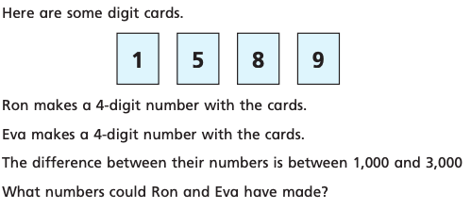  Could you create your own problems that are similar to this?
TOPIC (Forces- Science focus)  MONDAY –  Research the three forces: air resistance, water resistance and friction. Create a poster of information about the three of them.  TUESDAY –  Think of an enquiry question that will test one of the forces. This might be:  Do smaller objects have more water resistance than bigger objects?  Do lighter objects have more or less air resistance than heavier objects?  Talk these ideas through with your adult and settle on an idea today.  WEDNESDAY –  Today you are going to plan your enquiry. You need to plan this the way we do in school using the following headings:  - Enquiry question  - Equipment  - Fair test  - Prediction  - Hypothesis  THURSDAY–  Carry out your enquiry, remember to record your results. Think about the best way to record them, will it perhaps be a table?  FRIDAY-  Write up your findings. Explain what you found out and if there is any way you could improve your experiment. Are there anything you would test next? | LEARNING WEBSITES  https://www.topmarks.co.uk/maths-games/hit-the-button  https://www.mathplayground.com/  https://www.topmarks.co.uk/maths-games/7-11-years  https://whiterosemaths.com/homelearning/  https://nrich.maths.org/primary  https://ttrockstars.com/  https://www.bbc.co.uk/bitesize/levels/zbr9wmn  https://www.literacyshed.com/home.html  https://www.spellingshed.com/  https://pobble.com/  https://monsterphonics.com/?gclid= EAIaIQobChMI56aEu9yh6AIVFeDtCh2NMAcIEA AYASAAEgK1b_D_BwE  https://www.oxfordowl.co.uk/welcome-back/for-home/reading-owl/kids-activities  https://www.topmarks.co.uk/english-games/7-11-years  Audible are doing a free 30 day trial so that children can listen to lots of books online.
YEAR 5-6 SPELLING WORDS
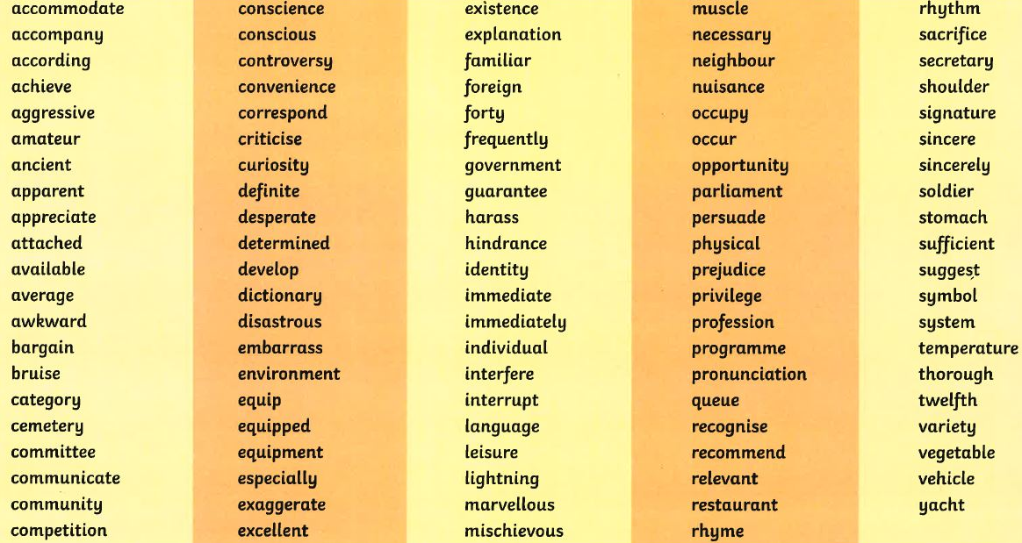
Maths answers:
MONDAY-
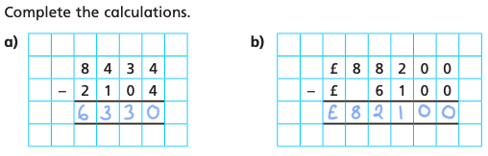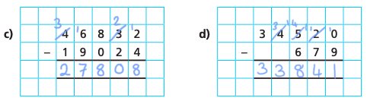
TUESDAY-
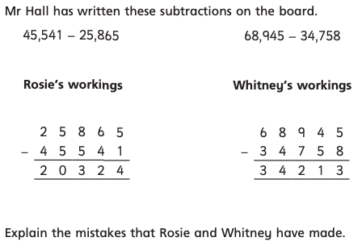
Rosie has switched the numbers. 45,541 should be above of 25,865 on the column.

Whitney has done 8-5 in the ones column when she should be exchanging. She should have made the 4 tens, 3 tens and added a 1 before the 5 to make 15 and then subtracted 8 from 15 making 7.

WEDNESDAY-
A)9 B)3273 C)5925

THURSDAY-
Jack scored 19,415 points. Altogether they scored 75,305.

FRIDAY-
Lots of different answers, they should use the column method to prove it. EG 8519 and 9815

