Dear Parent/Carer,

As the school continues to remain closed due to Coronavirus, we are continuing to provide educational tasks for your children to complete. We have received positive feedback on the new format of the home learning daily tasks. As always, please continue to keep in touch about your child’s home learning and let us know if there are any problems.

In primary, we suggest that children try to complete;
- 30 minutes a day of independent reading/reading to an adult
- 30 minutes of maths a day
- 30 minutes of English a day
- 30 minutes of topic based/creative learning
- 30 minutes of PE/ physical activity

Home learning tasks can be supplemented with work from a number of websites (see list below for ideas.) Daily work set on the BBC website is particularly useful as it contains tutorial videos.
https://www.bbc.co.uk/bitesize/primary

Teachers will set a weekly programme for your child to work through at home. This will be available for you to access on the school website every Monday. We know that children work at different speeds and different levels, so please have a look at work in other year groups too for extra support.

To help with maths and different terminology, we will try to add in some video links for tutorials and we will try to include answers for maths where possible to help the children check through their work.

Whilst it is important for your child to keep up with their learning at home, we appreciate that this can be a stressful time for children and adults. Looking after mental health is vital. Therefore, we suggest that the day is broken up into manageable learning chunks, interspersed with physical exercise, fun activities and time together as a family. Activities such as the 30 day lego challenge and using the real PE activities could be a good place to start. Setting up a weekly timetable can be a good place to start. As well as educational learning, the children could also begin to learn different life skills – how to boil an egg, sew on a button, learn to send an email, bake a cake using a recipe book etc.

Guidance for parents, regarding home learning, has been released by the government and can be found at the following link;
https://www.gov.uk/guidance/supporting-your-childrens-education-during-coronavirus-covid-19

We hope you are all keeping well and staying positive.

Kind regards,

The Year 5 team
Teacher email;
Large-becki@mayfield.portsmouth.sch.uk
Turner-peyton@mayfield.portsmouth.sch.uk

YEAR 5 HOME LEARNING TASKS
WEEK BEGINNING: Monday 15th June 2020
ENGLISH (Advert focus)

SPELLINGS FOR THIS WEEK:
guarantee, harass, hindrance, identity, immediate, immediately, individual

MONDAY (spelling)
Create a funny phrase to help you remember the spelling of each word. E.g. harass = hungry ants run at silly sausages

TUESDAY (reading comprehension)
Research adverts online. List the features, of adverts, that you find. What do you think the purpose of an advert is? Are all audiences the same? Why? Create a detailed explanation of an advert, explaining all that you have found out.

WEDNESDAY (Spelling)
Create a word search that contains all of your spelling words this week. Can you get someone in your house to complete it?

THURSDAY (writing)
Reflect on your findings about adverts, from Tuesday. Did you notice that the purpose was to persuade? This week you will be writing an advert to persuade people to buy a product of your choice. Today, plan your advert. You may like to think of it as a poster, with a clear title, and sectioned paragraphs.

FRIDAY (writing)
Using your plan from yesterday, write up your advert. Remember to include persuasive features including questions, similes and exclamations. E.g. What an amazing product this is! How could you possibly resist?

MATHS (Data)

Times tables for this week:
Continue to test yourself weekly, on your target times table. Give yourself 30 seconds per calculation. You can include as many calculations as you wish to in the test. If you pass, move onto the next calculation. If you do not pass in time, continue to remain on that times table until you do pass.

Use the link below for extra challenges
https://whiterosemaths.com/homelearning/year-5/

MONDAY –

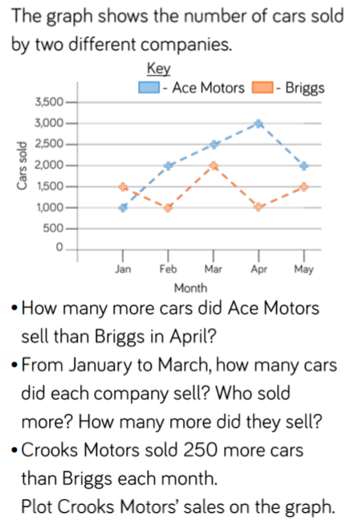

Challenge: List the potential difficulties with using this graph.

TUESDAY –

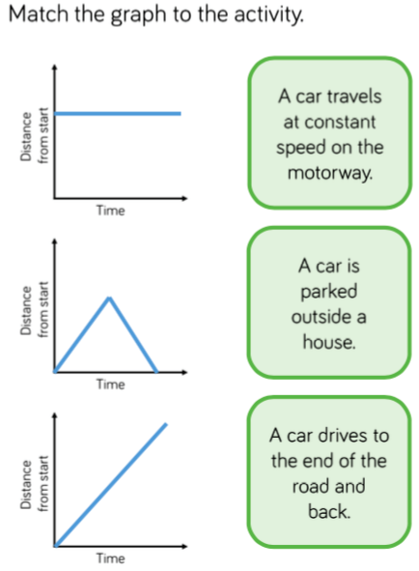

Challenge: Why has a bar graph not been used?

WEDNESDAY –

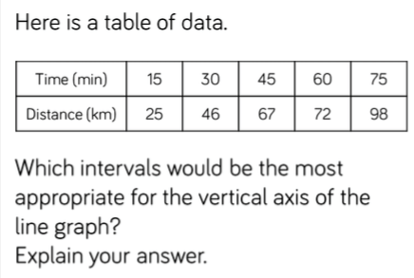

Challenge: Put the data into a graph

THURSDAY –
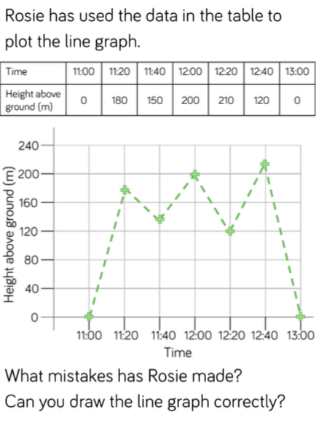

FRIDAY –

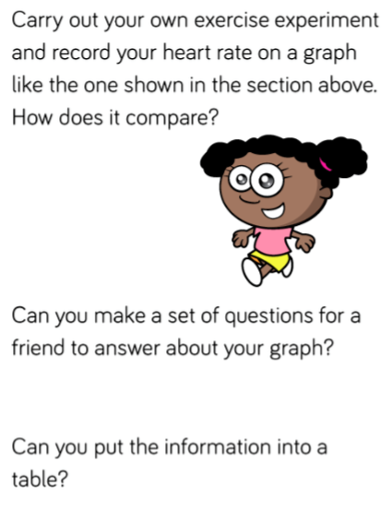

TOPIC (Science focus)
MONDAY –
Think back to your Harry Potter trip. When we were there, we saw the blue flying car. Why do we not have flying cars? Research the different forces to help.

TUESDAY –
Design a car that could fly. What features would it need? Annotate your design.

WEDNESDAY –
If you needed to carry 5 wizards in your flying car, how would the weight impact the speed? Make a prediction and then research the forces which would change, as a result of added weight.

THURSDAY –
Does a car need to have wings, in order to fly? Predict and then research objects which can fly without wings. List what you have found out. Were you surprised by what you found?

FRIDAY–
Which is the most important force, when enabling an object to fly? Put your decision forward in a conclusive paragraph. Use a diagram to illustrate your point.

LEARNING WEBSITES

https://www.topmarks.co.uk/maths-games/hit-the-button

https://www.mathplayground.com/

https://www.topmarks.co.uk/maths-games/7-11-years

https://whiterosemaths.com/homelearning/

https://nrich.maths.org/primary

https://ttrockstars.com/

https://www.bbc.co.uk/bitesize/levels/zbr9wmn

https://www.literacyshed.com/home.html

https://www.spellingshed.com/

https://pobble.com/

https://monsterphonics.com/?gclid= EAIaIQobChMI56aEu9yh6AIVFeDtCh2NMAcIEA AYASAAEgK1b_D_BwE

https://www.oxfordowl.co.uk/welcome-back/for-home/reading-owl/kids-activities

https://www.topmarks.co.uk/english-games/7-11-years

Audible are doing a free 30 day trial so that children can listen to lots of books online.

MATHS ANSWERS:

Monday:
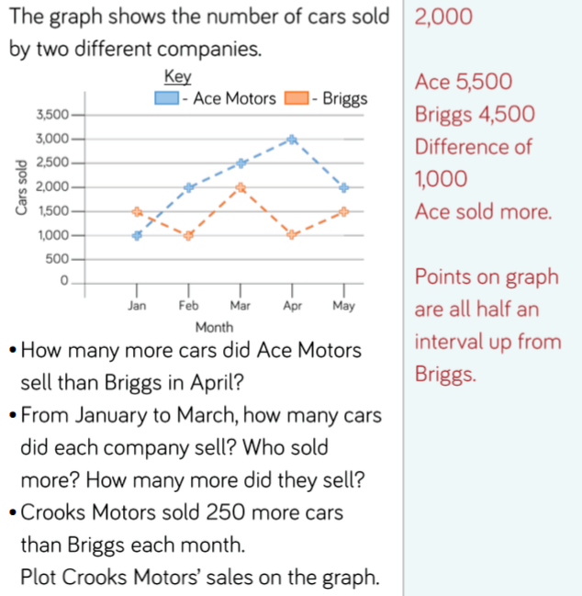

Tuesday:
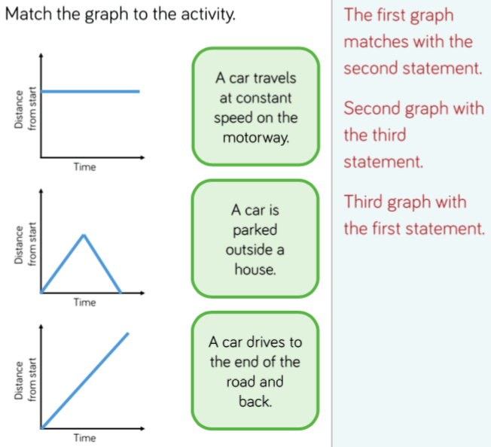

Wednesday:
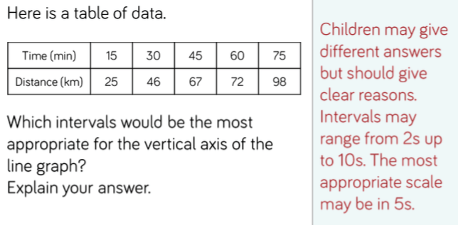

Thursday:

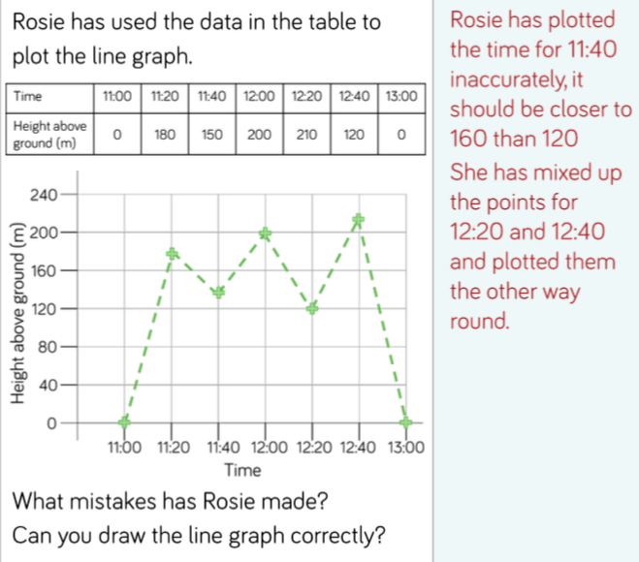

Friday:
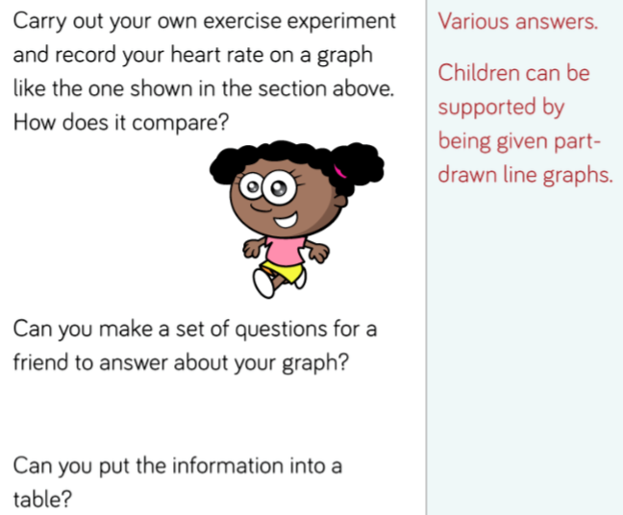

YEAR 5-6 SPELLING WORDS
