Dear Parent/Carer,

In light of the government’s latest guidance, we are very pleased that we are able to open up more on-site provision for all of our primary pupils. Your choice of provision can now be either; two days in ‘Bubble School’ or up to five days a week in ‘Key Worker School’ if you are a key worker. When the children are at school, they will access the home learning tasks, supported by their bubble teacher. When the children are at home, it is important that they continue with their home learning. The tasks that we set will be a mix of consolidation of previous work and new learning. To help the children with this work, we are including;
- The opportunity for you/your child to communicate with their class teacher via email on a set day, between certain times.
- More links to video resources/websites/ on-line clips or pre-recorded sessions from teachers.
- Feedback on a chosen piece of work (pictures/copies need to be emailed to the teacher or dropped off to a class box in the main reception area).
In primary, we suggest that children try to complete;
- 30 minutes a day of independent reading/reading to an adult
- 30 minutes of maths a day
- 30 minutes of English a day
- 30 minutes of topic based/creative learning
- 30 minutes of PE/ physical activity

Teachers will set a weekly programme for your child to work through at home. This will be available for you to access on the school website every Monday. We know that children work at different speeds and different levels, so please have a look at work in other year groups too for extra support.

Whilst it is important for your child to keep up with their learning at home, we appreciate that this can be a stressful time for children and adults. Looking after mental health is vital. Therefore, we suggest that the day is broken up into manageable learning chunks, interspersed with physical exercise, fun activities and time together as a family. Activities such as the 30 day Lego challenge and using the real PE activities could be a good place to start. Setting up a weekly timetable can be a good place to start. As well as educational learning, the children could also begin to learn different life skills – how to boil an egg, sew on a button, learn to send an email, bake a cake using a recipe book etc.

Guidance for parents, regarding home learning, has been released by the government and can be found at the following link;
https://www.gov.uk/guidance/supporting-your-childrens-education-during-coronavirus-covid-19

We hope you are all keeping well and staying positive.
We will be available via email to support parents and pupil with the tasks each week on Wednesdays between 10am-12pm and 1pm and 3pm.
We hope you are all keeping well.
Kind regards,

The Year 5 team
Teacher email;
Large-becki@mayfield.portsmouth.sch.uk Turner-peyton@mayfield.portsmouth.sch.uk
Head-Pete@mayfield.portsmouth.sch.uk

YEAR 5 HOME LEARNING TASKS
WEEK BEGINNING: Monday 13th July 2020
ENGLISH
SPELLINGS FOR THIS WEEK:
privilege, profession, programme, pronunciation, queue, recognise
MONDAY (Reading) FEEDBACK TASK – PLEASE EMAIL COPIES/PICTURES FOR FEEDBACK NEXT WEDNESDAY.

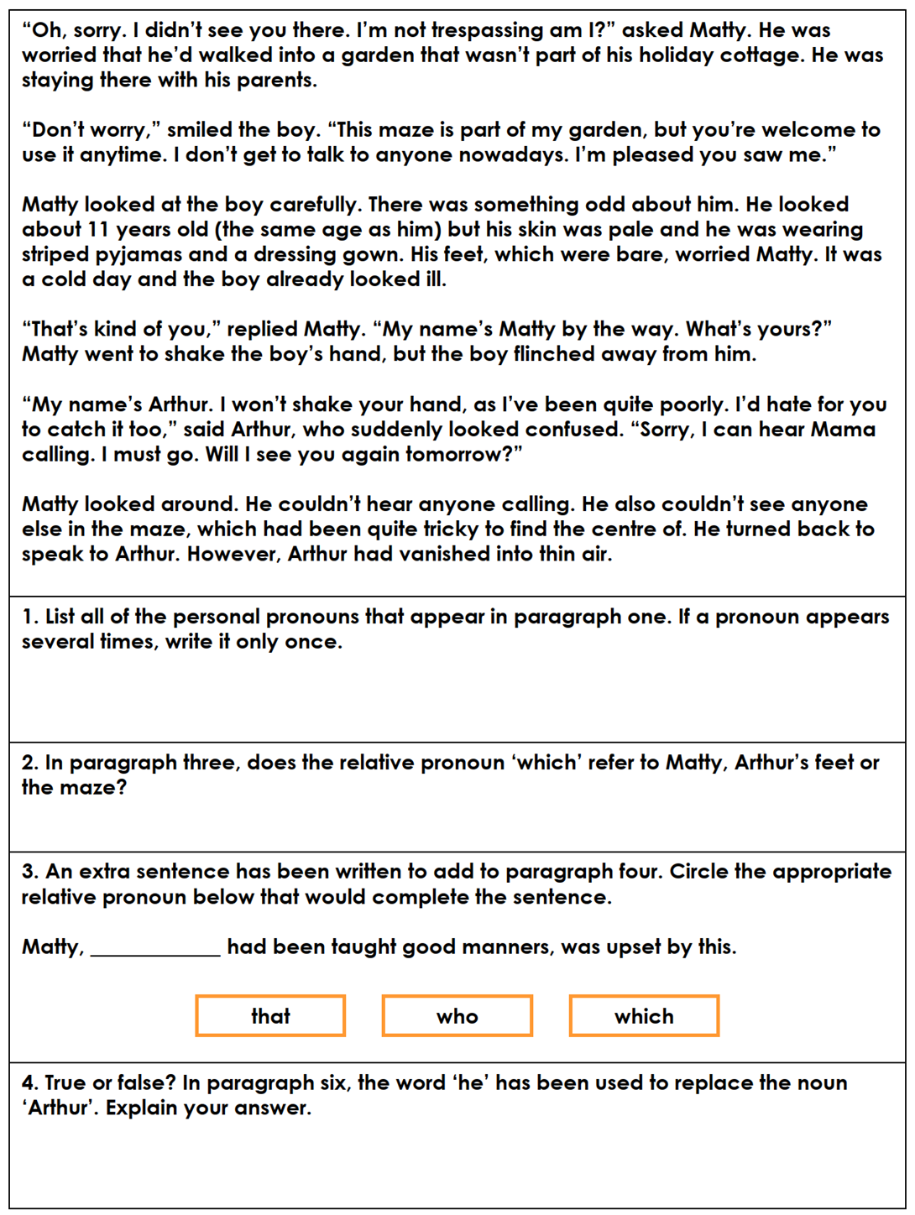

TUESDAY: Read the text below and answer the questions.

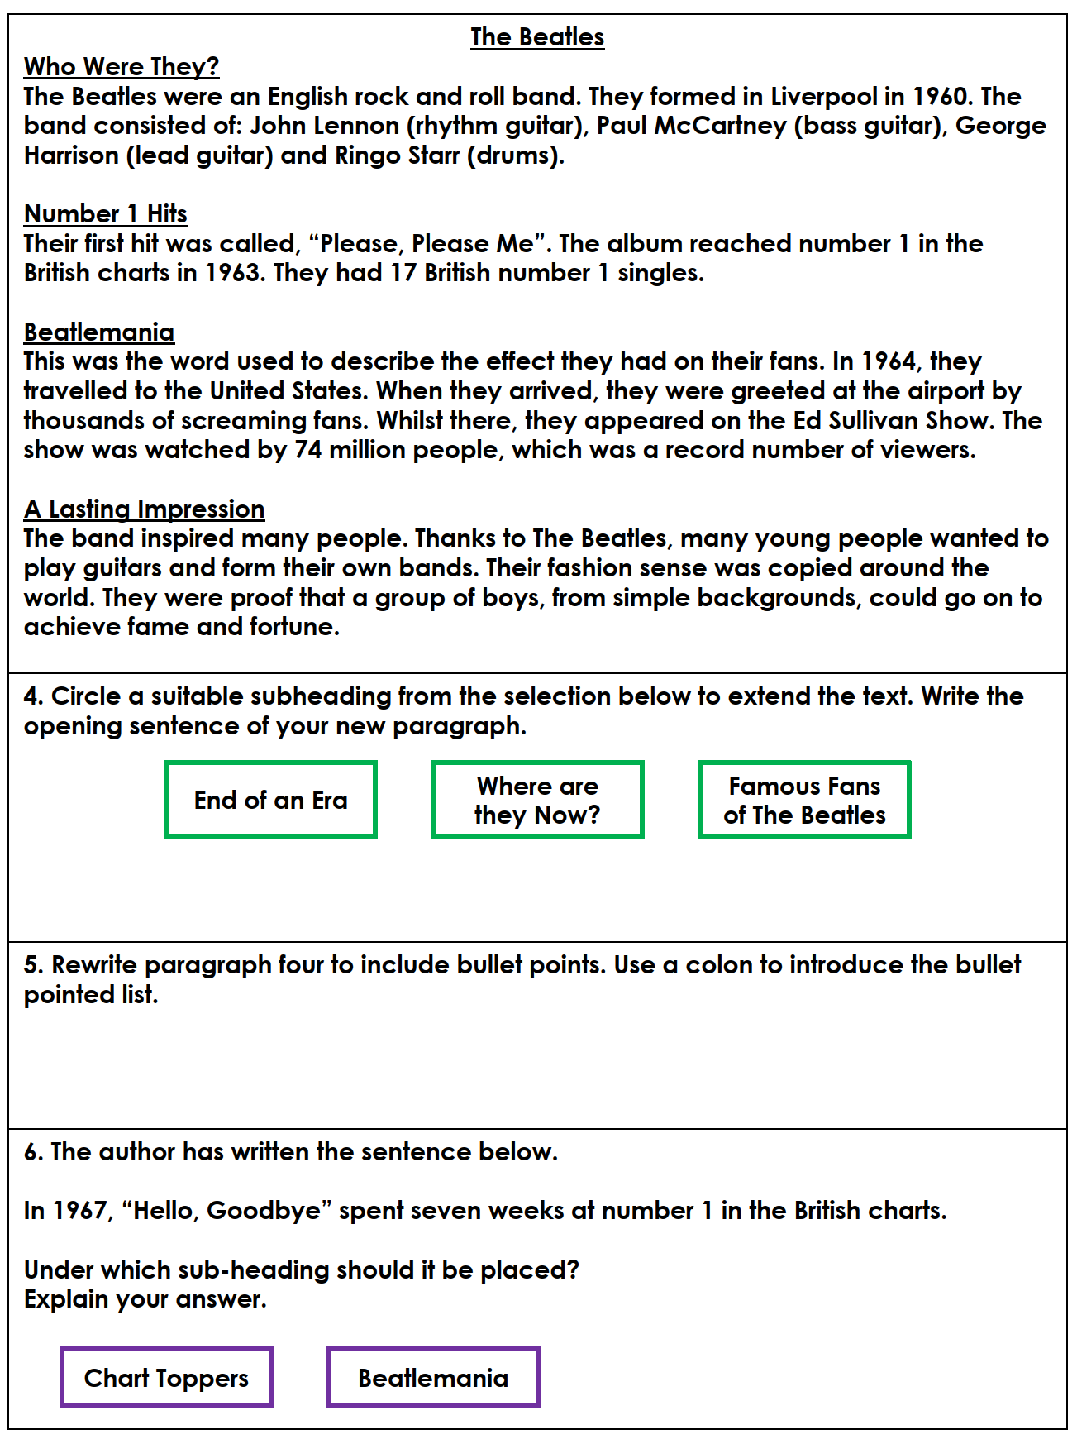

Click to listen to a Beatles song called Help!

https://www.youtube.com/watch?v=2Q_ZzBGPdqE

WEDNESDAY (Spelling)
Create a word search for the spellings of the week. Ask a family member to complete your word search.

THURSDAY (Writing)
A Letter to My Future Self

You are going to write a letter to your future self. This could be you in a years’ time or you in a few years’ time, at the end of secondary school.

Imagine what you like to become. How would like to be portrayed? What do you want people to think about you?
- What advice would you give yourself when starting something new?
- What would you like to get better at?
- What are your ambitions? Remember - 'your only limitation is your ambition.'
- What are your goals?
- What are your dreams?
- What new things would like to take part in?
Today you will plan and draft your letter.

FRIDAY (Writing)
- Look back at yesterdays work and reflect.
- Can you edit and improve your work?
- Have you thought about the advice that you have given yourself? How could you improve it?
- Complete and write up a final copy.

MONDAY (Reading)

SPELLINGS FOR THIS WEEK:

recommend, relevant, restaurant, rhyme, rhythm, sacrifice

Monday – Read the following and answer questions.

MATHS
Times tables for this week:
Continue to test yourself weekly, on your target times table. Give yourself 30 seconds per calculation. You can include as many calculations as you wish to in the test. If you pass, move onto the next calculation. If you do not pass in time, continue to remain on that times table until you do pass.

Addition and Subtraction
MONDAY-
Click on the link below for addition:
https://corbettmathsprimary.com/2018/05/30/addition-video/

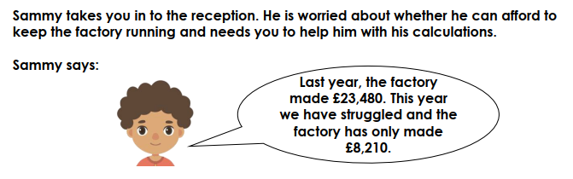

Use the column method to calculate the difference in earnings of the factory from last year to this year.
Challenge:
Can you write a good explanation how you solved this problem? Think about common mistakes children make. What are they and what advice would you give them?
Extra questions;
How much did he make over the two years?
In year 3, he doubled what he made in year 2. In year 4, he doubled what he had made in year 3. This pattern continues. What would he have earned after 10 years?
TUESDAY –

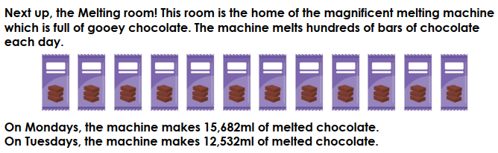

What is the difference between Monday and Tuesday?
How many litres of chocolate are made on the Monday and Tuesday?

Challenge:
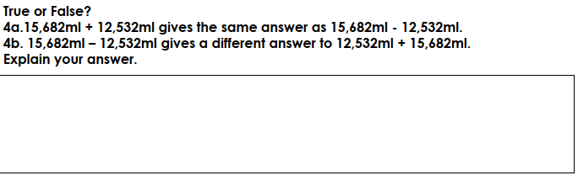

WEDNESDAY –

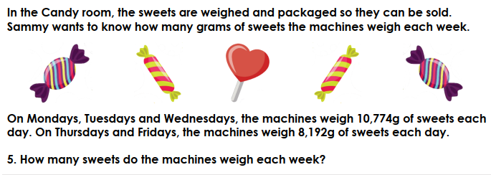
Challenge:
On Saturday, the factory made half the amount on a Monday and on Sunday, it made half the amount on a Friday.
How much did it make over 1 week?
How much did the factory make over 5 weeks?
Can you create a similar problem of your own? Include an answer sheet.

THURSDAY –

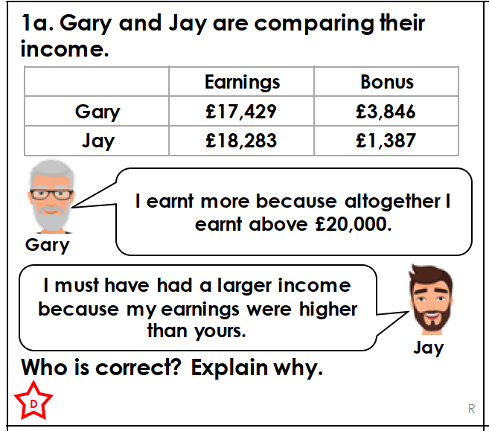
Challenge:

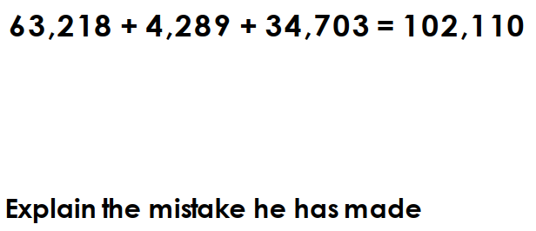

FRIDAY –

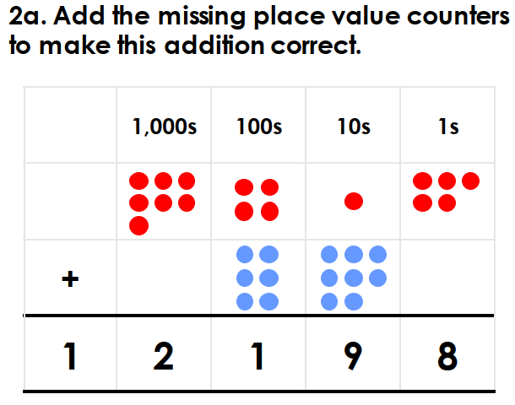
Challenge:
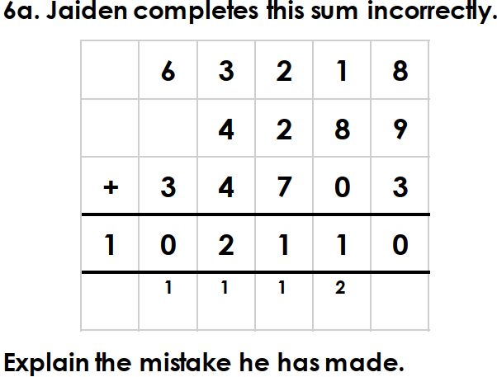
MONDAY-

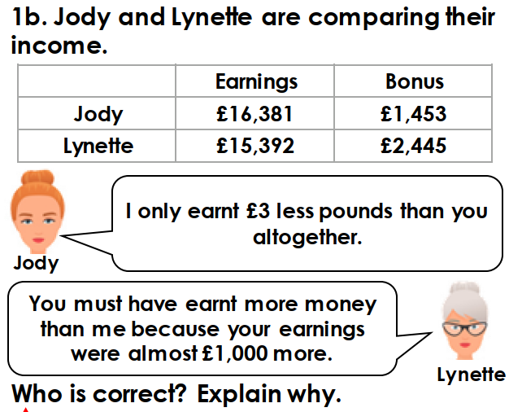

Challenge:

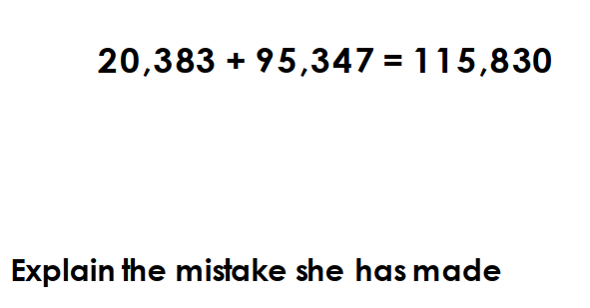
TUESDAY –
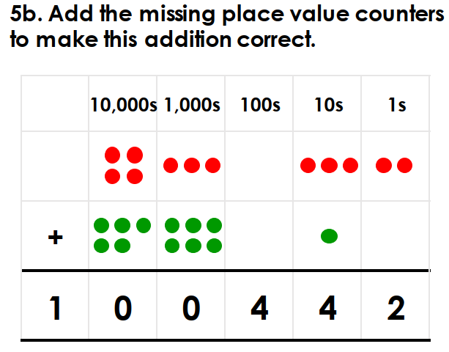

Challenge: Think about this problem. How is different? What advice would you give to someone solving it?

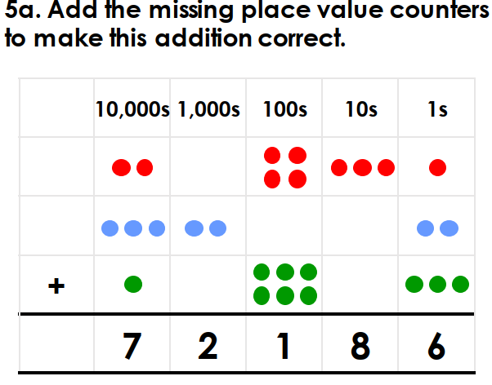
TOPIC:
MONDAY-
Viking Homes:
Draw and label a Viking City house. Use the sheet below to help.
What similarities and differences when compared to our own homes can you see?
What impact did the Viking homes have on modern homes today?
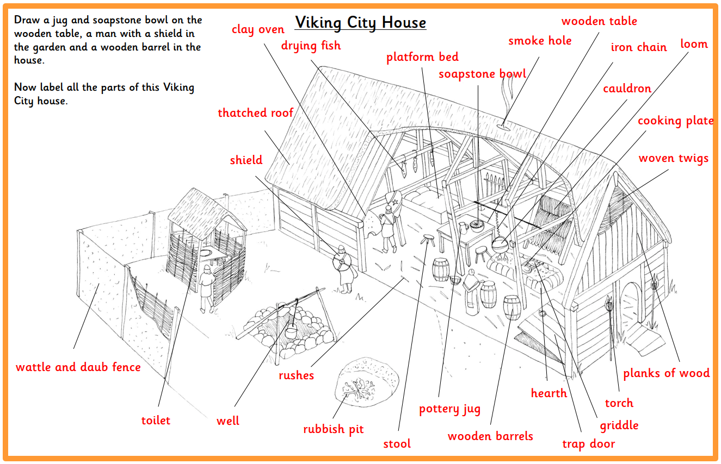
TUESDAY-
Amazing Viking Turf House Tour - Stunning Green Building!

What is a Turf House?
How are they environmentally friendly?
Could we use the Vikings’ ideas to build our homes today?
Design your own Turf house and label it. Watch the clip to help you.
https://www.youtube.com/watch?v=KA0VWfJEn9U

WEDNESDAY-

The secret messages of Viking runestones
Click here to find out more:
https://www.youtube.com/watch?v=wOcVy5dvwjs

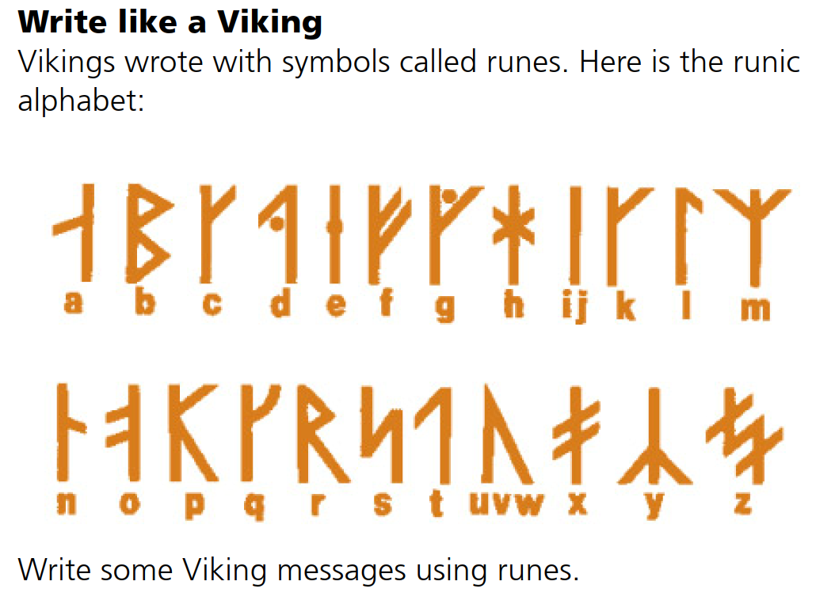
THURSDAY
Complete the activity below:

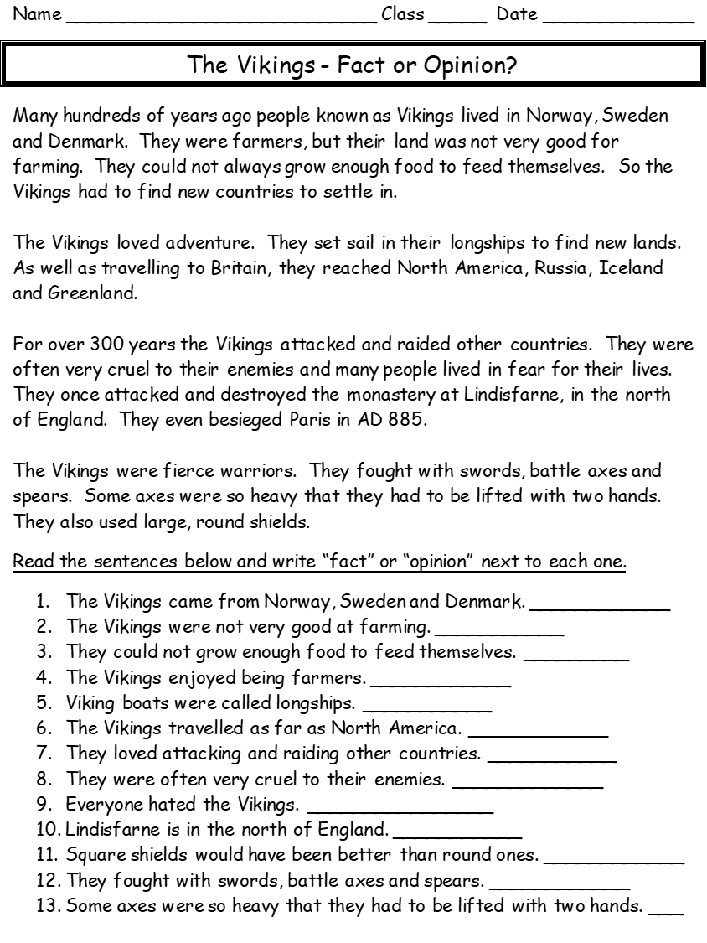

FRIDAY:
Horrible Histories and other educational programmes have created fun ways to teach us about the Vikings.
https://www.youtube.com/watch?v=8qSkaAwKMD4

https://www.youtube.com/watch?v=lwDyefAD7BY

https://www.youtube.com/watch?v=wbchlhlMLPE

Can you create your own about the Vikings? It could be a fun poem or poster. You could create even your own music video!

MONDAY

You have been on your own historical journey this year as the end of Year 5 approaches. Fun and exciting times await you in Year 6!
If you were going to create a time capsule what would you put inside it to represent your time in Year 5?
Think about the amazing times that you have had. Trips to Harry Potter world and your exciting residential. Reflect on your time during lockdown, what could put in your time capsule? Maybe toilet roll or a picture of a rainbow.

Draw your time capsule with all your exciting objects inside!

TUESDAY-

Many new children will start in our school in September. Joining are school will be the R children, some new Year 3’s, Year 7 children and new children too. Also, with have new teachers too!

Design a welcoming poster of our awesome school. Include all the great things that we do and offer.
Make it bright, colourful and fun.

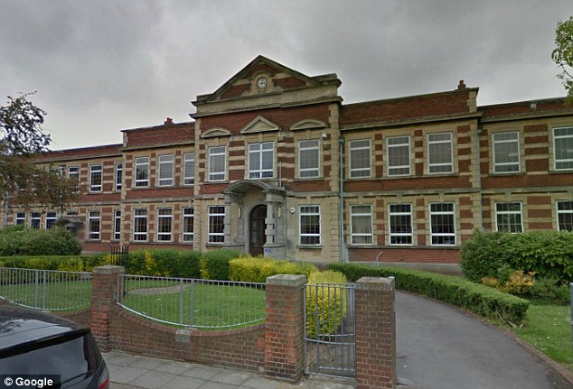

LEARNING WEBSITES

https://www.topmarks.co.uk/maths-games/hit-the-button

https://www.mathplayground.com/

https://www.topmarks.co.uk/maths-games/7-11-years

https://whiterosemaths.com/homelearning/

https://nrich.maths.org/primary

https://ttrockstars.com/

https://www.bbc.co.uk/bitesize/levels/zbr9wmn

https://www.literacyshed.com/home.html

https://www.spellingshed.com/

https://pobble.com/

https://monsterphonics.com/?gclid= EAIaIQobChMI56aEu9yh6AIVFeDtCh2NMAcIEA AYASAAEgK1b_D_BwE

https://www.oxfordowl.co.uk/welcome-back/for-home/reading-owl/kids-activities

https://www.topmarks.co.uk/english-games/7-11-years

Audible are doing a free 30 day trial so that children can listen to lots of books online.

MATHS ANSWERS:
Monday:

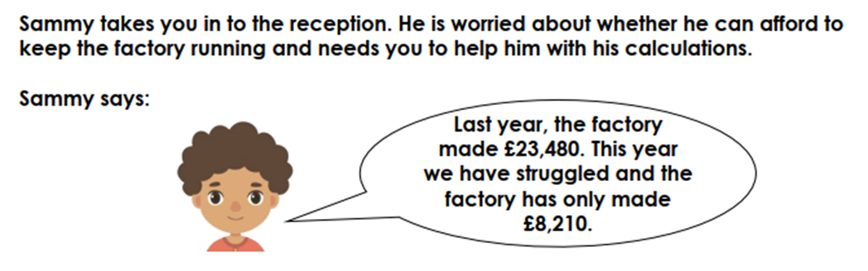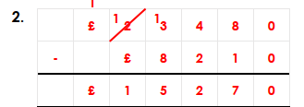

Tuesday:
The difference is 3 150ml

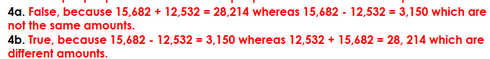
Wednesday:

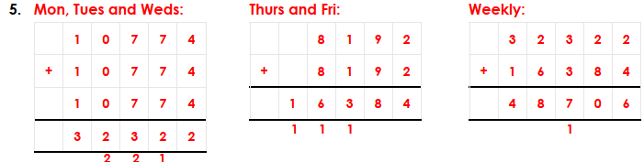
Thursday:

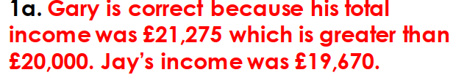

Tuesday:

Friday:

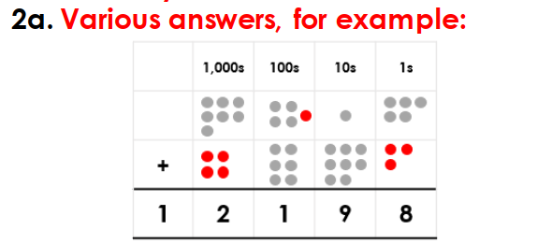
Challenge:
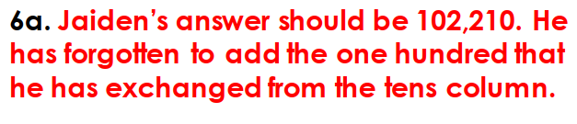

Monday:
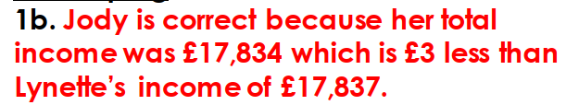

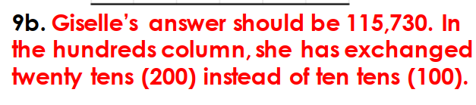

Tuesday:

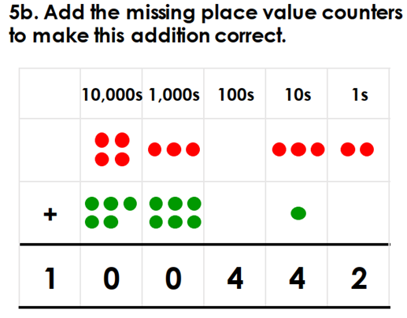

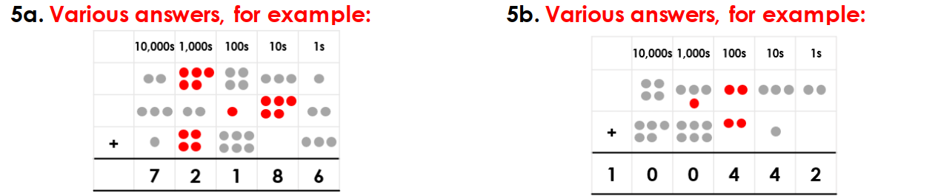

YEAR 5-6 SPELLING WORDS
