Dear Parent/Carer,

As the school continues to remain closed due to Coronavirus, we are continuing to provide educational tasks for your children to complete. We have received positive feedback on the new format of the home learning daily tasks. As always, please continue to keep in touch about your child’s home learning and let us know if there are any problems.

In primary, we suggest that children try to complete;
- 30 minutes a day of independent reading/reading to an adult
- 30 minutes of maths a day
- 30 minutes of English a day
- 30 minutes of topic based/creative learning
- 30 minutes of PE/ physical activity

Home learning tasks can be supplemented with work from a number of websites (see list below for ideas.) Daily work set on the BBC website is particularly useful as it contains tutorial videos.
https://www.bbc.co.uk/bitesize/primary

Teachers will set a weekly programme for your child to work through at home. This will be available for you to access on the school website every Monday. We know that children work at different speeds and different levels, so please have a look at work in other year groups too for extra support.

To help with maths and different terminology, we will try to add in some video links for tutorials and we will try to include answers for maths where possible to help the children check through their work.

Whilst it is important for your child to keep up with their learning at home, we appreciate that this can be a stressful time for children and adults. Looking after mental health is vital. Therefore, we suggest that the day is broken up into manageable learning chunks, interspersed with physical exercise, fun activities and time together as a family. Activities such as the 30 day lego challenge and using the real PE activities could be a good place to start. Setting up a weekly timetable can be a good place to start. As well as educational learning, the children could also begin to learn different life skills – how to boil an egg, sew on a button, learn to send an email, bake a cake using a recipe book etc.

Guidance for parents, regarding home learning, has been released by the government and can be found at the following link;
https://www.gov.uk/guidance/supporting-your-childrens-education-during-coronavirus-covid-19

We hope you are all keeping well and staying positive.

Kind regards,

The Year 5 team
Teacher email;
Large-becki@mayfield.portsmouth.sch.uk
Turner-peyton@mayfield.portsmouth.sch.uk

YEAR 5 HOME LEARNING TASKS
WEEK BEGINNING: Monday 18th May 2020
ENGLISH (Advert focus)

SPELLINGS FOR THIS WEEK:
Definite, desperate, determined, develop, dictionary, disastrous, embarrass

MONDAY (spelling)
Think of, and record in your red books, a funny/memorable way to remember the spelling of each word above.
E.g: Definite = D (dumb) E (elephants) F (fidget) I (in) N (numerous) I (itchy) T (tight) E (eggs)

TUESDAY (reading comprehension)
Think of your favourite Harry Potter character. Imagine that character needs a friend, what qualities will they require? Write an advert for this using your inference skills (your understanding of what type of friend that character will require)

WEDNESDAY (Spelling)
Reflect on Monday’s learning. How many words can you remember the spelling of, by using your funny phrases to help you? Keep trying to beat your score! You may try timing yourself, to beat your first time too! You could even compete against a family member – can you spell them quicker than them?

THURSDAY (writing)
Reflect on Tuesday’s learning. What type of friend would you like? Plan for a ‘Friend advert’, using your English skills. You may wish to plan using mind maps or bullet points, like we do in school. Your sub headings may be divided up into ‘Hobbies’, ‘Dislikes’ or ‘Personality’. Include the skills of description, questions, exclamations etc.

FRIDAY (writing)
Write up your ‘Friend advert’. Remember that presentation is very important, if you want people to apply to you and take you seriously. Don’t forget to edit!

MATHS (Multiplication focus)

Times tables for this week:
Continue to test yourself weekly, on your target times table. Give yourself 30 seconds per calculation. You can include as many calculations as you wish to in the test. If you pass, move onto the next calculation. If you do not pass in time, continue to remain on that times table until you do pass.

If you want to challenge yourself with more maths activities, please look at the link below;

https://whiterosemaths.com/homelearning/

The focus this week is multiplication. I have added a revision sheet in case you have forgotten a method to solve multiplication problems.

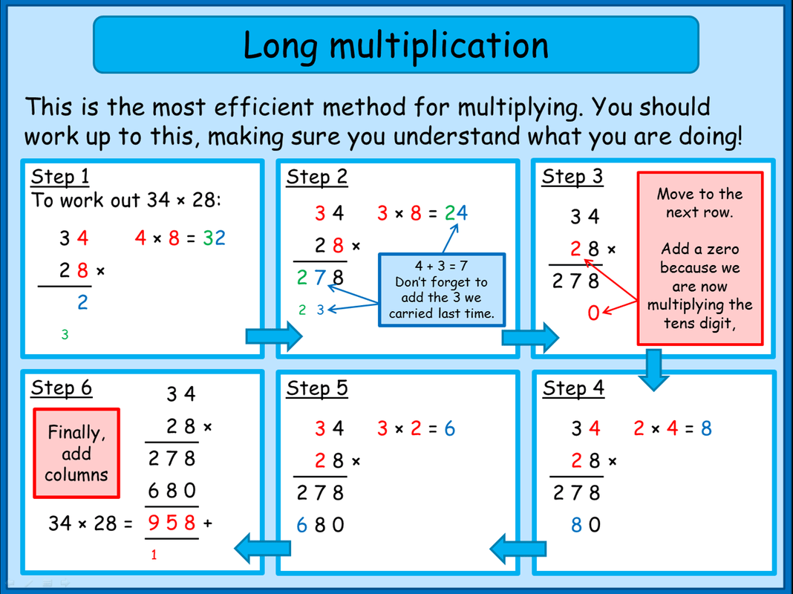

MONDAY –

If you find this task difficult, practice the column method for multiplication using 4 digit and 1 digit number.

TUESDAY –

WEDNESDAY –

THURSDAY -

FRIDAY –

TOPIC (Recap Space – Science focus)

MONDAY –
Research the Lunar cycle. Write up your findings, using bullet points. Now try grouping your findings together. Can you determine any relationships/patterns/interesting links in your findings? If so, write them up!

TUESDAY –
Present your findings in a clear way, that describes and illustrates the Lunar cycle. An example has been given to help guide you. You may not be able to see the text, as it is too small, but you can use the diagram as an idea for when writing up your own findings. Consider the impact of the illustrations alone, do you need the text or does the illustration demonstrate the Lunar cycle clearly, without text?

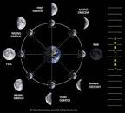

WEDNESDAY –
How important is the Lunar cycle for humans, on planet Earth? Research and use your own understanding to write a concluding paragraph.

THURSDAY–
There are 12 phases of the moon. Do you think they are all equally important to life on Earth? Write a reasoning paragraph, with your answer.

FRIDAY–
Without the moon, what would planet Earth look like? Research and use your own understanding to draw and label Planet earth, if there was not a moon.

LEARNING WEBSITES

https://www.topmarks.co.uk/maths-games/hit-the-button

https://www.mathplayground.com/

https://www.topmarks.co.uk/maths-games/7-11-years

https://whiterosemaths.com/homelearning/

https://nrich.maths.org/primary

https://ttrockstars.com/

https://www.bbc.co.uk/bitesize/levels/zbr9wmn

https://www.literacyshed.com/home.html

https://www.spellingshed.com/

https://pobble.com/

https://monsterphonics.com/?gclid= EAIaIQobChMI56aEu9yh6AIVFeDtCh2NMAcIEA AYASAAEgK1b_D_BwE

https://www.oxfordowl.co.uk/welcome-back/for-home/reading-owl/kids-activities

https://www.topmarks.co.uk/english-games/7-11-years

Audible are doing a free 30 day trial so that children can listen to lots of books online.
MATHS ANSWERS

Monday:

Tuesday:

Wednesday:

Thursday:

Friday:

YEAR 5-6 SPELLING WORDS
