Dear Parent/Carer,
In light of the government’s latest guidance, we are very pleased that we are able to open up more on-site provision for all of our primary pupils. Your choice of provision can now be either; two days in ‘Bubble School’ or up to five days a week in ‘Key Worker School’ if you are a key worker. When the children are at school, they will access the home learning tasks, supported by their bubble teacher. When the children are at home, it is important that they continue with their home learning. The tasks that we set will be a mix of consolidation of previous work and new learning. To help the children with this work, we are including;
- The opportunity for you/your child to communicate with their class teacher via email on a set day, between certain times.
- More links to video resources/websites/ on-line clips or pre-recorded sessions from teachers.
- Feedback on a chosen piece of work (pictures/copies need to be emailed to the teacher or dropped off to a class box in the main reception area).
In primary, we suggest that children try to complete;
- 30 minutes a day of independent reading/reading to an adult
- 30 minutes of maths a day
- 30 minutes of English a day
- 30 minutes of topic based/creative learning
- 30 minutes of PE/ physical activity

Teachers will set a weekly programme for your child to work through at home. This will be available for you to access on the school website every Monday. We know that children work at different speeds and different levels, so please have a look at work in other year groups too for extra support.

Whilst it is important for your child to keep up with their learning at home, we appreciate that this can be a stressful time for children and adults. Looking after mental health is vital. Therefore, we suggest that the day is broken up into manageable learning chunks, interspersed with physical exercise, fun activities and time together as a family. Activities such as the 30 day Lego challenge and using the real PE activities could be a good place to start. Setting up a weekly timetable can be a good place to start. As well as educational learning, the children could also begin to learn different life skills – how to boil an egg, sew on a button, learn to send an email, bake a cake using a recipe book etc.

Guidance for parents, regarding home learning, has been released by the government and can be found at the following link;
https://www.gov.uk/guidance/supporting-your-childrens-education-during-coronavirus-covid-19

We hope you are all keeping well and staying positive.
We hope you are all keeping well.
Kind regards,

The Year 5 team
Teacher email;
Large-becki@mayfield.portsmouth.sch.uk Turner-peyton@mayfield.portsmouth.sch.uk
Head-Pete@mayfield.portsmouth.sch.uk

YEAR 5 HOME LEARNING TASKS
WEEK BEGINNING: Monday 20th July 2020
ENGLISH
SPELLINGS FOR THIS WEEK:
recommend, relevant, restaurant, rhyme, rhythm, sacrifice

Monday – Read the following and answer questions.
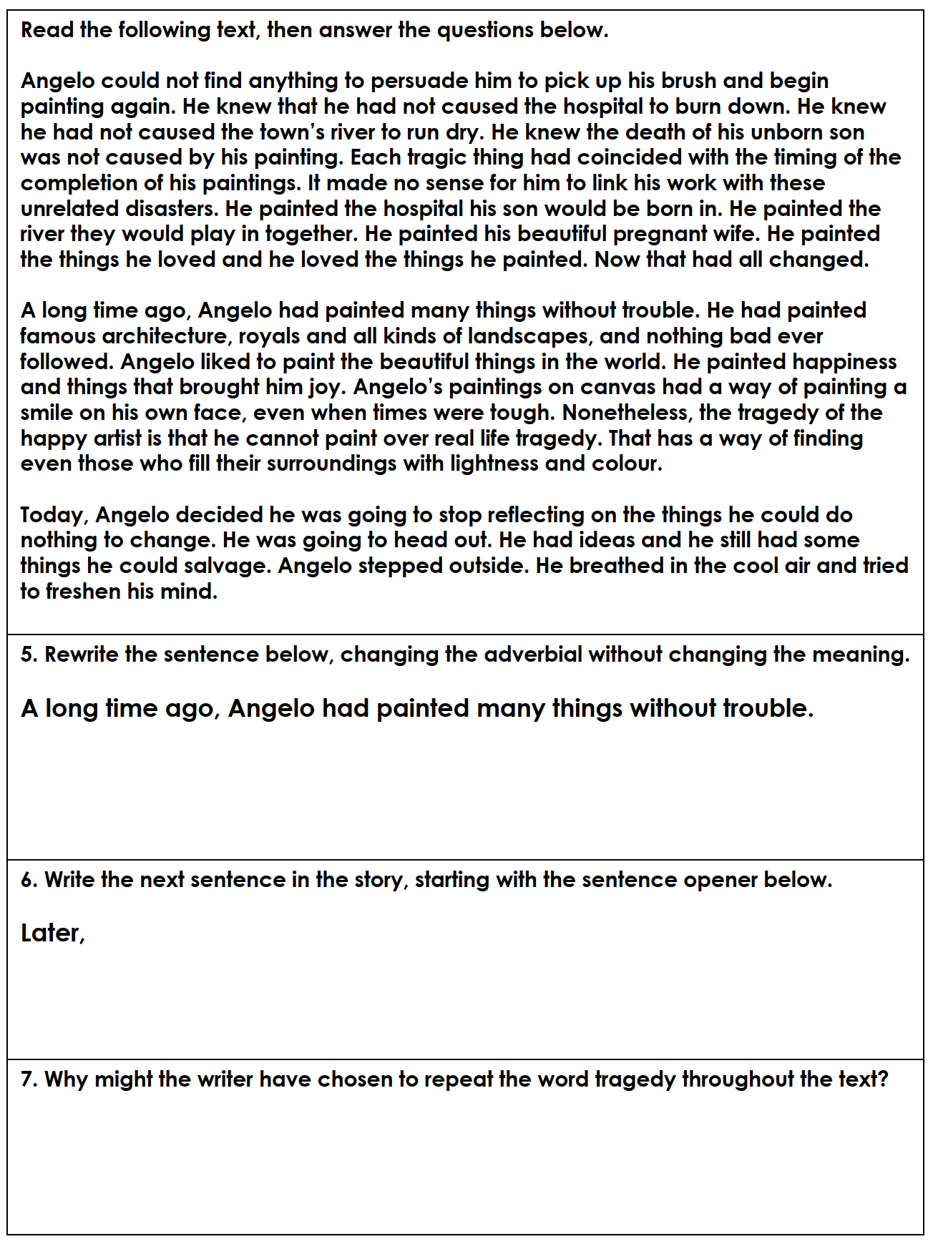

Challenge – create a ‘who, what, where, why and when question about the text that you could then ask someone.
EG – What did Angelo paint?
TUESDAY (Spelling)
Create a word search of year 5 spelling words. Use the list at the bottom of the home learning pages. Swap with someone.

MATHS
Times tables for this week:
Continue to test yourself weekly, on your target times table. Give yourself 30 seconds per calculation. You can include as many calculations as you wish to in the test. If you pass, move onto the next calculation. If you do not pass in time, continue to remain on that times table until you do pass.

Addition and Subtraction
MONDAY-

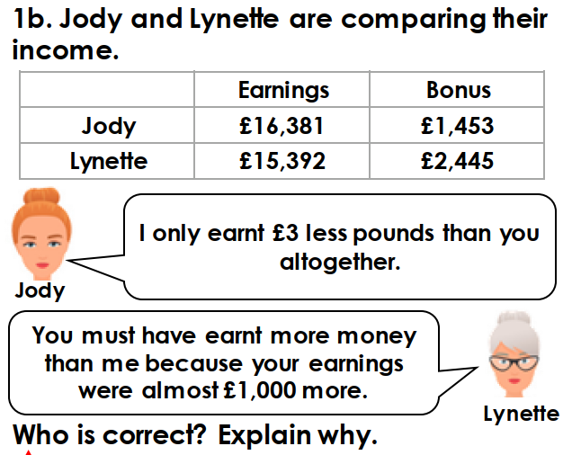

Challenge:

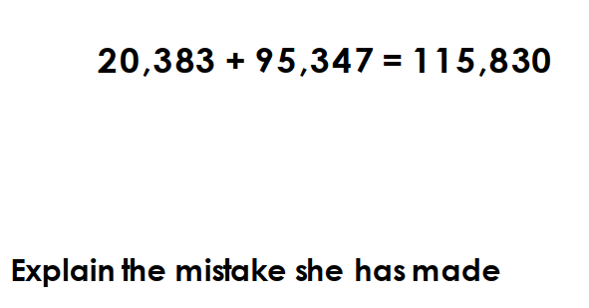
TUESDAY –
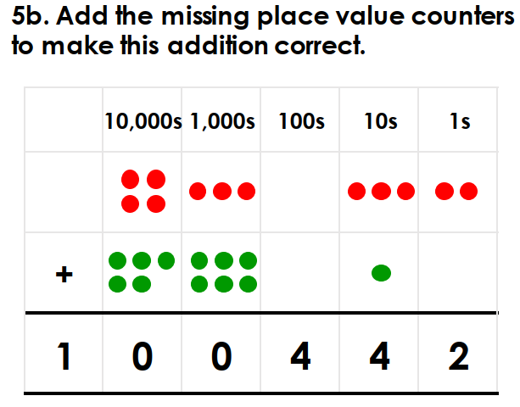

Challenge: Think about this problem. How is different? What advice would you give to someone solving it?

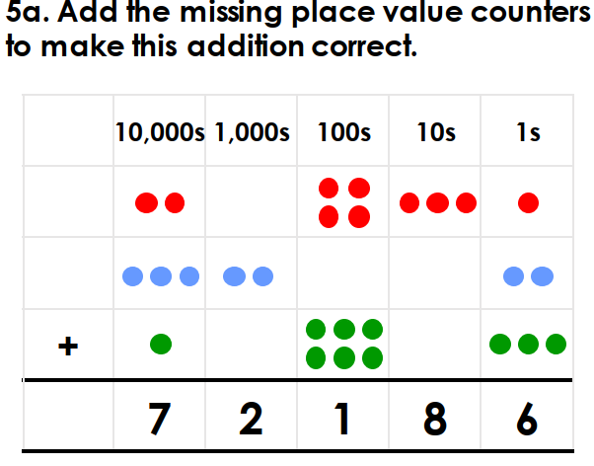

MONDAY TOPIC

You have been on your own historical journey this year as the end of Year 5 approaches. Fun and exciting times await you in Year 6!
If you were going to create a time capsule what would you put inside it to represent your time in Year 5?
Think about the amazing times that you have had. Trips to Harry Potter world and your exciting residential. Reflect on your time during lockdown, what could put in your time capsule? Maybe toilet roll or a picture of a rainbow.

Draw your time capsule with all your exciting objects inside!

TUESDAY- TOPIC

Many new children will start in our school in September. Joining are school will be the R children, some new Year 3’s, Year 7 children and new children too. Also, with have new teachers too!

Design a welcoming poster of our awesome school. Include all the great things that we do and offer.
Make it bright, colourful and fun.

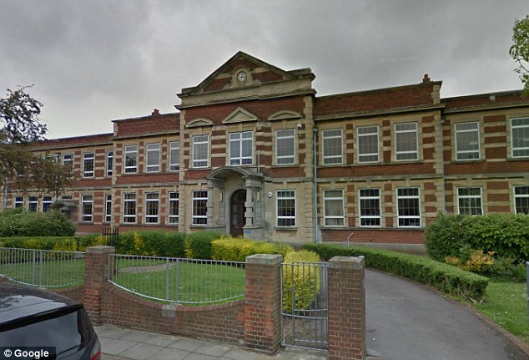

LEARNING WEBSITES

https://www.topmarks.co.uk/maths-games/hit-the-button

https://www.mathplayground.com/

https://www.topmarks.co.uk/maths-games/7-11-years

https://whiterosemaths.com/homelearning/

https://nrich.maths.org/primary

https://ttrockstars.com/

https://www.bbc.co.uk/bitesize/levels/zbr9wmn

https://www.literacyshed.com/home.html

https://www.spellingshed.com/

https://pobble.com/

https://monsterphonics.com/?gclid= EAIaIQobChMI56aEu9yh6AIVFeDtCh2NMAcIEA AYASAAEgK1b_D_BwE

https://www.oxfordowl.co.uk/welcome-back/for-home/reading-owl/kids-activities

https://www.topmarks.co.uk/english-games/7-11-years

Audible are doing a free 30 day trial so that children can listen to lots of books online.

MATHS ANSWERS

Monday:
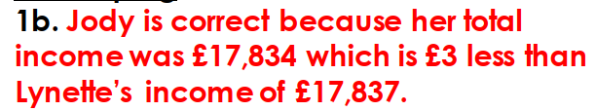

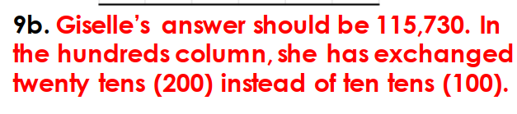

Tuesday:

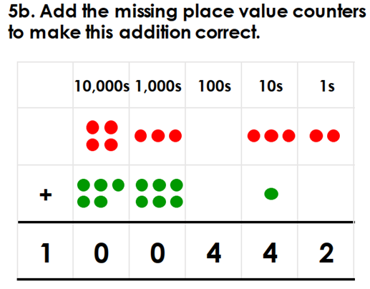

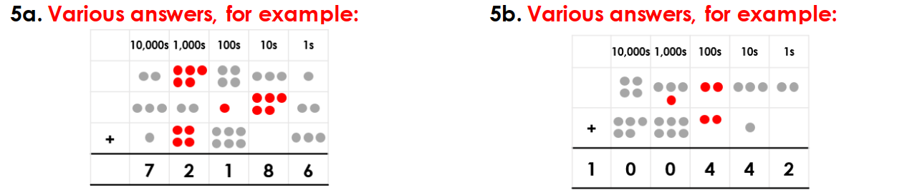

YEAR 5-6 SPELLING WORDS
