Dear Parent/Carer,

In light of the government’s latest guidance, we are very pleased that we are able to open up more on-site provision for all of our primary pupils. Your choice of provision can now be either; two days in ‘Bubble School’ or up to five days a week in ‘Key Worker School’ if you are a key worker. When the children are at school, they will access the home learning tasks, supported by their bubble teacher. When the children are at home, it is important that they continue with their home learning. The tasks that we set will be a mix of consolidation of previous work and new learning. To help the children with this work, we are including;
- The opportunity for you/your child to communicate with their class teacher via email on a set day, between certain times.
- More links to video resources/websites/ on-line clips or pre-recorded sessions from teachers.
- Feedback on a chosen piece of work (pictures/copies need to be emailed to the teacher or dropped off to a class box in the main reception area).

In primary, we suggest that children try to complete;
- 30 minutes a day of independent reading/reading to an adult
- 30 minutes of maths a day
- 30 minutes of English a day
- 30 minutes of topic based/creative learning
- 30 minutes of PE/ physical activity

Whilst it is important for your child to keep up with their learning at home, we appreciate that this can be a stressful time for children and adults. Looking after mental health is vital. Therefore, we suggest that the day is broken up into manageable learning chunks, interspersed with physical exercise, fun activities and time together as a family. Activities such as the 30 day lego challenge and using the real PE activities could be a good place to start. Setting up a weekly timetable can be a good place to start. As well as educational learning, the children could also begin to learn different life skills – how to boil an egg, sew on a button, learn to send an email, bake a cake using a recipe book etc.

Guidance for parents, regarding home learning, has been released by the government and can be found at the following link;
https://www.gov.uk/guidance/supporting-your-childrens-education-during-coronavirus-covid-19

We will be available via email to support parents and pupil with the tasks each week on Wednesdays between 10am-12pm and 1pm and 3pm. Please email your Friday Maths task to your teacher by Tuesday evening of the following week. Feedback will be given via email on Wednesday.

We hope you are all keeping well and staying positive.

Kind regards,

The Year 5 team
Teacher email;
Large-becki@mayfield.portsmouth.sch.uk
Turner-peyton@mayfield.portsmouth.sch.uk

YEAR 5 HOME LEARNING TASKS
WEEK BEGINNING: Monday 22nd June 2020
ENGLISH (Poetry focus)

SPELLINGS FOR THIS WEEK:
individual, interfere, interrupt, language, leisure, lightning.

MONDAY (Reading)
Look at the poems attached at the bottom of the home learning sheet. What do you notice about them? What is the purpose of the poem? Is it to inform or entertain? How do you know this? They are called ‘kennings’. Use the internet to search where kennings come from.

TUESDAY (Reading)
Read the following poem:
Sky-toucher
Fire-kindler
Ant-dwarfer
Child-hider
Woodlouse-wormer
Monkey-exercise
Paper-maker
Cat-trapper

How does the language, structure and presentation contribute to meaning of the poem? How does the hyphen change the poem, would it be the same without it? What do you notice about the suffix? Why is that important?

WEDNESDAY (Spelling)
Create a spelling rap for each spelling. For example: individual, there’s only one, i n d i , v i d , u a l, individual.

THURSDAY (Writing) New Learning! Video attached.
Reflect on your knowledge of kenning poetry. Kenning poetry uses figurative language to describe a person, animal, object or a place. The hyphen feature is probably the most noticeable part of a kenning poem. Reason why a kenning uses a hyphen and not a dash (use the link https://www.bbc.co.uk/bitesize/topics/zvwwxnb/articles/zg8gbk7 for help). Explain where a hyphen is used and where a dash is used? How do hyphens make the work clearer?

FRIDAY (Writing)
Choose a person, animal, object or a place and start to bullet point the features to plan your description. Use those bullet points to create hyphen phrases for your kenning. Think about the order of the poem and the purpose to entertain. Reflect on your poem and make changes.

MATHS (Geometry focus)
Times tables for this week:
Continue to test yourself weekly, on your target times table. Give yourself 30 seconds per calculation. You can include as many calculations as you wish to in the test. If you pass, move onto the next calculation. If you do not pass in time, continue to remain on that times table until you do pass.

MONDAY –
Does it matter which way around coordinates are written?
If I moved the point one place to the left, what would be different about the coordinates? If I moved the point down
one, what would be different about the coordinates?
TUESDAY –
Which of these shapes show reflections in the given mirror line?
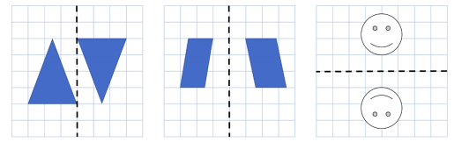
Explain why the correct answer is the reflection.
Explain why the other answers are incorrect.
When I reflect something, what changes about the object? Is it exactly the same?

WEDNESDAY –
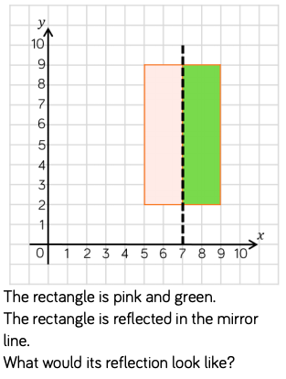
What are the coordinates of this point? If I reflect it in the mirror line, what are the new coordinates?
If I reflect this point/shape in a vertical/horizontal mirror line, what will happen to the 𝑥-coordinate/𝑦-coordinate?
THURSDAY –
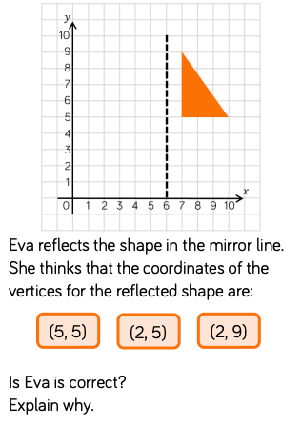
What is the 𝑥-coordinate for this vertex? What is the 𝑦- coordinate for this vertex?
If we look at this point, where will its new position be on the image, when it is reflected? What’s different about the coordinates of the object compared to the coordinates of the image?
FRIDAY – Video link Please send your Friday maths work via email by Tuesday 30th June.
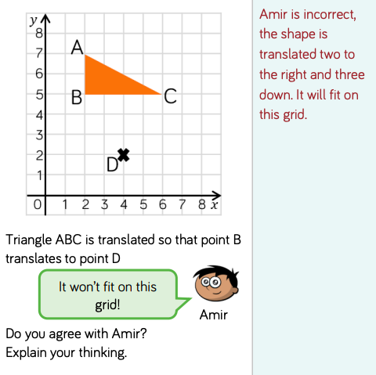
What does translate mean?
Look what happens when I translate this shape. What has happened to the shape? Have the dimensions of the shape changed? Does it still face the same way?
Are there any other ways I can get the shape to this position?
TOPIC New learning! Video attached!
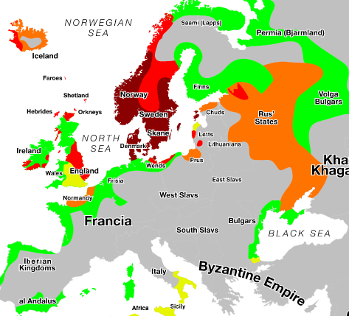
Viking topic: Raiders, traders or invaders? (Video https://www.bbc.co.uk/bitesize/topics/ztyr9j6/articles/zjcxwty)
MONDAY-
Here is a map of some of the places that were invaded by the Vikings. Which countries did the Viking’s invade and what are the countries current capital cities?
Extension: Can you find out facts about populations of the city?

TUESDAY-
The Vikings only settled in countries that are now part of the European Union. Reason why you agree or disagree. Look at countries that are currently in the EU and create a list of countries who have been in it.

WEDNESDAY-
Use the web page Have a look at https://www.bbc.co.uk/newsround/38518527 and record some notes of how Brexit changed the European Union.

THURSDAY-
Did the Vikings settle near mountains? Prove whether they did or didn’t. Use maps on the internet to compare to the map above of the Viking invasion and locate mountains. Which mountains were the Vikings close to? Are there any mountains which they may have settled near?

FRIDAY-
Did the Vikings settle near rivers? Prove whether they did or didn’t. Use maps on the internet to compare to the map above of the Viking invasion and locate rivers. Which rivers were the Vikings close to? Are there any rivers which they may have settled near?

LEARNING WEBSITES

https://www.topmarks.co.uk/maths-games/hit-the-button

https://www.mathplayground.com/

https://www.topmarks.co.uk/maths-games/7-11-years

https://whiterosemaths.com/homelearning/

https://nrich.maths.org/primary

https://ttrockstars.com/

https://www.bbc.co.uk/bitesize/levels/zbr9wmn

https://www.literacyshed.com/home.html

https://www.spellingshed.com/

https://pobble.com/

https://monsterphonics.com/?gclid= EAIaIQobChMI56aEu9yh6AIVFeDtCh2NMAcIEA AYASAAEgK1b_D_BwE

https://www.oxfordowl.co.uk/welcome-back/for-home/reading-owl/kids-activities

https://www.topmarks.co.uk/english-games/7-11-years

Audible are doing a free 30 day trial so that children can listen to lots of books online.

MATHS ANSWERS:
Monday:
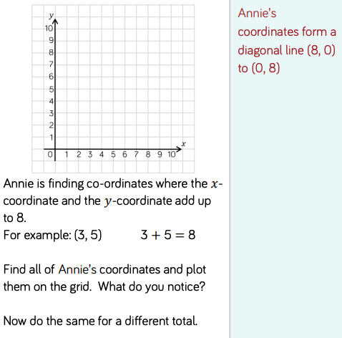
Tuesday:
The smiley face is reflected along the mirror line, only the positions change to flip.
Wednesday:
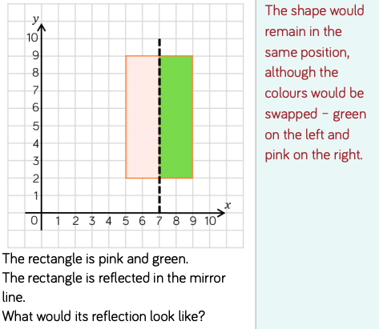
Thursday:
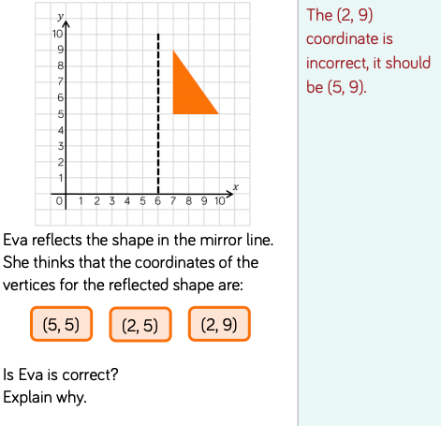
Friday:

YEAR 5-6 SPELLING WORDS
