Dear Parent/Carer,

As the school continues to remain closed due to Coronavirus, we are continuing to provide educational tasks for your children to complete. We have received positive feedback on the new format of the home learning daily tasks. As always, please continue to keep in touch about your child’s home learning and let us know if there are any problems.

In primary, we suggest that children try to complete;
- 30 minutes a day of independent reading/reading to an adult
- 30 minutes of maths a day
- 30 minutes of English a day
- 30 minutes of topic based/creative learning
- 30 minutes of PE/ physical activity

Home learning tasks can be supplemented with work from a number of websites (see list below for ideas.) Daily work set on the BBC website is particularly useful as it contains tutorial videos.
https://www.bbc.co.uk/bitesize/primary

Teachers will set a weekly programme for your child to work through at home. This will be available for you to access on the school website every Monday. We know that children work at different speeds and different levels, so please have a look at work in other year groups too for extra support.

Whilst it is important for your child to keep up with their learning at home, we appreciate that this can be a stressful time for children and adults. Looking after mental health is vital. Therefore, we suggest that the day is broken up into manageable learning chunks, interspersed with physical exercise, fun activities and time together as a family. Activities such as the 30 day lego challenge and using the real PE activities could be a good place to start. Setting up a weekly timetable can be a good place to start. As well as educational learning, the children could also begin to learn different life skills – how to boil an egg, sew on a button, learn to send an email, bake a cake using a recipe book etc.

Guidance for parents, regarding home learning, has been released by the government and can be found at the following link;
https://www.gov.uk/guidance/supporting-your-childrens-education-during-coronavirus-covid-19

We hope you are all keeping well and staying positive.

Kind regards,

The Year 5 team
YEAR 5 HOME LEARNING TASKS
WEEK BEGINNING: Monday 27th April 2020
ENGLISH (Description focus)  SPELLINGS FOR THIS WEEK:  apparent, appreciate, attached, available, average, awkward, bargain  MONDAY –  Reflect on SPAMROD (Simile, personification, alliteration, metaphor, repetition, onomatopoeia and description in general) Create a definition for each of these terms, using examples to illustrate your point. Use this helpful guide for the rest of the week’s English learning.  TUESDAY –  Using SPAMROD from Yesterday’s learning, plan, write and edit a poem which is about self-isolation. Remember to think about the theme/mood that you want your poem to create for the reader. Also, remember to incorporate the poetic devices that we have tried out in school! This may include; verses, repetition or rhyming.  WEDNESDAY –  Remind yourself of your poem from yesterday. Now write a poem, which expresses the opposite mood to the mood that your poem portrayed Yesterday. For example, if your poem was cheerful then today your poem should portray a moody/sad theme.  THURSDAY –  Remind yourself of your favourite day from Year 5, so far. Describe it to the current Year 4 pupils, to encourage them to look forward to starting Year 5, in September. Use the features of SPAMROD, to help create a vivid picture of your favourite day. This will be shared with Year 4, once we come back to school.  FRIDAY –  Remind yourself of the Harry Potter trip (if you did not go then remind yourself of any school trip). Imagine that the teacher’s want to cancel that trip in the future because it is too expensive for families. Write a persuasive letter to the teachers, to encourage them not to cancel the trip. Remember to use SPAMROD to help you become extra persuasive! | MATHS (Place value focus)  Times tables for this week:  Continue to test yourself weekly, on your target times table. Give yourself 30 seconds per calculation. You can include as many calculations as you wish to in the test. If you pass, move onto the next calculation. If you do not pass in time, continue to remain on that times table until you do pass.  MONDAY –  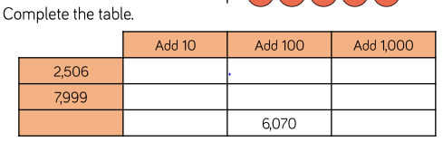  TUESDAY –  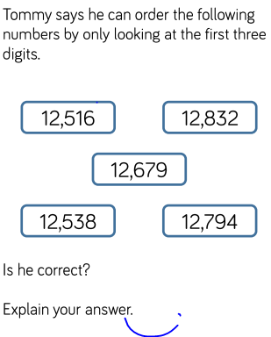  WEDNESDAY –  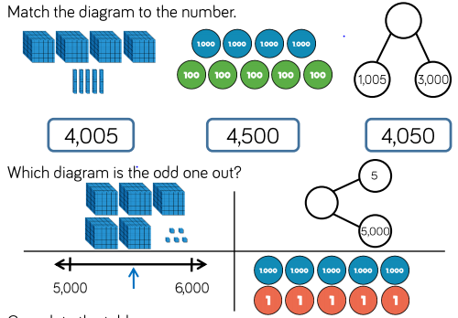  THURSDAY -  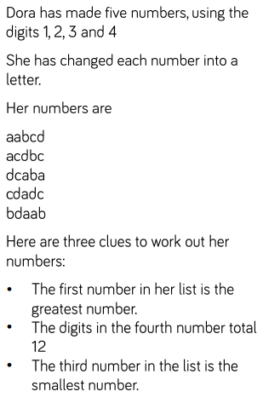  FRIDAY –  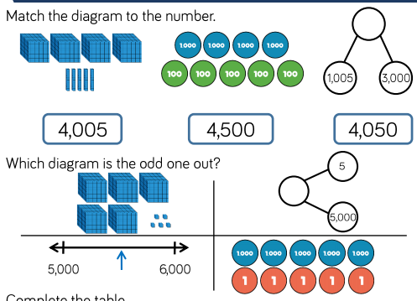
TOPIC (Recap Space – Science focus)  MONDAY –  Recap the different planets in our solar system. Describe the relationship between each of them, in a leaflet. The leaflet should be aimed at young Scientists who are curious about Space.  TUESDAY –  Imagine that planet Earth is about to explode! Which other planet could the human race survive on? Use scientific evidence to justify your idea. Think about what humans need to survive.  WEDNESDAY –  Linking to Yesterday’s topic learning, which planet would be most harmful to the human race? Persuade someone, who lives with you, why humans should not live there.  THURSDAY–  Using your understanding of the planets, predict what type of ‘aliens’ could exist on any of the other planets. Think about what features the planets have, and how the aliens may be suited to live there.  FRIDAY–  Reflect on your learning from this week. Imagine that our moon is being destroyed from an unknown source. Persuade someone in your household to help you save the moon, by explaining the importance of the moon on the survival of the human race. Remember to use Scientific facts as well as persuasive devices! | LEARNING WEBSITES  https://www.topmarks.co.uk/maths-games/hit-the-button  https://www.mathplayground.com/  https://www.topmarks.co.uk/maths-games/7-11-years  https://whiterosemaths.com/homelearning/  https://nrich.maths.org/primary  https://ttrockstars.com/  https://www.bbc.co.uk/bitesize/levels/zbr9wmn  https://www.literacyshed.com/home.html  https://www.spellingshed.com/  https://pobble.com/  https://monsterphonics.com/?gclid= EAIaIQobChMI56aEu9yh6AIVFeDtCh2NMAcIEA AYASAAEgK1b_D_BwE  https://www.oxfordowl.co.uk/welcome-back/for-home/reading-owl/kids-activities  https://www.topmarks.co.uk/english-games/7-11-years  Audible are doing a free 30 day trial so that children can listen to lots of books online.
YEAR 5-6 SPELLING WORDS
