Dear Parent/Carer,

Dear Parent/Carer,
In light of the government’s latest guidance, we are very pleased that we are able to open up more on-site provision for all of our primary pupils. Your choice of provision can now be either; two days in ‘Bubble School’ or up to five days a week in ‘Key Worker School’ if you are a key worker. When the children are at school, they will access the home learning tasks, supported by their bubble teacher. When the children are at home, it is important that they continue with their home learning. The tasks that we set will be a mix of consolidation of previous work and new learning. To help the children with this work, we are including;
- The opportunity for you/your child to communicate with their class teacher via email on a set day, between certain times.
- More links to video resources/websites/ on-line clips or pre-recorded sessions from teachers.
- Feedback on a chosen piece of work (pictures/copies need to be emailed to the teacher or dropped off to a class box in the main reception area).
In primary, we suggest that children try to complete;
- 30 minutes a day of independent reading/reading to an adult
- 30 minutes of maths a day
- 30 minutes of English a day
- 30 minutes of topic based/creative learning
- 30 minutes of PE/ physical activity
Teachers will set a weekly programme for your child to work through at home. This will be available for you to access on the school website every Monday. We know that children work at different speeds and different levels, so please have a look at work in other year groups too for extra support.
Whilst it is important for your child to keep up with their learning at home, we appreciate that this can be a stressful time for children and adults. Looking after mental health is vital. Therefore, we suggest that the day is broken up into manageable learning chunks, interspersed with physical exercise, fun activities and time together as a family. Activities such as the 30 day Lego challenge and using the real PE activities could be a good place to start. Setting up a weekly timetable can be a good place to start. As well as educational learning, the children could also begin to learn different life skills – how to boil an egg, sew on a button, learn to send an email, bake a cake using a recipe book etc.

Guidance for parents, regarding home learning, has been released by the government and can be found at the following link;
https://www.gov.uk/guidance/supporting-your-childrens-education-during-coronavirus-covid-19

We hope you are all keeping well.
Kind regards,

The Year 5 team
Teacher email;
Large-becki@mayfield.portsmouth.sch.uk
Turner-peyton@mayfield.portsmouth.sch.uk
Head-Pete@mayfield.portsmouth.sch.uk

YEAR 5 HOME LEARNING TASKS
WEEK BEGINNING: Monday 6th July 2020
ENGLISH (Non-Chronological Reports)

SPELLINGS FOR THIS WEEK:
occur, opportunity, parliament, persuade, physical, prejudice

MONDAY (Reading)
Read the text below.
Non-chronological reports: iPad
What is an iPad?
It is a tablet computer – that is a one-piece mobile computer that has no
extra pieces such as a keyboard or mouse. It is operated by touching the screen (touchscreen). It has an onscreen, virtual keyboard, which is integrated into the display. The user’s finger effectively functions as a ‘mouse’ or ‘cursor’, making it possible to touch or ‘swipe’ the screen to access different things and to change from one mode to another. This innovation is known as ‘touchscreen’ technology. The screen is high-quality and full colour.
When did the iPad arrive?
The first iPad was unveiled in 2010 on April 3rd. There is now a fifth generation iPad and an iPad Mini (both released in November 2012). So, there are now five generations of iPad and a choice of screen size, processor and other gadgets such as video cameras and voice detectors.
What can you do on your iPad?
The iPad has built in Wi-Fi and, on some models, cellular connectivity allowing you to access the Internet using a mobile phone signal. This means that it is ideal for web-browsing and communicating via social media such as Facebook, email and twitter. An iPad can shoot video, take photos, play and store music, and enable you to play games and read books, newspapers or magazines. Other functions—maps, reference, GPS navigation, train timetables, etc.—can be enabled by downloading and installing apps. As of 2012, the App Store offered more than 700,000 apps by Apple and third parties.
Conclusion
The iPad was selected by Time Magazine as one of the 50 Best Inventions of the Year 2010, while Popular Science chose it as the top gadget behind the overall "Best of What's New 2010" winner Groasis Waterboxx.

- What are the features of a Non-Chronological report?
- Can you find these features in the text above?

TUESDAY
Which of these are fact or opinion? Can you tell me why?

Fact or Opinion?
iPads are the best tablet computer.
The iPad has built in Wi-Fi.
You can take video with an iPad.
It is fun to take videos of your friends.
Real books are better than e-books.
The average person spends around 1 hour and 40 minutes on social media every day.
Some people spend too much time on social media.
WEDNESDAY (Spelling)
Create a word search for the spellings of the week. Ask a family member to complete your word search.

THURSDAY (Writing)
Reflect on your knowledge of Non-Chronological reports. Look at the example above to help you. Using facts about the Vikings, plan a Non-Chronological report. You can use the information that you have researched or find new, fun facts about the Vikings to use. You can use the link below to help you:
https://www.bbc.co.uk/bitesize/topics/ztyr9j6
FRIDAY (Writing) FEEDBACK TASK – PLEASE EMAIL COPIES/PICTURES FOR FEEDBACK NEXT WEDNESDAY
Today you will write a Non – Chronological report about Vikings. Once completed you can add illustrations to your report.

MATHS
Times tables for this week:
Continue to test yourself weekly, on your target times table. Give yourself 30 seconds per calculation. You can include as many calculations as you wish to in the test. If you pass, move onto the next calculation. If you do not pass in time, continue to remain on that times table until you do pass.

Addition and Subtraction
MONDAY-

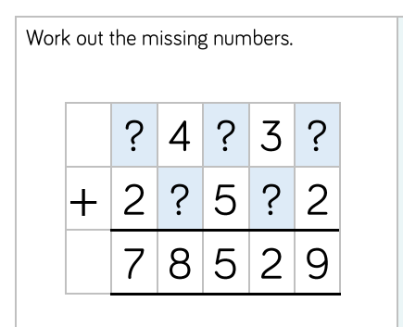

Click on the link below for addition:
https://corbettmathsprimary.com/2018/05/30/addition-video/
Challenge
Can you explain your process for working this out?
Sam started adding up from the left. Where would he have gone wrong?
Explain why you need to start with the ones column.

TUESDAY –

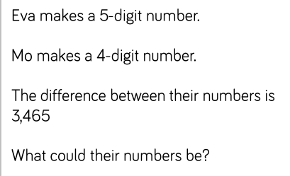

Click on the link below for subtraction:

https://corbettmathsprimary.com/2018/05/30/subtraction-video/
RUCSAC the problem.
Where are you going to start?
Do you think you think that both of their numbers could be even numbers? Explain.

WEDNESDAY –

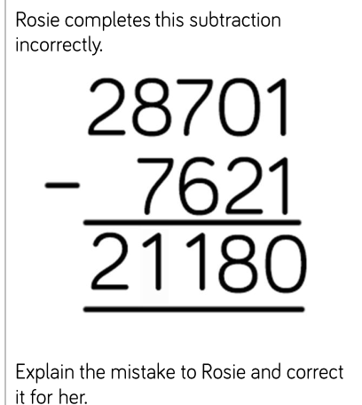
Challenge
Imagine you are teaching this method to year 3. Write out a step by step set of instructions for column subtraction. You can use diagrams and examples to explain your points more clearly.

THURSDAY –

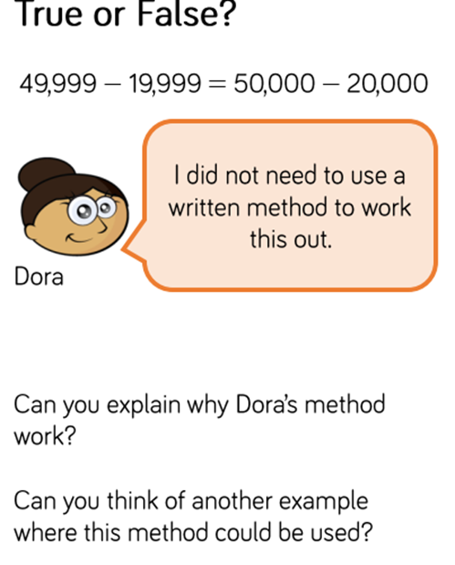

Do you think that Dora’s method is useful or confusing? Explain why.

FRIDAY –

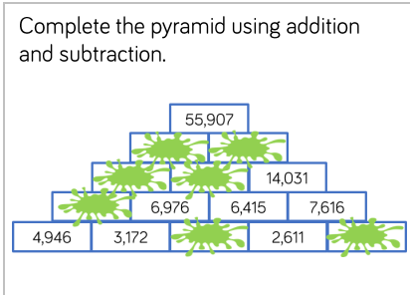

Challenge: Can you create one your own?
TOPIC: Raiders, traders or invaders?
(Video link: https://www.bbc.co.uk/bitesize/topics/ztyr9j6/articles/zjcxwty)

MONDAY-
Questions to think about:
Where did the Vikings settle? Do the areas that they settled differ from where the originally invaded? Why?
Over the next two days you are going to research about Viking settlements in Europe. On a map show clearly where they settled and when. You are going to draw a map and clearly label it. What other facts can you find out and include in your map? This work will be completed over two days.
The link below will help you:
https://www.nationalgeographic.com/magazine/2017/03/vikings-ships-realm-raiders-scandinavian/

TUESDAY-
Today you are going to complete yesterdays work.

Viking fun video of the day:
https://www.youtube.com/watch?v=lwDyefAD7BY

WEDNESDAY-
Imagine that you are a Viking getting on a long boat, heading towards unknown lands. You are unaware of what lies ahead. The journey across the sea is going to be dangerous. You hope the gods, including Thor the god of thunder, will be kind. What will you find when you land?
Write a short diary extract. Remember to write in first person.

Fun overview of the history of the Vikings:
https://www.youtube.com/watch?v=wbchlhlMLPE

THURSDAY-
Design your long boat. What will it look like? What would you have on board? What would your sail look like? What about the shields on board?
Click on the link for some good ideas. (Scroll to the bottom of the page to find out long boats.)
https://www.nationalgeographic.com/magazine/2017/03/vikings-ships-realm-raiders-scandinavian/

FRIDAY-
Reflect on your learning today. What have you learnt about the Vikings? Can you now see the impact that they have had on our lives? What did you enjoy finding out about?
Now complete any unfinished work that you have started over the last few weeks on Vikings.
Click for a fun song about Vikings:
https://www.youtube.com/watch?v=8qSkaAwKMD4

LEARNING WEBSITES

https://www.topmarks.co.uk/maths-games/hit-the-button

https://www.mathplayground.com/

https://www.topmarks.co.uk/maths-games/7-11-years

https://whiterosemaths.com/homelearning/

https://nrich.maths.org/primary

https://ttrockstars.com/

https://www.bbc.co.uk/bitesize/levels/zbr9wmn

https://www.literacyshed.com/home.html

https://www.spellingshed.com/

https://pobble.com/

https://monsterphonics.com/?gclid= EAIaIQobChMI56aEu9yh6AIVFeDtCh2NMAcIEA AYASAAEgK1b_D_BwE

https://www.oxfordowl.co.uk/welcome-back/for-home/reading-owl/kids-activities

https://www.topmarks.co.uk/english-games/7-11-years

Audible are doing a free 30 day trial so that children can listen to lots of books online.

MATHS ANSWERS:
Monday:
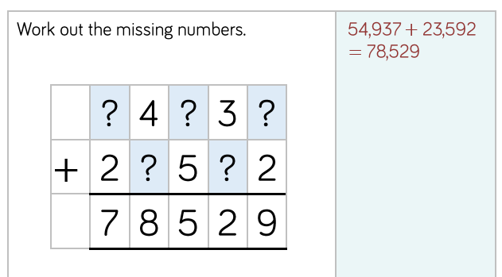

Tuesday:

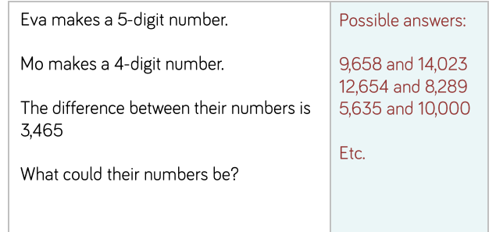
Wednesday:

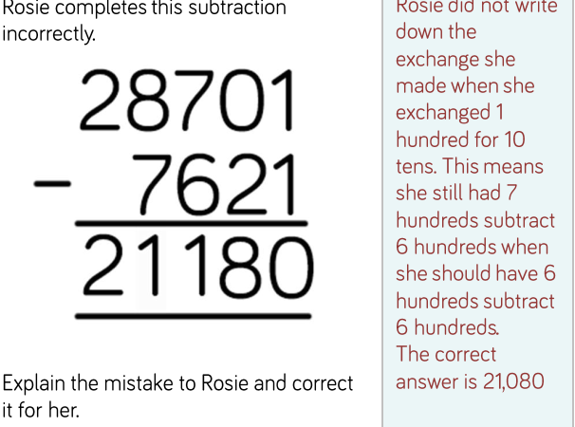

Thursday:

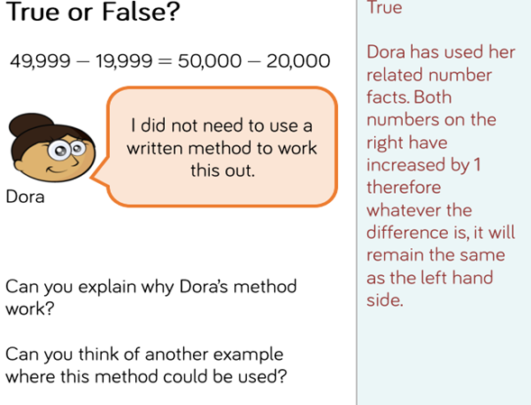
Friday:

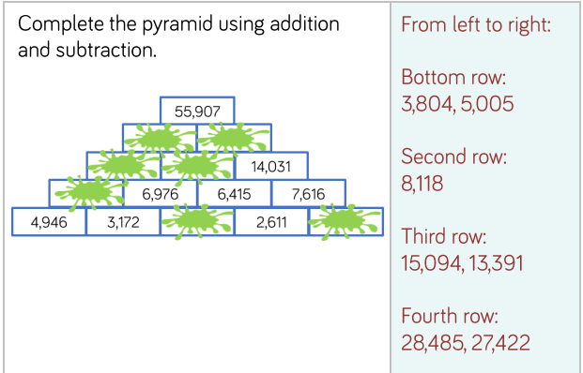
YEAR 5-6 SPELLING WORDS
