Dear Parent/Carer,

As the school continues to remain closed due to Coronavirus, we are continuing to provide educational tasks for your children to complete. We have received positive feedback on the new format of the home learning daily tasks. As always, please continue to keep in touch about your child’s home learning and let us know if there are any problems.

In primary, we suggest that children try to complete;
- 30 minutes a day of independent reading/reading to an adult
- 30 minutes of maths a day
- 30 minutes of English a day
- 30 minutes of topic based/creative learning
- 30 minutes of PE/ physical activity

Home learning tasks can be supplemented with work from a number of websites (see list below for ideas.) Daily work set on the BBC website is particularly useful as it contains tutorial videos.
https://www.bbc.co.uk/bitesize/primary

Teachers will set a weekly programme for your child to work through at home. This will be available for you to access on the school website every Monday. We know that children work at different speeds and different levels, so please have a look at work in other year groups too for extra support.

To help with maths and different terminology, we will try to add in some video links for tutorials and we will try to include answers for maths where possible to help the children check through their work.

Whilst it is important for your child to keep up with their learning at home, we appreciate that this can be a stressful time for children and adults. Looking after mental health is vital. Therefore, we suggest that the day is broken up into manageable learning chunks, interspersed with physical exercise, fun activities and time together as a family. Activities such as the 30 day lego challenge and using the real PE activities could be a good place to start. Setting up a weekly timetable can be a good place to start. As well as educational learning, the children could also begin to learn different life skills – how to boil an egg, sew on a button, learn to send an email, bake a cake using a recipe book etc.

Guidance for parents, regarding home learning, has been released by the government and can be found at the following link;
https://www.gov.uk/guidance/supporting-your-childrens-education-during-coronavirus-covid-19

We hope you are all keeping well and staying positive.

Kind regards,

The Year 5 team
Teacher email;
Large-becki@mayfield.portsmouth.sch.uk
Turner-peyton@mayfield.portsmouth.sch.uk

YEAR 5 HOME LEARNING TASKS
WEEK BEGINNING: Monday 8th June 2020
ENGLISH (leaflet focus)

SPELLINGS FOR THIS WEEK:
existence, explanation, familiar, foreign, forty, frequently, government
MONDAY (spelling)
Create pictures that reflect your spellings, for example: a picture of a teacher for explanation.

TUESDAY (reading comprehension)
Research leaflets online, list the features of a leaflet. Look at how the words are laid out, what does the leaflet contain, what is the purpose of the writing, are there any pictures?
https://www.bbc.co.uk/bitesize/topics/zkgcwmn/articles/zrjqpg8

WEDNESDAY (Spelling)
Create a word search that contains all of your spelling words this week. Can you get someone in your house to complete it?

THURSDAY (writing)
Reflect on the leaflet that you found, on Tuesday. Did you notice that the purpose was to persuade? This week you will be writing a leaflet to explain how and why people should pick up their litter when they visit Southsea. Leaflets have a similar structure to information texts, they have an introduction and some paragraphs with subheadings. Today plan your introduction and 2 or 3 paragraphs. You might decide that you will write about why litter shouldn’t be dumped, how to dispose of it properly and what you can do to help. 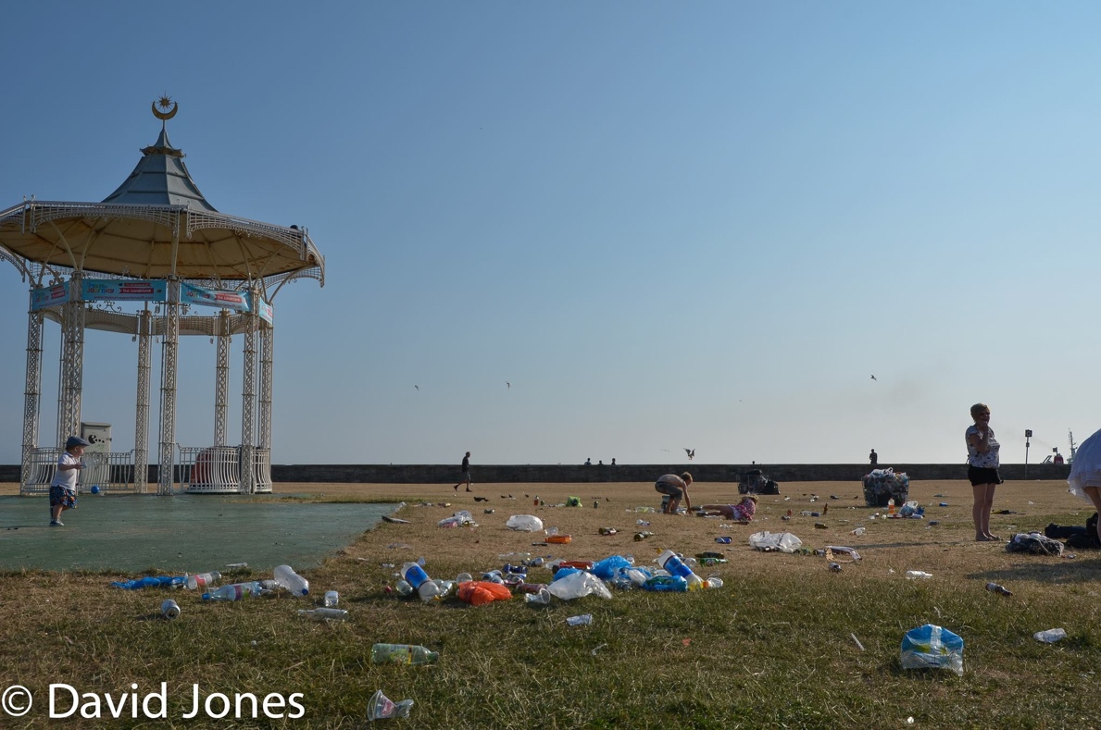

FRIDAY (writing)
Using your plan from yesterday, write up your leaflet. Make sure that you are using persuasive language and that you are using the correct tense, try to use some punctuation for parenthesis. Don’t forget to edit when you are done.

MATHS (Division focus)

Times tables for this week:
Continue to test yourself weekly, on your target times table. Give yourself 30 seconds per calculation. You can include as many calculations as you wish to in the test. If you pass, move onto the next calculation. If you do not pass in time, continue to remain on that times table until you do pass.

Use the link below for extra challenges
https://whiterosemaths.com/homelearning/year-5/

MONDAY –
Use the video link below to help you remember methods for division.
https://www.bbc.co.uk/bitesize/topics/z36tyrd

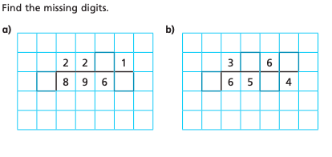
How did you know what the missing digits were?
Can you write a set of instructions for how to use this method?

TUESDAY –
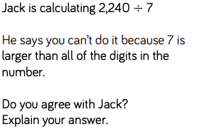

Practise this method by creating 10 more division calculations.

WEDNESDAY –
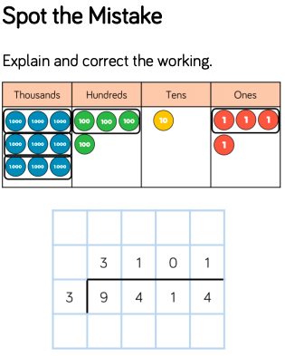

THURSDAY –
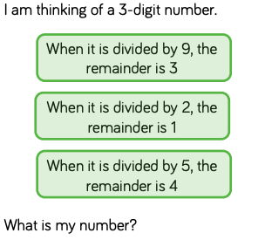
Make up 2 examples of your own?

FRIDAY –
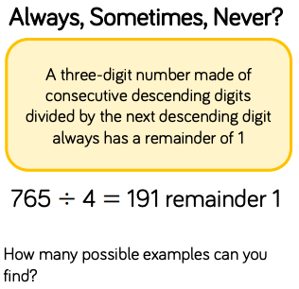

TOPIC (DT focus)
MONDAY – Design
Think back to your Harry Potter trip. When we were there, we participated in a costume workshop, write a list to explain the things that costume designers consider when they are thinking about characters costumes.
TUESDAY – Design
At the studios, we discussed how they choose a costume and how they consider colour and texture based on what the character is like. Research one character from Harry Potter and describe their character. For example: Harry Potter: orphan, smart, kind and special. Explain how you know that your character has these traits.
WEDNESDAY – Design
https://www.bbc.co.uk/teach/class-clips-video/art-and-design-ks2-costume-design/z4wkbdm

We will be creating a mood board for a costume for your character. Today, create a criteria to be successful, for example “I will be able to explain why I have picked the fabric”. Spend some time researching different fabrics, you might want to look online or feel the textures of clothes you have at home.
THURSDAY – Make
Today you will create your mood board. Reflecting on what your chosen character is like, sketch or list what materials and colours you might use for your character and why. You might want to sketch out an outfit if it is easier than describing. You should explain why you have chosen a material, for example ‘I have used flannel for Harry Potter as it is worn and as he is an orphan, he hasn’t ever had new clothing’.
FRIDAY–
Reflect on your mood board, did you successfully meet your criteria? If not make some changes. Have a look now at real costumes for your character and see how they compare, can you justify your costume?

Send a picture of your design to your teacher.

LEARNING WEBSITES

https://www.topmarks.co.uk/maths-games/hit-the-button

https://www.mathplayground.com/

https://www.topmarks.co.uk/maths-games/7-11-years

https://whiterosemaths.com/homelearning/

https://nrich.maths.org/primary

https://ttrockstars.com/

https://www.bbc.co.uk/bitesize/levels/zbr9wmn

https://www.literacyshed.com/home.html

https://www.spellingshed.com/

https://pobble.com/

https://monsterphonics.com/?gclid= EAIaIQobChMI56aEu9yh6AIVFeDtCh2NMAcIEA AYASAAEgK1b_D_BwE

https://www.oxfordowl.co.uk/welcome-back/for-home/reading-owl/kids-activities

https://www.topmarks.co.uk/english-games/7-11-years

Audible are doing a free 30 day trial so that children can listen to lots of books online.

MATHS ANSWERS:

Monday:
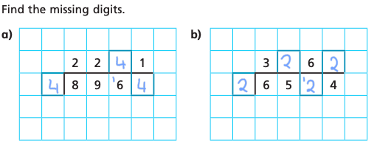
Tuesday:
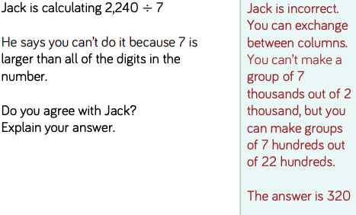

Wednesday:
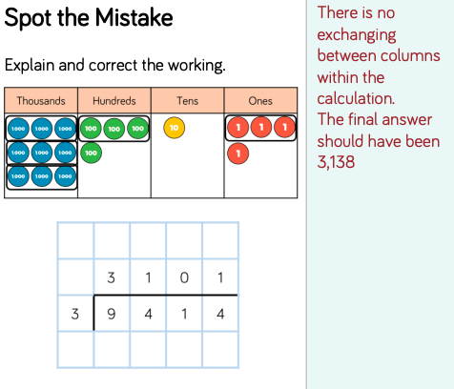
Thursday:
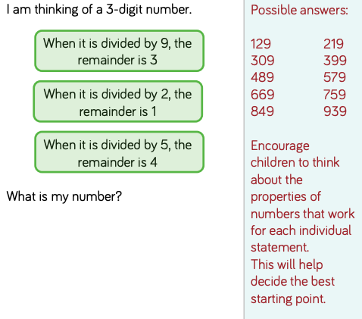
Friday:
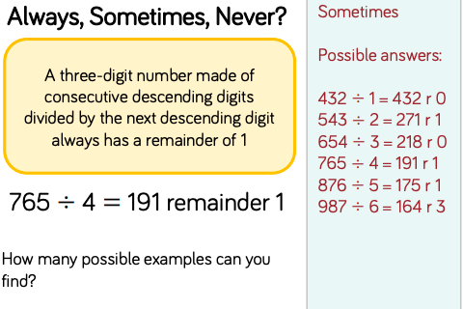

YEAR 5-6 SPELLING WORDS
