Dear Parent/Carer,

Although the school is currently closed due to Coronavirus, we are continuing to provide educational tasks for your children to complete.

In year 8, we suggest that children try to complete.
- 1 hour per week of English, Maths and Science (i.e. 3 hours a week in total)
- 30 minutes per week of Art, Dance, Drama, Geography, History, ICT, Music, PSHE, RE, Spanish and Technology (i.e. 5.5 hours a week in total)
- 30 minutes of PE per day
- 30 minutes of reading per day

Home learning tasks can be supplemented with work from several websites (see the school home learning page on the website for examples of these).

Teachers will set a weekly programme for your child to work through at home. This will be available for you to access on the school website every Monday. Please note that to access the work on a mobile or laptop you may need to install Word (available here for Android and here for Apple) and PowerPoint (available here for Android and here for Apple). If accessing the work on a laptop then pupils should be able to use Office 365 through their web browser and won't need to install any extra programs. If you have any problems accessing the work, then please email Mr Clark-Lyons (clark-lyons-richard@mayfield.portsmouth.sch.uk).

Whilst it is important for your child to keep up with their learning at home, we appreciate that this can be a stressful time for children and adults. Looking after mental health is vital. Therefore, we suggest that the day is broken up into manageable learning chunks, interspersed with physical exercise, fun activities and time together as a family. Activities such as the 30-day lego challenge and the daily Joe Wicks PE lessons could be a good place to start.

As well as educational learning, the children could also begin to learn different life skills – make a meal for the family, sew on a button, write a letter to a distant family member, bake a cake using a recipe book etc.

We hope you are all keeping well and staying positive.

Subject Based work

English
20/7/2020
It’s been great to see so many of you in school and online-we hope you’ve enjoyed some contact time with your teachers and getting on with some learning. We know you’ve had some extra work to do but you can still carry on with this work pack below, too!
This term, you are going to create a narrative/story focusing on your writing and technical skills. There are ten lessons in all, and we would like you to work on a minimum of ONE (or more able students TWO) of the tasks from the English Mastery Student Workbook found here. We have included an answer book to help you review your work and check you haven’t made any mistakes. You can find this here.
If your parents are trying to help you, there’s a guide for them too – but why not be resilient and explain it to them!
So, this week, attempt Lesson 8, pages 43-50. Remember, to be resourceful and challenge yourself to complete all the tasks and read instructions carefully! You can make your own notes using lined paper or use your own lined notebook, if you have one. Don’t forget you can use the answer booklet to self-assess, check your answers, and make corrections, found here. Writing takes time and concentration to do it well, so try to focus on the task and don’t rush through tasks-really think about you are writing. Enjoy being creative and improving your skills!
In addition, we want you to work on your spelling! These spellings will help with expanding your vocabulary helping to improve reading and writing. Now you’ve learnt them, why not ask a friend, parent, carer or sibling to test you on all 70 spellings? You can find all the spellings here All spellings Summer 2 . Remember, use your strategies: look, cover, write and check to re-learn any you still haven’t quite cemented in your head. Also, if any of the words are still unfamiliar, look them up using a dictionary or online.
Finally, a reminder to be reading privately and completing Accelerated Reader quizzes for the books you have read. Try to make time for at least 15 minutes reading a day.
Looking for an extension? How about creating a reading log or journal to show your teachers when you return to school? You could add pictures, author notes and personalise your journal?

Summer Holiday English Learning:
To help you prepare for your Autumn 1 English lessons please read Alice in Wonderland by Lewis Carroll. This link provides you with a free pdf of the story: https://www.adobe.com/be_en/active-use/pdf/Alice_in_Wonderland.pdf
You can also listen to it for free at: http://www.audiobooktreasury.com/alice-in-wonderland/
Alice in Wonderland by Lewis Carroll (Free Audio Book) | Audiobook Treasury
This is Alice’s Adventures in Wonderland the free audio book by Oxford mathematician and children’s story teller Lewis Carroll. Following a picnic along the Thames, Charles Dodgson began telling the story of Alice and her adventures down the rabbit-hole.
www.audiobooktreasury.com
By all means also watch the film versions - the Disney carton or the live action with Johnny Depp. Knowing the story in advance will help you with your learning when you return.
What about other work, over the summer?
Here’s some additional ideas to keep you engaged over the summer:
- Complete the writing work pack above, through to lesson 10, and follow up with the quizzes, to test your learning.
- Create your own summer journal, filled with writing about your activities, your reading (noting books read), adventures outdoors, friendships, family-try to use all the skills you’ve learnt in creative writing.
- Become a summer poet! Choose a topic weekly and put your ideas into poetry-it's a great way of being creative, expressing yourself and applying your writing skills!
- Become an expert on an author or poet-create a guide to a poet or author, using research skills and your own ideas to create a great reference booklet or a scrapbook.
- Design a board game based on a book you’ve read/a film you’ve watched or an online game.
- Write a short play or memorise a famous scene from a play; try performing and recording it with friends or as a monologue.
- Finally, revisit the work set over the last term-if you missed some go back to it. If you want even more try accessing the free quizzes online like here- https://www.educationquizzes.com/ks3/english/
There are so many ways to keep your skills up to speed and be creative. Don't be bored ; be brilliant!

Maths

20/7/2020
Please write any answers on paper, you do not need to print out any sheets (although feel free if you want to).
You need to spend about 1 hour on this work. You might not complete the whole sheet, but still work for an hour. Make sure you select the correct file for your set. All files can be found here. There are worked solutions for the first three questions on each task and the answers to all the tasks are at the end of the main worksheet.
Set 1 – Averages 2
Set 2 – Averages 2
Set 3 – Averages 1
Set 4 – Averages 1
Start on Task 1
- Read the instruction for Task and answer the first 3 questions.
- Check your answers against the Worked Solutions (Make sure you select the correct file for your set)
- If you feel confident move onto the next Task and repeat these steps for each task. If you are not confident, complete 3 more questions of the Task you are on (Answers are at the end of the first document). Move on when you feel confident.
Here are some links to videos to on how to calculate the perimeter and area of different shapes to support.

- Mode
- Median
- Range
- Mean

If you have any issues please email Mr. Ralph on the following ralphs@mayfield.portsmouth.sch.uk with your: Name, Year and Maths Class and he will try to help you.

Science

20/7/20
Please write any answers on paper, you do not need to print out any sheets
It's all revision this week, you have recapped a lot in recent weeks and Mr Jackson has prepared a selection of activities to test your knowledge . Click on this link to take you to the tasks for this week.
Answers for last week’s work can be found will be gone through in your online session this week. Please make sure you attend these sessions to check and correct your work.

If you have any questions, or would like to send some examples of your work to us please email them to
Mr. Jackson – JacksonG@Mayfield.portsmouth.sch.uk

PE
20/07/20
Year 8 – Practical Home Learning
Time to finish off your training! Please email your PE teacher with your results and progress.
You had two options to choose from to develop either your skills or performance over the Summer Term.
Option 1
Aerobic fitness improvement – Choose either running or cycling
Design a training plan to exercise a minimum 3 times a week with rest days in between. Set yourself an appropriately challenged distance and monitor your progress over the 5 weeks. We would like you to monitor changes in time and distance and how your heart rate is being affected. A standard plan would suggest exercising Monday / Wednesday / Friday. Please email your PE teacher with any data, progress, or pictures of your exercise achievements.
Option 2
Skill improvement
For those that prefer to play sports or perform routines, we are asking you to pick an activity that you enjoy and strive to improve your consistency and accuracy. You can choose any activity, such as gymnastic skills, basketball shooting or throwing and catching. We ask that you practice every day and then review your progress at the end of the week. Please video your performance and email it to your PE teacher and pictures would be welcomed.
Good luck – Remember “Healthy Body = Healthy Mind”
Well done to all of you who have sent your plans and work outs to your teacher by Email – Keep up the good work!
Important - In September, due to the restrictions on physical activities that we can do easily with Covid 19, please be prepared to complete a couch to 5K running programme in your PE Lessons. Any training you can do over the summer will help prepare you mentally and physically.

Art
20/07/20
Complete the following google document and tasks: https://forms.gle/oAsCZ27Duqyzjezu9
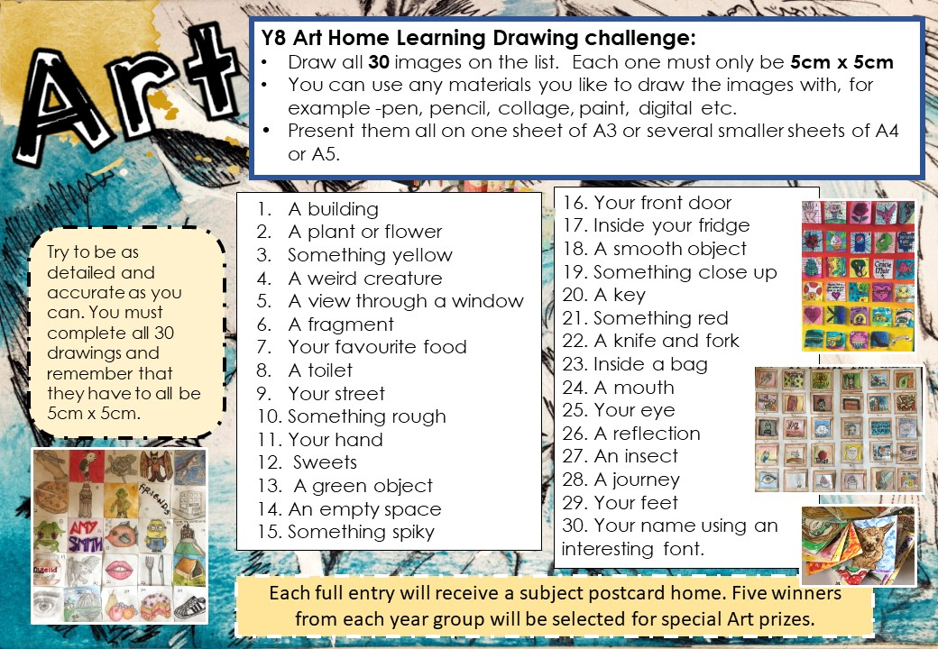

Dance
20/07/2020
Practical: 30 minutes
This is your third week of practical now so you should be varying the exercise that you re completing.
Complete a full warm up consisting of the following stages:
- Pulse raiser: eg. Jogging
- Stretching: this should work on all areas of the body from head to toe. Remember to stretch both sides equally.
- Mobility: eg. Arm swings/hip circles
- Dynamic movements: practice sharp changes in speed and direction eg: shuttle runs
- Skill rehearsal- practice specific skills.
This warm up should take you around 10- 15 minutes if completed to a high standard
You must now complete a HIIT workout.
This can focus on any of the following areas (focus on a different area each week to mix it up)
- Abdominals and core
- Legs and Glutes
- Arms, back and shoulders
- Cardiovascular.
You can either create your own HIIT workout or research an existing one, there are loads online for example Joe Wicks or Courtney Black.
Ensure that you stretch and cool down once you have completed the workout to lower your heart rate.
You now need to email your teacher to let them know what HIIT workout you did and how you found it.
Franklina@mayfield.portsmouth.sch.uk
Taylor-hayley@mayfield.portsmouth.sch.uk

Drama
20/7/20
Task 1; Add this weeks words to your Drama Dictionary with your definition. If you have access to the internet you can use the drama pages on BBC bitesize, you can use a dictionary or your own knowledge, you could also ask family members.

Week 8 words;
- Props
- Set
- Costume
- Stage Crew
- Playwright
- Director
- Ensemble

Task 2; This week and over the summer watch ‘Joseph and the Amazing Technicolor Dreamcoat’ and answer the questions via the google form https://forms.gle/5qDJ4MNyLSeBWM7J7 Enjoy!!
Well done for all your hard work in Drama this term, can’t wait to see you all in September 😊

Geography
20.7.20
There are 1000's of news stories every day and a large number of these will have a geography element within them. That might be to do with the physical landscape, environmental issue or social and economic impacts of events on people in different places.
This summer we would like you to investigate one news story that has geography involved in it.
It must be a recent story, no older than a couple of months and you need to complete the table below with the information relevant to your story. Feel free to include pictures if they are relevant in the 5Ws section. Consider the short term and long term effects and the social, economic and environmental impacts.
The form to complete you work can be found here

History
20/7/20
Please watch the video lesson, which is about Charles II. You will need a piece of paper and 2 different coloured pens to complete and mark the tasks, or a word document (or equivalent) open and ready to type in. Please click here for the video lesson.

ICT
20th July 2020
Follow the link to complete the task on online working or complete it below.
Name ……………………………………………………..

1. What are the benefits of online communication?

2. What are the risks of online communication?

3. What can you do to keep yourself safe whilst online?

4. If you are uncomfortable or feel threatened by anyone online, what should you do?

Music

20th July 2020

Please follow the link below, complete the work and send it back to me. Thanks! Please be sure to use your school email to complete and send the work
If you are struggling to get access to the google form it is because you are not logged in to your school email address on the google page. You can log in to google using your school email address by clicking the round sign in icon in the top right-hand corner, then use your school email address and log in. This will allow you access to the form.
https://docs.google.com/forms/d/e/1FAIpQLSeIjjqfwJc7ef6C67xsRPEBtza8aOYluud0ZJAXlHoCpSlu3g/viewform?usp=sf_link

PSHE
20.07.20
In recent weeks, you have been thinking about keeping safe on the internet. This week, you need to show everything that you have learnt about online safety and fake news/biased writing. It is completely up to you how you present this information. You could choose to:
- Write it out as an essay
- Make a poster to encourage others to be safe online
- Make a leaflet all about online safety
- Design a ‘website’ home page, which has lots of information about keeping safe
- Write a story or draw a storyboard, which demonstrates how to keep safe online

However you choose to present the information, you should show:
- How to stay safe on social media
- How to make sure you are sharing information carefully online and why that is important
- What cyber bullying is
- What different types of cyber bullying there are
- What to do if you are worried about something that you have seen or experienced online
- What fake news is and how to identify it
- What biased writing is and how to identify it

Please either email your work or pictures of your work to Miss Colmer on colmer-rachael@mayfield.portsmouth.sch.uk and she will give you feedback or keep your work safe and bring it in in September, when Miss Colmer will be able to give you feedback.

RE
20/07/20
Christianity: Prayer and Worship
Christianity- revision  Christian practises and beliefs | Oak National Academy Lessons-Unit 1 Lesson 9 | https://classroom.thenational.academy/lessons/prayer-and-worship | 1.Press ‘start lesson’ to begin. Do not take the quiz and press ‘next activity’ to take you to the video  2.Watch the video (19 mins) and pause if you need to.  3.Multiple-choice quiz. Press ‘start quiz’. Once answered press ‘submit’ and then ‘view score’. Make sure you read the correct answers to any you got wrong.  You can email your teacher your score
I

Spanish
Week beginning 20th July 2020
Here is a selection of videos for you to watch for any areas you feel you need to revise on.
Video – J.O.E - Justify your Opinion with an Example
- Video link: J.O.E Opinion video
- Video worksheet: J.O.E Opinions Worksheet
- Google Form link: Google Quiz
Video – Adjectival agreement
- Video link: Video adjectival agreement
- Video worksheet: Adjective worksheet
Video – Present tense regular AR/ER/IR verbs
- Video link: Video AR/ER/IR present tense
- Video worksheet: Present tense AR/ER/IR worksheet
- Google Form link: Present ER/IR quiz
Video – Preterite tense regular AR/ER/IR verbs
- Video link:Preterite video lesson
- Video worksheet:Preterite worksheet
- Google Form link: Google quiz
Video – Near future tense
- Video link: Video near future
- Video worksheet: Near future worksheet
- Google Form link: Near future quiz
Video – Phonics in Spanish
- Video link: Video Spanish phonics
- Video worksheet: Phonics worksheet

Research
Tapas en España
Follow the link to an interactive map which has a variety of tapas dishes from different regions in Spain. Follow the instructions on each slide which will require you to translate the name of the dish, look at the recipe and understand the ingredients needed and the technique to make it.
If you are feeling really brave, why don’t you try and create one of the dishes for your family and then share photos with Mr Scardigno scardigno-giuseppe@mayfield.portsmouth.sch.uk

Technology
20/07/20
Plan a party celebration for the end of lockdown that you would like to share with your family. Plan the type of food you would like to make, where you would like to meet and who you would like to be there. Then design an invitation you can send out to those people.
Complete the following google form: https://forms.gle/1HXoWQ9khKgfd2YT7

